Experiment No. 11
Aim To demonstrate contract-to-contract interaction within the Ethereum ecosystem, simulating complex dApp structures (Interacting with Other Contracts).
- Objectives:
  - Show how contracts can invoke functions of other contracts.
  - Outline best practices for managing contract dependencies.
  - Explore the potential for modular contract development.

Steps:
  - Access Remix IDE: Open Remix IDE in your web browser.

Create the Contract File
    - Click on the "Create New File" icon in the "File Explorers" tab on the left side.
    - Name your file CalledContract.sol and paste the provided Access Control contract code into it.
// SPDX-License-Identifier: MIT pragma solidity ^0.8.22;

// Contract to be called contract CalledContract {
uint public storedData; // State variable to store a number

// Function to store a value function set(uint x) public {
storedData = x; // Assigns value to the state variable
}

// Function to retrieve the stored value function get() public view returns (uint) {
return storedData; // Returns the value of the state variable
}
}

Compile the Contract
    - Click on the "Solidity compiler" tab on the left sidebar.
    - Ensure the compiler version is set to match the version specified in your contract (^0.8.22). If necessary, select the correct version manually.
    - Click "Compile CalledContract.sol".

Deploy the Contract
    - Switch to the "Deploy & Run Transactions" tab.
    - In the "Environment" dropdown, select "JavaScript VM" for testing purposes.
    - Click "Deploy". The contract does not require any constructor parameters, so deployment should be straightforward.
    - Copy CallerContract Address.

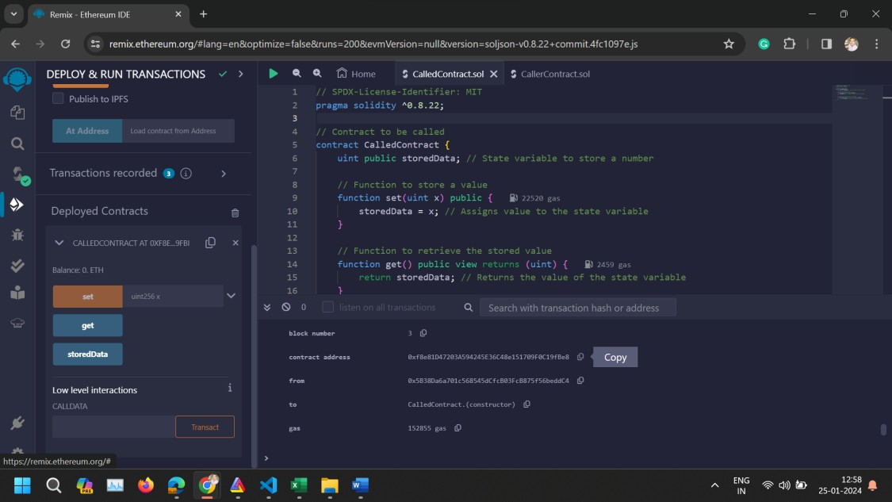

Deploy CallerContract with CalledContract's Address
    - Create a new file named CallerContract.sol and paste the CallerContract code.
// SPDX-License-Identifier: MIT pragma solidity ^0.8.22;

// Interface for CalledContract to interact with interface ICalledContract {
function set(uint x) external;
function get() external view returns (uint);
}

// Contract that calls CalledContract contract CallerContract {
address calledContractAddress; // Address of CalledContract

// Event to log the value retrieved from CalledContract event ValueRetrieved(uint value);

// Constructor to set the address of CalledContract constructor(address _calledContractAddress) {
calledContractAddress = _calledContractAddress;
}

// Function to call set function of CalledContract function callSet(uint _value) public {
ICalledContract(calledContractAddress).set(_value);
}

// Function to call get function of CalledContract and emit the retrieved value
function callGet() public {
uint value = ICalledContract(calledContractAddress).get(); emit ValueRetrieved(value); // Emitting event with the value
}
}
    - Compile CallerContract.sol.
    - In the "Deploy & Run Transactions" panel, paste the CalledContract's address as the _calledContractAddress parameter for the CallerContract constructor.
    - Deploy CallerContract.
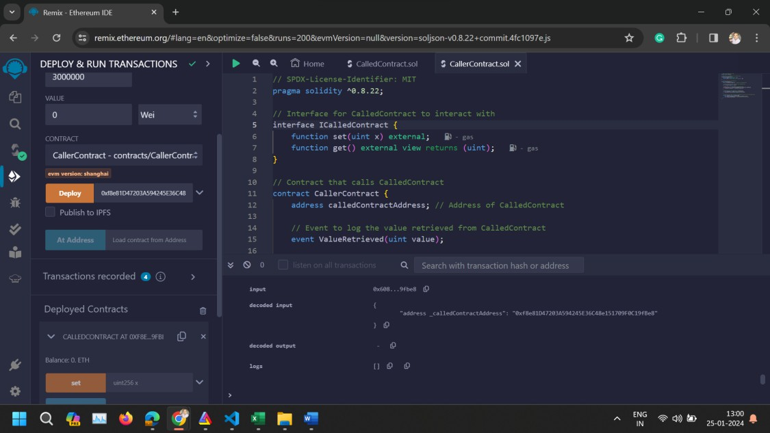

Interact with the Contracts
    - Call callSet: Use CallerContract's callSet function to store a value in CalledContract.
    - Call callGet: Then, use CallerContract's callGet function to retrieve and log the stored value.

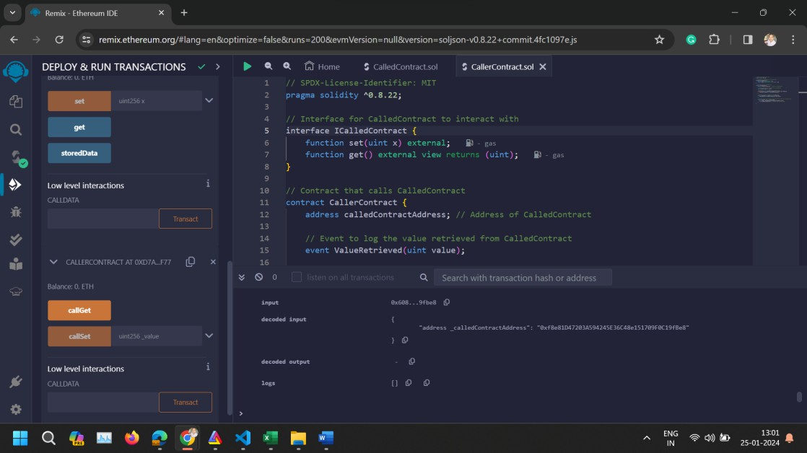
- Conclusion: This experiment demonstrates contract-to-contract interaction within the Ethereum blockchain using Remix IDE. This setup illustrates how contracts can leverage functionality of other contracts, a foundational concept for building complex decentralized applications.

