Experiment No.2
Aim: To install Geth on machines to understand the basics of blockchain technology.

Geth is an official command-line interface (CLI) tool that is used to run an Ethereum node with the Go programming language it’s a short form of "Go Ethereum". It serves as a client for the Ethereum blockchain and is one of the three original implementations (along with C++ and Python) of the Ethereum protocol. Being an essential part of the Ethereum network, Geth allows users to mine Ether, transfer funds between addresses, create smart contracts, and explore block history.

Steps:
- Open a Terminal Window: First, open a terminal window on your Ubuntu system. You can do this by searching for "Terminal" in your applications menu or by pressing Ctrl + Alt + T on your keyboard.
- Add the Ethereum PPA (Personal Package Archive): Ethereum provides a PPA to make it easy to install Geth. You can add this PPA to your system with the following command.
sudo add-apt-repository -y ppa:ethereum/ethereum

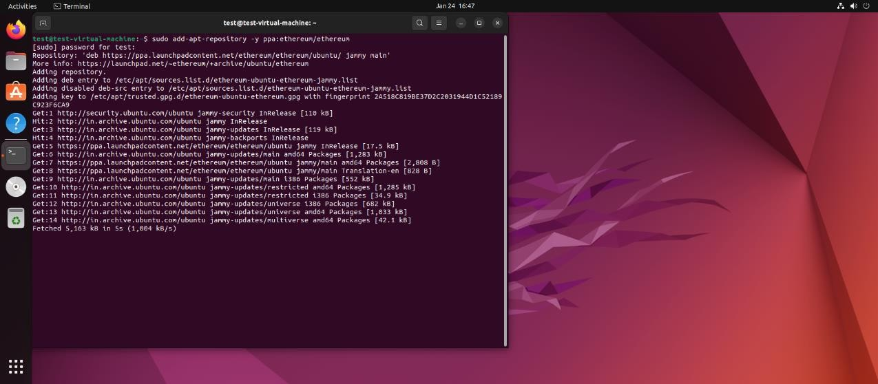
- Update the Package List: After adding the PPA, update your package list to ensure your system knows about the packages available in the newly added repository.
sudo apt-get update

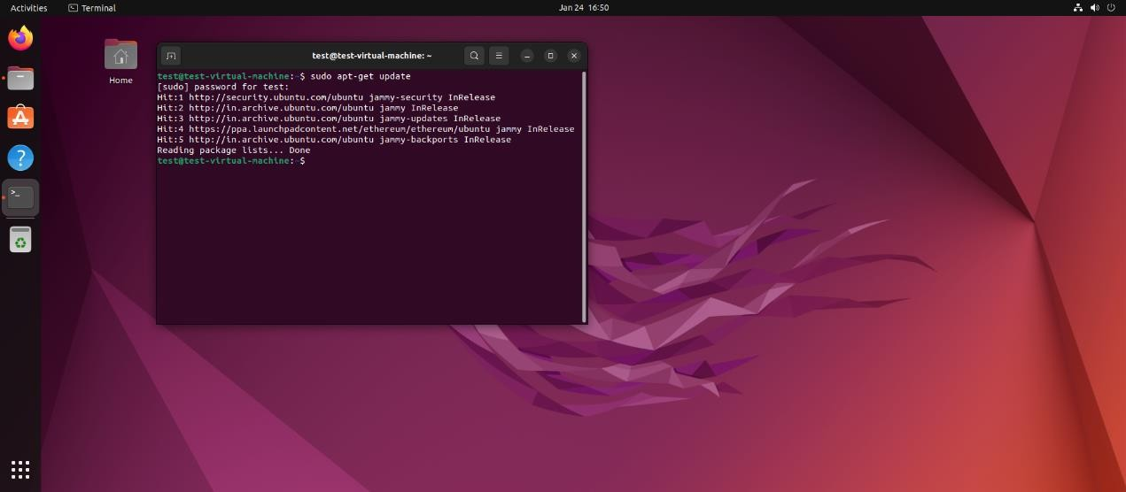
- Install Geth: Now, you can install Geth using the following command.
sudo apt-get install Ethereum
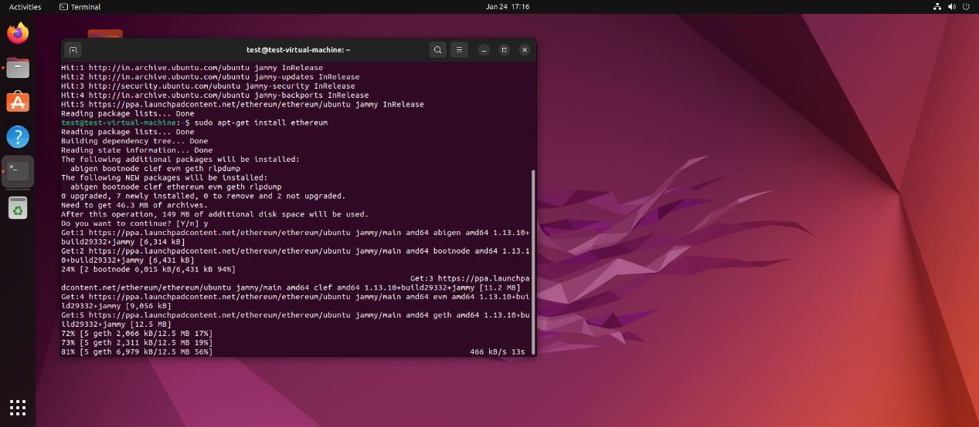
- Verify the Installation: Once the installation process is complete, you can verify that Geth has been installed correctly by checking its version with the following command.
geth version

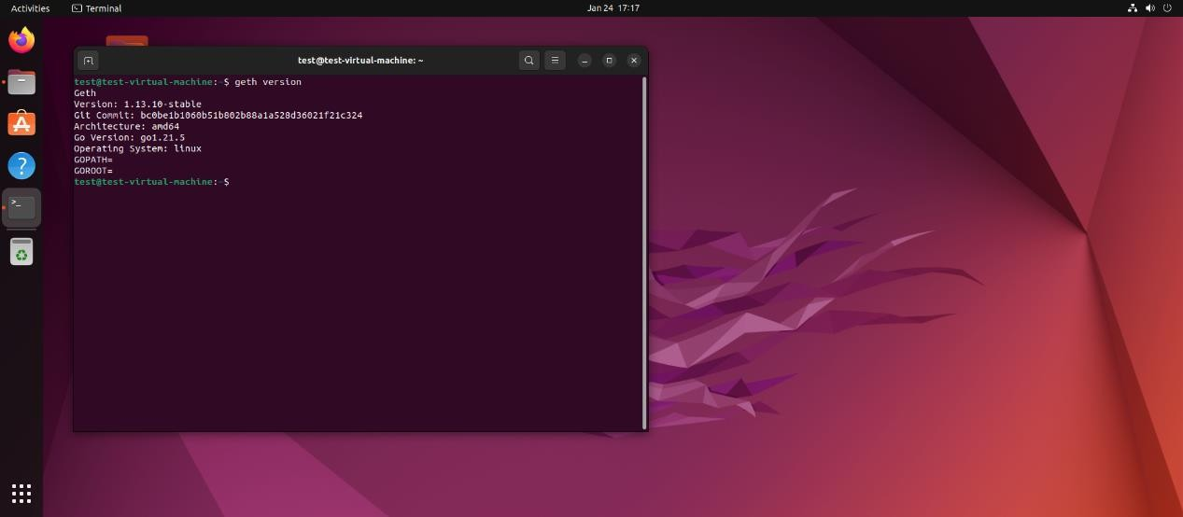
- Run Geth: To start running a Geth node that connects to the Ethereum network, you can simply run.

Geth
- Synchronization: Geth offers several synchronization modes. The default mode is "fast", but you can specify a different mode using the --syncmode flag. For example, to start Geth in light mode, which requires less disk space.
geth --syncmode "light"

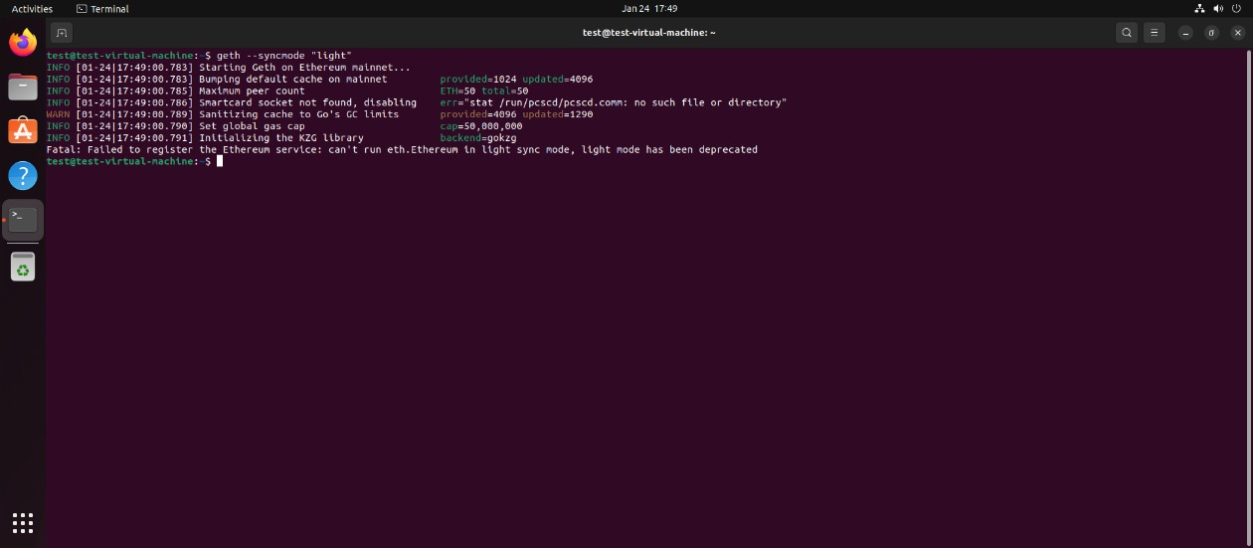
Testing Geth

Testnet Steps: 'Ropsten' is crucial testnet for developers, as it provides an environment that mimics/ simulates the Ethereum mainnet but uses free, valueless Ether for testing purposes. This allows developers to deploy and test their smart contracts and applications without risking real money.

Example Use:
- Start Geth in goerli Testnet Mode: To connect to the Ropsten testnet using goerli, you need to start Geth with specific flags that tell it to connect to goerli instead of the main Ethereum network. Use the following command:
geth --goerli --syncmode "full" --http --http.api "eth,net,web3,personal"
- Wait for Synchronization: After running the command, Geth will start synchronizing the Gerli blockchain. This process can take some time, depending on your internet connection and the chosen sync mode. Geth needs to download the entire blockchain to be fully operational.

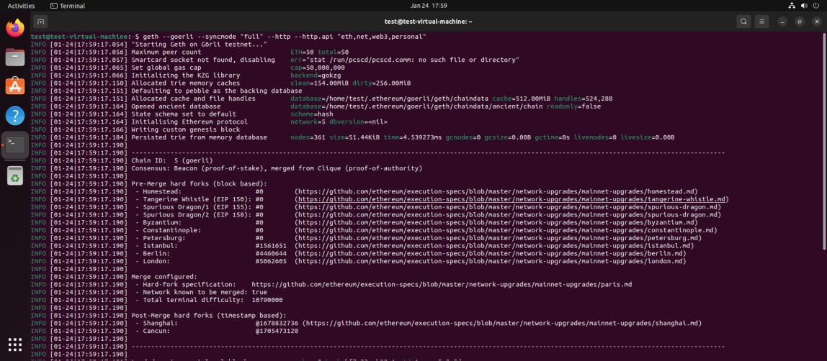
- Interact with Geth: Once the synchronization is complete, you can start interacting with Geth and the Ropsten testnet. You can use the Geth JavaScript console to directly interact with the network by opening another terminal window and running.
geth attach http://127.0.0.1:8545

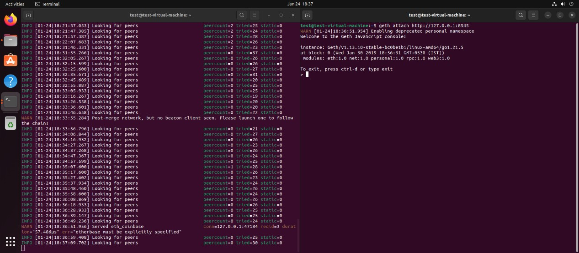
- Obtain Test Ether: To conduct transactions on the Ropsten testnet, you'll need test Ether. You can obtain it from a Ropsten faucet, which distributes free test Ether. Search for "Ropsten faucet" online and follow the instructions on the website to receive your test, Ether.
- Perform Transactions: With test Ether in your account, you can start deploying contracts, making transactions, or testing your applications without spending real Ether.

