Experiment No.3
Aim: To install Truffle, a popular development framework forEthereum blockchain.

Truffle is a development framework and toolset for building decentralized applications (dapps) on the Ethereum blockchain. It provides developers with a suite of tools to write, compile, test, and deploy smart contracts efficiently using the Solidity programming language. Truffle also simplifies the integration of smart contracts with user interfaces using a front-end library called Drizzle. With Truffle, developers can create robust and secure dapps that leverage the power and transparency of blockchain technology.

Truffle Installation:

Installing Truffle, a development framework for Ethereum, allows you to compile, deploy, and test your smart contracts easily. It requires Node.js and npm (Node Package Manager) to be installed.

- Install Node.js and npm: Installed Node.js and npm, by executing the following commands in your terminal. These commands install Node.js and npm using the NodeSource repository, which often has more up-to-date versions than the official Ubuntu repositories.

Install Curl:
sudo apt update && sudo apt install curl
  - Download Node.js (This will install Node.js and npm): You can install the LTS (Long-Term Support) version of Node.js for stability. Node.js LTS version is 16.x, but you should check the current LTS version for Node.js.
curl -sL https://deb.nodesource.com/setup_16.x | sudo -E bash -

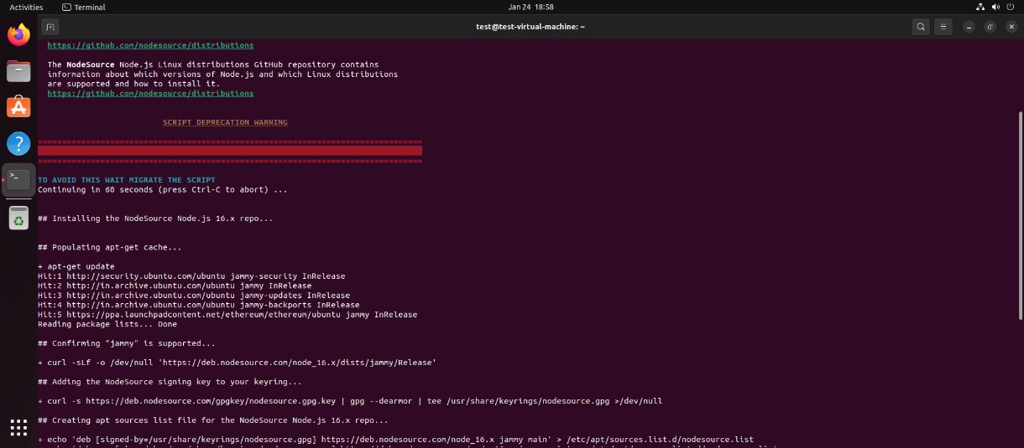
Install Node.js and npm:
sudo apt-get install -y nodejs

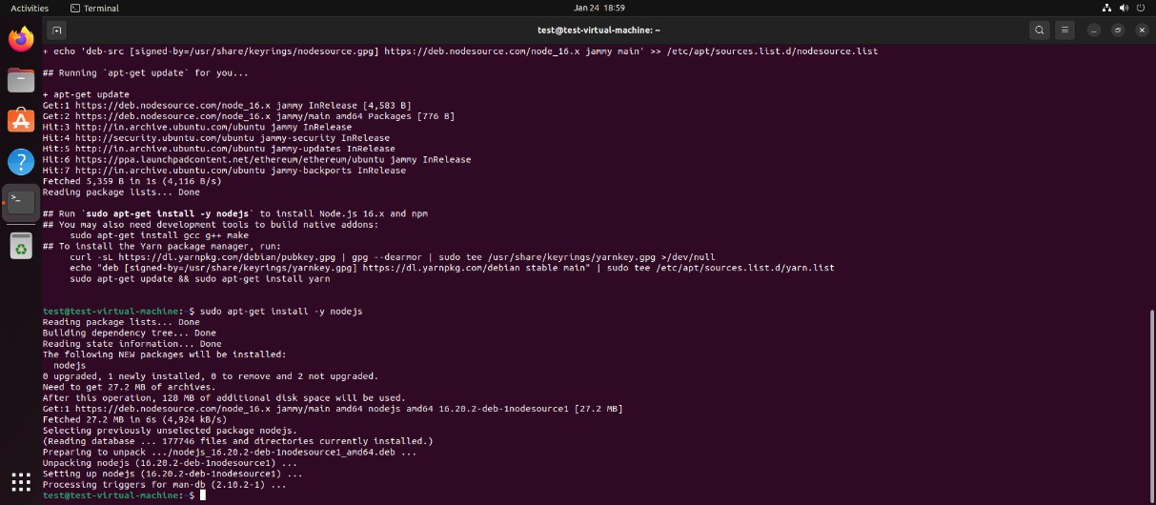
- Install Truffle: With Node.js and npm installed, you can now install Truffle using npm. Run the following command in your terminal:
sudo npm install -g truffle

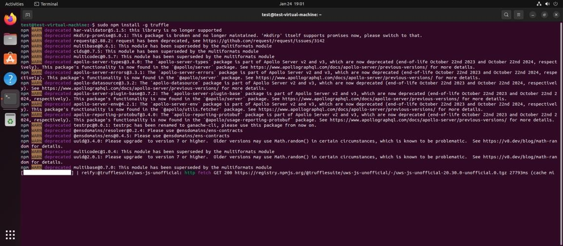
- Verify the Installation: After installation, you can verify that Truffle is installed correctly by checking its version:
truffle version

