Experiment No.4
Aim: To demonstrate the basics of Ethereum smart contract development, deployment, and interaction using a simple "Hello World" example.
Once the Truffle is installed, you can start experimenting with it to develop, test, and deploy your smart contracts. Here's a simple experiment to get you started by creating a basic project:

Objective:
  - Learn how to write a basic smart contract in Solidity.
  - Understand the process of compiling and deploying a smart contract using Truffle.
  - Practice interacting with the smart contract through the Truffle console.

Steps:
- Create a New Directory for Your Project: Create a new directory for your Truffle project and navigate into it.
mkdir MyTruffleProject
cd MyTruffleProject

- Initialize a New Truffle Project: Initialize a new Truffle project within the directory.
truffle init
This command sets up a new Truffle project with the necessary configuration files and directories. You'll see folders like contracts/, migrations/, and test/, along with a truffle- config.js configuration file.
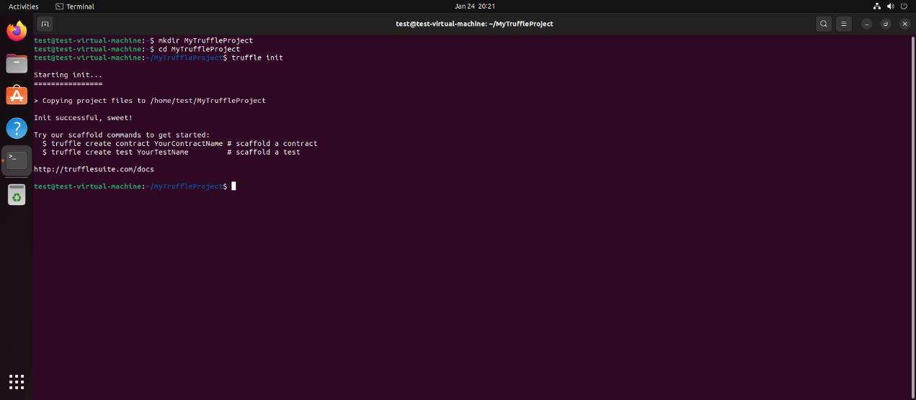

- Create a Simple Smart Contract: Create a new file within the contracts/ directory to hold your smart contract. You can use a simple contract like a HelloWorld contract. For example, create HelloWorld.sol.
// contracts/HelloWorld.sol pragma solidity ^0.8.0; contract HelloWorld {

function sayHello() public pure returns (string memory) { return "Hello, World!";
}
}

- Compile Your Smart Contract: Compile your smart contract using Truffle.
truffle compile
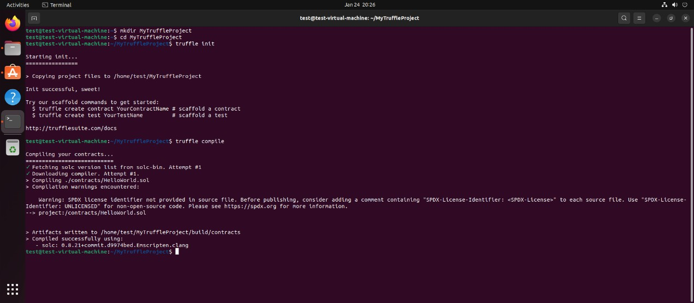

- Write a Migration Script: Migrations are JavaScript files that help you deploy contracts to the Ethereum network. Create a new file in the migrations/ directory to deploy your HelloWorld contract, for example, 2_deploy_contracts.js.
const HelloWorld = artifacts.require("HelloWorld"); module.exports = function (deployer) {
deployer.deploy(HelloWorld);
};
- Start a Local Ethereum Blockchain: Truffle Develop provides a built-in blockchain for development purposes.
truffle develop

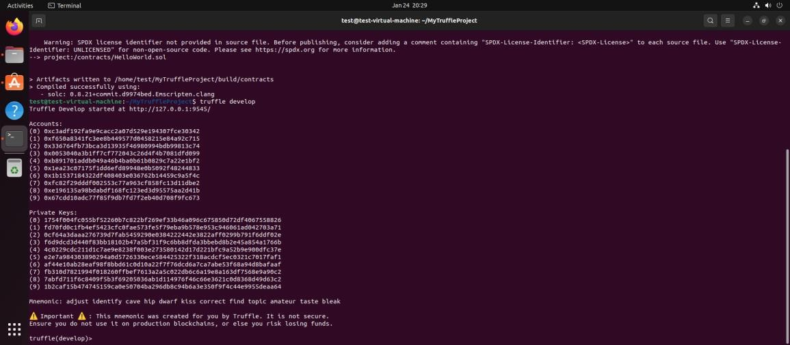

- Deploy Your Contract: Inside the Truffle Develop console, deploy your contract to the local blockchain.
Migrate

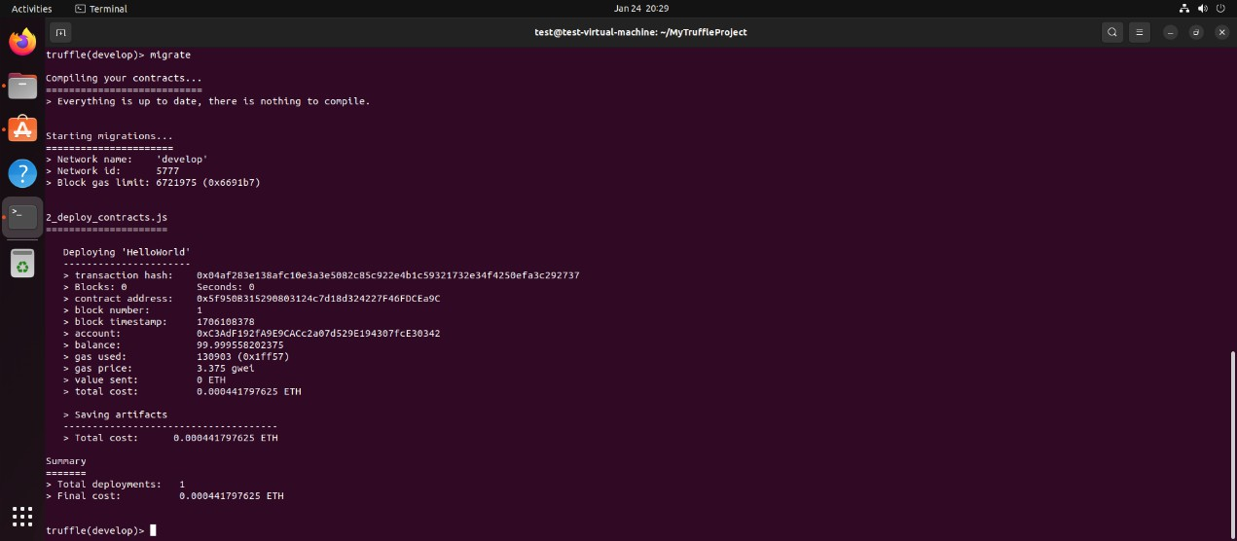
- Conclusion: This basic experiment introduces you to the process of developing with Truffle, including writing, compiling, deploying, and interacting with a smart contract. From here, you can explore more complex contracts, write tests in JavaScript or Solidity, and deploy to public testnets or the main Ethereum network.

