Experiment No.6
Aim: To implement a basic voting mechanism within a smart contract, allowing users to vote for predefined candidates. (Voting Contract)
- Objectives:
  - Introduce the concept of state variables and mappings in Solidity.
  - Demonstrate the use of functions to modify and retrieve the contract's state.
  - Highlight the importance of contract security and input validation.

Steps:
- Access Remix IDE: Navigate to Remix IDE using your web browser.

Create the Contract File:
  - In the "File Explorers" tab on the left sidebar, create a new file by clicking the "Create New File" icon. Name your file Voting.sol.
  - Paste the Voting contract code into Voting.sol:
// Specifies the license under which this contract is released, MIT in this case
// SPDX-License-Identifier: MIT

// Set the compiler version to be used for this contract pragma solidity ^0.8.22;

// Declares a new contract named Voting contract Voting {
// A mapping to keep track of each candidate's vote count, using their name (bytes32) as the key
mapping(bytes32 => uint256) public votesReceived;

// An array to store the list of candidates eligible for voting bytes32[] public candidateList;

// Constructor to initialize the contract with a list of candidate names
constructor(bytes32[] memory candidateNames) { candidateList = candidateNames;
}

// Function to record a vote for a candidate
function voteForCandidate(bytes32 candidate) public {
// Check if the candidate is valid before allowing a vote require(validCandidate(candidate), "Not a valid candidate");
// Increment the vote count for the specified candidate votesReceived[candidate] += 1;
}

// Function to retrieve the total votes a candidate has received function totalVotesFor(bytes32 candidate) view public returns
(uint256) {
// Ensure the candidate is valid before fetching the vote count require(validCandidate(candidate), "Not a valid candidate");
// Return the vote count for the specified candidate return votesReceived[candidate];
}

// Helper function to check if a candidate is in the list of valid candidates
function validCandidate(bytes32 candidate) view public returns (bool) {
// Iterate over the list of candidates
for(uint i = 0; i < candidateList.length; i++) {
// If the candidate matches one in the list, return true if (candidateList[i] == candidate) {
return true;
}
}
// If no match is found, return false return false;
}
}

Compile the Contract:
  - Click on the "Solidity compiler" tab on the left sidebar.
  - Ensure the compiler version matches the version specified in your contract (^0.8.22). Remix usually auto-detects the correct version. If not, select it manually from the "Compiler" dropdown.
  - Click "Compile Voting.sol" to compile your contract.

Deploy the Contract:
  - Switch to the "Deploy & run transactions" tab.
  - Select an environment. "JavaScript VM" is suitable for testing; it simulates an Ethereum blockchain environment within Remix.
  - Before deploying, you need to provide candidate names as an array. Since Solidity expects bytes32[] for candidate names, you must format the input accordingly. For example, to input candidates "Alice" and "Bob", you would use:
["0x416c6963650000000000000000000000000000000000000000000000000 00000","0x426f6200000000000000000000000000000000000000000000000
00000000000"]

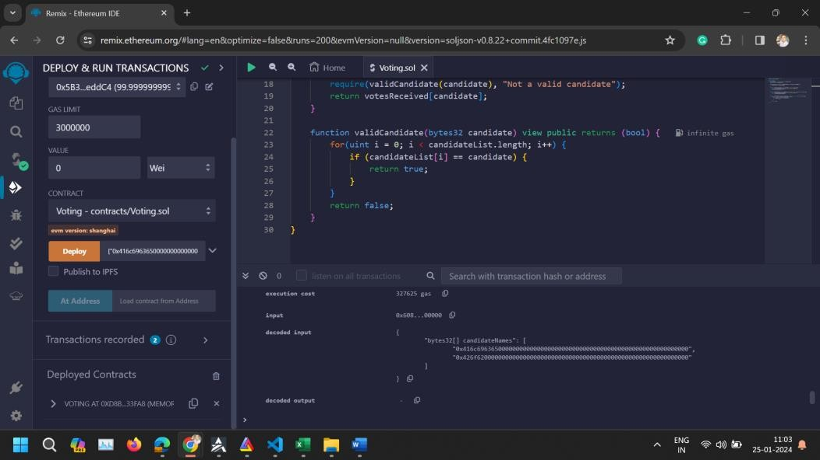
  - These are hexadecimal representations of "Alice" and "Bob" in bytes32 format. You can use online tools to convert strings to bytes32 hex format.
  - Paste the bytes32 array into the "Deploy" field that appears after selecting the "Voting" contract.
  - Click "Deploy". Your contract is now deployed, and you'll see it under "Deployed Contracts".

Interact with the Contract:
  - To vote for a candidate, expand your deployed contract in the "Deployed Contracts" section, find the voteForCandidate function, and input the bytes32 representation of the candidate's name. For example, to vote for Alice, you would input:
"0x416c69636500000000000000000000000000000000000000000000000000 0000"
  - Click the button to call voteForCandidate.
  - To check the total votes for a candidate, use the totalVotesFor function with the candidate's bytes32 representation as the argument.
  - To verify a candidate is valid, use the validCandidate function similarly.

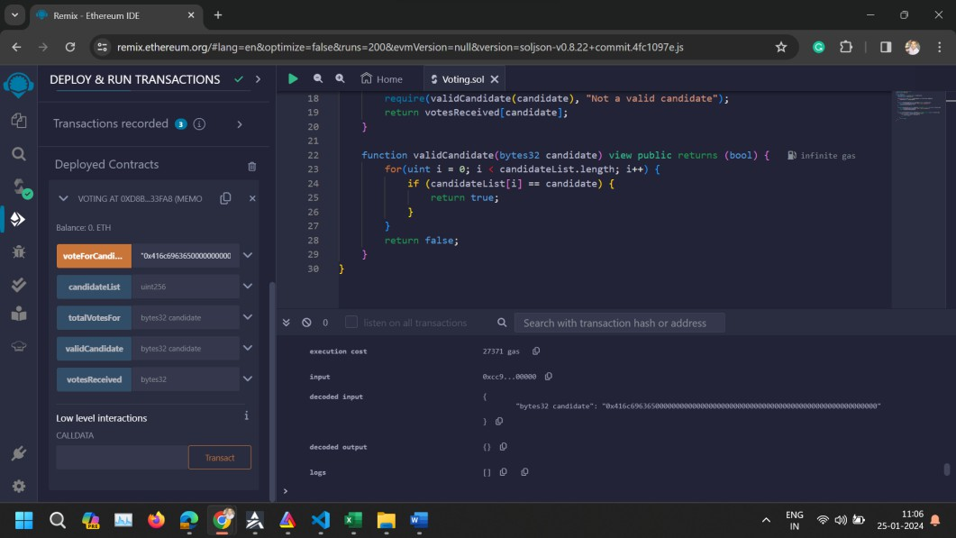
- Conclusion: The voting contract experiment illustrates how Ethereum can be used for decentralized decision-making processes. It demonstrates how to deploy and interact with contracts that require more complex inputs and how to manage state within a contract. By deploying this contract, you've taken a step further into Ethereum development, learning to work with mappings, arrays, and user inputs. It also underscores the critical aspects of smart contract development, such as data storage, function execution, and access control.

