Experiment No.7
Aim: To create a simple auction contract where users can place bids and the highest bidder wins at the auction's conclusion (Auction Contract).

- Objectives:
  - Show how to manage Ethereum transactions and handle Ether within contracts.
  - Implement time-based logic to manage auction start and end times.
  - Utilize events to log important contract activities.

Steps:
  - Access Remix IDE: Open your web browser and navigate to Remix IDE.

Create and Prepare the Contract File
    - In the "File Explorers" tab, click on the "Create New File" icon and name your file SimpleAuction.sol.
    - Copy and paste the SimpleAuction contract code into SimpleAuction.sol.
// Specifies the license under which this contract is released; MIT in this case
// SPDX-License-Identifier: MIT

// Set the compiler version to be used for this contract pragma solidity ^0.8.22;

// Declares a new contract named SimpleAuction contract SimpleAuction {
// Address that will receive the funds of the auction address payable public beneficiary;
// Timestamp for when the auction ends uint public auctionEndTime;

// Address of the bidder with the highest bid address public highestBidder;
// Amount of the highest bid uint public highestBid;

// Mapping to keep track of funds each address has contributed,
// to be returned if they are outbid mapping(address => uint) pendingReturns;

// Events to emit when a bid is higher than the previous ones,
// and when the auction ends
event HighestBidIncreased(address bidder, uint amount); event AuctionEnded(address winner, uint amount);

// Constructor to initialize the auction with a bidding time

// and the beneficiary's address
constructor(uint _biddingTime, address payable _beneficiary) { beneficiary = _beneficiary;
auctionEndTime = block.timestamp + _biddingTime;
}

// Function to place a bid on the auction function bid() public payable {
// Requires that the auction has not yet ended require(block.timestamp <= auctionEndTime, "Auction already
ended.");
// Requires that the bid is higher than the current highest bid require(msg.value > highestBid, "There already is a higher
bid.");

// If there was a previous bid, it adds the previous highest bid to
// the pending returns of the previous highest bidder if (highestBid != 0) {
pendingReturns[highestBidder] += highestBid;
}

// Updates the state with the new highest bid and bidder highestBidder = msg.sender;
highestBid = msg.value;
emit HighestBidIncreased(msg.sender, msg.value);
}

// Function to withdraw a bid that was overbid by another bidder function withdraw() public returns (bool) {
uint amount = pendingReturns[msg.sender]; if (amount > 0) {
// Resets the pending return before sending to prevent re- entrancy attacks
pendingReturns[msg.sender] = 0;

// Attempts to send the amount back to the sender if (!payable(msg.sender).send(amount)) {
// If sending fails, reset the pending return to allow retrying pendingReturns[msg.sender] = amount;
return false;
}
}
return true;

}

// Function to end the auction, can only be called after the auctionEndTime
function auctionEnd() public {
// Requires that the current time is past the auction end time require(block.timestamp >= auctionEndTime, "Auction not yet
ended.");
// Requires that auctionEnd has not already been called require(!ended, "auctionEnd has already been called.");

// Sets the auction as ended and emits the AuctionEnded event ended = true;
emit AuctionEnded(highestBidder, highestBid);

// Transfers the highest bid to the beneficiary of the auction beneficiary.transfer(highestBid);
}

// State variable to keep track if the auction has ended bool ended = false;
}

Compile the Contract
    - Click on the "Solidity compiler" tab on the left sidebar.
    - Ensure the compiler version is set correctly to match the version specified in your contract (^0.8.22). Remix might automatically select the appropriate version based on your code. If not, select it manually.
    - Click "Compile SimpleAuction.sol" to compile your contract.

Deploy the Contract:
    - Switch to the "Deploy & run transactions" tab by clicking its icon on the left sidebar.
    - Select an environment from the "Environment" dropdown. For testing, "JavaScript VM" is recommended as it provides a simulated blockchain.
    - Before deploying, you need to provide initial parameters to the constructor. The SimpleAuction constructor requires:
    - _biddingTime: The duration of the auction in seconds. For testing, you can use a value like 300 (for 5 minutes).
    - _beneficiary: The address that will receive the funds of the auction. In the "JavaScript VM" environment, you can use one of the test accounts provided by Remix. Copy one of the account addresses from the account dropdown.
    - Enter these parameters in the "Deploy" field. It should look something like this (replace the address with one from your environment):

300, "0x5B38Da6a701c568545dCfcB03FcB875f56beddC4"
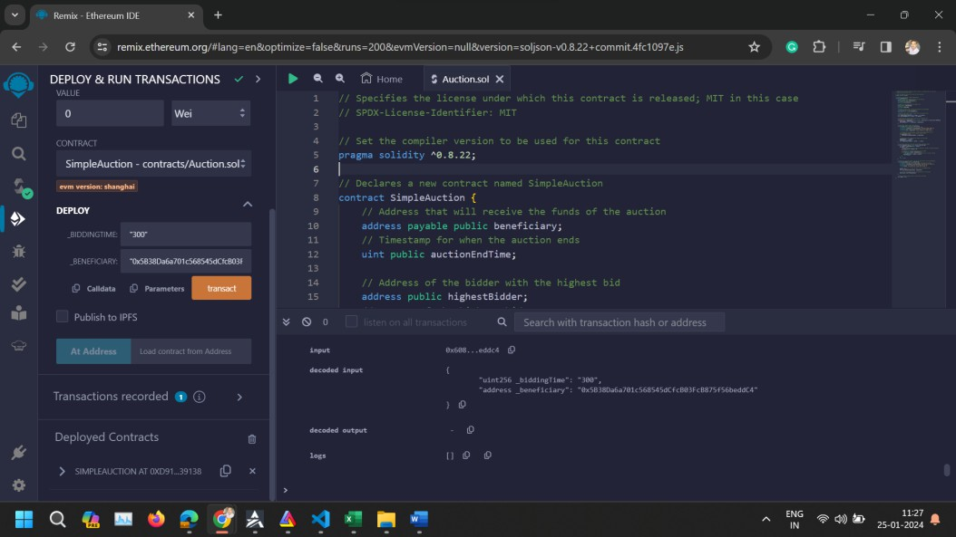
    - Click "Deploy" to deploy your contract. After deployment, the contract will appear under "Deployed Contracts".

Interact with the Contract
    - To Place a Bid: Find your deployed SimpleAuction contract in the "Deployed Contracts" section. Use the bid function to place a bid. Since bid is a payable function, you need to specify the value to send along with the transaction. In the "Value" field (above the "Deploy" button), enter the amount you want to bid and select the correct unit (e.g., ether). Then, click the bid button within your contract's UI in Remix.
    - To Withdraw: If a bidder has been outbid, they can withdraw their funds using the withdraw function. Simply click the withdraw button.
    - To End the Auction: Use the auctionEnd function after the bidding time has passed. Click the auctionEnd button to finalize the auction and transfer the funds to the beneficiary.
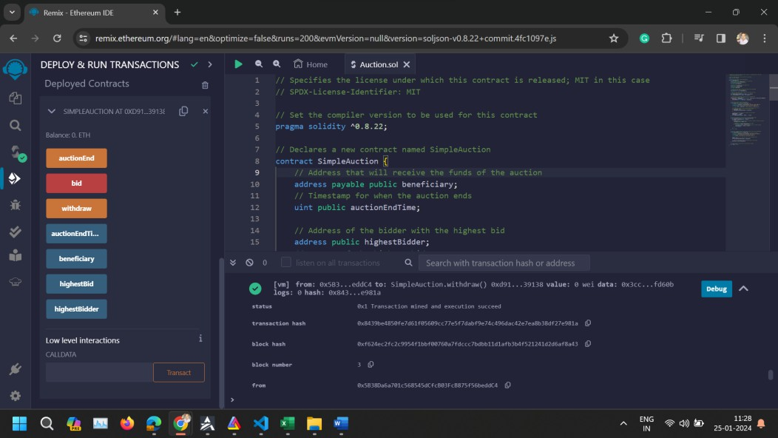

Conclusion: This experiment demonstrates the dynamic and interactive capabilities of smart contracts, especially in handling financial transactions and time-dependent operations. It provides insights into building more complex decentralized applications (dApps) involving financial logic. It showcases the basics of creating a timed auction system on the Ethereum blockchain. By following these steps, you can deploy and test the auction contract in a simulated environment using Remix IDE. This process provides hands-on experience with contract deployment, interaction, and understanding key concepts like payable functions and time-based logic in Solidity

