Experiment No.8
Aim: To develop a fungible token using the ERC-20 standard, familiarizing with token creation and manipulation on the Ethereum blockchain. (Token Contract).

- Objectives:
  - Understand the ERC-20 token standard and its key functions. Such as totalSupply, balanceOf, transfer, approve, allowance, and transferFrom, as well as the Transfer and Approval events.
  - Gain experience in interacting with deployed smart contracts through the Remix IDE interface. This includes executing contract functions that change the state of the blockchain (such as transferring tokens) and querying the blockchain to retrieve current state information (such as token balances).
  - Prepare for the integration of the smart contract into decentralized applications (dApps) by adhering to the ERC-20 standard, facilitating the exchange and management of tokens within the Ethereum ecosystem.

Steps:
  - Open Remix IDE: Navigate to Remix IDE in your web browser.

Create the Contract File
    - In the "File Explorers" pane, click the "Create New File" icon.
    - Name your file MyToken.sol and paste the provided ERC-20 token contract code into it.

Compile the Contract
    - Click on the "Solidity Compiler" tab on the left sidebar.
    - Ensure the compiler version matches the version in your contract (^0.8.22). If necessary, select the correct version manually.
    - Click "Compile MyToken.sol".
// Specifies the license under which this contract is released; MIT in this case
// SPDX-License-Identifier: MIT

// Set the compiler version to be used for this contract pragma solidity ^0.8.22;

// ERC-20 interface containing the standard functions and events of an ERC-20 token
interface IERC20 {
// Returns the total token supply
function totalSupply() external view returns (uint256);

// Returns the account balance of another account with address
`account`
function balanceOf(address account) external view returns (uint256);

// Transfers `amount` tokens to address `recipient`, and MUST fire the `Transfer` event
function transfer(address recipient, uint256 amount) external returns (bool);

// Returns the amount of tokens approved by the owner that can be transferred to the spender's account
function allowance(address owner, address spender) external view returns (uint256);

// Sets `amount` as the allowance of `spender` over the caller's tokens, and MUST fire the `Approval` event
function approve(address spender, uint256 amount) external returns (bool);

// Transfers `amount` tokens from address `sender` to address
`recipient`, and MUST fire the `Transfer` event
function transferFrom(address sender, address recipient, uint256 amount) external returns (bool);

// Events declaration
event Transfer(address indexed from, address indexed to, uint256 value);
event Approval(address indexed owner, address indexed spender, uint256 value);
}

// MyToken contract implementing the IERC20 interface contract MyToken is IERC20 {
// Token metadata
string public constant name = "MyToken"; // Token name string public constant symbol = "MTK"; // Token symbol uint8 public constant decimals = 18; // Token decimals

// State variables
mapping(address => uint256) balances; // Mapping of token balances mapping(address => mapping (address => uint256)) allowed; //
Mapping of token allowances
uint256 totalSupply_ = 1000 ether; // Total supply of tokens, `ether` is used for simplicity to denote 18 decimals

// Constructor to initialize the contract with token supply assigned to the deployer

constructor() {
balances[msg.sender] = totalSupply_;
}

// Returns the total token supply
function totalSupply() public override view returns (uint256) { return totalSupply_;
}

// Returns the token balance of `tokenOwner`
function balanceOf(address tokenOwner) public override view returns (uint256) {
return balances[tokenOwner];
}

// Transfers `numTokens` from the caller to `receiver`
function transfer(address receiver, uint256 numTokens) public override returns (bool) {
require(numTokens
balance");
<=
balances[msg.sender], "Insufficient
balances[msg.sender] -= numTokens; balances[receiver] += numTokens;
emit Transfer(msg.sender, receiver, numTokens); return true;
}

// Approves `delegate` to spend `numTokens` on behalf of the caller function approve(address delegate, uint256 numTokens) public
override returns (bool) { allowed[msg.sender][delegate] = numTokens; emit Approval(msg.sender, delegate, numTokens); return true;
}

// Returns the number of tokens `delegate` is allowed to spend on behalf of `owner`
function allowance(address owner, address delegate) public override view returns (uint) {
return allowed[owner][delegate];
}

// Transfers `numTokens` from `owner` to `buyer`

function transferFrom(address owner, address buyer, uint256 numTokens) public override returns (bool) {
require(numTokens <= balances[owner], "Insufficient balance");
require(numTokens
"Insufficient allowance");
<=
allowed[owner][msg.sender],
balances[owner] -= numTokens; allowed[owner][msg.sender] -= numTokens; balances[buyer] += numTokens;
emit Transfer(owner, buyer, numTokens);
return true;
}
}

Deploy the Contract
    - Switch to the "Deploy & Run Transactions" tab.
    - In the "Environment" dropdown, select "JavaScript VM" for testing purposes.
    - Click "Deploy". The initial total supply is set in the contract constructor and will be assigned to the account that deploys the contract.

Interact with the Contract
    - Once deployed, you'll see the contract under "Deployed Contracts".
    - Use the provided functions to interact with your token:
    - balanceOf: Enter an account address to get its token balance.
    - transfer: Enter a recipient address and amount to transfer tokens.
    - approve and transferFrom: Use these to allow and then transfer tokens on behalf of another account.
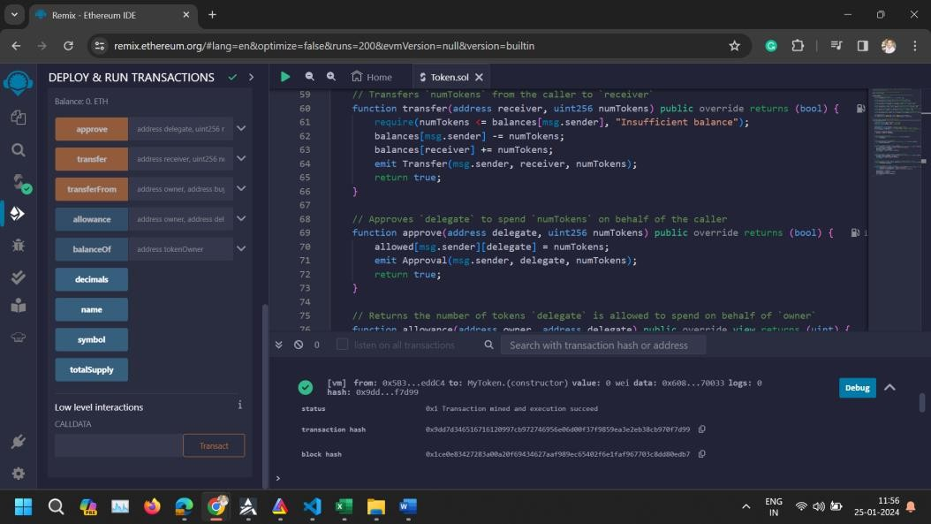
- Conclusion: This ERC-20 token contract demonstrates how to create and interact with a fungible token on the Ethereum blockchain. By following the steps above, you can deploy and test the token contract in Remix, providing a hands-on experience with the ERC-20

standard. This foundational knowledge is crucial for developing more complex decentralized applications and understanding the tokenomics within the Ethereum ecosystem.

