Week 3 — Map It & Give It a Face
1. One-Line Claim
I turn data into insights and build machine learning solutions for real-world problems.

2. Content Map
Home Page
Sections in order:
- Hero / Introduction
- About Me
- Featured Projects
- Skills
- Certificates
- Activities & Leadership
- Contact
Featured work: Customer Segmentation, Customer Sentiment Analysis, and Automobile Price Prediction.
Primary CTA: View My Projects

Projects Page
Sections in order:
- Projects Overview
- Customer Segmentation using K-Means Clustering
- Customer Sentiment Analysis using NLP and Machine Learning
- Automobile Price Prediction System
- Other Programming Projects
- GitHub / Project Links
Primary CTA: View Project
About Page
Sections in order:
- Introduction
- Education
- Data Science & Machine Learning Journey
- Technical Skills
- Activities & Leadership
- Certificates
Primary CTA: View My Projects
Image: Use my real professional photograph.

Contact Page
Sections in order:
- Short Introduction
- Email
- LinkedIn
- GitHub
- Closing Message
Primary CTA: Get in Touch

3. Still Need to Gather
- Professional profile photograph
- Clean screenshot of the Customer Segmentation project
- Clean screenshot of the Customer Sentiment Analysis project
- Clean screenshot of the Automobile Price Prediction project
- Screenshots of other projects that will be featured
- Final GitHub project links
- LinkedIn profile link
- Certificate images
- Any available project demo links
- Important project performance numbers or results

4. Identity Kit
Fonts
Heading Font: Poppins
Body Font: Inter
Poppins will be used for major headings and section titles, while Inter will be used for body text, descriptions, labels, and smaller information.
Color Palette
Background: #0B1020
Primary Text: #F8FAFC
Secondary Text: #94A3B8
Accent: #6366F1

The palette is intentionally limited so that the actual project screenshots remain the most noticeable elements of the portfolio.

Logo / Favicon

Use a simple AK monogram based on my initials.
The logo should use Poppins SemiBold and the portfolio accent color #6366F1. Keep the design minimal so it works as both a portfolio logo and browser favicon.
Style Note
The portfolio uses Poppins and Inter with a dark, clean, modern data-science aesthetic. The palette uses near-black, near-white, and one blue-purple accent to create a calm and professional mood while keeping the real project work as the visual focus.

5. Image Curation
Real Images — Keep
1. Professional Photo
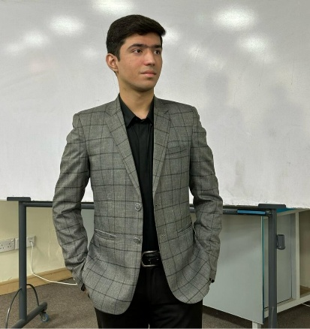

2. Customer Segmentation
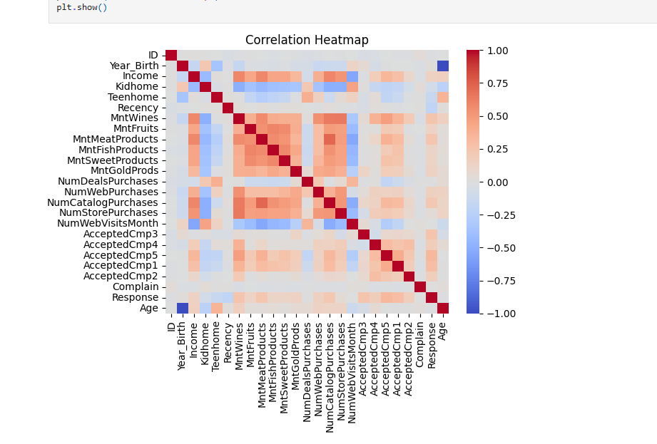
3. Customer Sentiment Analysis
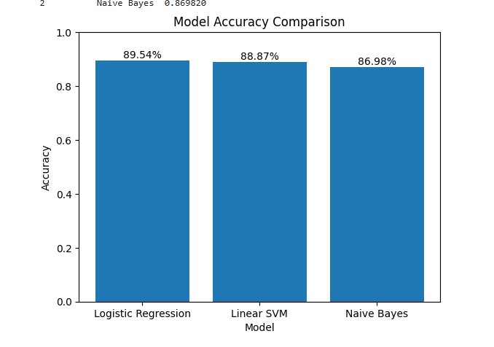
4. Automobile Price Prediction
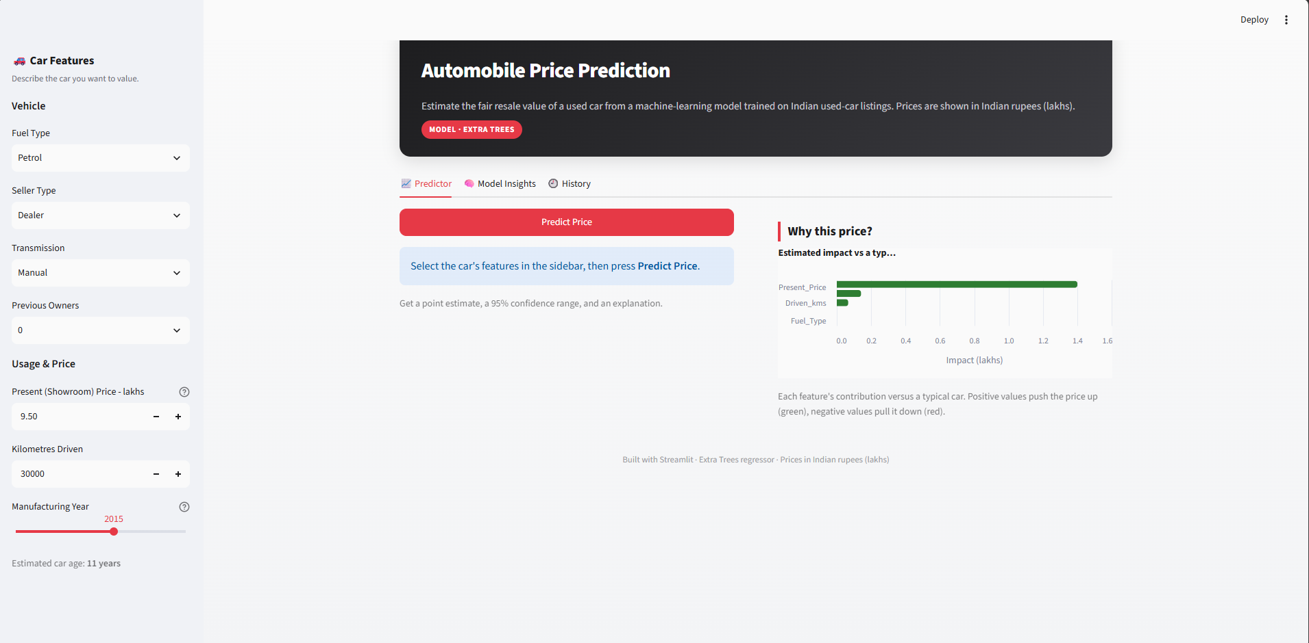

5. Certificates
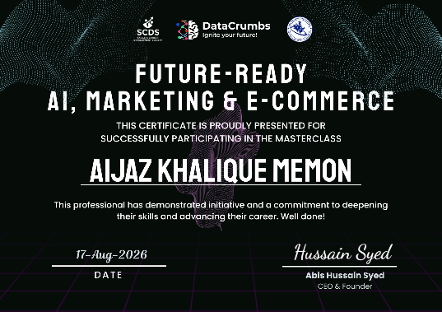
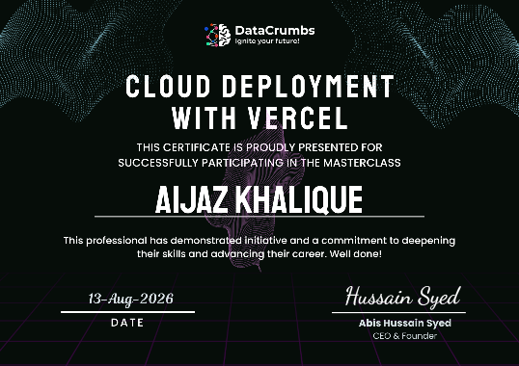
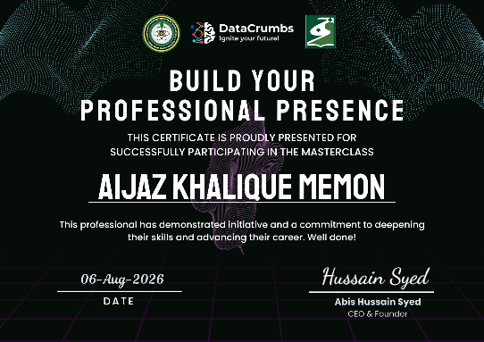

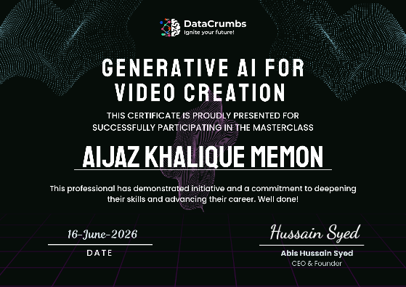

AI-Generated Images — Keep
AI-generated images will only be used for decorative and connective elements, not as evidence of my projects.
The selected visual style is:
Dark, minimal, modern data-science aesthetic with blue and purple accents, subtle data particles, clean geometric forms, connected nodes, charts, and soft lighting.
The AI-generated visuals will be used selectively for:
- Hero decoration
- Section transitions
- Background/visual accents
- Data-science themed decorative elements
The AI visuals will not replace screenshots of my actual work.
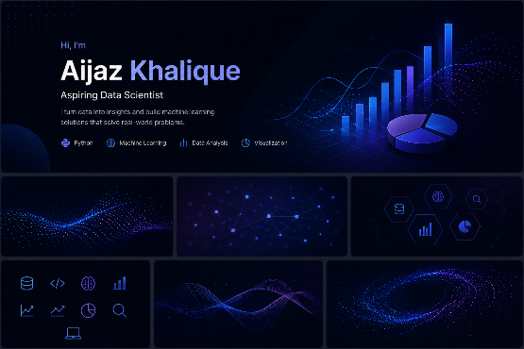

- Rejected AI Image
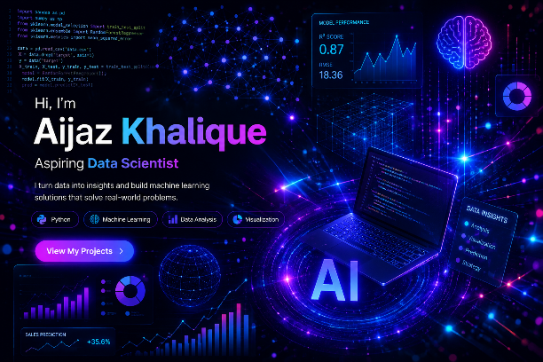
I rejected a generated hero image because it was visually impressive but too busy for the portfolio. The excessive glowing elements and multiple visual effects competed with the actual project content. It also felt more like a generic technology advertisement than a professional data-science portfolio.
I chose simpler data-focused visuals because they support the portfolio without distracting visitors from the real screenshots and evidence of my work.

