Analysis of toothgrowth data

Aijing Gao

2015年12月25日

[1]Basic explantory analysis of ToothGrowth data from datasets

library(datasets)  
library(ggplot2)  
data(ToothGrowth)  
help("ToothGrowth")

## starting httpd help server ... done

str(ToothGrowth)

## 'data.frame': 60 obs. of 3 variables:  
## $ len : num 4.2 11.5 7.3 5.8 6.4 10 11.2 11.2 5.2 7 ...  
## $ supp: Factor w/ 2 levels "OJ","VC": 2 2 2 2 2 2 2 2 2 2 ...  
## $ dose: num 0.5 0.5 0.5 0.5 0.5 0.5 0.5 0.5 0.5 0.5 ...

summary(ToothGrowth)

## len supp dose   
## Min. : 4.20 OJ:30 Min. :0.500   
## 1st Qu.:13.07 VC:30 1st Qu.:0.500   
## Median :19.25 Median :1.000   
## Mean :18.81 Mean :1.167   
## 3rd Qu.:25.27 3rd Qu.:2.000   
## Max. :33.90 Max. :2.000

This data has 60 observation, three variables (1)len(numeric): Tooth length (2) supp(factor): Supplement type (VC or OJ). (3) dose(numeric): Dose in milligrams/day

[2].Summary of data by comparisons

#make plot to campare Tooth length with different supplement type for each dosage  
g<-qplot(supp,len,data=ToothGrowth, facets=~dose, main="Tooth growth of guinea pigs by different supplement type in each dose",xlab="Supplement type", ylab="Tooth length")   
g<-g+geom_boxplot(aes(fill = supp))  
g

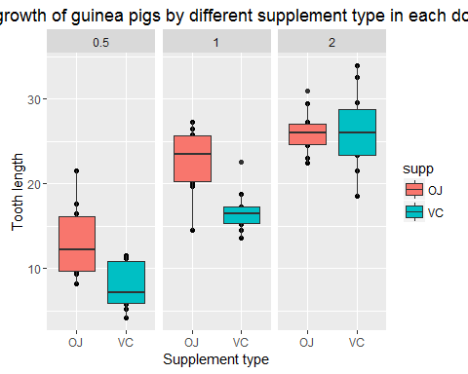

As we can observe in the plot, the average tooth length increases as the dose increases.

[3].Use confidence intervals and/or hypothesis tests to compare tooth growth by supp and dose Hypothesis testing (1). Assumption: the variables are independent and identically distributed. Tooth growth follows a normal distribution. (2). Null hypothesis for different supplement type: There is no difference in tooth growth when using the supplement OJ and VC. Alternative hypothesis: There is a difference in tooth growth when using the supplement OJ and VC.

Null hypothesis for different dose : There is no difference in tooth growth when using different dose. Alternative hypothesis: There is a difference in tooth growth when using different dose.

Here we are going to use two-way ANOVA for identifying effects of supplement type and dose on tooth growth

#Perform two-way ANOVA to identify effects of supplement type, dose and their interaction  
ToothGrowth$dose = factor(ToothGrowth$dose, levels=c(0.5,1.0,2.0), labels=c("low","med","high"))  
ToothGrowth$supp=factor(ToothGrowth$supp,levels=c("OJ","VC"))  
replications(len ~ supp+dose+supp:dose, data=ToothGrowth)

## supp dose supp:dose   
## 30 20 10

anova<- aov(len ~ supp+dose+supp:dose, data=ToothGrowth)  
summary(anova)

## Df Sum Sq Mean Sq F value Pr(>F)   
## supp 1 205.3 205.3 15.572 0.000231 ***  
## dose 2 2426.4 1213.2 92.000 < 2e-16 ***  
## supp:dose 2 108.3 54.2 4.107 0.021860 *   
## Residuals 54 712.1 13.2   
## ---  
## Signif. codes: 0 '***' 0.001 '**' 0.01 '*' 0.05 '.' 0.1 ' ' 1

As the result shows, there are two significant main effects and a significant interaction between dose and supp.

#Perform post hoc test to do pairwise comparison in different factors  
TukeyHSD(anova)

## Tukey multiple comparisons of means  
## 95% family-wise confidence level  
##   
## Fit: aov(formula = len ~ supp + dose + supp:dose, data = ToothGrowth)  
##   
## $supp  
## diff lwr upr p adj  
## VC-OJ -3.7 -5.579828 -1.820172 0.0002312  
##   
## $dose  
## diff lwr upr p adj  
## med-low 9.130 6.362488 11.897512 0.0e+00  
## high-low 15.495 12.727488 18.262512 0.0e+00  
## high-med 6.365 3.597488 9.132512 2.7e-06  
##   
## $`supp:dose`  
## diff lwr upr p adj  
## VC:low-OJ:low -5.25 -10.048124 -0.4518762 0.0242521  
## OJ:med-OJ:low 9.47 4.671876 14.2681238 0.0000046  
## VC:med-OJ:low 3.54 -1.258124 8.3381238 0.2640208  
## OJ:high-OJ:low 12.83 8.031876 17.6281238 0.0000000  
## VC:high-OJ:low 12.91 8.111876 17.7081238 0.0000000  
## OJ:med-VC:low 14.72 9.921876 19.5181238 0.0000000  
## VC:med-VC:low 8.79 3.991876 13.5881238 0.0000210  
## OJ:high-VC:low 18.08 13.281876 22.8781238 0.0000000  
## VC:high-VC:low 18.16 13.361876 22.9581238 0.0000000  
## VC:med-OJ:med -5.93 -10.728124 -1.1318762 0.0073930  
## OJ:high-OJ:med 3.36 -1.438124 8.1581238 0.3187361  
## VC:high-OJ:med 3.44 -1.358124 8.2381238 0.2936430  
## OJ:high-VC:med 9.29 4.491876 14.0881238 0.0000069  
## VC:high-VC:med 9.37 4.571876 14.1681238 0.0000058  
## VC:high-OJ:high 0.08 -4.718124 4.8781238 1.0000000

1. Conclusions The above results indicate that different supplement types result in different tooth growth. Different doses of a supplement type also result in different tooth growth.