Name: Javier, Aisha Bernadette A. Date: 9/29/2022

Section: BSCS2B

**DB101 PRELIM EXAM**

1. 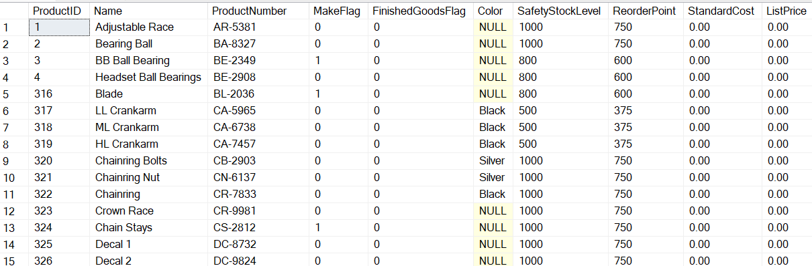Create an sql query based on the image below. (The table name is **tbl_Product**)
2. Create a query that will display all the products with black color.

**Select Name From tbl_Product WHERE Color = 'Black'**

1. Create a query that will display the sum of SafetyStockLevel for silver color only. Name the column name as SumOf SafetyStockLevel.

**Select Sum(SafetyStockLevel) AS [SumOfSafetyStockLevel] FROM tbl_Product**

1. Create a query that will display the columns ProductId,Name,ProductNumber and ReOrderPoint on tbl_Products that’s starts with ProductNumber “DC-“

**Select ProductID,Name, ProductNumber,ReOrderPoint FROM tbl_Product WHERE ProductNumber LIKE = ‘DC%’**

1. Display all the products with the productid greater than 320 and its MakeFlag value is 0.

**SELECT ProductID, MakeFlag FROM tbl_Product WHERE ProductID = (SELECT MIN(320) FROM tbl_Product WHERE MakeFlag = 0)**

1. Display all the products with that a NULL value color.

**SELECT Name FROM tbl_Product WHERE Color IS NULL**

1. Display the total count of rows that has letter “B” on the Name. Set the column name as Total_Count.

**SELECT Name AS TotalCount FROM tbl_Product WHERE Name LIKE ‘%B%’**

1. Update the column color and change the color to “Yellow” for all colors that has NULL value.

**Update tbl_Product set Color = ‘Yellow’ where Color = null**

1. Create a query that will display the minimum value of column SafetyStockLevel.

**Update tbl_Product set Color = ‘Yellow’ where Color = null**

1. Create a query that will display the average value of column SafetyStockLevel where its productNumber has a pattern value of “23”.

**Update tbl_Product set Color = ‘Yellow’ where Color = null**

1. Create a query that will display all the products. Arrange the Name in Descending Order.

**Select * from tbl_Product order by Name desc**

1. Based on the image above, Create an sql script that will create tbl_Product. Use the appropriate datatypes for each column. (Note. Use ProductId as Primary Key)

CREATE TABLE tbl_Product

(

ProductID INT PRIMARY KEY,

Name VARCHAR(50),

ProductNumber VARCHAR(50),

MakeFlag BIT,

FinishedGoodFlag BIT,

Color VARCHAR(50),

SafetyStockLevel INT,

ReorderPoint INT,

StandardCost INT,

ListPrice INT,

)

1. Enumeration
2. Give atleast 3 DDL sql commands.

* CREATE
* DROP
* ALTER

1. Provide the 4 DML sql Commands.

* SELECT
* INSERT
* UPDATE
* DELETE