Raz Reed

Samad Farooqui

Xiaowei Hu

ITWS Term Project Plan: JobLine

Objective:

The objective of JobLine is to create a universal job application that can be used by any company or any applicant, regardless of job or company. It will be the standard job application, which will be synonymous with the term, “apply online”.

Scope:

JobLine is an online application site where companies can post jobs for anyone to apply to. Applicants will only have to fill out basic information that is required for almost all jobs once, and then can go on an application spree if need be. It is simple and easy to use, and is accessible for anyone who is looking for a job or trying to recruit their team. Users seeking out jobs can search for job postings by title, company, keyword, or location and apply to them. Users can also see deadlines for any job posting that they have already applied to, as well as the status of their application.

Companies will have an interface similar to the applicants’, with a few differences. Companies will also have a profile page, but they use it in order to view their applications and add openings. Of course, some companies may need specific information that is not standard, so companies can add supplemental questions to their job postings. Companies can also view the applicants to any job that they have posted, as well as each applicant’s responses to their supplemental questions. Companies can approve or reject applicants based on the information provided by the applicants, which can also be seen on an applicant’s profile page.

Timeline:

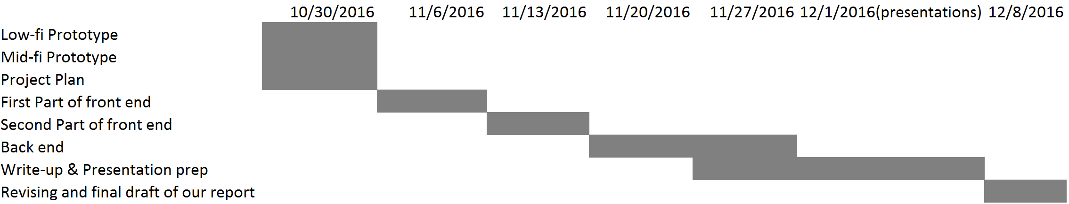

For this project, our group will be working together for everything since details need to be discussed throughout the whole process. The grey area in the chart above represents the tasks we will be working on together during each time frame. Following the timeline, we will be finishing our website development by November 27th and prepare for the presentation for the following weeks. Wrapping up and revising of the final copy of our project will them be during the presentation weeks and finally be ready to submit by the deadline of the project.

Prototype:

bs

“The Universal Job Application!”

About Us | Explore Jobs | Register | Login

<JobLine Logo>

Our partners:





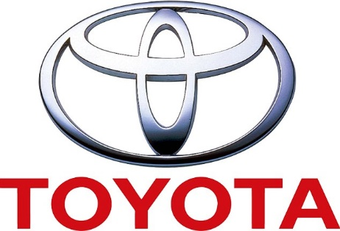



 © JobLine 2016

About Us | Careers | Contact Us | Privacy Policy |



bs

“The Universal Job Application!”

About Us | Explore Jobs | Register | Login

<JobLine Logo>



We’re proud to partner with <company 1>, <company 2>, <company 3>, and more. Click here to become a partner!

 © JobLine 2016

About Us | Careers | Contact Us | Privacy Policy |

Lorem ipsum dolor sit amet, consectetur adipiscing elit, sed do eiusmod tempor incididunt ut labore et dolore magna aliqua. Ut enim ad minim veniam, quis nostrud exercitation ullamco laboris nisi ut aliquip ex ea commodo consequat. Duis aute irure dolor in reprehenderit in voluptate velit esse cillum dolore eu fugiat nulla pariatur. Excepteur sint occaecat cupidatat non proident, sunt in culpa qui officia deserunt mollit anim id est laborum

Lorem ipsum dolor sit amet, consectetur adipiscing elit, sed do eiusmod tempor incididunt ut labore et dolore magna aliqua. Ut enim ad minim veniam, quis nostrud exercitation ullamco laboris nisi ut aliquip ex ea commodo consequat. Duis aute irure dolor in reprehenderit in voluptate velit esse cillum dolore eu fugiat nulla pariatur. Excepteur sint occaecat cupidatat non proident, sunt in culpa qui officia deserunt mollit anim id est laborum

History

Partners

Our Philosophy

**About us**

bs

“The Universal Job Application!”

About Us | Explore Jobs | Register | Login

<JobLine Logo>

Log in

Go back

Register now!

Join now!

Log in

/////////////////Company/////////////////////

Company ID:

Password:

Not a partner?

Applicant

Email:

Password:

Not a user?

 © JobLine 2016

About Us | Careers | Contact Us | Privacy Policy |



bs

“The Universal Job Application!”

About Us | Explore Jobs | Register | Login

<JobLine Logo>



**I’m a candidate**

**I’m a company**

 © JobLine 2016

About Us | Careers | Contact Us | Privacy Policy |

bs

“The Universal Job Application!”

About Us | Explore Jobs | Register | Login

<JobLine Logo>



Register now!

Apply for an ID!

Register now!

ID (click to apply):

Name of company:

Email:

Password:

Retype password:

How did you hear about us? (optional)

First Name:

Middle name (optional):

Last name:

Date of Birth:

Email:

Password:

Retype password:

How did you hear about us? (optional)

Company

Applicant

About Us | Careers | Contact Us | Privacy Policy |

 © JobLine 2016

bs

“The Universal Job Application!”

About Us | Explore Jobs | Register | Login

<JobLine Logo>



Search for Jobs

Enter city/state/zip code

Enter keyword/name of company/job title

By location:

By keyword:

About Us | Careers | Contact Us | Privacy Policy |

 © JobLine 2016



“The Universal Job Application!”

<JobLine Logo>

About Us | Explore Jobs | Register | Login



Alphabet Mountain View, CA CEO Cool guy

Name of company Location Position title Description

Search for Jobs

 © JobLine 2016

About Us | Careers | Contact Us | Privacy Policy |



Application Status:

CEO of Alphabet:

Barista at Starbucks:

Welcome, SwagDaddy!

Search for a job…

<JobLineLogo>



Work experience:

* Former CEO of Microsoft, Inc. <insert dates here>
* Employee at Commons Dining Hall from <insert dates here>

Education:

* Rensselaer Polytechnic Institute, B.S. in Underwater Basket Weaving, <insert dates here>

Skills:

* Being awesome!
* C++

View(Upload) Resume

Edit information

Description of why you are an amazing candidate for any job you go for! Should be a short bio about yourself, first thing a company would see.

SwagDaddy Moody

Upcoming Deadlines:

Nothing to report!

Declined.

Expect Contact!

 © JobLine 2016

About Us | Careers | Contact Us | Privacy Policy |



View applicants:

Software Engineer:

* Samad Farooqui
* Raz Reed
* SwagDaddy Moody

Professional Goat Breeder:

* SwagDaddy Moody
* Samad Farooqui

Welcome, Google!

Thanks for being a partner!

<JobLineLogo>



View all applicants….

Edit Position

Edit Position

Posted Positions:

* Software Engineer
  + <description of position>
* Professional Goat Breeder
  + Someone to make the best lawnmowers

Add open position

Edit information

Description of why you are an amazing company! Should be a short bio about your company and your mission statement.

Google, Inc.

 © JobLine 2016

About Us | Careers | Contact Us | Privacy Policy |

<JobLineLogo>

<company name>

<Position name> <Job type here – Intern/Full-time/part-time>

<Job Description>

* Be able to be veeeeeeery coooooooool.

<Location>

* 11 CoolMan Road
* A nice place, NJ

<Requirements>

* Be cool
* Be able to do work
* Don’t complain

<Application deadline goes here>

Apply now!



 © JobLine 2016

About Us | Careers | Contact Us | Privacy Policy |

Contact information

Title: First name: Middle name: Last name: Preferred name:

Address: Address Line 2: Country:

City: State: Zip code:

Home phone: Cell phone: Work phone:

Preferred Email: Other email:

Web Address (LinkedIn/Personal Website/ Etc):

<JobLineLogo>



MM/YYYY

MM/YYYY

Organization: Title:

Start date: End Date: I currently work here.

Tasks:

- Remove work experience

+ Add work experience

Work Experience

 © JobLine 2016

About Us | Careers | Contact Us | Privacy Policy |



MM/YYYY

MM/YYYY

Degree:

School:

Major:

Start Date: End Date:

Education



View Applications

Wendy Hu

Applying for: Barista at Starbucks

Qualifications

Resume

Swagdaddy

Applying for: CEO of Alphabet

Qualifications

Resume

<JobLineLogo>

About Us | Careers | Contact Us | Privacy Policy |

 © JobLine 2016

Title:

Description:

Additional Questions

1. [question that has been added already]

Cancel

<JobLineLogo> New Job Posting



About Us | Careers | Contact Us | Privacy Policy |

 © JobLine 2016

Congratulations! You have successfully applied to [position] at [company name]!

**←Back To My Profile**

<JobLineLogo>



 © JobLine 2016

About Us | Careers | Contact Us | Privacy Policy |

Questions from [employer’s name]

How did you hear about us?

Have you worked with a government contractor before?

Yes

No

<JobLineLogo>



 © JobLine 2016

About Us | Careers | Contact Us | Privacy Policy |