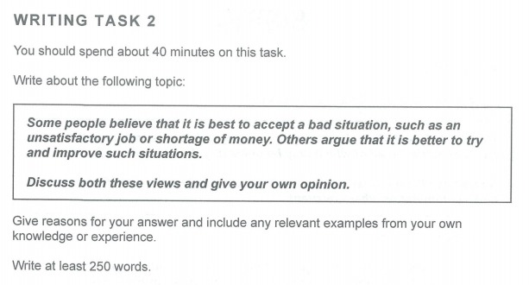

We live in a world where everything is connected, or everyone, where we depend on each other. For example, you can be late for a train because of busy traffic, even you left home as early as possible, and after that you got that “bad” conversation with your boss and lost your job. So, should we accept such unwelcomed situations, or should we try to solve it, and it get back which was yours from the first time? I argue that it is better to try and improve that circumstances, even sometimes it is impossible to change the situation.

From my point of view, all that cases such as unsatisfactory job and/or shortage of money come from our steps to the future goals. However, we could get a job, be happy in the beginning, but later we found the job conditions are terrible. Maybe, it was our mistake, we did not read the contract. In such cases, we can just leave that job and find out another one. Nevertheless, no one said it will be easy, or another employee will offer better conditions/salary. Even though it is better to try to improve your life if you can. For example, during the quarantine I lost my job, and my financial state was purely bad. I was stressed at first, I tried to search a new one, because I could not accept it, but every time I failed. For some seconds, I thought maybe I should accept it and try to save money, but I woke up quickly and asked for help from my friends. Lately, I found part-time job, and my financial case improved. Maybe, if I accepted my case, I could not allow myself even my lovely food sushi.

To conclude, there could be cases where you think you cannot change anything, but I believe that if we try harder everything can be changed.