Exploratory Data Analysis

Eastern Bluefin

23 enero, 2018

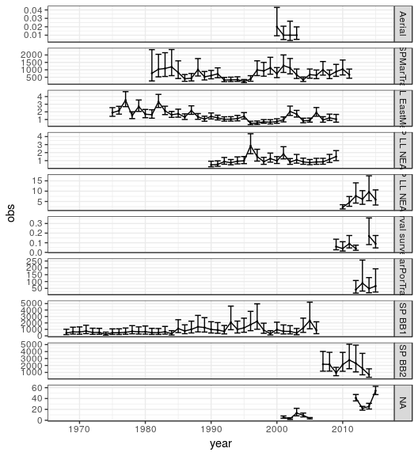 **Figure 1.** Time series of CPUE indices with 95% confidence intervals.

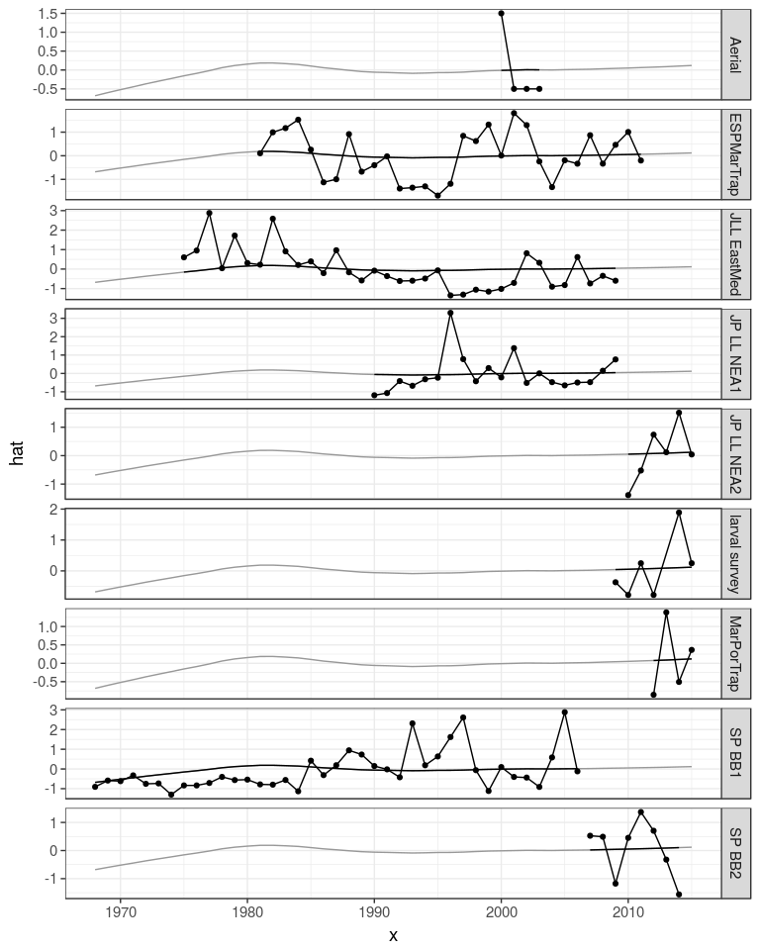 **Figure 2.** Time series of CPUE indices, continuous black line is a lowess smother showing the average trend by area (i.e. fitted to year for each area with series as a factor)

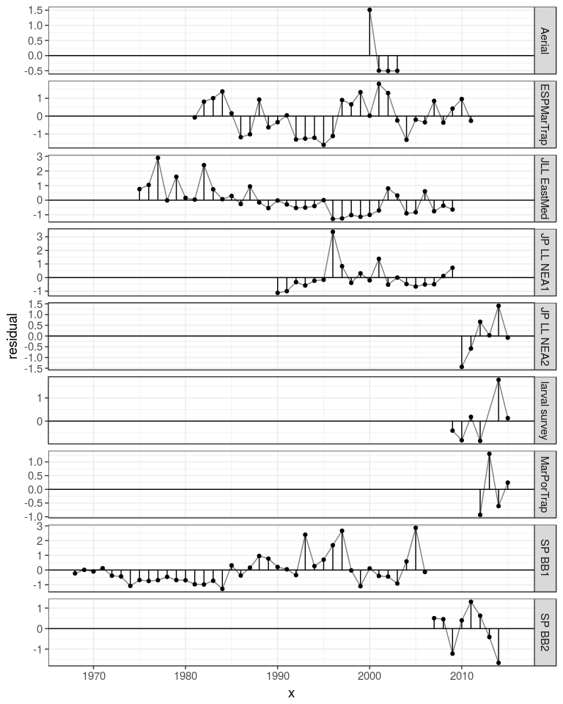 **Figure 3.** Time series of residuals from the lowess fit.

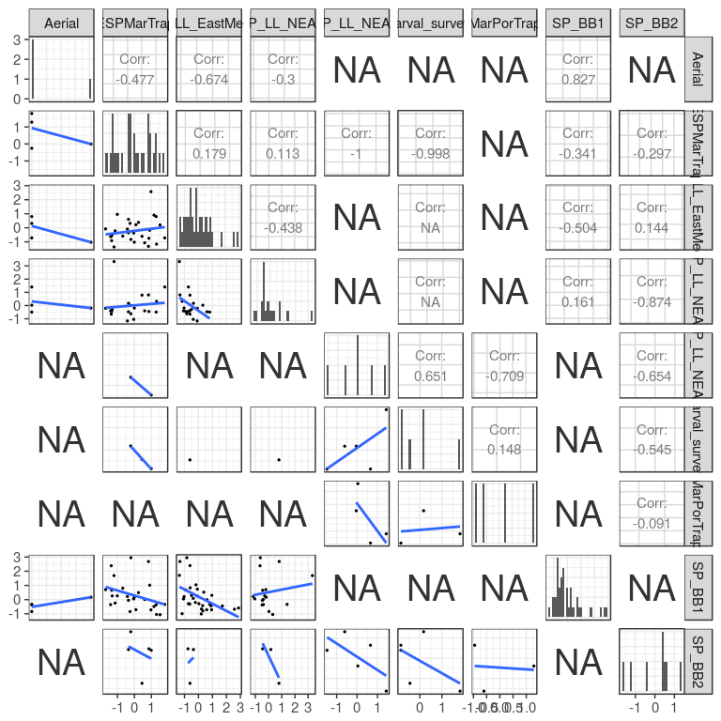 **Figure 4.** Pairwise scatter plots to look at correlations between Indices, North.

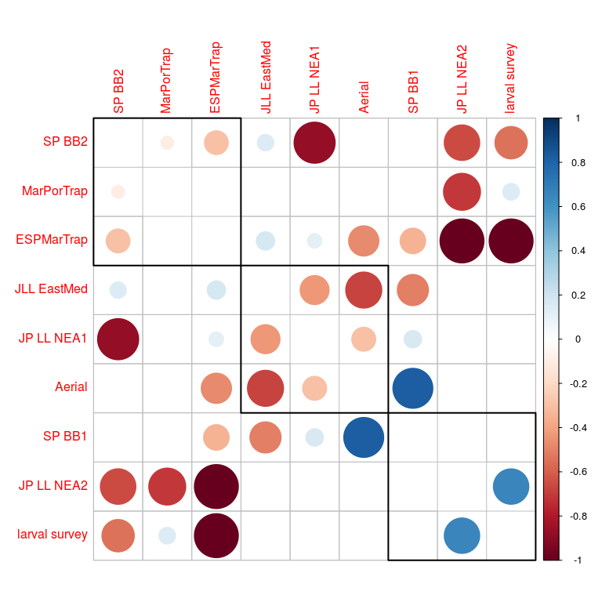

NULL

**Figure 5.** Plot of the correlation matrix for the Southern CPUE indices, blue indicate a positive correlation and red negative. the order of the indices and the rectanglur boxes are chosen based on a hierarchical cluster analysis using a set of dissimilarities for the indices being clustered.

[1] "FLQuants" "FLlst" "list" "vector"

**Figure 6** Cross correlations between Northern indices, to identify potential lags due to year-class effects.

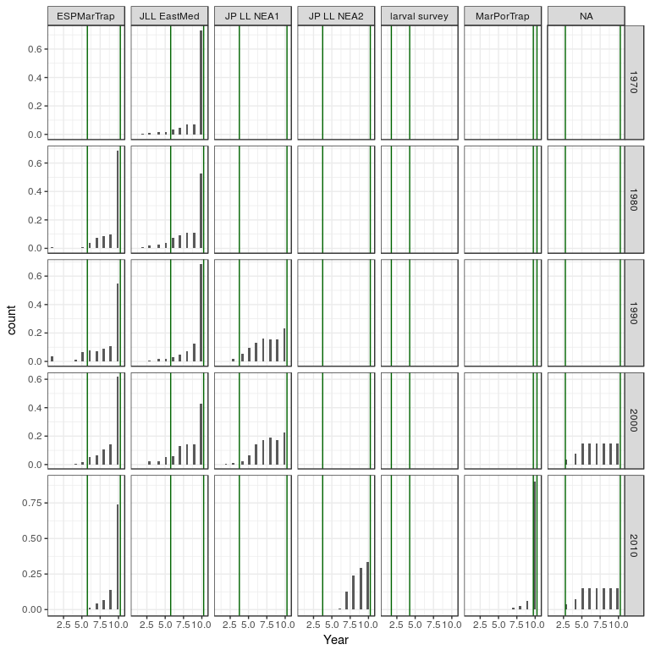 **Figure 7** Catch compostion, vertical lines show the ages used in calibration.

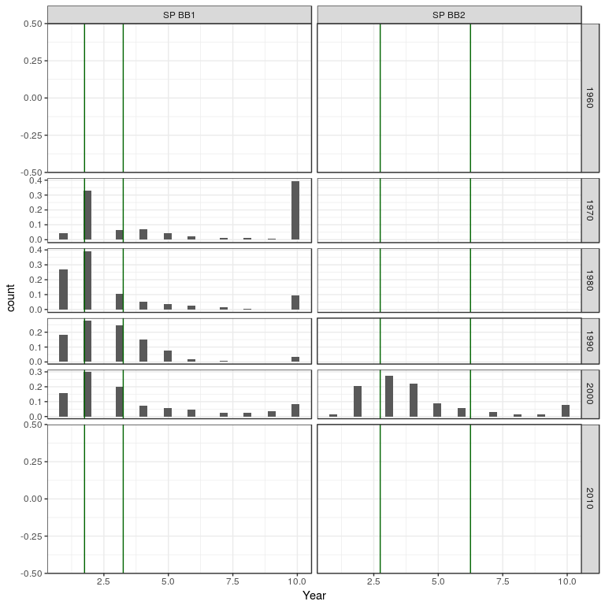 **Figure 8** Catch biomass compostion, vertical lines show the ages used in calibration.

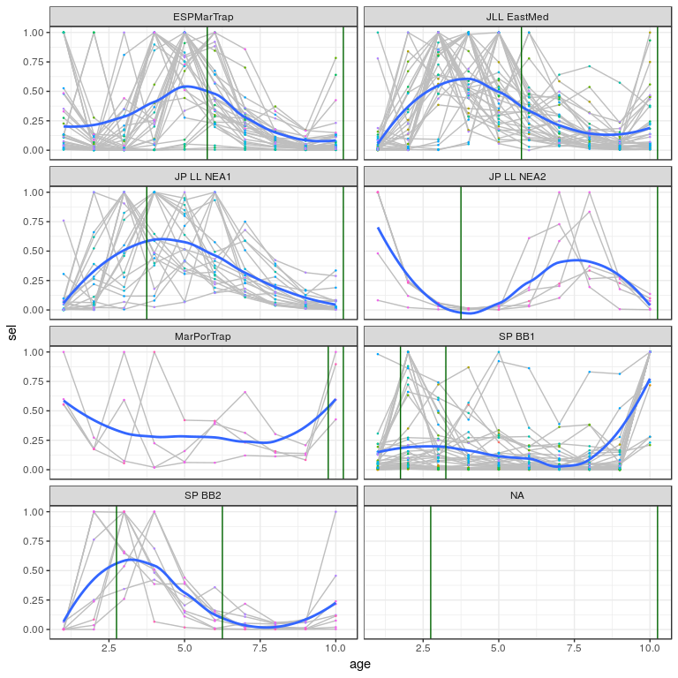 **Figure 9** Catch curve analyses, vertical lines show the ages used in calibration.

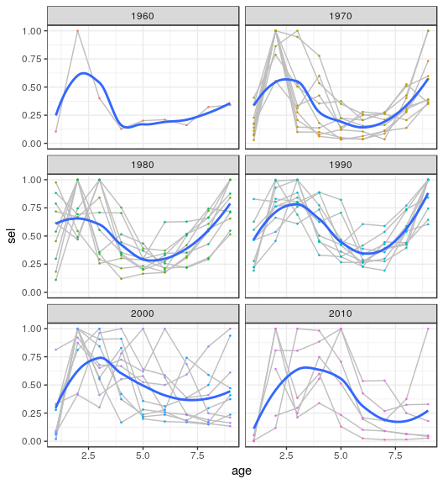 **Figure 10** Selection pattern of the entire catch-at-age.