Decoder for  
24 In/Out channels

## TMC - Aiko Pras

## November 6, 2024 - Version 1.1

## IO24-1.png

# Connecting

1. **Power-In** should be connected to 12V. Because of the bridge rectification on the PCB, it does not matter how the + and - are connected. Basically, any DC or AC voltage between 9V and 24V will do. The current consumption is a few tens of mA, depending on the load on the output pins.
2. The **DCC** and **RS-Bus** cables should be connected to the appropriate connectors. For the RS-Bus, make sure that the R and S are not reversed (see letters on the PCB figure below).
3. The three sliders on the red DIP switch determine whether the corresponding port behaves as input (Melden = Feedback) or output (Schakelen = Switching). See **Ports and Pin Numbering**.
4. Each PCB has been assigned a number of unique DCC switch and feedback addresses as the "factory setting." If desired, these addresses can be changed by pressing the **Address** key. For details, see *Addresses*.
5. The green LED next to the **Power-In** connector illuminates when the decoder is powered. The two LEDs next to the DCC and RS-Bus connectors light when a valid DCC / RS-Bus signal is recognised. The **DCC** and **RS** LEDs (between the pushbutton and DIP-Switch) light briefly when a switch (accessory) command has been received for this decoder, or a feedback has been sent by this decoder.
6. The white LED on the center of the PCB (V1.0), or the red LED to the left of the **Address** button (> V1.0) indicates the **status of the decoder:**

* At startup: 2 x flash, to indicate that the program has started.
* When a DCC command is received or RS-Bus message is sent: 1 x flash.
* If the decoder does not possess a valid DCC address: continuous flashing.
* When the decoder is in "address programming" mode, the LED is continuously on.   
  For details, see **Address button**.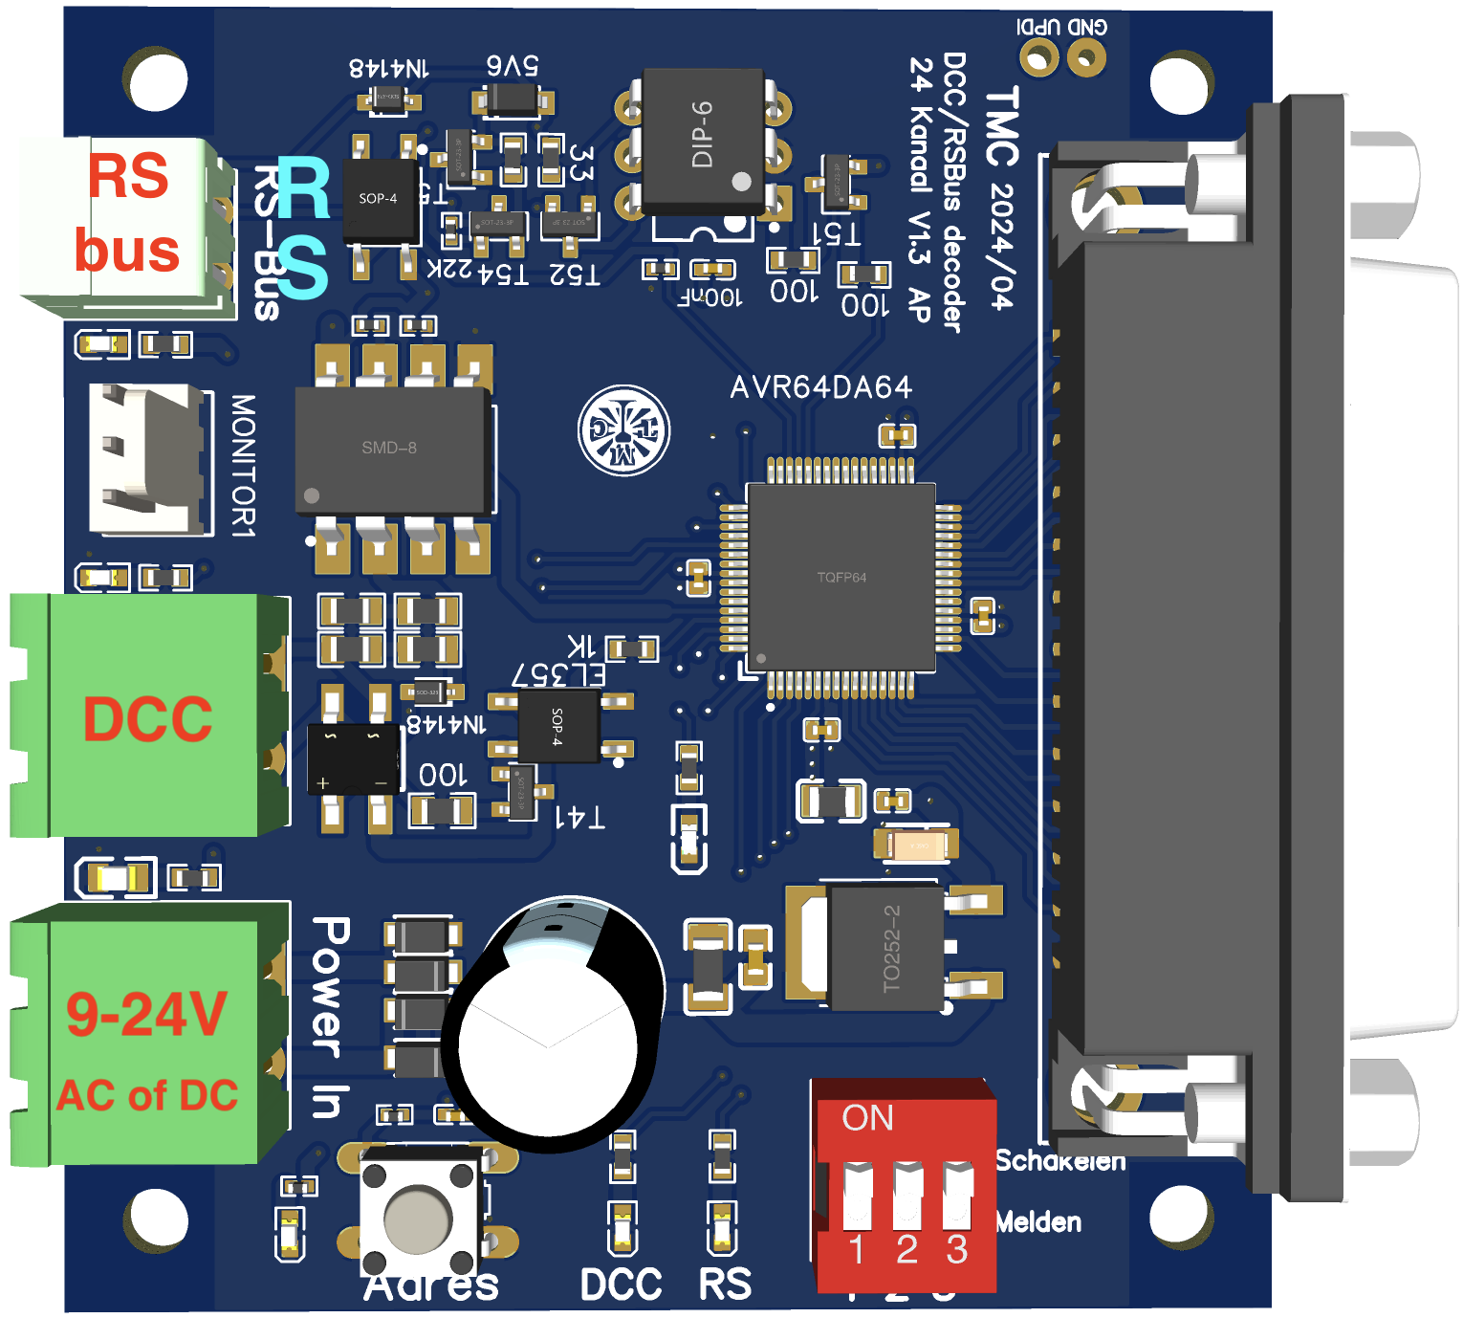

# Ports and Pin numbering

The 24 channels are divided into 3 ports, each with 8 inputs or outputs. The three DIP sliders determine the behaviour of a port:

* **Switching**: the port listens for switch (accessory) commands.
* **Feedback**: (RS-Bus) feedback commands are sent when the voltage on a pin changes between high (5V) and low (0V).

| Port 1 | | Port 2 | | Gate 3 | |
| --- | --- | --- | --- | --- | --- |
| Number | Pin (SUBD25) | Number | Pin (SUBD25) | Number | Pin (SUBD25) |
| 1 | 1 | 1 | 5 | 1 | 9 |
| 2 | 14 | 2 | 18 | 2 | 22 |
| 3 | 2 | 3 | 6 | 3 | 10 |
| 4 | 15 | 4 | 19 | 4 | 23 |
| 5 | 3 | 5 | 7 | 5 | 11 |
| 6 | 16 | 6 | 20 | 6 | 24 |
| 7 | 4 | 7 | 8 | 7 | 12 |
| 8 | 17 | 8 | 21 | 8 | 25 |
| Relationship between ports and pins of the SUBD25 connector | | | | | |

The pins of the microprocessor are connected directly to the pins of the SUBD-25 connector. If a port is set to **Feedback**, but nothing is connected to the port, the input voltage of the port is not defined, possibly resulting in unwanted feedback.

The relationships between ports and pins of the SUBD-25 connector are shown in the table and figure below.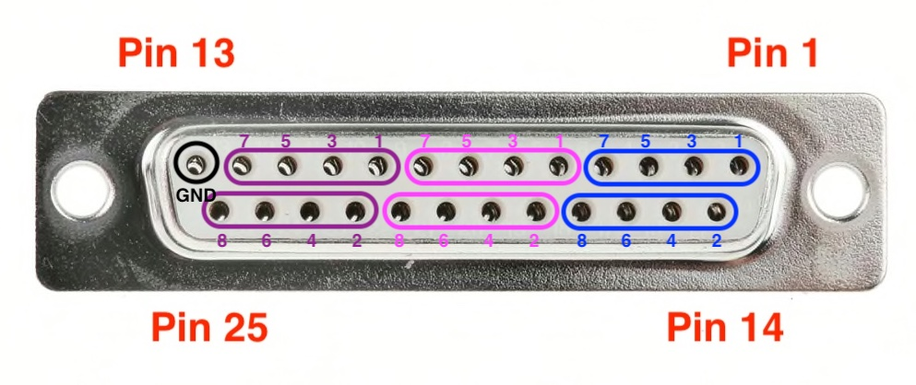

# Addresses (factory setting)

Each decoder has already been assigned unique accessory (switch) and feedback addresses as factory settings. These addresses should be put on a sticker on the bottom of the PCB. In principle, therefore, a decoder does not need to be pre-configured.

Each decoder has 24 inputs/outputs divided into 3 ports.

## RS-Bus addresses

When all three sliders on the red DIP switch are set to **Feedback (Melden)**, all three ports are configured as inputs. Each RS-Bus address covers 8 bits. Thus, for 24 inputs, three RS-Bus addresses are required.

Regardless of whether 0, 1, 2 or 3 sliders are set to **Feedback**, *3 RS-Bus addresses* will always be reserved.

## Accessory addresses

When all three sliders on the red DIP switch are set to **Switching (Schakelen)**, all three ports are configured as outputs and can therefore control up to 24 switches. This therefore requires 24 switch (accessory) addresses.

Regardless of whether 0, 1, 2 or 3 sliders are set to **Switching**, 24 switch addresses will always be reserved.

## Factory settings

Addresses are always reserved in blocks. For switches, the first block is from 1 to 24; the second block is from 25 to 48 and so on.

| **DCC** | | | **RS** | | | **DCC** | | | **RS** | | | **DCC** | | | **RS** | | | **DCC** | | | **RS** | | |
| --- | --- | --- | --- | --- | --- | --- | --- | --- | --- | --- | --- | --- | --- | --- | --- | --- | --- | --- | --- | --- | --- | --- | --- |
| 1 | .. | 24 | 1 | .. | 3 | 289 | .. | 312 | 35 | .. | 37 | 577 | .. | 600 | 71 | .. | 73 | 865 | .. | 888 | 107 | .. | 109 |
| 25 | .. | 48 | 4 | .. | 6 | 313 | .. | 336 | 38 | .. | 40 | 601 | .. | 624 | 74 | .. | 76 | 889 | .. | 912 | 110 | .. | 112 |
| 49 | .. | 72 | 7 | .. | 9 | 337 | .. | 360 | 41 | .. | 43 | 625 | .. | 648 | 77 | .. | 79 | 913 | .. | 936 | 113 | .. | 115 |
| 73 | .. | 96 | 10 | .. | 12 | 361 | .. | 384 | 44 | .. | 46 | 649 | .. | 672 | 80 | .. | 82 | 937 | .. | 960 | 116 | .. | 118 |
| 97 | .. | 120 | 13 | .. | 15 | 385 | .. | 408 | 47 | .. | 49 | 673 | .. | 696 | 83 | .. | 85 | 961 | .. | 984 | 119 | .. | 121 |
| 121 | .. | 144 | 16 | .. | 18 | 409 | .. | 432 | 50 | .. | 52 | 697 | .. | 720 | 86 | .. | 88 | 985 | .. | 1008 | 122 | .. | 124 |
| 145 | .. | 168 | 19 | .. | 21 | 433 | .. | 456 | 53 | .. | 55 | 721 | .. | 744 | 89 | .. | 91 | 1009 | .. | 1032 | 125 | .. | 127 |
| 169 | .. | 192 | 22 | .. | 24 | 457 | .. | 480 | 56 | .. | 58 | 745 | .. | 768 | 92 | .. | 94 | 1033 | .. | 1056 |  |  |  |
| 193 | .. | 216 | 25 | .. | 27 | 481 | .. | 504 | 59 | .. | 61 | 769 | .. | 792 | 95 | .. | 97 | 1057 | .. | 1080 |  |  |  |
| 217 | .. | 240 | 28 | .. | 30 | 505 | .. | 528 | 62 | .. | 64 | 793 | .. | 816 | 98 | .. | 100 | 1081 | .. | 1104 |  |  |  |
| 241 | .. | 264 | 31 | .. | 33 | 529 | .. | 552 | 65 | .. | 67 | 817 | .. | 840 | 101 | .. | 103 | 1105 | .. | 1128 |  |  |  |
| 265 | .. | 288 | 34 | .. | 36 | 553 | .. | 576 | 68 | .. | 70 | 841 | .. | 864 | 104 | .. | 106 | 1129 | .. | 1152 |  |  |  |
| Combinations of DCC and RS-Bus addresses (factory setting). | | | | | | | | | | | | | | | | | | | | | | | |

# Feedback

The decoder checks once every 10ms for each pin for which the corresponding DIP switch is set to "Report" whether the input voltage is HIGH (5V) or LOW (0V). If there is a change, the yellow **RS** LED lights for about 1 second.

To limit the influence of possible interference, the HIGH (busy) signal is not reported until it is measured HIGH three consecutive times. A HIGH signal thus leads to an RS-Bus message after 30ms at the earliest. This number may be changed by adjusting CV33 (Min_1Samples).

To limit the influence of bad rail contacts, the LOW (free) signal is not reported until it has been measured LOW 150 consecutive times. A LOW signal thus leads to an RS-Bus message after 1.5 sec at the earliest. This number may be changed by adjusting CV34 (Min_0Samples).

As mentioned above, the decoder checks once every 10ms to see if the input voltage of a pin has changed. This interval of 10ms may also be changed by adjusting CV35 (Int_Samples).

If multiple pins (of a port) change value at exactly the same time, these changes are sent together in one RS-Bus message.

When the decoder starts up, it waits about twenty measurements before sending an RS-Bus message. During this time, the input signal can first stabilise, resulting in no (or fewer) incorrect values being transmitted. This number of 20 can also be changed, if necessary, by adjusting CV36 (Start_Delay).

Switching

Immediately after receiving a switch command whose address corresponds to this decoder, the output voltage of the corresponding Port/Pin will be adjusted:

* HIGH: The switch command was "straight through" (green or +).
* LOW: The change command was "off" (red or -).

The DCC accessory command also contains a bit called "activate." This bit, as with most decoders on the market today, is not interpreted.

# Address Button

Although each decoder has preconfigured unique switch addresses, it is possible to change these addresses. To do so, press the **Address** button briefly (about 1 second). The LED indicating the **status of the decoder** will now light continuously and the decoder will use the next switch command received to determine the new start address. The decoder then restarts, and will listen for the new addresses from now on.

Switch addresses are always given in blocks of four, and these blocks start with 1, 5, 9, 13 etc. If, for example, after the **Address** button is pressed, the switch address is entered as 7, then the starting address will not be 7, but 5. When the **Address** button is pressed, it makes no difference whether the next switch command has address 5, 6, 7 or 8. In all these cases the new start address will be 5.

The last address after which the decoder will listen is always the start address + 23. If the **Address** button is pressed, and the next switch command has address 7 (so start address 5), then the last address after which this decoder listens will be 28.

Note that the address button can change the switch addresses, but *not* the RS-Bus feedback addresses. To still change the RS-Bus addresses, CV (Configuration Variables) programming via **Service Mode** or **Programming on Main** (PoM) messages should be used. For details, see the appropriate chapters.

In programming mode, if the **Address** button is pressed a second time before a valid switch command is received, programming mode is exited again and the old addresses remain unchanged.

Restoring Factory Settings

All original settings can be restored by holding down the **Address** button for at least 5 seconds. The decoder then retrieves the factory settings from its memory, and restarts with these factory settings.

Note that not only the switch addresses are restored, but also the RS-Bus addresses and any other CV settings that may have been changed using **Service Mode** or **Programming on Main** (PoM) messages.

# Configuration Variables (CVs).

The behaviour of this decoder can be modified by changing the value of a number of CVs. The main CVs implemented are listed in the table below.

| CV number | CV name | Meaning |
| --- | --- | --- |
| 1 | myAddrL | First part of decoder address. See RCN-225, chapter 3.1 |
| 9 | myAddrH | Second part of decoder address. See RCN-225, chapter 3.1 |
| 7 | version | Software version |
| 8 | VID | 0x0D = DIY Decoder) / If the value 0x0D is written, all CVs return to the factory setting. See RCN-225, chapter 3.1 |
| 10 | myRSAddr | RS-Bus address |
| 19 | CmdStation | Master Station: 0 = Roco/Multimouse, 1 = Lenz, 2 = OpenDCC Z1 (Xpressnet V3.6). See RCN-213, chapter 2.1 |
| 23 | Search | If this CV is set to 1, the LED on the decoder flashes. This can be useful to find the correct decoder under the layout. |
| 25 | Restart | Setting this CV to 1 will reboot the decoder. |
| 26 | DccQuality | Counter that is incremented when a DCC command has an incorrect CRC. Can be used as an indication of whether the quality of the DCC signal is satisfactory. |
| 31 | ParityErrors | Counter that is incremented when the *command station has* detected an error in the parity bit of the RS-Bus message. Can be used as an indication of whether the quality of the RS-Bus signal is satisfactory. |
| 32 | PulseErrors | Counter that is incremented when the *decoder* sees an error in the RS-Bus signal. Can be used as an indication of whether the quality of the RS-Bus signal is satisfactory. |
| 33 | Min_1Samples | For an explanation, see the earlier section **Feedback.** |
| 34 | Min_0Samples | For an explanation, see the earlier section **Feedback.** |
| 35 | Int_Samples | For an explanation, see the earlier section **Feedback.** |
| 36 | Start_Delay | For an explanation, see the earlier section **Feedback.** |

Further information can be found in RCN 225, RCN 213 and the description of AP_DCC_Decoder_Core on [GitHub](https://github.com/aikopras/AP_DCC_Decoder_Core/blob/main/src/CvValues/CvValues.md%23CvValues).

# Adjusting CVs: Service Mode Programming

All CV values can be adjusted by connecting the decoder to the programming track output of the command station. Of course, only one decoder may be connected at a time. Programming is similar to programming locomotive decoders.

Customising CVs: Programming on Main (PoM)

It is also possible to change the values of CVs by sending PoM messages. As PoM address, the locomotive address 5000 plus the RS-Bus address must be chosen. So if the RS-Bus address is 100, the PoM address is 5100.

Note that the value of 5000 can also be adjusted by changing CV37 (Offset_PoM).

A special feature of this decoder, and not offered by other decoders without RailCom support, is that the values of CVs can also be read out. For this purpose, after receiving a PoM read command, each decoder sends the CV value back via the RS-Bus using address 128. This makes it possible to develop PC programs that make adjusting CV values easier.

Note: Although RailCom is now standard for locomotive decoders, RailCom is relatively new for accessory decoders. Currently, there are only a limited number of central units that can handle it. Some additional hardware (and software) is required on the decoder, which is not added on this decoder.