

CENTENNIAL COLLEGE PROGRESS CAMPUS

COURSE COMP125

ASSIGNMENT #1

JavaScript Loops

Create an HTMLdocument called **assignment1.html** that implements a webpage that dynamically creates (using JavaScript code) a 10X10 HTML table and displays in each cell the value of row times the column to create a multiplication table. Allow the user to select the number of rows and columns to redraw a new table.

Follow these guidelines to implement your assignment:

1. Create a JavaScript file called assignment1.js and write the code for a function that draws the table.
2. Invoke the function when the visitor clicks on the assignment1.html page.
3. Load the assignment2.js file at the end of the body in assignment1.html.
4. (**10% of the grade**) Accept user input for the number of rows and columns in the table.
5. (**10% of the grade**) Use good web design practices to enhance visually your html page. Add a title, picture, colors, copyright line, etc.

Basic screenshots for the functionality of this assignment are shown below:

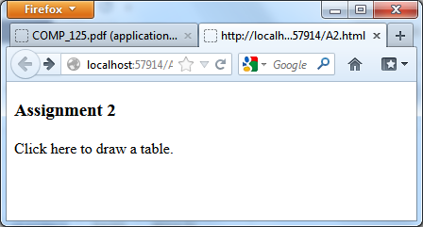

Submit your files assignment1.html and assignment1.js to the Assignment 1 drop box.

ALSO PUBLISH IT to the student web and then copy the link to assignment1.html to your drop box submission. For example: http://studentweb.cencol.ca/username/comp125/assignment1.html