Base:
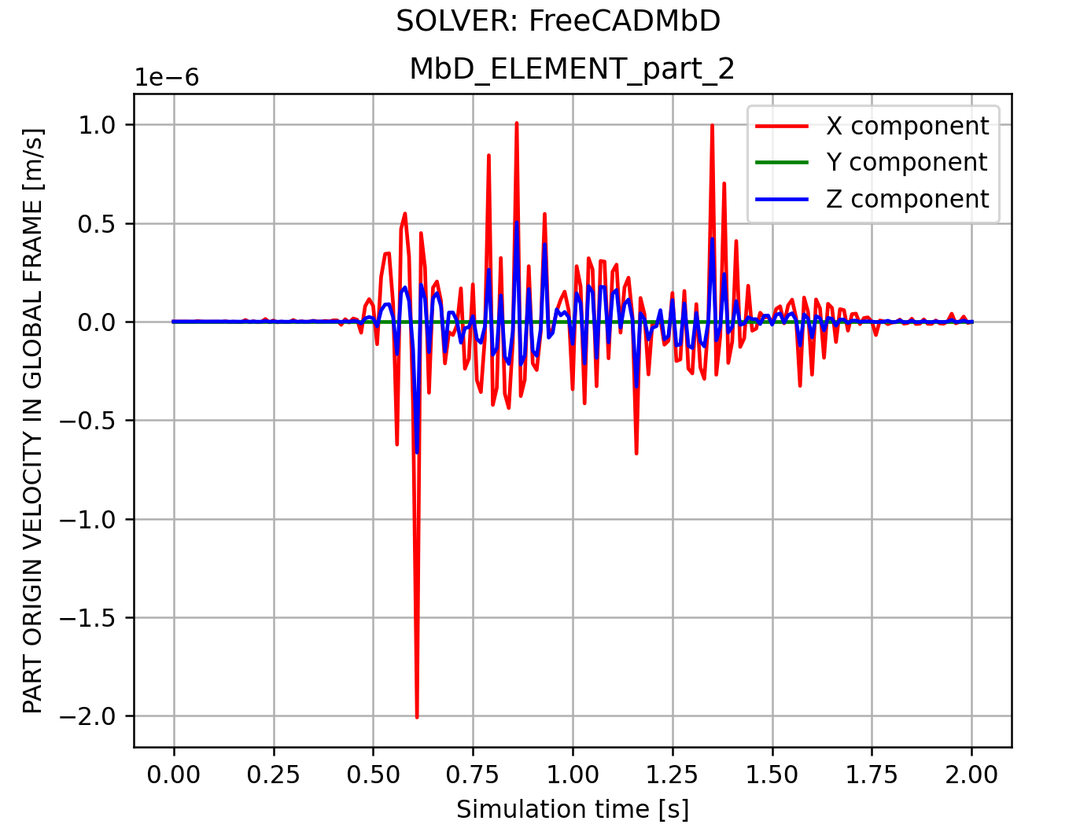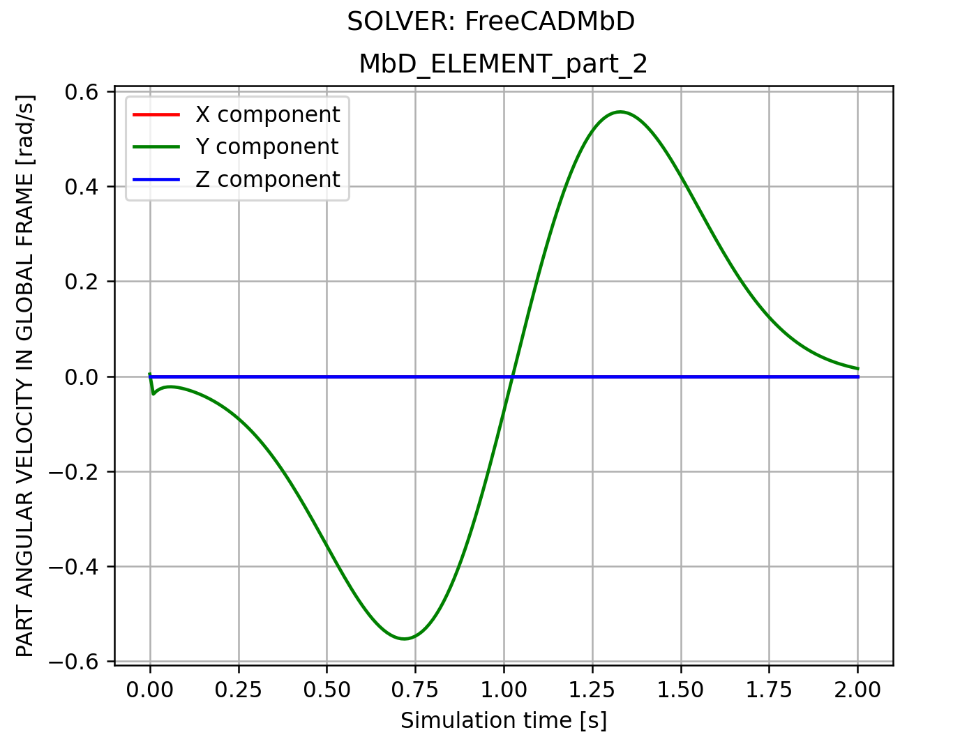
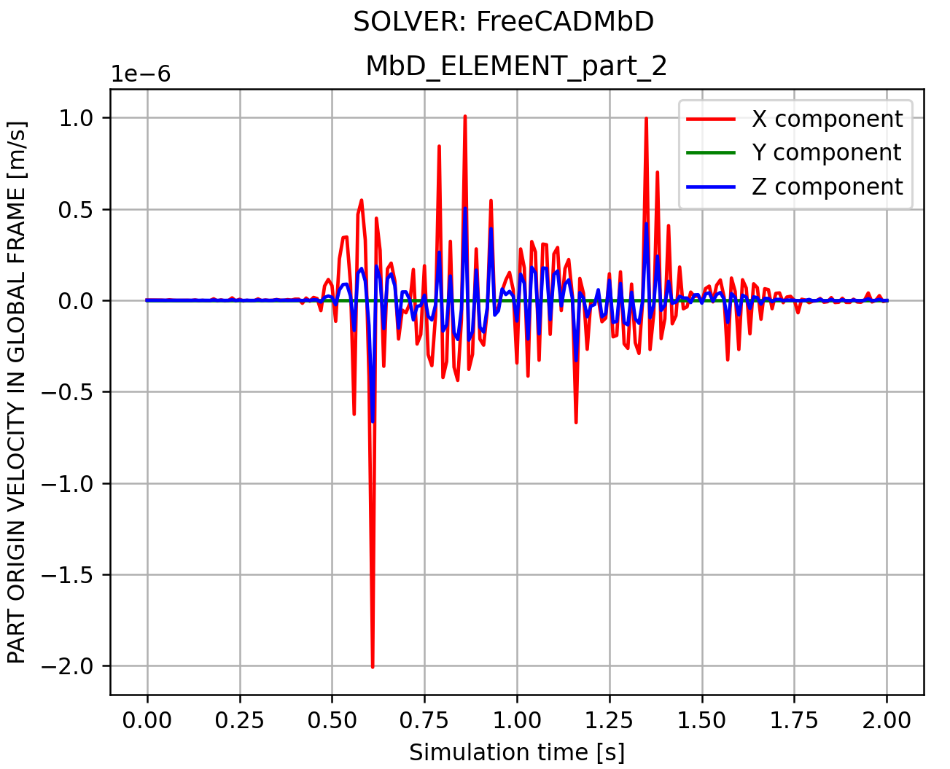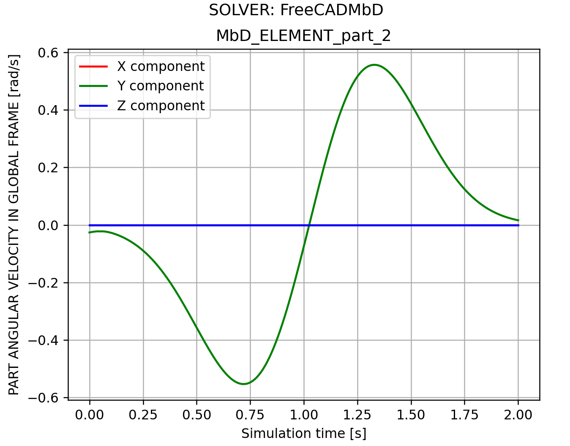
v = array([1.12779952e-09, 6.75817746e-16, 1.99865717e-10])
w = array([ 8.81065902e-16, -2.62925521e-02, -1.10830008e-14])

Connector:
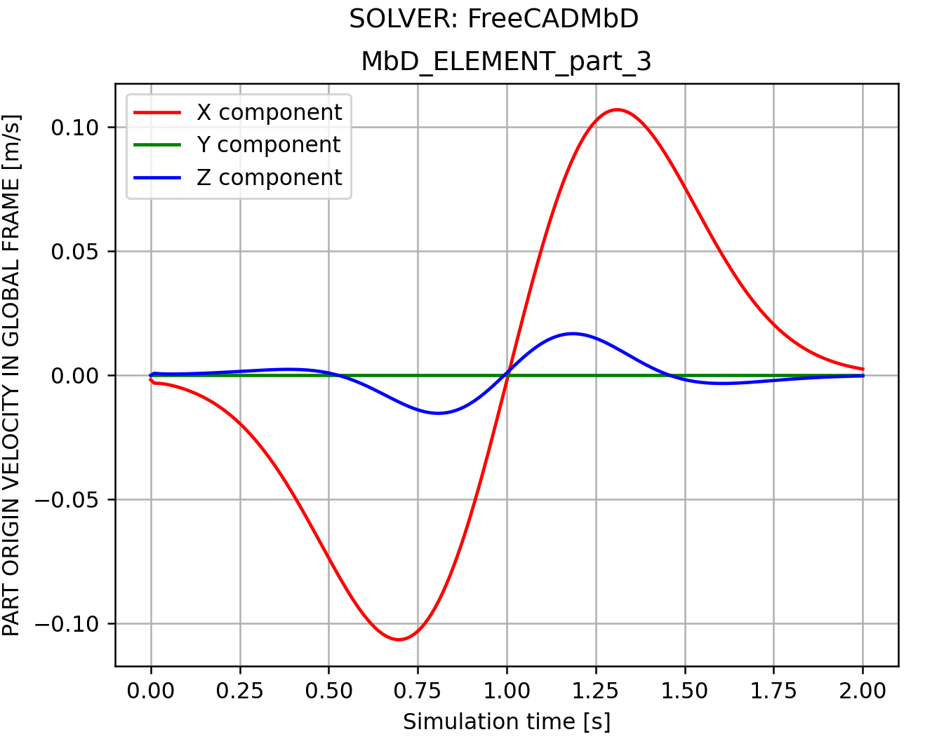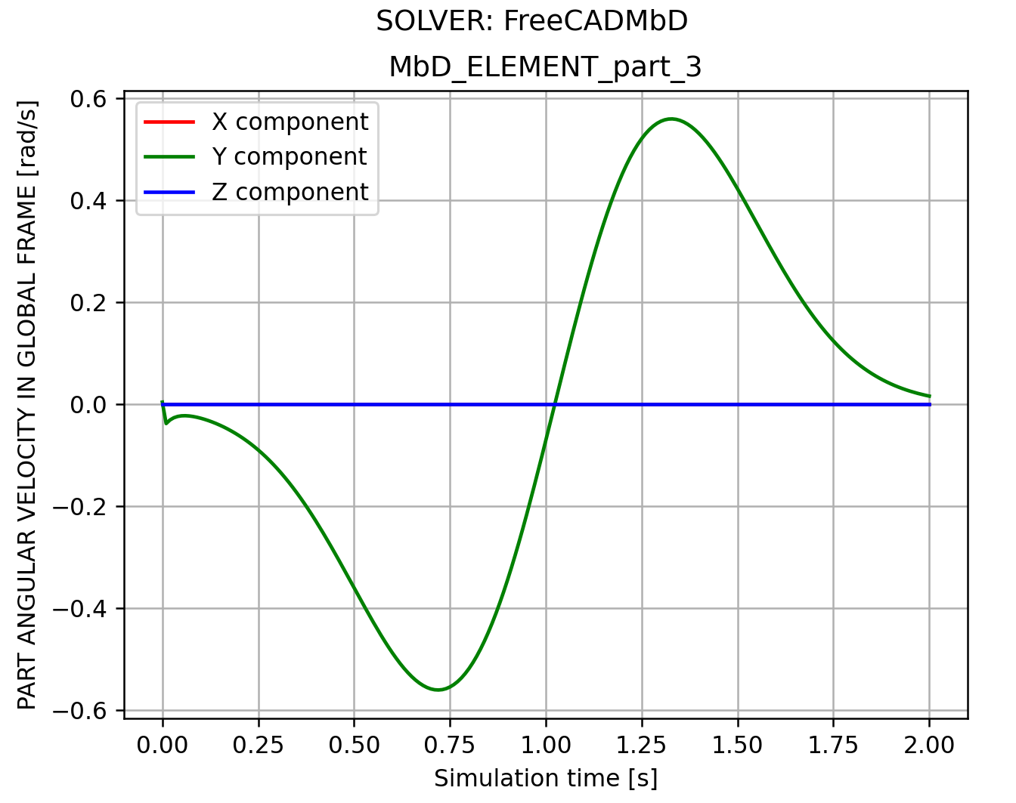
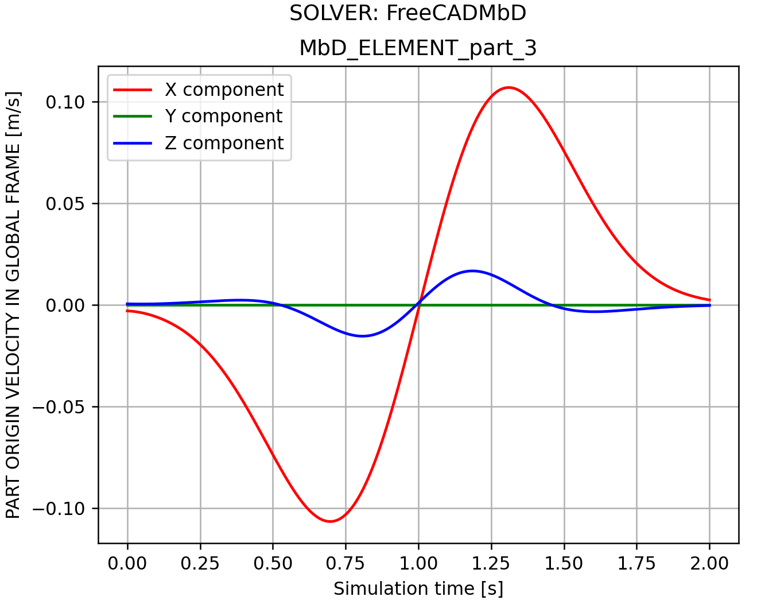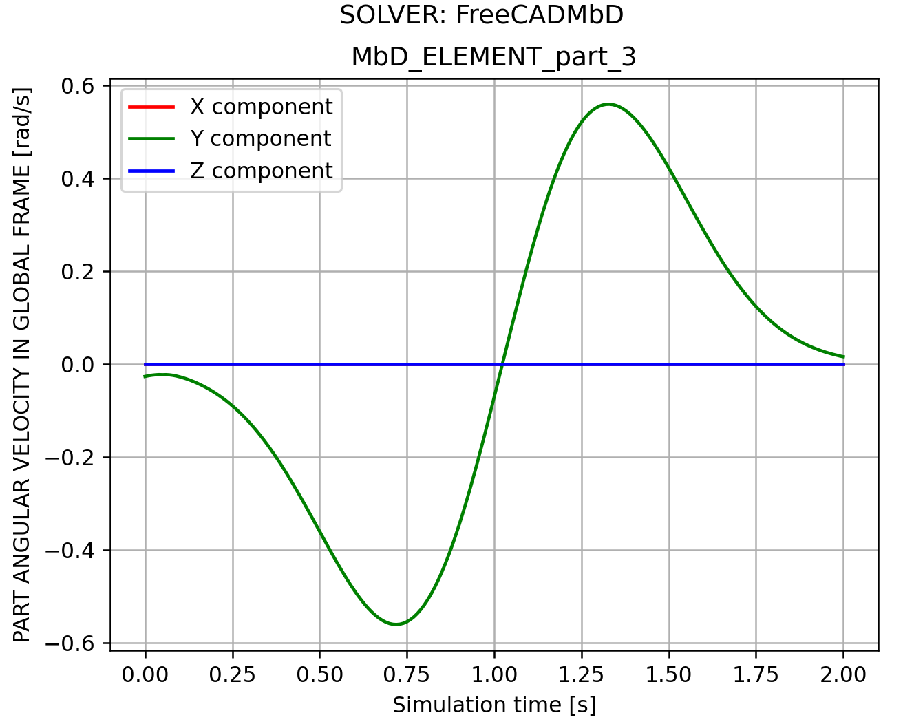
v = array([-2.96424292e-03, 2.81877567e-15, 5.08485449e-04])
w = array([-1.33136135e-15, -2.62862341e-02, 1.27115102e-14])

Handle:
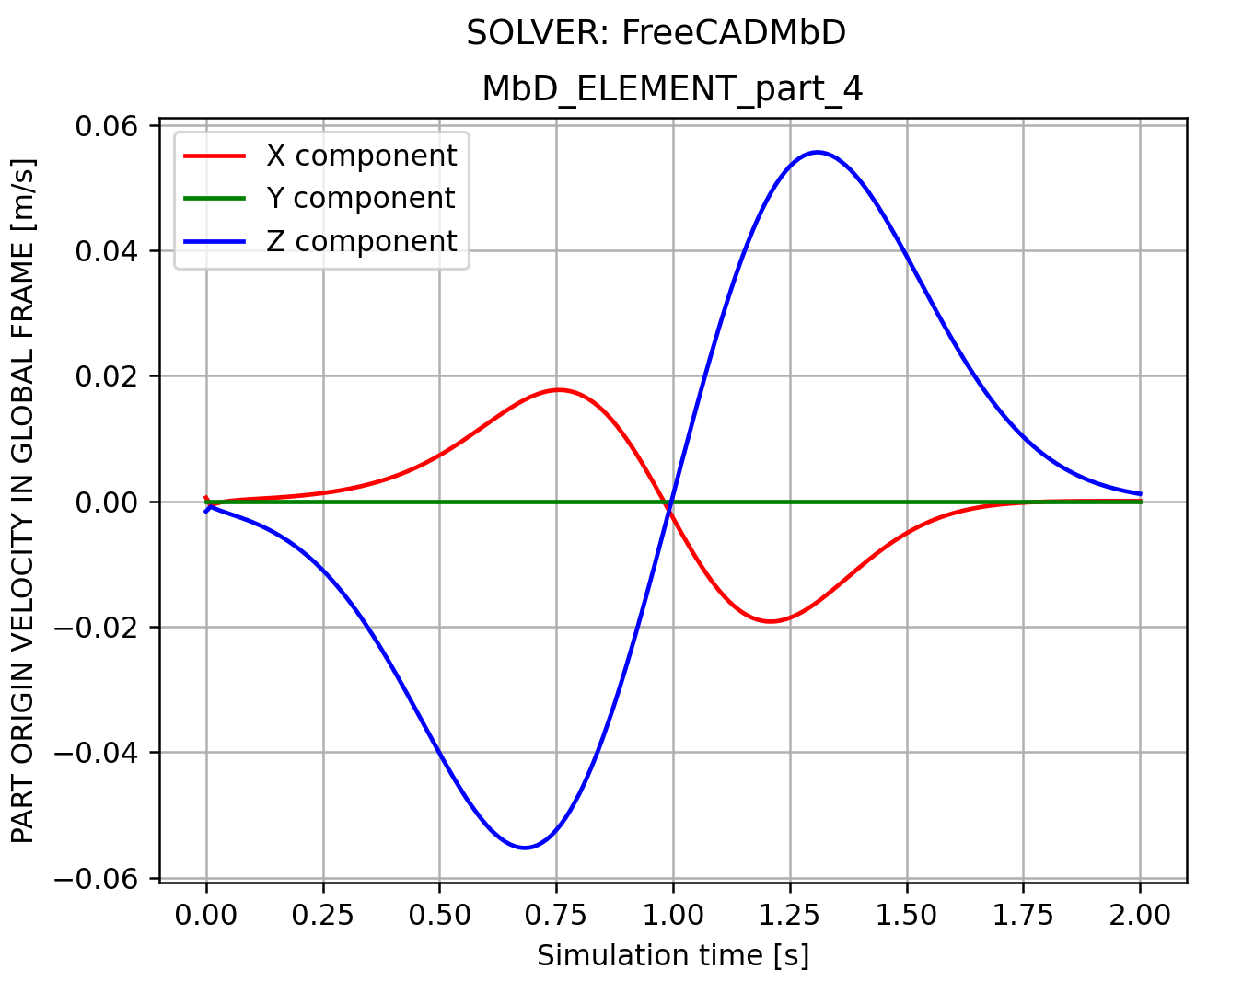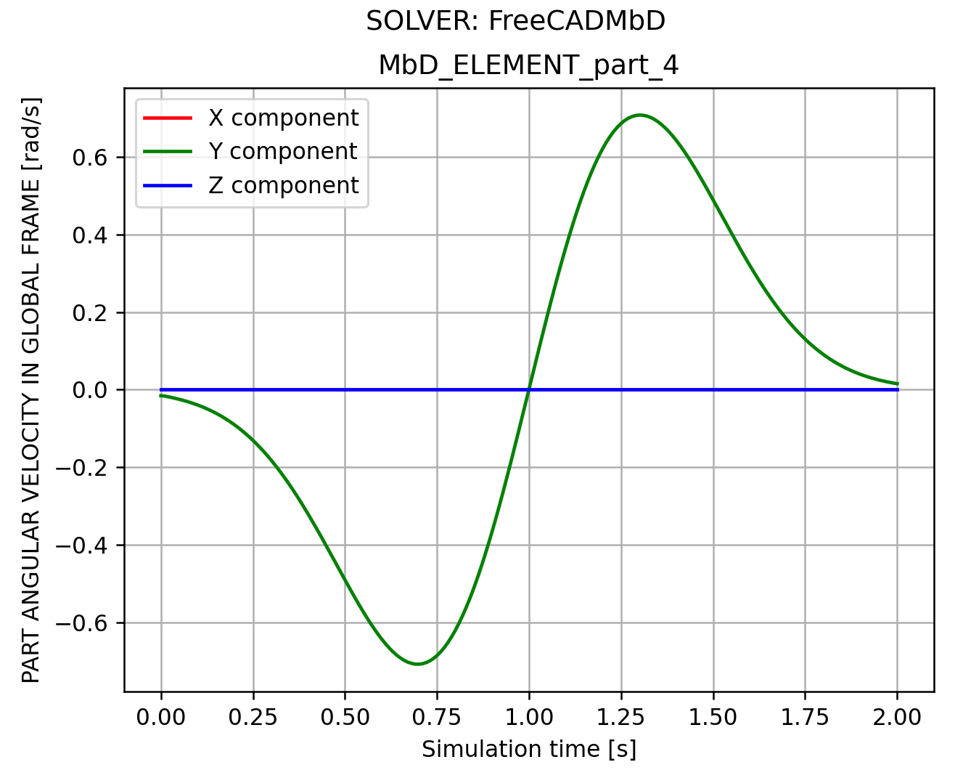
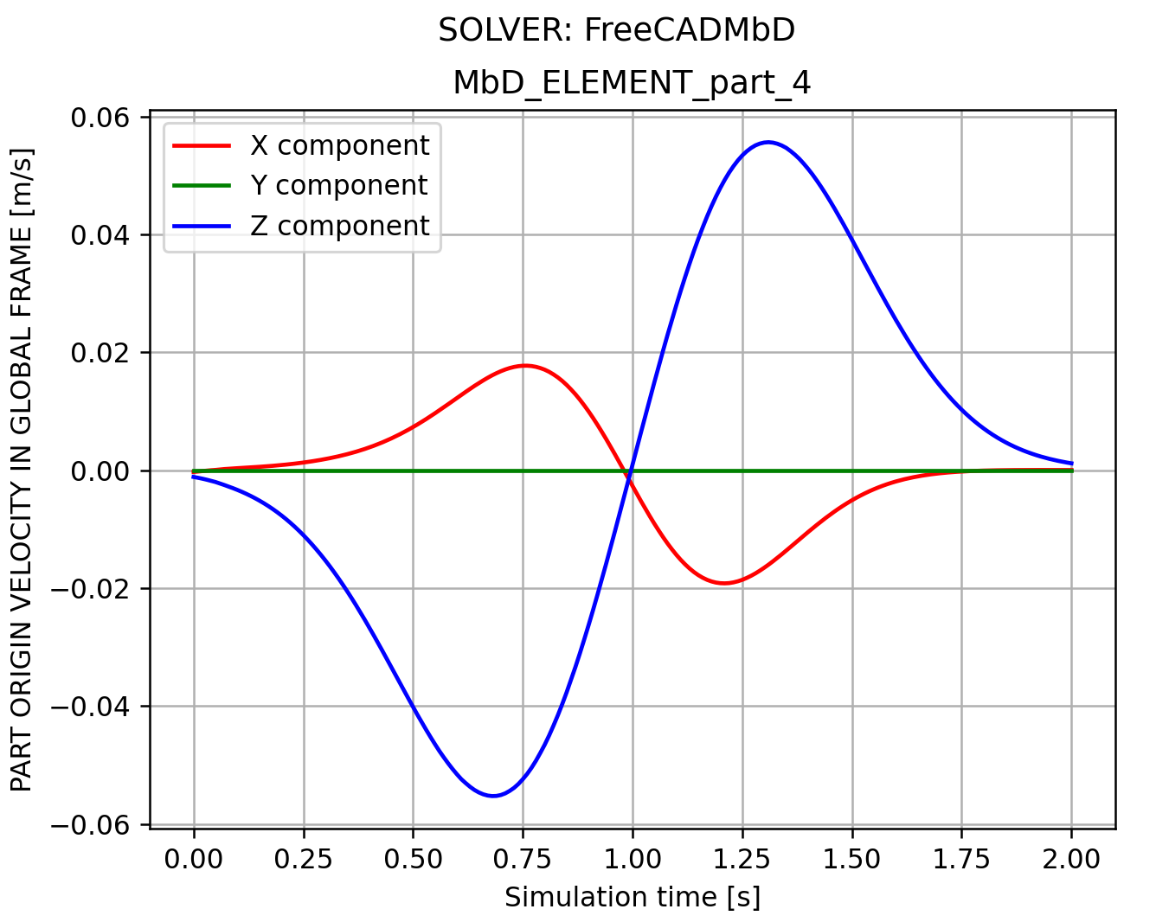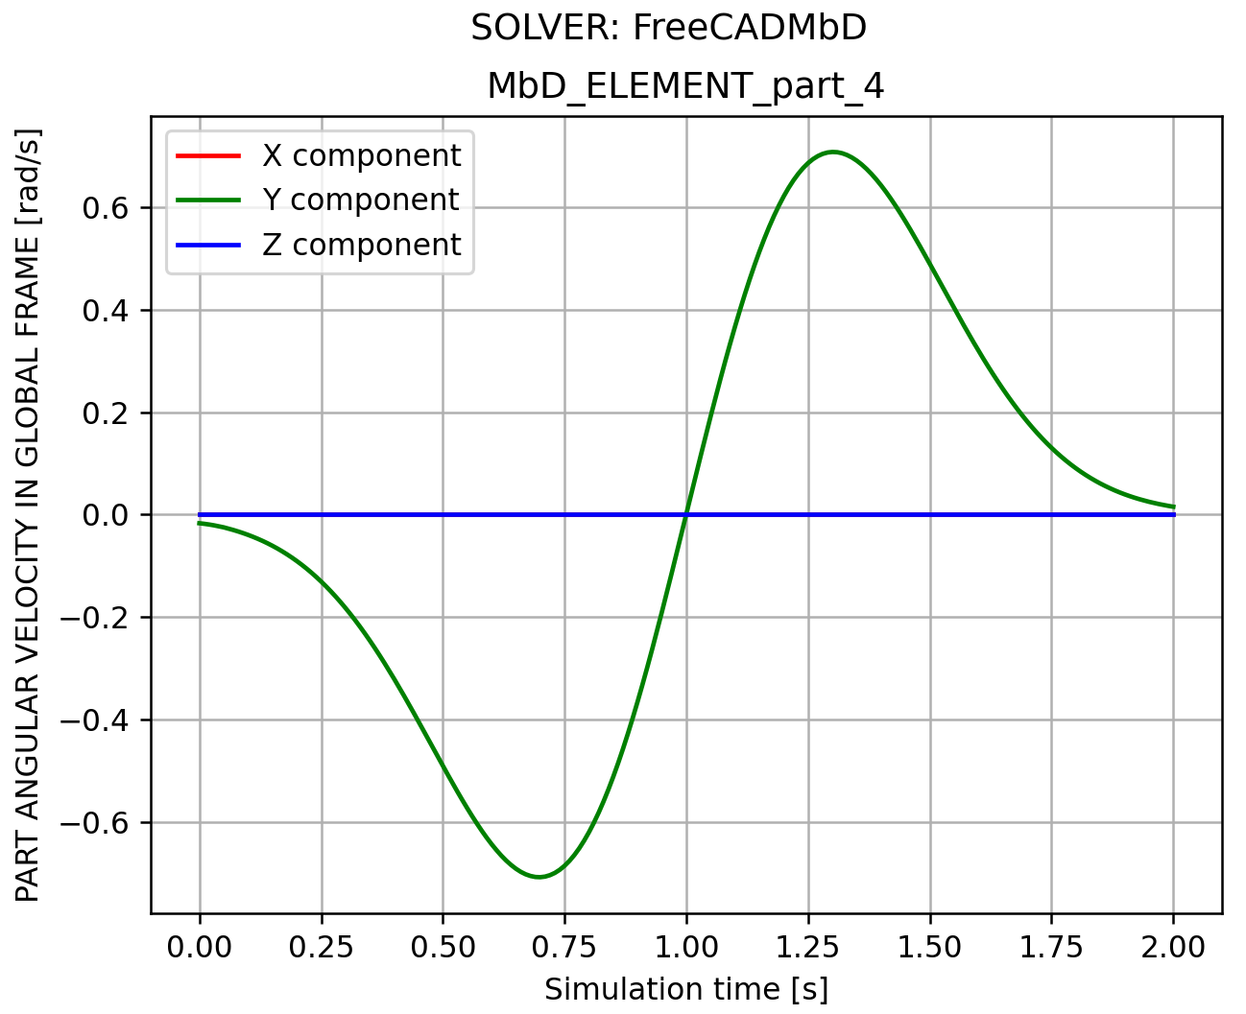
v = array([-2.85225102e-04, -1.04248457e-15, -1.13700717e-03])
w = array([ 1.39869298e-16, -1.69879656e-02, 1.32656781e-14])
Jaw:
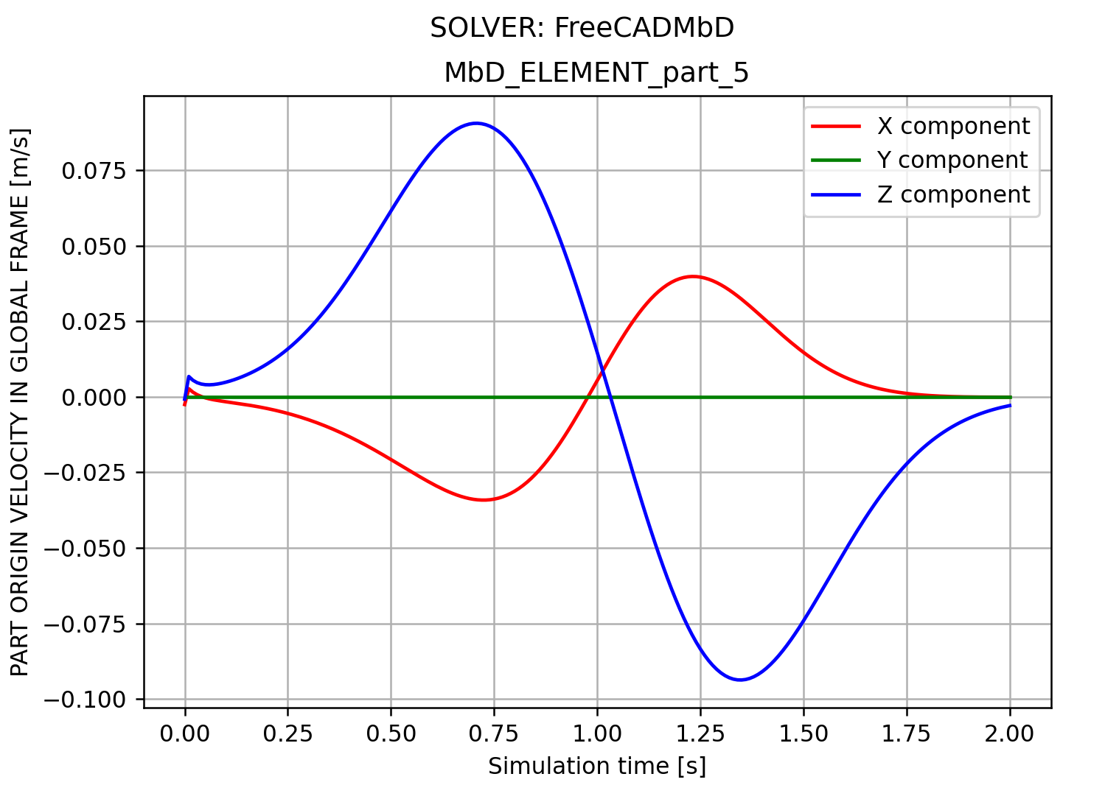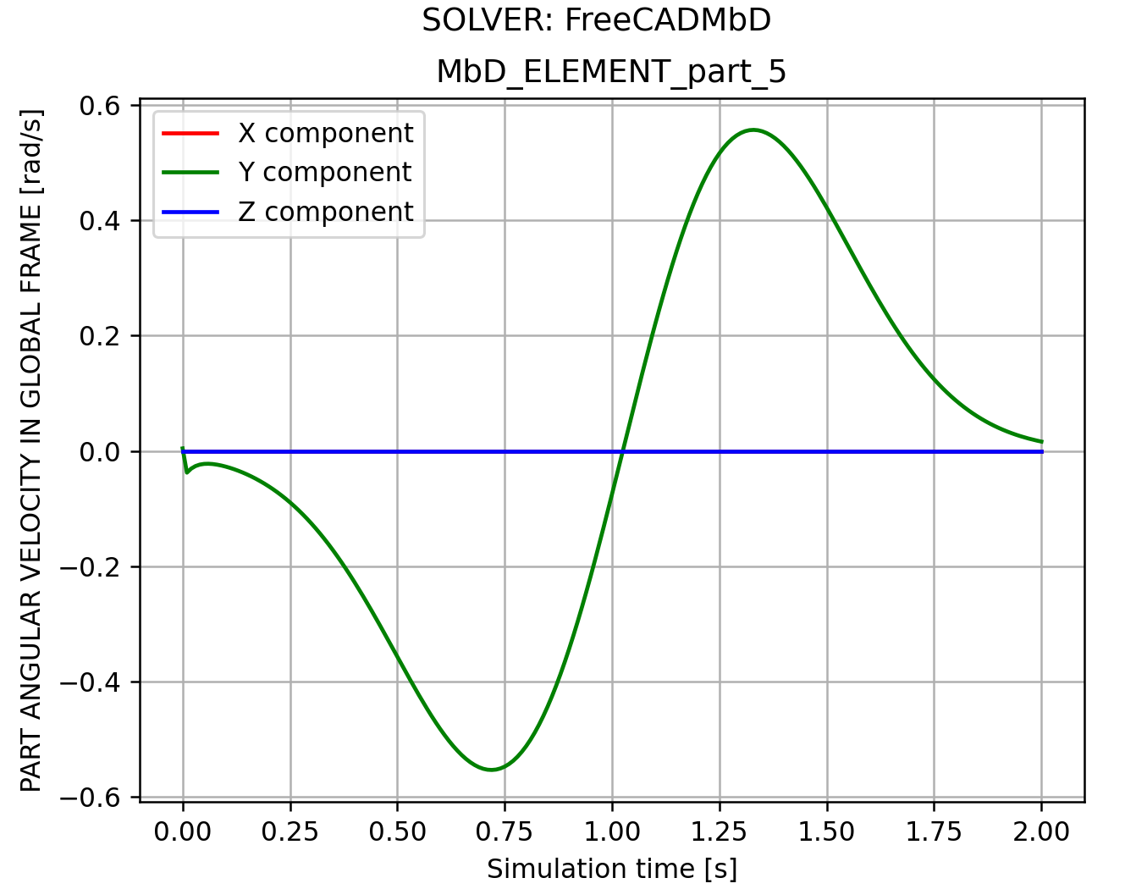
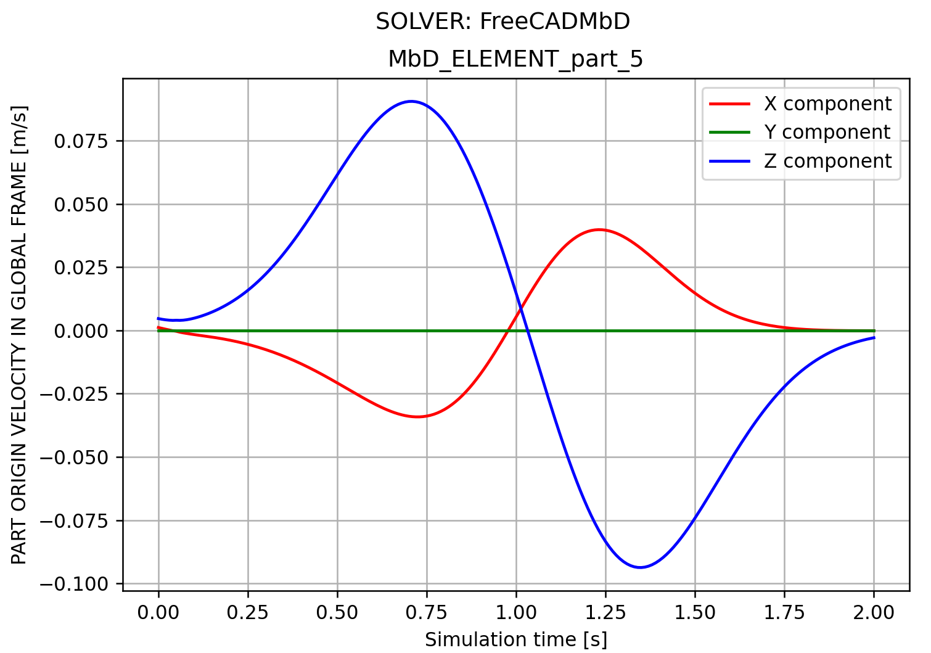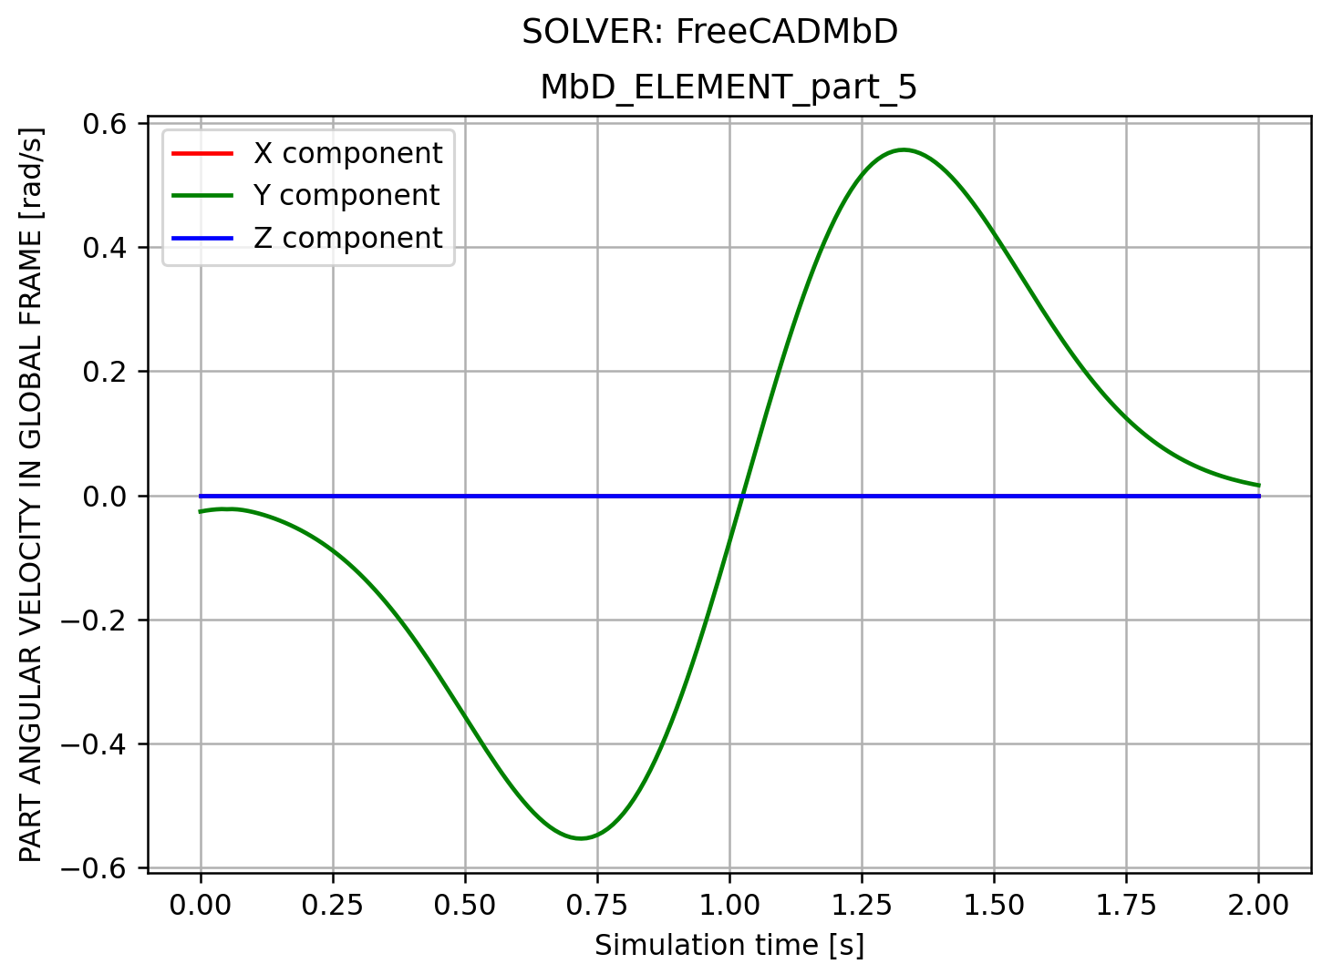
v = array([1.16718633e-03, 6.61955475e-15, 4.69473401e-03])
w = array([ 9.25988094e-17, -2.62925521e-02, 9.79627784e-15])

