# **Bootcamp Day 1 – Git Assignment**

Note: I have already have GCP compute instance , so I have used to the same to perform the below assignments.

1. Create a local git repository developerA and create 3 files into it. (demo1,2 and 3)

* I have created a directory called developerA and created 3 python scripts in the directory.

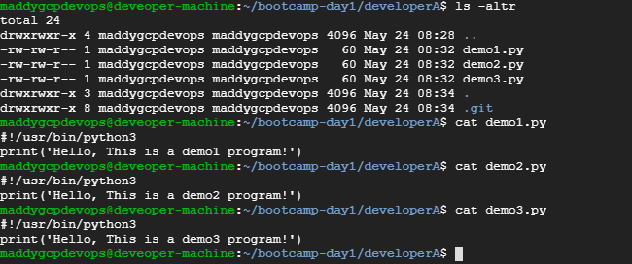

1. Add all the 3 files into staging area and commit it in the local repository

* I have used **git init** to initialize the git and configured with my email and user names.
* Added the files to staging area with **git add .**
* Committed with comments as **“First commit’**

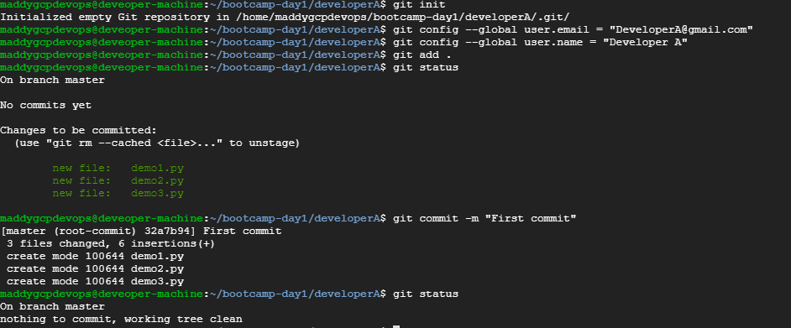

1. Create a remote repository.

* I have created a git repository named as 915972_bootcamp10 in my login.

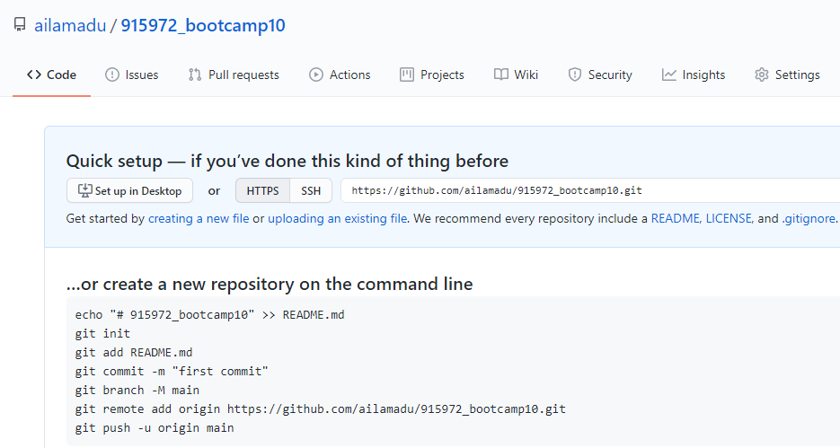

1. Add the remote repository to the local repository and push the changes to the remote repository from local repository

* I have added remote repository to local repository with **git remote add origin** [**https://github.com/ailamadu/915972_bootcamp10.git**](https://github.com/ailamadu/915972_bootcamp10.git)
* Pushed the content to remote repository with **git push origin master**. I have provided my credentials while it asked for.

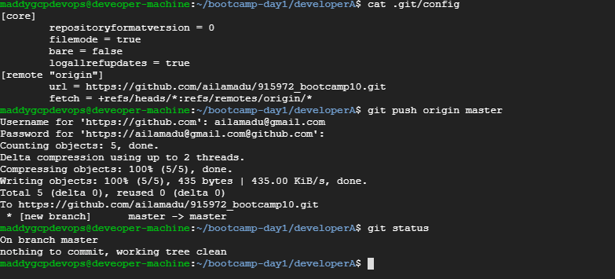

* This is the evidence that content has been pushed to remote repository.

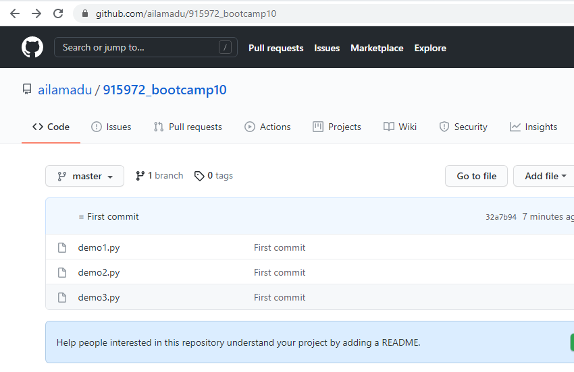

1. Clone the remote repository to another folder developerB.

* As part of this, I have copied the remote repository URL and used got clone using **git cone <URL>** to clone to the local .

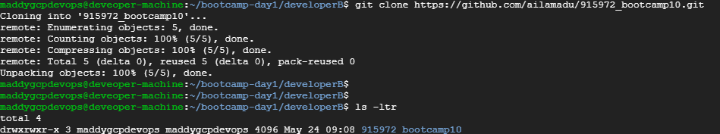

1. Make and commit the changes via developer B and synchronize the changes in developer A repository

* I have added an extra line “# This is not edited by developerB”
* I have committed the changes with message “changed by developerB”
* After committing, I have pushed the code to remote with “**git push origin master**”
* In DeveloperA, I have pulled these changes with “**git pull origin master**” command

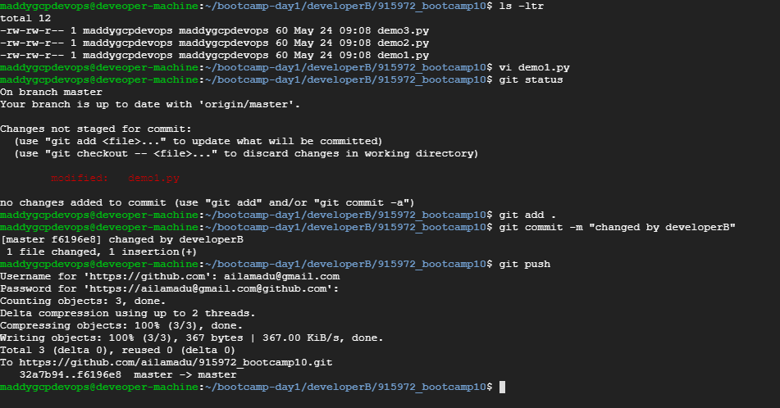

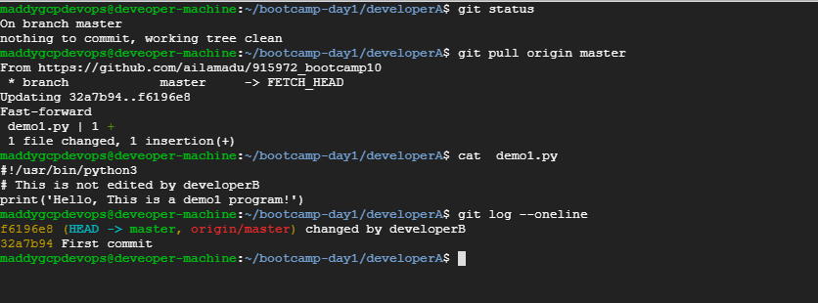

1. Create a new branch for a new feature you want to add to the application(say feature1) and change the files.

* I have created a new branch called feature1 with the command “git branch feature1” and switched to branch with “git checkout feature1”
* I have changed the file demo2.py by adding “print("This file is ediated as part of feature development")” line.
* I have added to staging and committed with message “new feature development”

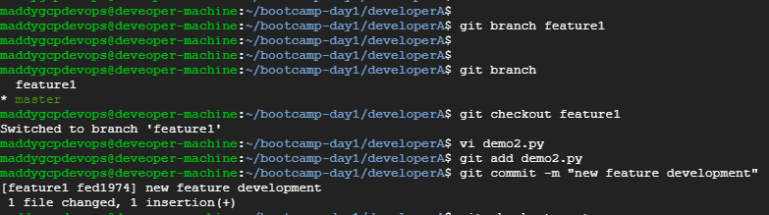

1. Merge back the created branch with the master branch

* As I already committed the code, I have now switched to master branch with “**git checkout master**” and merge the branch with master with the command “**git merge feature1**”

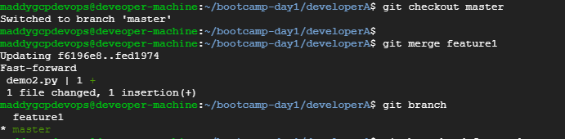

1. Delete the feature1 branch after merging.

* After merging the code, I have used the git branch -d feature1 to delete the branch.
* Though, it was not said to push the code to remote, I have finally pushed the modifying code to remote.

