Heart Disease Risk Prediction

An End-to-End MLOps Pipeline
Data acquisition → EDA → feature engineering → model training with MLflow tracking → automated testing → CI/CD → containerized FastAPI service → Kubernetes deployment → Prometheus/Grafana monitoring.
Repository: https://github.com/ailearnharim-agent/mlops-e2e
MLOps Experimental Learning Assignment — Final Report

1. Executive Summary
This project builds a binary classifier that predicts the presence of heart disease from patient clinical features, and wraps it in a production-style MLOps pipeline: reproducible data acquisition, exploratory data analysis, feature engineering, multi-model training with experiment tracking, automated testing, CI/CD, containerization, Kubernetes deployment, and monitoring. The modelling itself is intentionally simple (classical scikit-learn classifiers on a small tabular dataset) — the emphasis of this assignment is the pipeline and automation around the model, not squeezing out state-of-the-art accuracy.
Personalization: rather than the widely-used 303-row Cleveland-only subset of the UCI Heart Disease dataset, this project combines all four original collection sites (Cleveland, Hungary, Switzerland, VA Long Beach — 920 rows), which has real, site-correlated missingness that the clean subset does not. This drove genuine preprocessing and EDA decisions rather than a token clean-data pass.

What was verified end-to-end (not just written)
- Data download, preprocessing, and training run from a clean checkout.
- 17 automated tests pass; ruff/black lint and format checks pass.
- Docker image built and run locally; /health and /predict verified with curl.
- Full monitoring stack (API + Prometheus + Grafana) run via docker-compose, with live traffic populating a Grafana dashboard.
- Deployed to a real local Kubernetes cluster (minikube) via Helm: 2/2 pods Running, Service/Ingress/HPA created, /health and /predict verified through the cluster.

2. Setup & Installation
All commands below run from a clean checkout with only Python 3.9 and pip available; no manually-downloaded files are required.
python3 -m venv .venv && source .venv/bin/activate
pip install -r requirements-dev.txt
python data/download_data.py # -> data/raw/heart_disease_raw.csv
python -m src.data.preprocess # -> data/processed/heart_disease_processed.csv
python -m src.models.train # trains 3 models, logs to MLflow, saves models/model.pkl

Run the API locally:
uvicorn src.api.main:app --host 0.0.0.0 --port 8000

Run tests / lint (identical to what CI runs):
ruff check src tests data && black --check src tests data && pytest -v --cov=src

3. Dataset & Exploratory Data Analysis

3.1 Dataset choice and acquisition
Source: UCI Machine Learning Repository, “Heart Disease” dataset (id=45). data/download_data.py fetches the official ZIP archive (archive.ics.uci.edu) and concatenates all four processed site files — processed.cleveland.data, processed.hungarian.data, processed.switzerland.data, processed.va.data — into a single 920-row raw CSV. Target is binarized: the original 0-4 severity scale becomes 0 (no disease) vs. 1 (any disease present).
14 columns: age, sex, cp, trestbps, chol, fbs, restecg, thalach, exang, oldpeak, slope, ca, thal, and the target.

3.2 Missingness
Because only Cleveland consistently recorded every field, three columns are substantially missing in the combined dataset: ca (66%), thal (53%), and slope (34%) — and the missingness is strongly correlated with collection site, not random. This is the key reason for choosing the combined dataset over the clean subset: it forces real handling of missing data instead of a token pass.
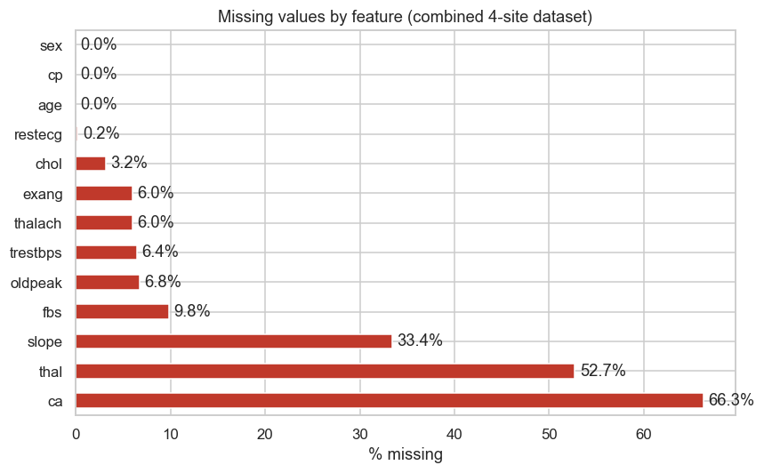
Figure 1. Missing data by feature across the combined 4-site dataset.
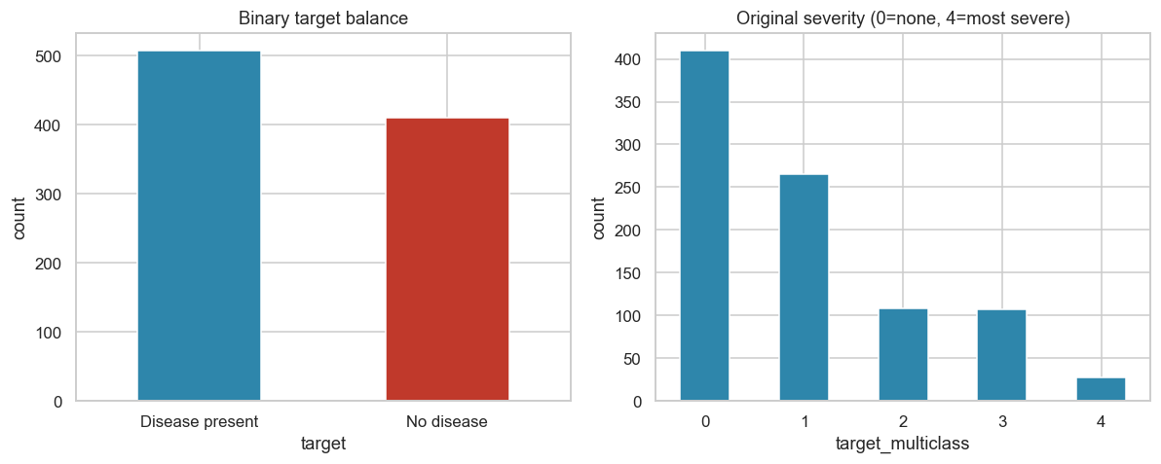
Figure 2. Binary target is reasonably balanced (~55% / 45%); no resampling needed.
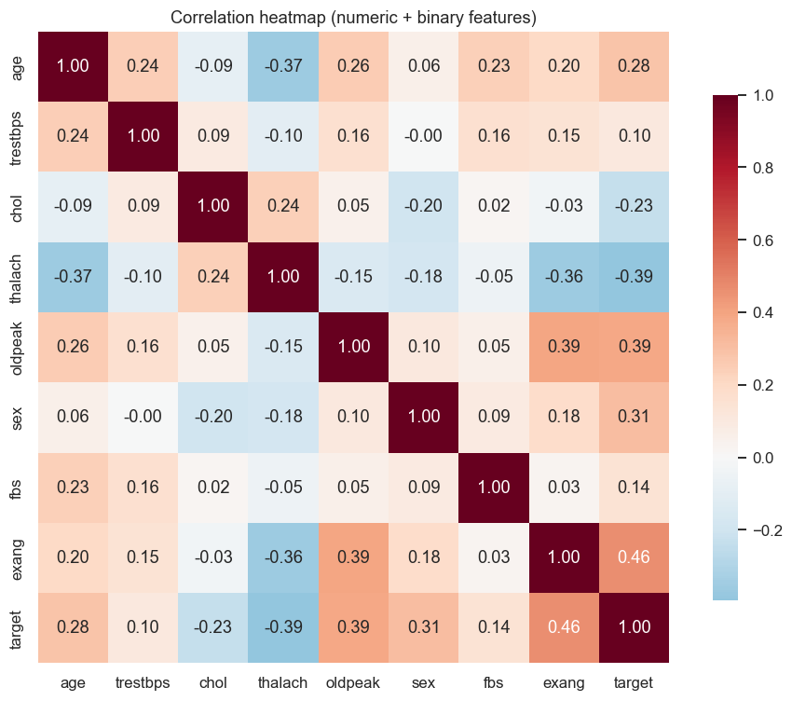
Figure 3. Correlation heatmap — thalach negatively correlated with disease; oldpeak, exang, sex, age positively correlated, consistent with clinical literature.

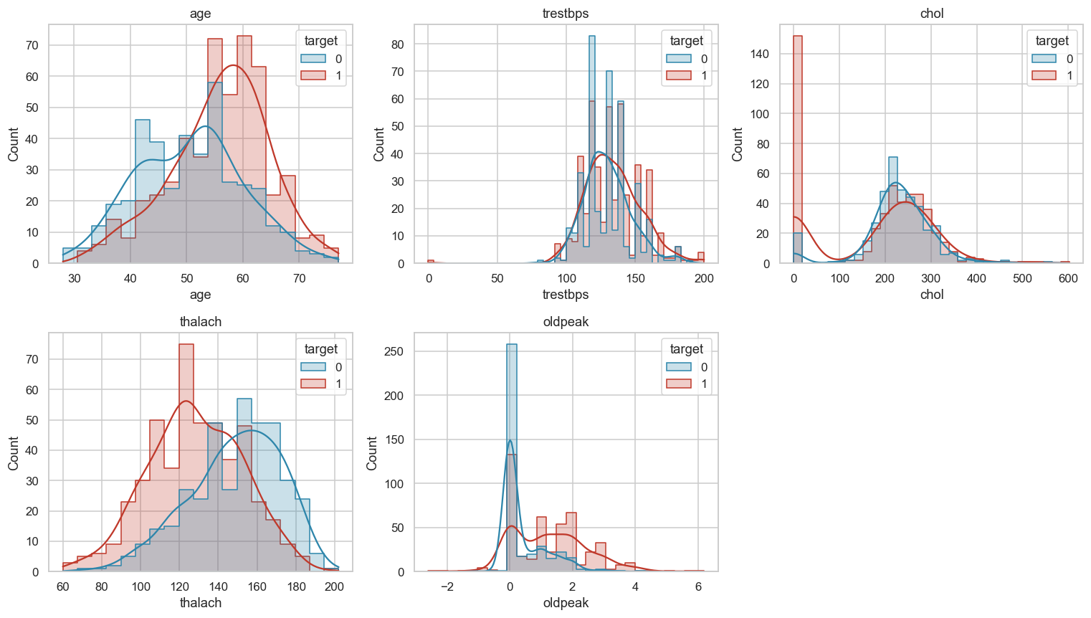
Figure 4. Numeric feature distributions split by target class.
Full analysis with additional plots (boxplots, categorical breakdowns) is in notebooks/01_eda.ipynb, executed in-place so every output is viewable without rerunning.

4. Feature Engineering & Model Development

4.1 Preprocessing pipeline
Implemented as a scikit-learn ColumnTransformer (src/data/preprocess.py), composed into the model Pipeline and fit only on the training split to avoid leakage:
- Numeric (age, trestbps, chol, thalach, oldpeak): median imputation + standard scaling.
- Categorical (cp, restecg, slope, ca, thal): constant sentinel (-1) imputation + one-hot encoding — chosen over mode imputation because missingness here is large and site-correlated, so “not recorded” is itself informative rather than noise to be papered over.
- Binary (sex, fbs, exang): mode imputation, passed through as-is.

4.2 Models & tuning
Three classifiers, each wrapped with the same preprocessing pipeline, tuned via GridSearchCV over RepeatedStratifiedKFold (5 splits × 2 repeats), scored on ROC-AUC: Logistic Regression, Random Forest, and HistGradientBoosting (a third model beyond the required two, chosen for a stronger comparison without an extra native-compiled dependency like XGBoost).
Held-out test set results (20% stratified split, never touched by cross-validation):
Model | Accuracy | Precision | Recall | F1 | ROC-AUC | CV ROC-AUC
Logistic Regression | 0.853 | 0.832 | 0.922 | 0.874 | 0.928 | 0.887
Random Forest | 0.837 | 0.827 | 0.892 | 0.858 | 0.928 | 0.890
HistGradientBoosting (selected) | 0.859 | 0.845 | 0.912 | 0.877 | 0.929 | 0.884

HistGradientBoosting was selected by best held-out ROC-AUC and refit on the full dataset with its tuned hyperparameters for the deployed artifact; the table above reports the honest held-out metrics, not the full-data refit (which has no held-out set by construction).

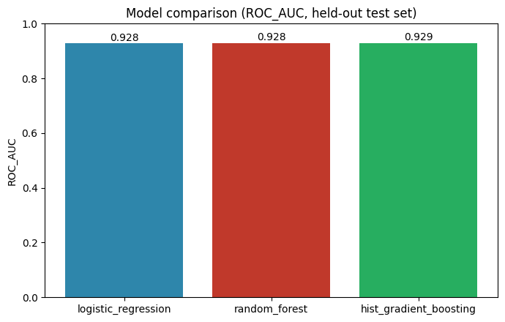
Figure 5. Held-out ROC-AUC comparison across the three candidate models.
Selected model diagnostics (HistGradientBoosting):
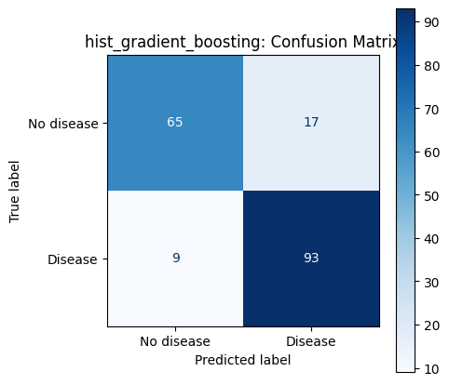 | 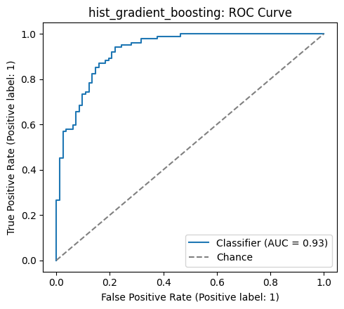
Figure 6. Confusion matrix and ROC curve for the selected (HistGradientBoosting) model on the held-out test set.

5. Experiment Tracking (MLflow)
Every GridSearchCV run (one per candidate model) and the final full-data refit are logged as separate MLflow runs under the heart-disease-classification experiment (local file store, mlruns/), each capturing:
- Parameters: model type and the GridSearchCV-selected hyperparameters.
- Metrics: CV best ROC-AUC and held-out test accuracy/precision/recall/F1/ROC-AUC.
- Artifacts: confusion matrix, ROC curve, and precision-recall curve plots.
- Model: the fitted end-to-end sklearn Pipeline via mlflow.sklearn.log_model, which also captures an inferred signature and conda environment for reproducibility.
Browse locally with:
mlflow ui --backend-store-uri file:./mlruns

6. Model Packaging & Reproducibility
- Final model saved twice: as an MLflow-logged Pipeline (mlruns/, includes signature + environment) and as a plain joblib pickle (models/model.pkl, checked into the repo) for a lightweight, MLflow-runtime-free load in the serving container.
- requirements.txt (full/training), requirements-api.txt (minimal serving-only subset), and requirements-dev.txt (+ pytest/ruff/black/jupyter) are all pinned to exact versions.
- The preprocessing ColumnTransformer is part of the saved Pipeline object itself — there is no separate transformer to lose track of; loading models/model.pkl reproduces cleaning, imputation, encoding, and scaling identically to training time.

7. CI/CD Pipeline & Automated Testing

7.1 Tests
17 pytest tests across three files: preprocessing (no-NaN guarantees after transform, dedup, correct target binarization, columns that are entirely missing in a batch), training (pipeline fit/predict shapes, metric computation correctness), and the API (FastAPI TestClient — valid/partial/invalid payloads, correct status codes, /metrics exposition). A small 40-row fixture (tests/fixtures/sample_data.csv) keeps unit tests fast and network-free; the full download/train pipeline is exercised separately in CI.

7.2 GitHub Actions (.github/workflows/ci-cd.yml)
Three sequential jobs, each blocking the next — any lint/test/training/build failure fails the pipeline with no continue-on-error anywhere:
- lint-and-test: ruff, black --check, pytest with coverage + JUnit XML artifacts.
- train: downloads data, preprocesses, and trains all three models on the runner itself (not just replaying committed artifacts) — proving the pipeline is reproducible from a clean checkout. Uploads model.pkl, mlruns/, and comparison plots as workflow artifacts.
- docker-build-test: builds the image using the freshly-trained model from the previous job, runs the container, polls /health, smoke-tests /predict with a sample payload, and (on push to main) pushes the image to GHCR.

8. Model Containerization
docker/Dockerfile is a multi-stage build (python:3.9-slim): a builder stage installs the minimal requirements-api.txt into a venv, and the runtime stage copies just that venv + src/ + models/model.pkl, running as a non-root user with a container HEALTHCHECK. Verified locally end-to-end:
$ ./scripts/build_and_run_docker.sh
==> Building image heart-disease-api:local ... DONE
==> Running container ... API is healthy
$ curl http://localhost:8000/health
{"status":"ok","model_loaded":true}
$ curl -X POST http://localhost:8000/predict -d '{...sample patient...}'
{"prediction":0,"label":"No disease","confidence":0.7373,
"model_version":"HistGradientBoostingClassifier-1.0.0"}
Full logs: reports/screenshots/docker_build_run_proof.txt.

9. Production Deployment (Kubernetes)
Deployed to a real local Kubernetes cluster (minikube, docker driver) via the project's Helm chart (k8s/helm/heart-disease-api — raw manifests also provided under k8s/manifests/), run end-to-end via scripts/deploy_minikube.sh:
$ minikube start --driver=docker --cpus=2 --memory=4096 # Running
$ minikube addons enable ingress # enabled
$ docker build -f docker/Dockerfile -t heart-disease-api:local .
$ minikube image load heart-disease-api:local
$ helm upgrade --install heart-disease-api k8s/helm/heart-disease-api \
--set image.repository=heart-disease-api --set image.tag=local

$ kubectl get pods -n heart-disease-mlops
heart-disease-api-7c5758cf6f-2qd4d 1/1 Running 0 2m37s
heart-disease-api-7c5758cf6f-gtdkp 1/1 Running 0 2m37s

$ kubectl get svc,ingress,hpa -n heart-disease-mlops
service/heart-disease-api-svc ClusterIP 80/TCP
ingress.../heart-disease-api-ingress nginx heart-disease.local 192.168.49.2
horizontalpodautoscaler.../heart-disease-api-hpa cpu:<unknown>/70% 2 5 2

$ kubectl port-forward -n heart-disease-mlops svc/heart-disease-api-svc 8080:80
$ curl http://localhost:8080/health
{"status":"ok","model_loaded":true}
The Deployment carries readiness/liveness probes against /health and Prometheus scrape annotations; an HPA (2–5 replicas, 70% CPU target) and an nginx Ingress are also deployed. Full logs: reports/screenshots/kubernetes_deployment_proof.txt.

10. Monitoring & Logging
docker/docker-compose.yml wires the API with Prometheus (scraping /metrics every 5s) and Grafana (auto-provisioned datasource + a dashboard covering request rate, p95 latency, prediction-class mix, and HTTP status codes). Verified locally with live traffic:
$ docker compose up -d --build
$ curl http://localhost:9090/api/v1/targets
{"job": "heart-disease-api", "health": "up"}

$ curl -s http://localhost:8000/metrics | grep -E 'api_requests_total|predictions_total'
api_requests_total{endpoint="/predict",http_status="200",method="POST"} 43.0
api_requests_total{endpoint="/predict",http_status="422",method="POST"} 9.0
predictions_total{predicted_class="0"} 29.0
predictions_total{predicted_class="1"} 14.0
Every request is also logged as a single structured JSON line to stdout (src/api/logging_config.py), which is how container/Kubernetes log aggregation would consume it in this project's scope — no separate log-shipping agent. Full proof log: reports/screenshots/monitoring_stack_proof.txt.

11. Architecture
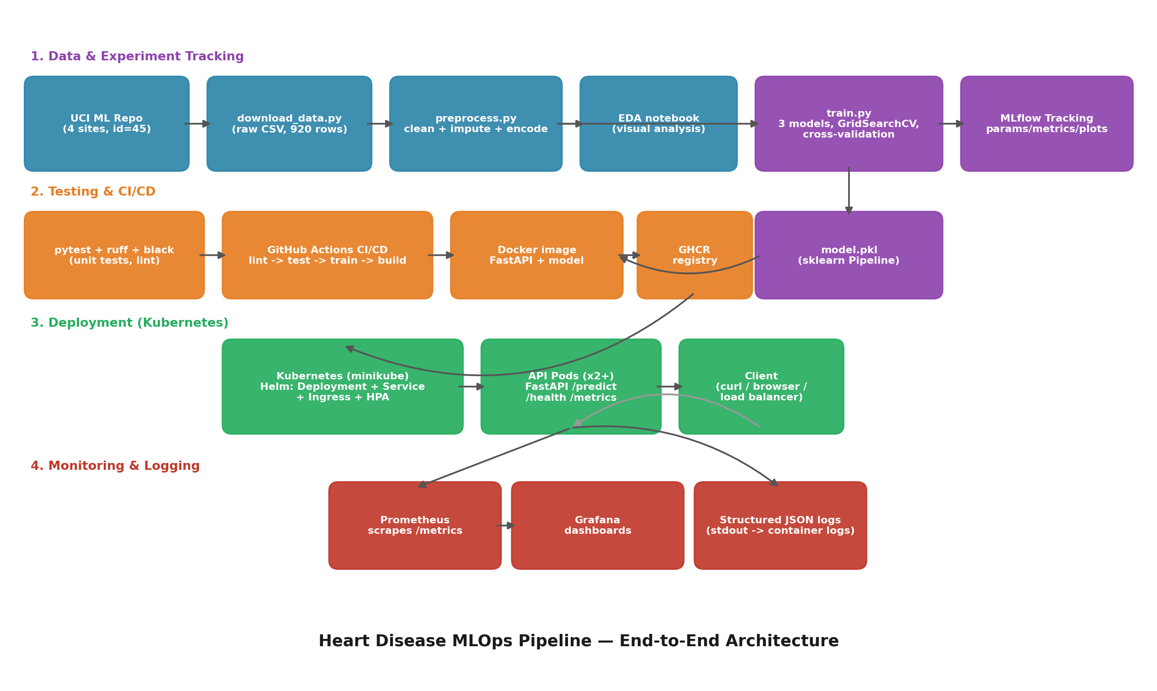
Figure 7. End-to-end architecture: data & experiment tracking → testing & CI/CD → Kubernetes deployment → monitoring & logging.

12. Conclusion & Deliverables
All assignment deliverables are present in the repository:
- Code, Dockerfile(s), requirements.txt / requirements-api.txt / requirements-dev.txt
- Download script (data/download_data.py) — no manually-shipped raw dataset
- Notebooks/scripts for EDA (notebooks/01_eda.ipynb), training (src/models/train.py), and inference (src/models/predict.py)
- tests/ with 17 automated unit tests
- GitHub Actions workflow (.github/workflows/ci-cd.yml)
- Deployment manifests (k8s/manifests/) and a Helm chart (k8s/helm/heart-disease-api/)
- Screenshot/proof folder (reports/screenshots/)
- This report (reports/MLOps_Heart_Disease_Report.docx) and a video walkthrough script (VIDEO_SCRIPT.md)
Repository: https://github.com/ailearnharim-agent/mlops-e2e

