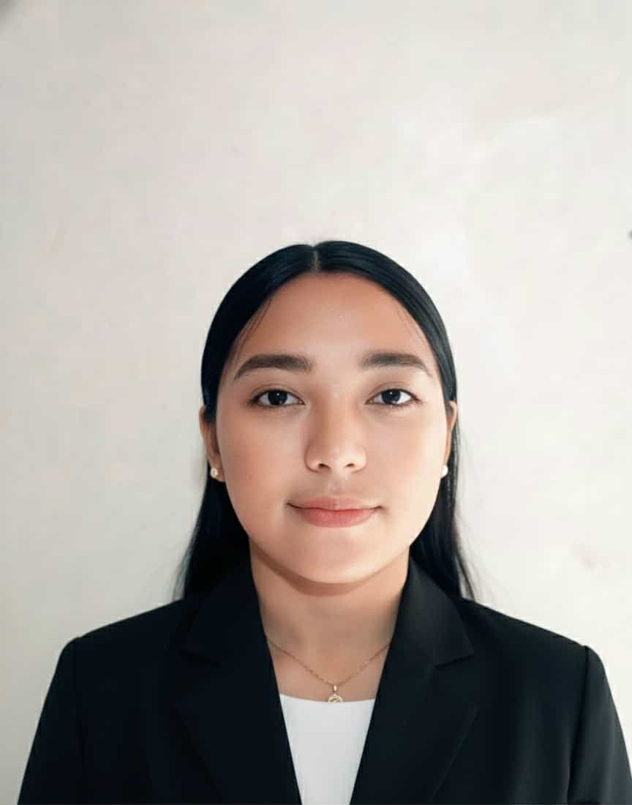

AILEEN T. LAGURA
Dagohoy, Bilar, Bohol
aileenlagura16@gmail.com
09945122977

OBJECTIVES:

PERSONAL BACKGROUND
Motivated Computer Science student seeking an On-the-Job Training (OJT) placement to apply academic training in programming and problem-solving within a professional tech environment. Eager to learn from experienced developers, contribute to real-world projects, and support team objectives while fulfilling academic requirements..
PERSONAL BACKGROUND

Nickname : “ai”
Age : 20 years old
Civil Status : Single
Birth Date : October 30, 2005
Residence : Bilar, Bohol
Religion : Roman Catholic
QUALITY AND STRENGTH

Relevant Coursework : Data Management, Web Development, Mobile App Development
Tools & Software : Microsoft Office Suite (Word, Excel, PowerPoint), Google Workspace (Docs, Sheets, Slides, Calendar, Meet), Zoom, Canva ,
Skills : Computer Literate, Communication Skills, Administrative Tasks, Time Management, Can work with less supervision, Eager to learn, Open-minded
EDUCATIONAL BACKGROUND

Tertiary : BOHOL ISLAND STATE UNIVERSITY- Bilar
Zamora, Bilar, Bohol
Bachelor of Science in Computer Science
S.Y. 2023 - Present

Secondary : BILAR NATIONAL HIGH SCHOOL
Yanaya, Bilar, Bohol
Strand: Computer Systems Servicing (CSS)
S.Y. 2022 - 2023

Elementary : DAGOHOY ELEMENTARY SCHOOL
Dagohoy, Bilar, Bohol
S. Y. 2016 - 2017
CHARACTER REFERENCES

Danie Baldesco
Class Adviser – BISU Bilar
Email : dbaldesco@yahoo.com
Phone Number: 09225032227

