UVM Template with Checker – Student Guide
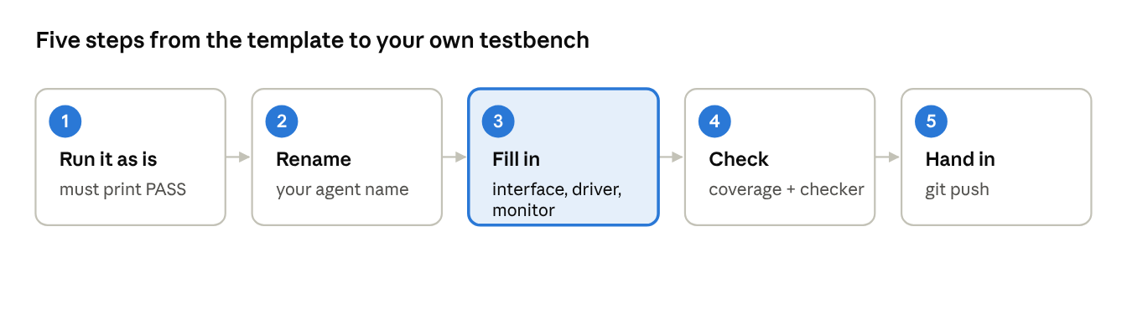
start here · the 5 steps of the lab

The template in 30 seconds
A working UVM testbench with 2 agents and a scoreboard, around a tiny DUT. You keep the structure and swap in your own DUT.
The DUT (my_dut):
irq_o = psel_i && penable_i && valid_i && (paddr_i == addr_i)
Agent | Drives | Interface
apb_agent | psel, penable, paddr | apb_interface_dut
rename_agent | valid, addr (and watches irq) | rename_interface_dut
rename is a placeholder: you replace it with your own interface name (fifo, uart, mem, …).

Architecture
The environment is a tree of components: top starts the test, the test builds the environment, and the environment builds two agents of the same shape and one scoreboard.
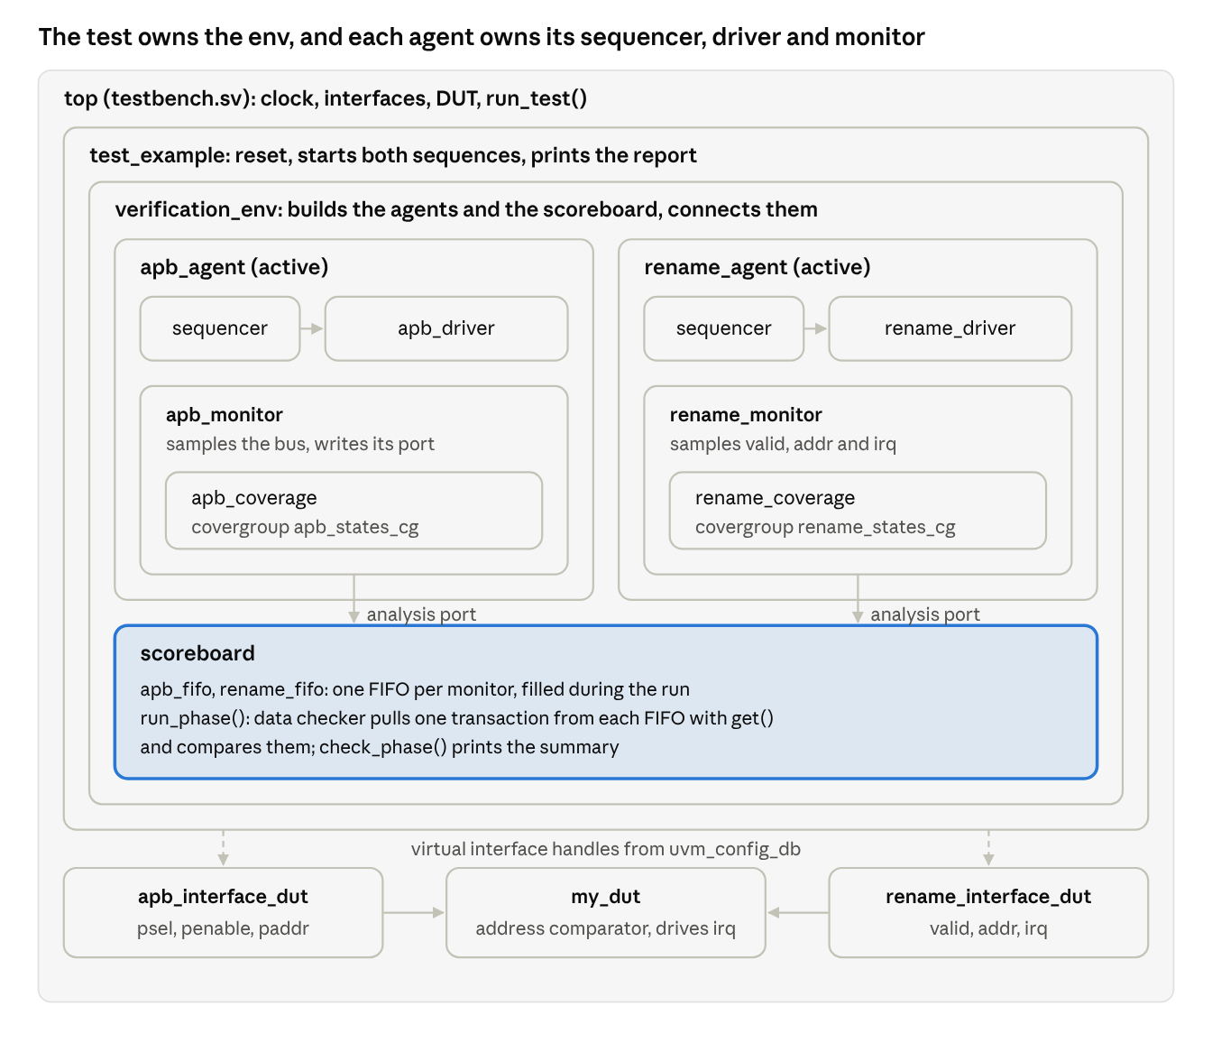
component hierarchy · top, test, env, 2 agents, scoreboard
Each agent's monitor feeds the scoreboard; drivers and monitors never touch the DUT directly, only its interfaces.

Data flow
A transaction travels as an object until the driver turns it into signals, and becomes an object again when the monitor reads those signals back.
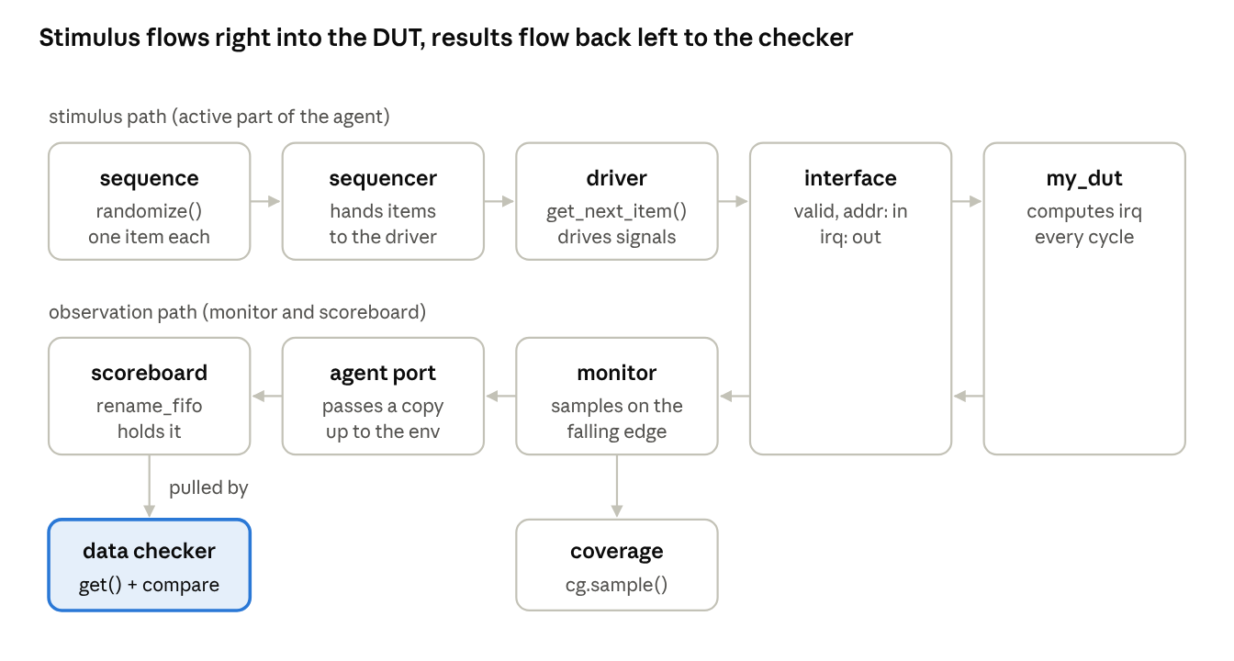
one transaction's path · rename agent shown, APB is identical
Top row: what you send in. Bottom row: what you check. The APB agent follows the same path into apb_fifo.

File map and include structure
The template uses `include chains instead of packages: testbench.sv includes the test, the test includes the environment, and so on down to each agent's files. You compile only testbench.sv.
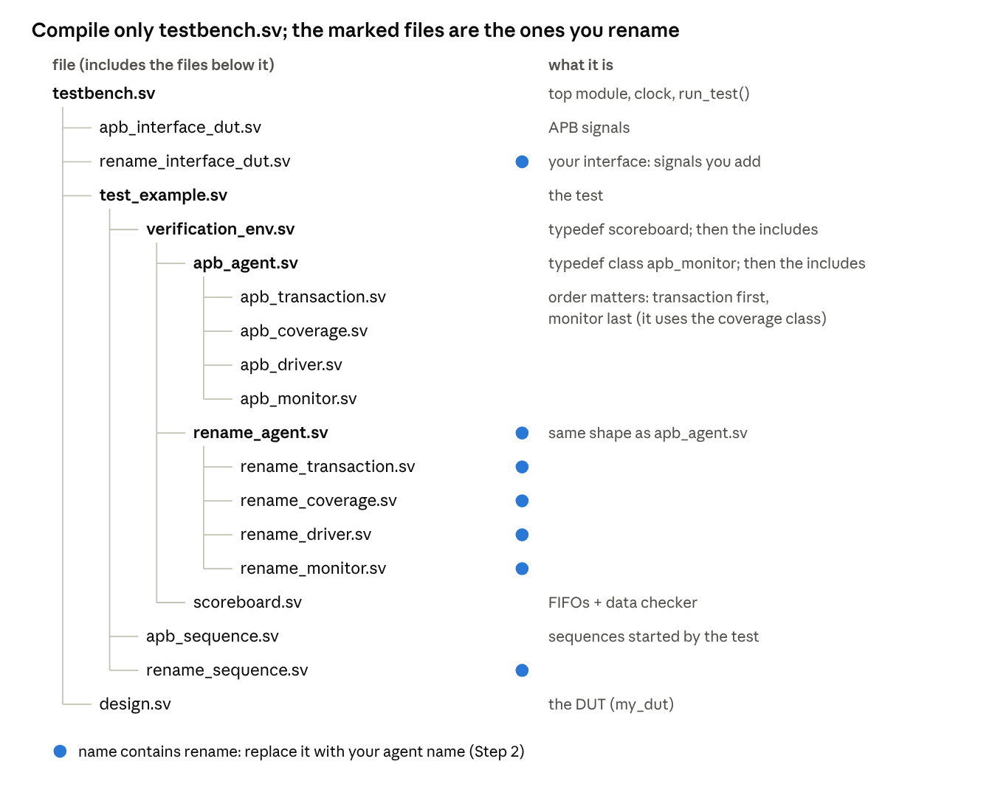
include tree · 19 files, testbench.sv at the root
- Each file has an `ifndef guard, so including it twice is harmless.
- typedef class apb_monitor; lets the monitor and its coverage class point at each other.
- New file? Include it from the file that uses it, after what it depends on.

What each file does
Component | File (rename agent) | Its job in one line
Transaction | rename_transaction.sv | The data of one transfer: rand for what you drive, plain for what the DUT outputs
Sequence | rename_sequence.sv | Creates and randomizes transactions: start_item → randomize() → finish_item
Driver | rename_driver.sv | Turns each transaction into signal values, cycle by cycle (send_transaction())
Monitor | rename_monitor.sv | Reads the signals back into a transaction and sends a copy on its port
Coverage | rename_coverage.sv | Covergroup sampled by the monitor after each transaction
Agent | rename_agent.sv | Builds driver + sequencer (if active) and monitor, connects them
Scoreboard | scoreboard.sv | One FIFO per agent + the data checker
Environment | verification_env.sv | Builds both agents and the scoreboard, connects them
Test | test_example.sv | Reset, starts both sequences in parallel, prints coverage and PASS/FAIL
Top | testbench.sv | Clock, interfaces, DUT, run_test()
The APB agent has the same files with the apb_ prefix.

The data checker
The test sends the same list of addresses on both interfaces, so both FIFOs must hold the same values in the same order.
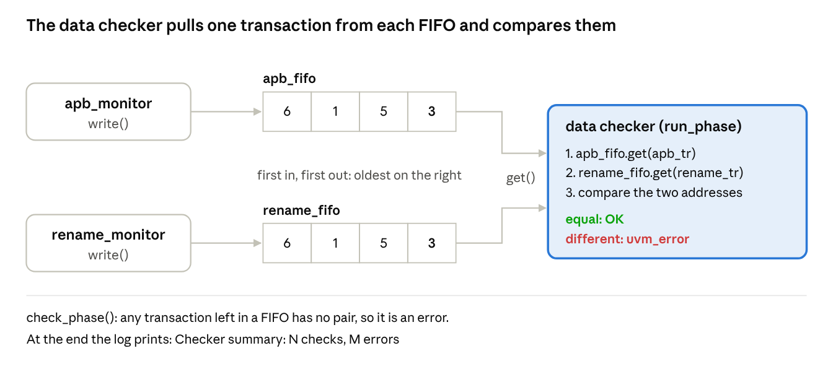
data checker · monitors → FIFOs → get() → compare
In your project, one FIFO holds what went into the DUT (expected) and the other what came out (actual).

Make it yours: 10 steps
Compile after every step. The examples use fifo as your agent name.
# | Do this | Where
1 | Run the template unchanged: it must print TEST PASS | —
2 | Replace rename with your agent name everywhere (commands below) | all files
3 | Put your DUT's signals in the interface; wire them in top; swap my_dut for your DUT | fifo_interface_dut.sv, testbench.sv
4 | One field per piece of data: rand for inputs, plain for outputs; add it to copy() and display_transaction_info() | fifo_transaction.sv
5 | Constrain the values to what your spec allows | fifo_sequence.sv
6 | Drive one transaction cycle by cycle, as the spec says | send_transaction() in fifo_driver.sv
7 | Sample on the falling edge when a transfer is valid; never drive a signal | fifo_monitor.sv
8 | Bins for min, max, thresholds and modes | fifo_coverage.sv
9 | One FIFO for what goes in, one for what comes out; compare them | scoreboard.sv
10 | Update reset, idle values, sequences and the coverage print | test_example.sv
Step 2 in two commands (Git Bash, inside your copy of the folder):
for f in *rename*; do git mv "$f" "${f//rename/fifo}"; done
sed -i 's/rename/fifo/g; s/RENAME/FIFO/g' *.sv
The interface name is a text key: spell "fifo_interface_dut" the same in testbench.sv, test_example.sv, the driver and the monitor, or they stop with uvm_fatal.

Checklist and common pitfalls
Before you hand in, every box below should be ticked.
- ☐ The unchanged template compiled and printed TEST PASS before you started.
- ☐ No file or identifier still contains rename (search the folder for it).
- ☐ The interface key string is identical in testbench.sv, the test, the driver and the monitor.
- ☐ Every transaction field appears in copy() and in display_transaction_info().
- ☐ Outputs of the DUT are not rand in the transaction.
- ☐ The driver follows the specification cycle by cycle; the monitor never drives a signal.
- ☐ Coverage bins span the full range the sequences generate, and the coverage report is above your target.
- ☐ The checker prints a summary with a non-zero number of checks.
- ☐ At least one run where you broke the DUT on purpose made the checker report an error.
Symptom | Likely cause | Fix
uvm_fatal “Could not access … interface” | Key string or set path differs between testbench, test and component | Make the four spellings identical (Step 3)
Scoreboard receives nothing | Agent port not connected in verification_env.sv, or monitor waits on the wrong condition | Check the connect() lines and the monitor's wait(…)
Fields arrive at the scoreboard as 0 | Field missing from copy() | Add it to copy()
Same transaction seen twice | Monitor samples a condition that stays true for two cycles | Wait one extra edge after sampling, or sample on a single-cycle event
Coverage 100% but values never generated | Bins narrower than the generated range | Widen the bins or add a bin per value
Test ends before traffic finishes | Objection dropped too early | Drop it only after the fork … join completes
TEST PASS but the DUT is wrong | Checker compares nothing, or pairs the wrong transactions | Check the summary's number of checks; test with a broken DUT
Don't copy blindly from test_example: its apply_reset() and the fixed #100 at the end fit my_dut only. Use your DUT's reset polarity (_n = active low).

How to run
Run the project in Vivado by following Vivado_User_Guide.docx (in the repository, next to this guide). It shows step by step how to create the project, add the simulation files, run the simulation and get the coverage report. Its last section lists what is specific to this template:
- add only testbench.sv as a simulation source; it includes every other file;
- set the simulation top module to top, not to the DUT;
- set xsim.simulate.runtime to -all, so the test runs until UVM ends it (the default stops after 1000 ns).
The default test is test_example. To run another test, add -testplusarg UVM_TESTNAME=<test_class_name> to xsim.simulate.xsim.more_options in the Simulation settings.
Without Vivado: the template also runs on EDA Playground with UVM 1.2 and a SystemVerilog simulator (e.g. Synopsys VCS or Cadence Xcelium). Put design.sv in the design pane and all other files in the testbench pane, then run.
Reading the result. At the end of the log, look for the checker summary (Checker summary: N checks, M errors), the error and warning count, and TEST PASS or TEST FAIL. The test fails on any UVM_ERROR, UVM_FATAL or UVM_WARNING.

Good to know
Short answers to the questions that come up every lab. Look at the picture first; read the text only if you need it.

Git in 7 commands
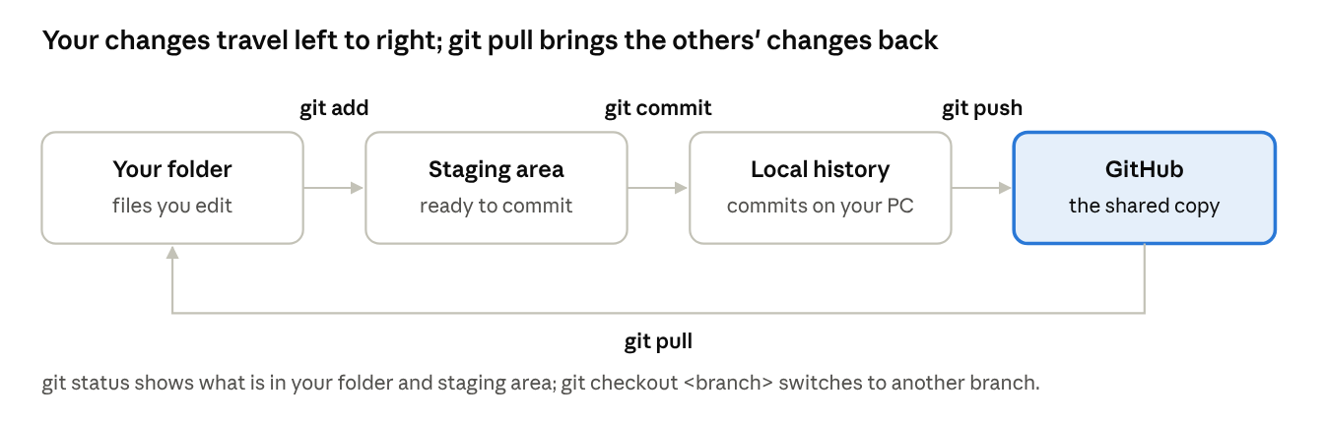
git in one picture · add, commit, push, pull, checkout
git pull # 1. get the latest version first
git checkout -b my-fifo-agent # 2. new branch for your work
git status # 3. see what you changed (run it often)
git add fifo_driver.sv # 4. choose what goes in the commit
git commit -m "Add fifo driver" # 5. save it in your history
git push origin my-fifo-agent # 6. send it to GitHub
git checkout main # 7. go back to the main branch
Never commit simulator output (xsim.dir/, *.log, *.jou, .Xil/): list it in a .gitignore file.

APB protocol
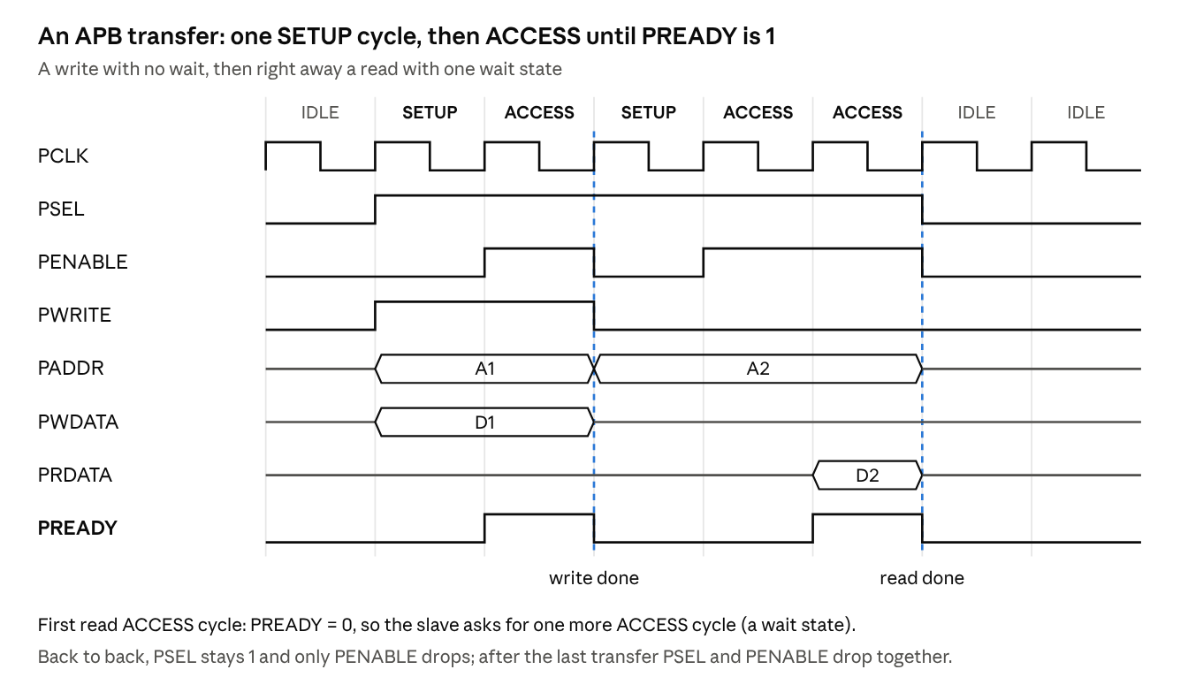
APB write and read · setup, access, wait state
Signal | From | Meaning
PSEL | master | this slave is selected
PENABLE | master | 0 = SETUP cycle, 1 = ACCESS cycle
PWRITE | master | 1 = write, 0 = read
PADDR, PWDATA | master | address and write data, stable from SETUP to the end
PRDATA | slave | read data, valid when PREADY = 1
PREADY | slave | 0 = wait, 1 = transfer done
The template's APB driver is simplified (no PWRITE, PWDATA, PREADY); completing it is part of the exercise.

Req/ack handshake
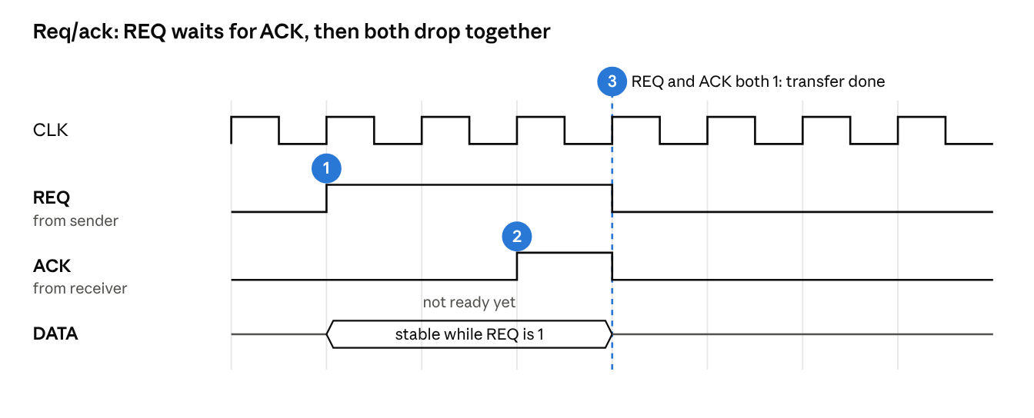
4-phase req/ack handshake · numbered steps
- Sender puts the data on the bus and raises REQ; the data stays stable while REQ is 1.
- Receiver raises ACK when it is ready (it may take a few cycles).
- On the clock edge where REQ and ACK are both 1, the transfer is done: both drop together.
In a testbench: the driver plays the sender, and the monitor counts one transaction on each edge where REQ and ACK are both 1.

Debugging a failing test
- Read the first error, not the last. Later errors are usually caused by the first one.
- uvm_fatal about an interface → the uvm_config_db key strings do not match (see Step 3).
- More detail in the log → add +UVM_VERBOSITY=UVM_HIGH (in Vivado: -testplusarg UVM_VERBOSITY=UVM_HIGH).
- Look at the waveform → in Vivado, the signals of top show what the driver really drove.
- Not sure the env is built right → uvm_top.print_topology() (already called in test_example) prints the component tree.

SystemVerilog traps
Trap | Do this instead
= on a clock edge in RTL | <= (non-blocking) for flip-flops
== with X or Z values | === when X/Z must count as different
Sending the same object twice | Send a copy(), never the handle you keep reusing
Forgetting phase.raise_objection() | The test ends at time 0
Dropping the objection too early | Drop it after the fork … join
randomize() result ignored | Wrap it: assert (req.randomize());

