Vivado User Guide

Start by creating a project

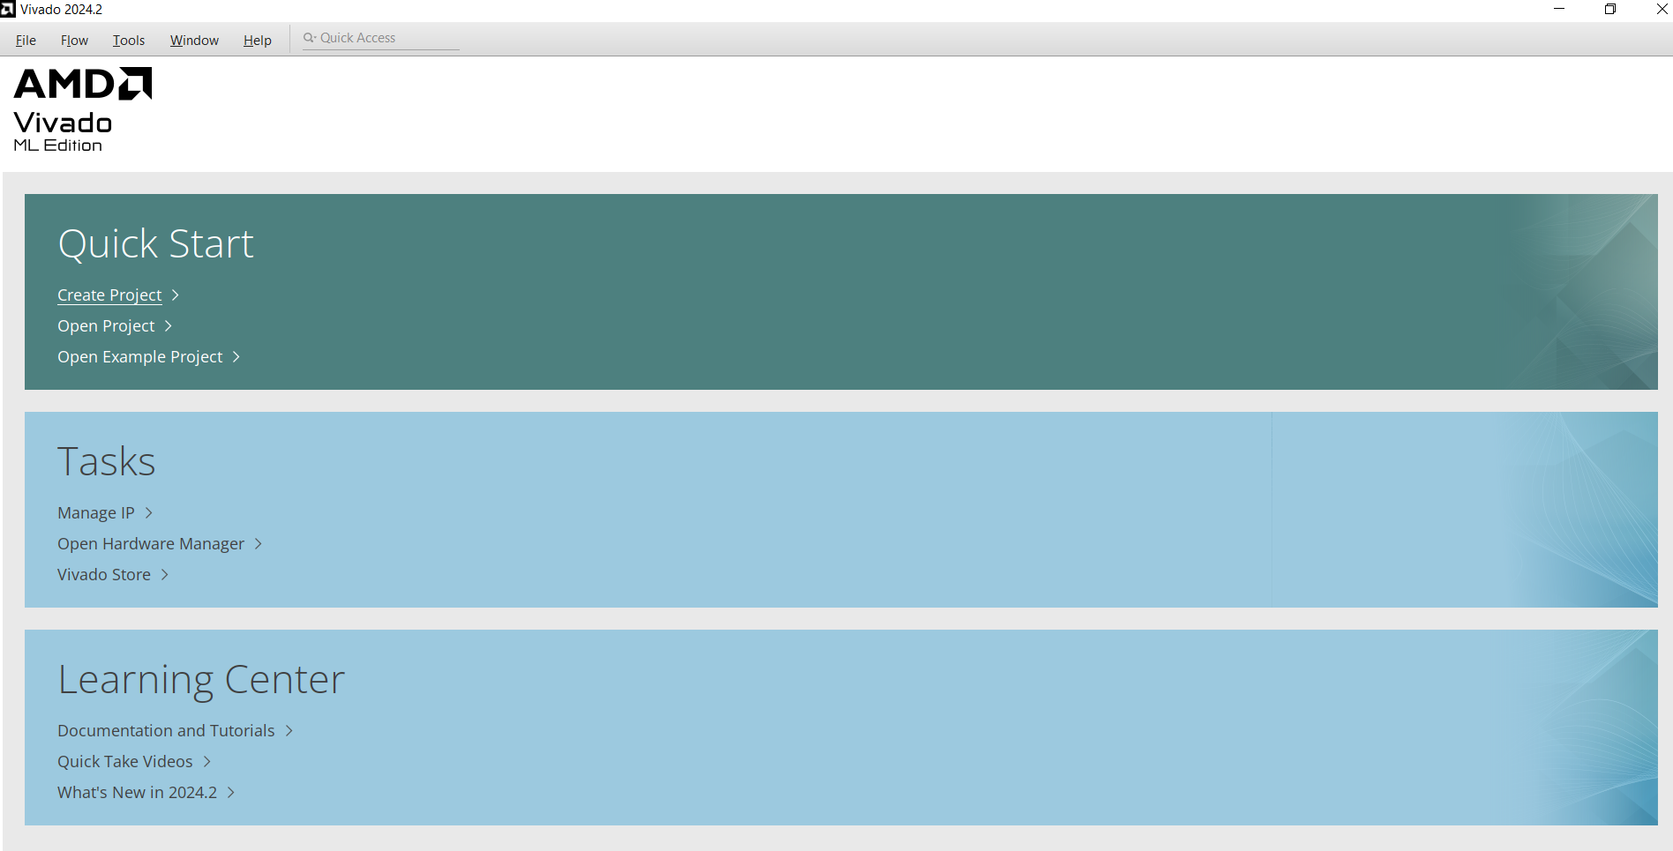
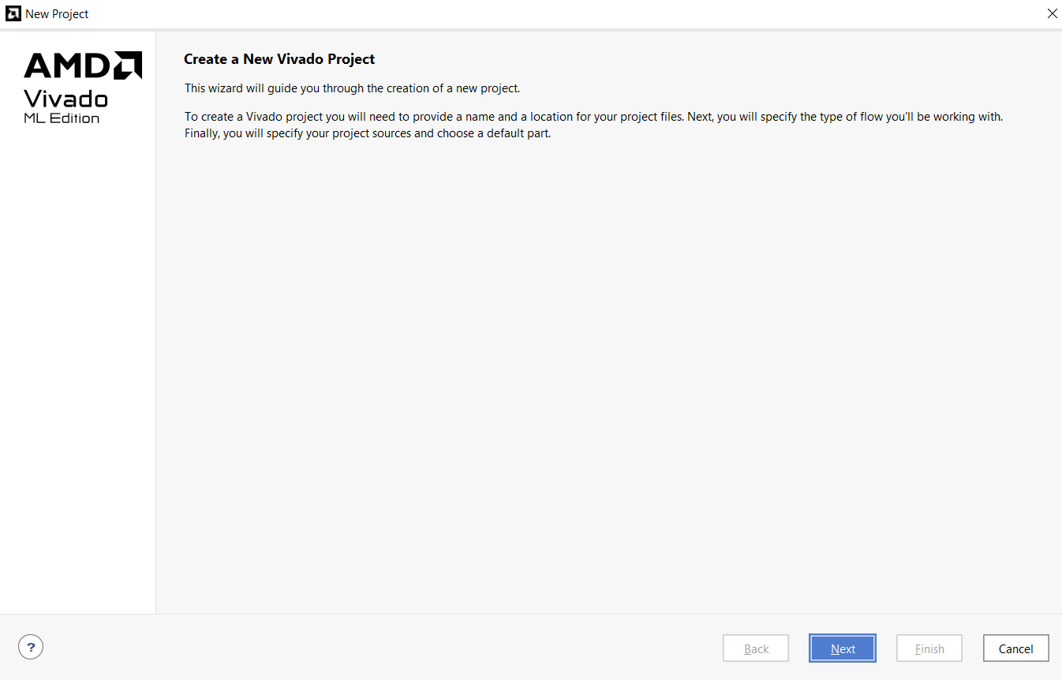

Choose where to save the project and a name for it

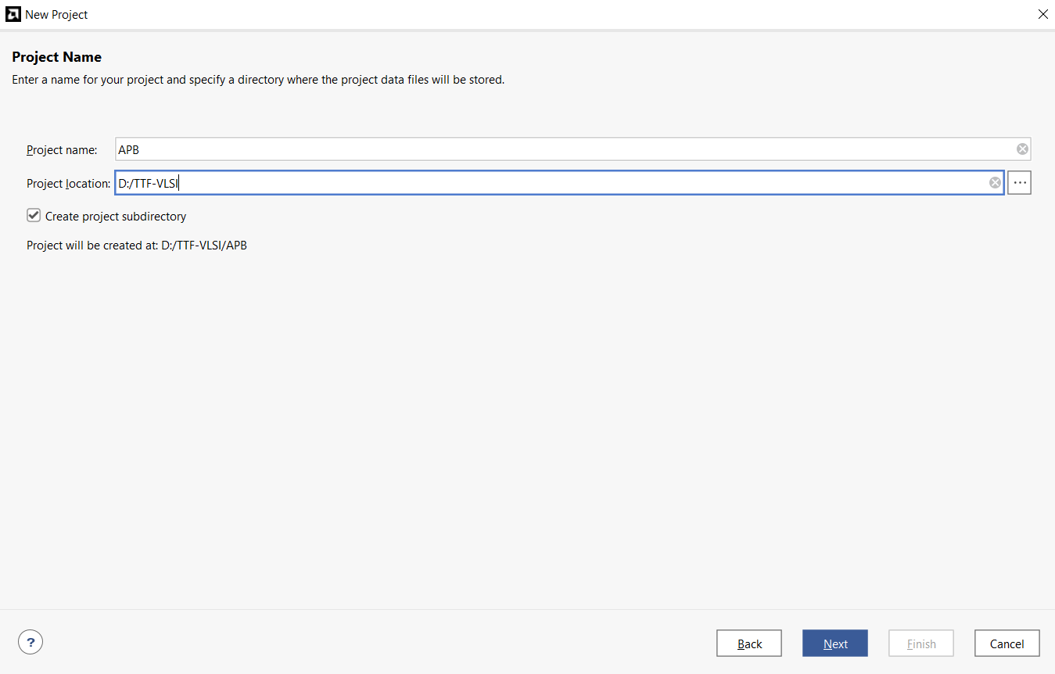
The project type must be RTL Project
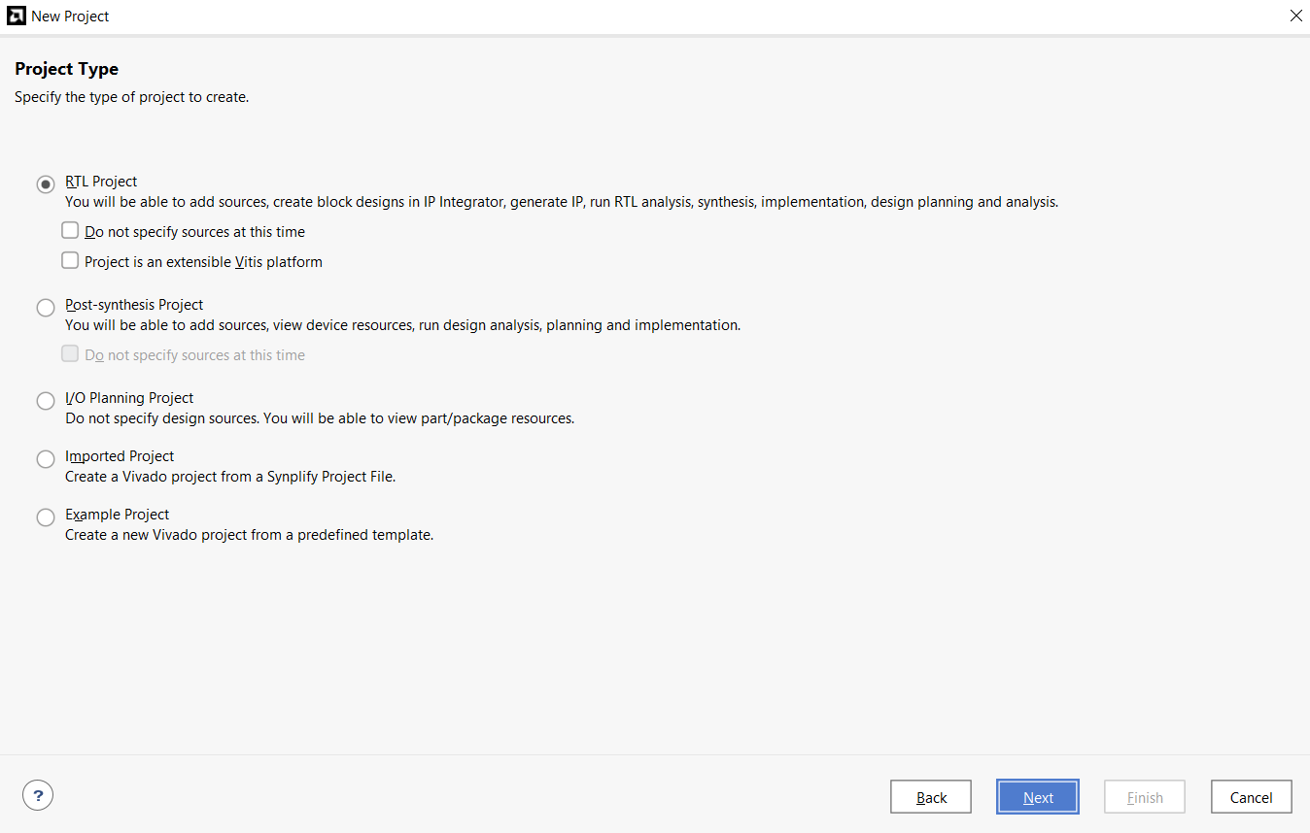

You can add the RTL files now or after the project is created. We will add the RTL files now.
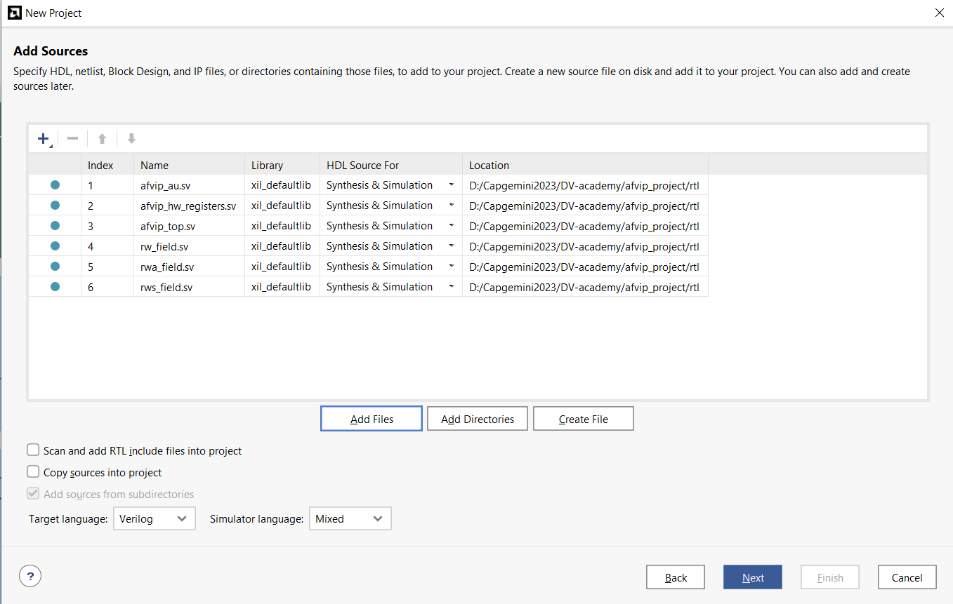
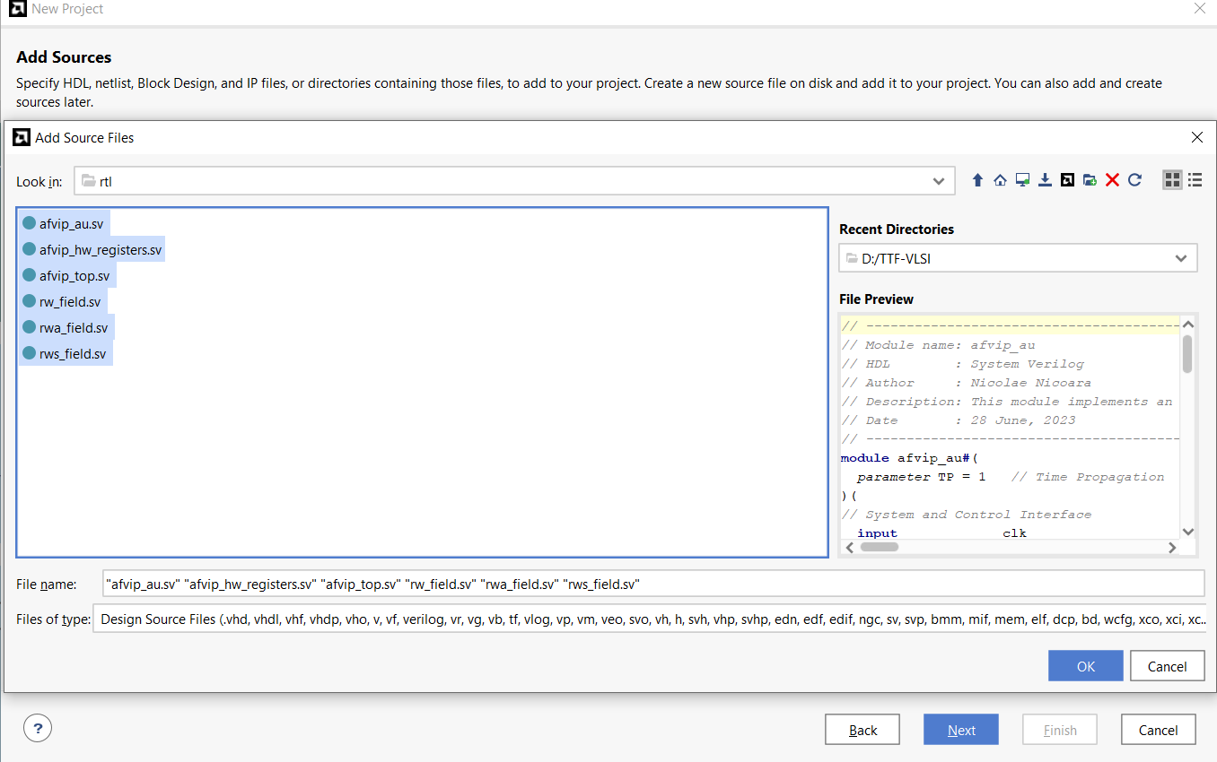

Skip the Add Constraints step
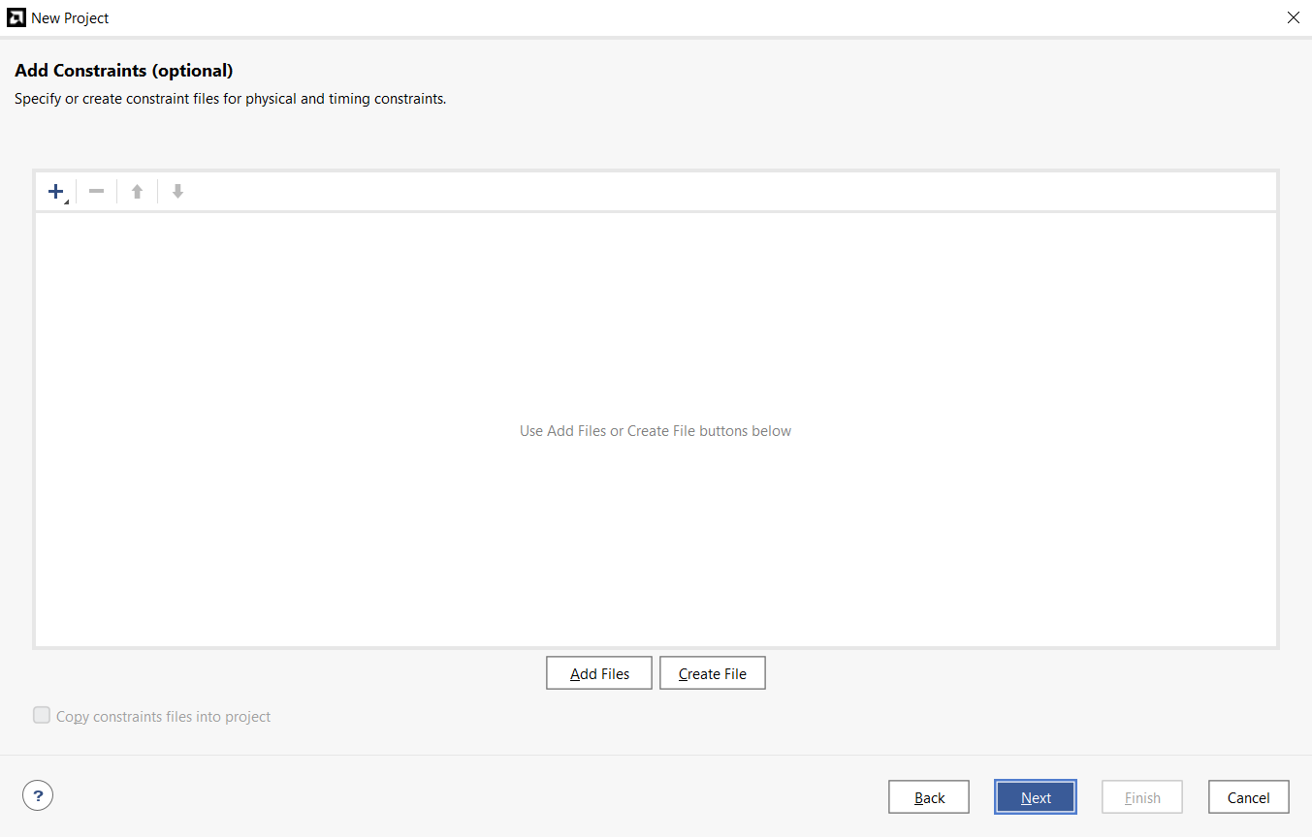

At this step select Boards and choose the first one (this step can also be skipped without selecting a board ☺)
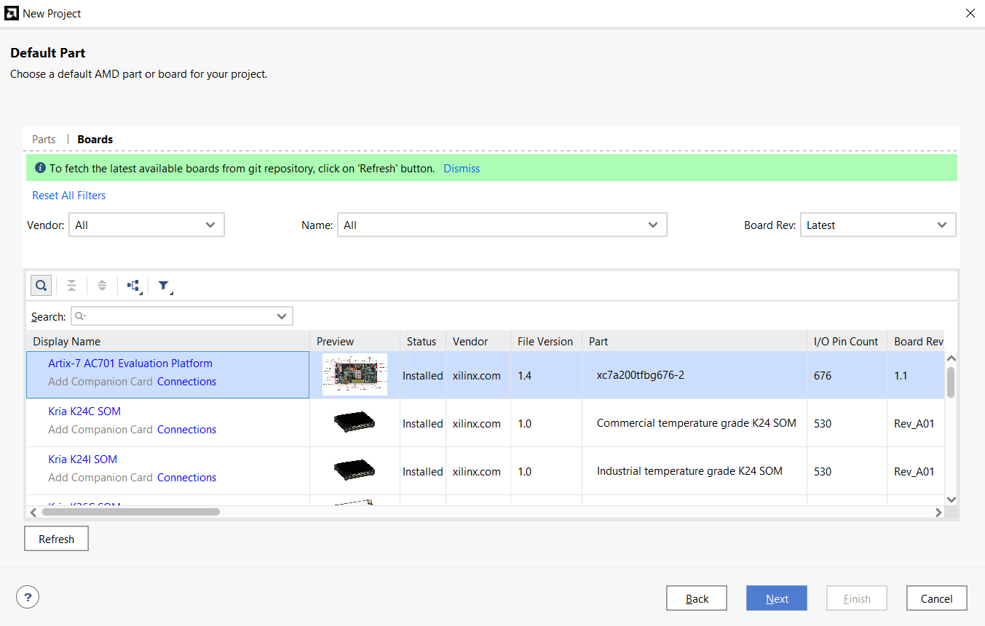

Add the verification files (.sv etc.): select Simulation sources and click +
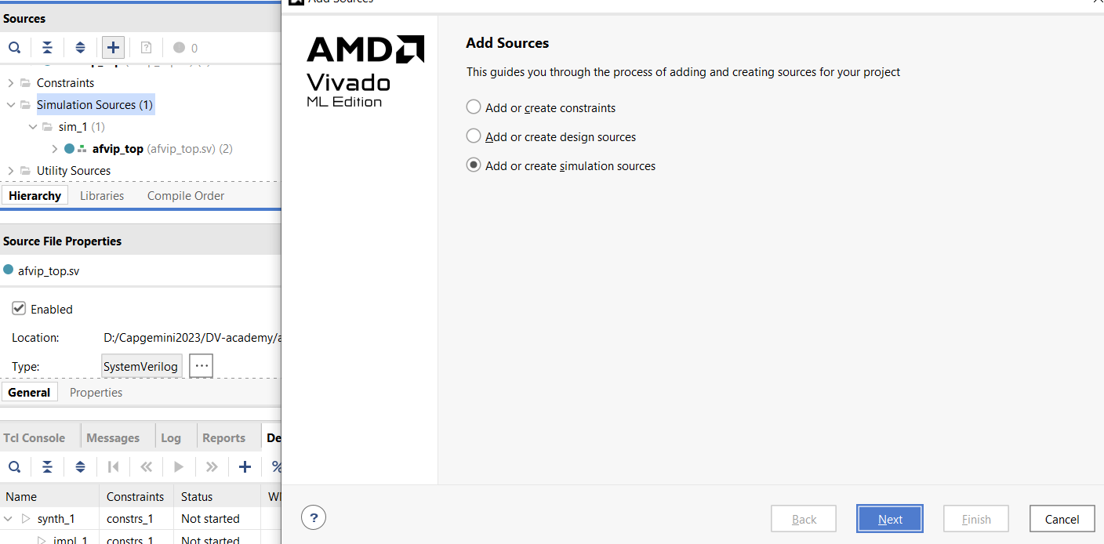

Load the files
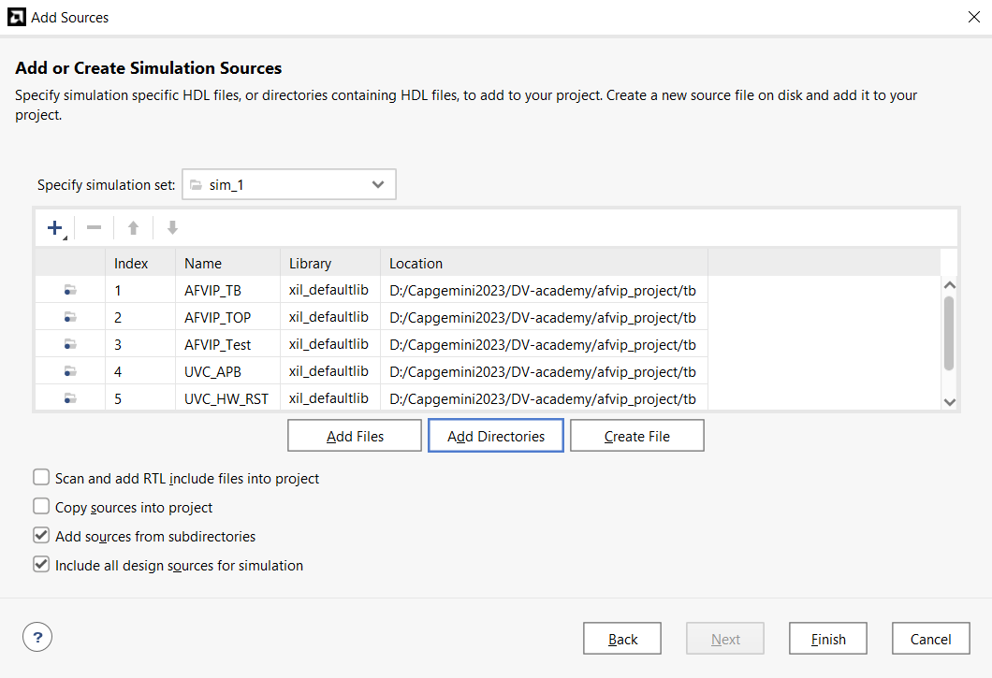

Run a simulation by selecting Run Simulation
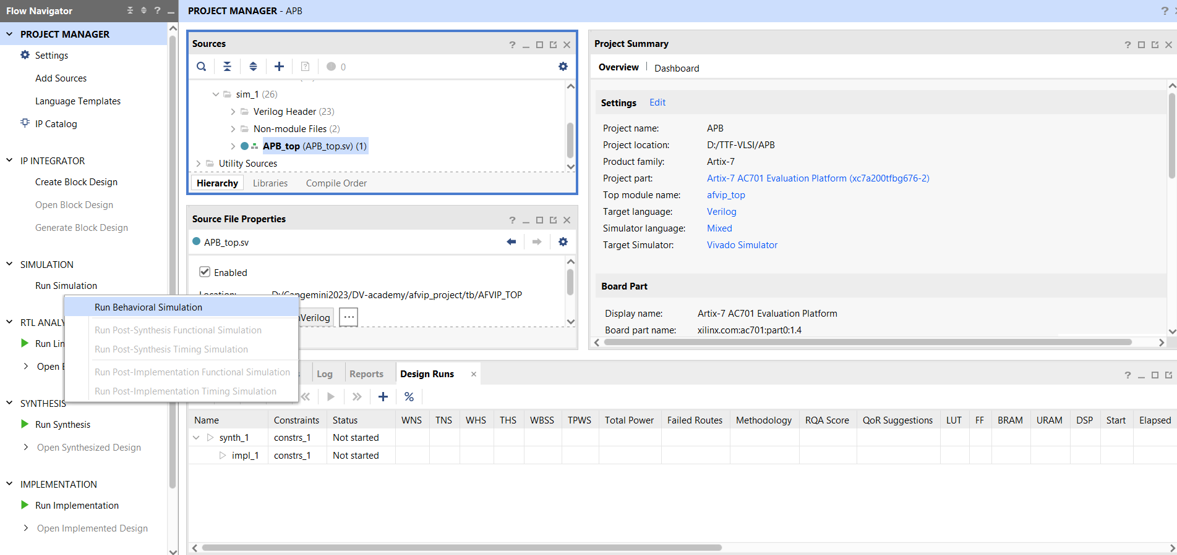
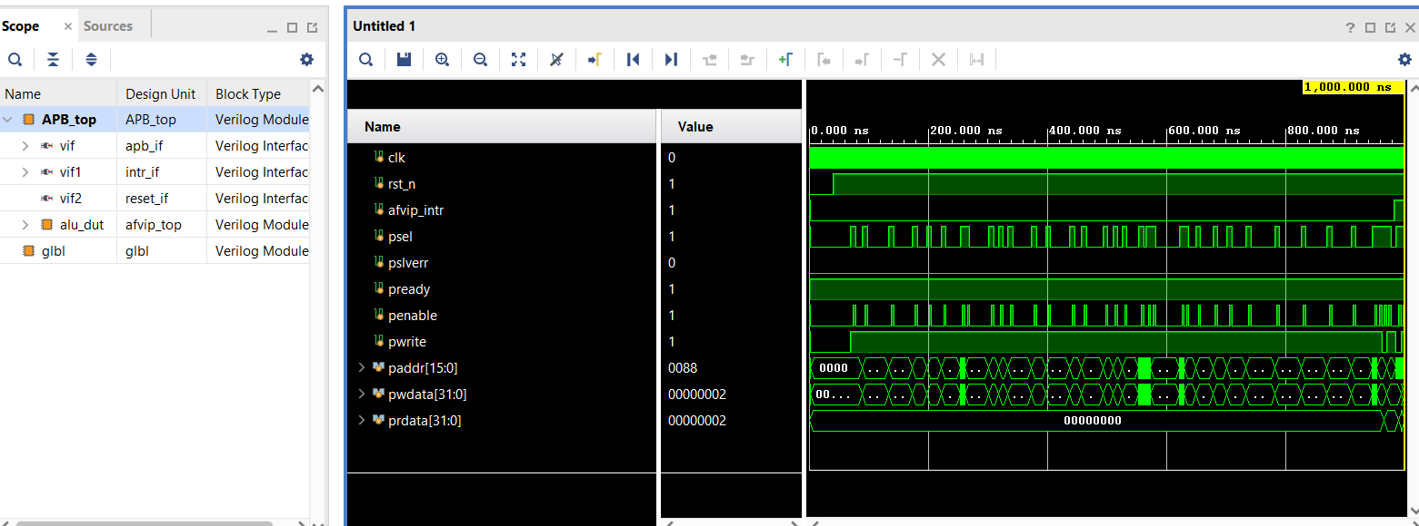

To collect coverage, open the settings from Edit -> Settings and fill them in as shown in the images.
The values to set:
Compilation tab: xsim.compile.xvlog.more_options = -L uvm
Elaboration tab: xsim.elaborate.xelab.more_options = -L uvm
Elaboration tab: xsim.elaborate.coverage.name = cov_report, xsim.elaborate.coverage.dir = ./, xsim.elaborate.coverage.type = sbct (all coverage types)

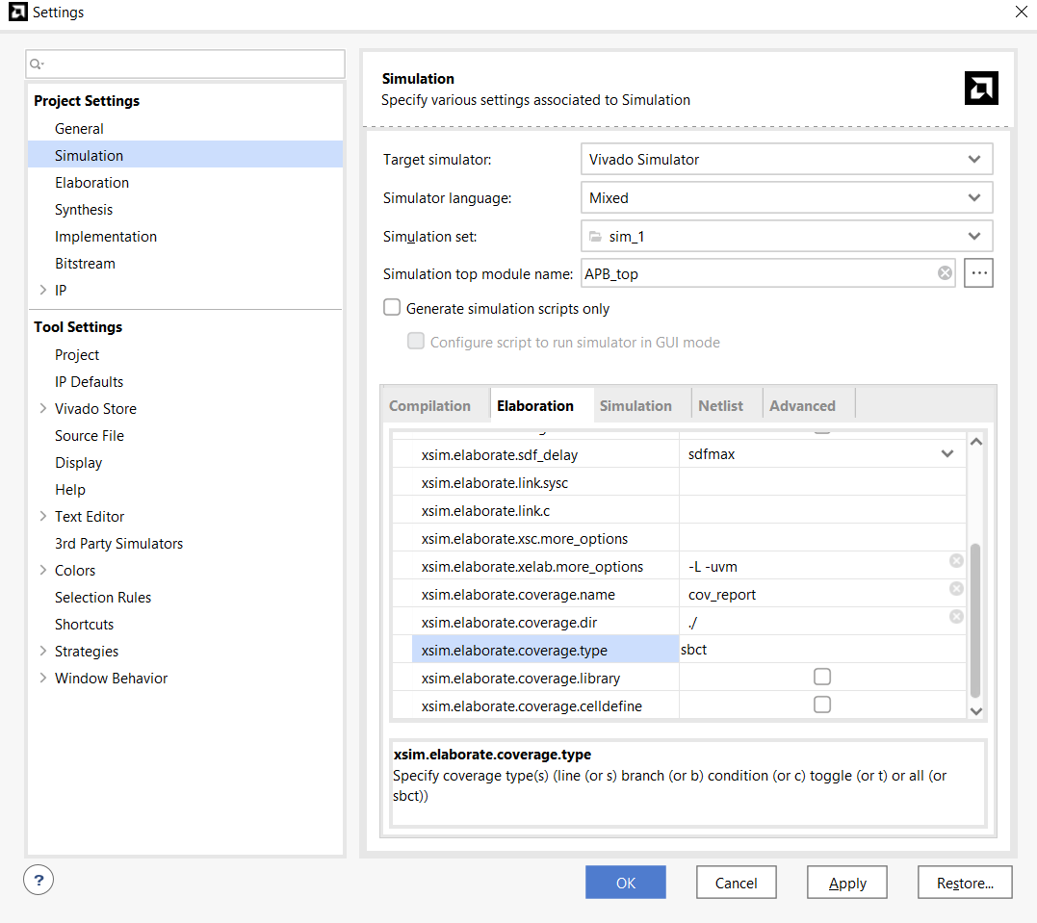
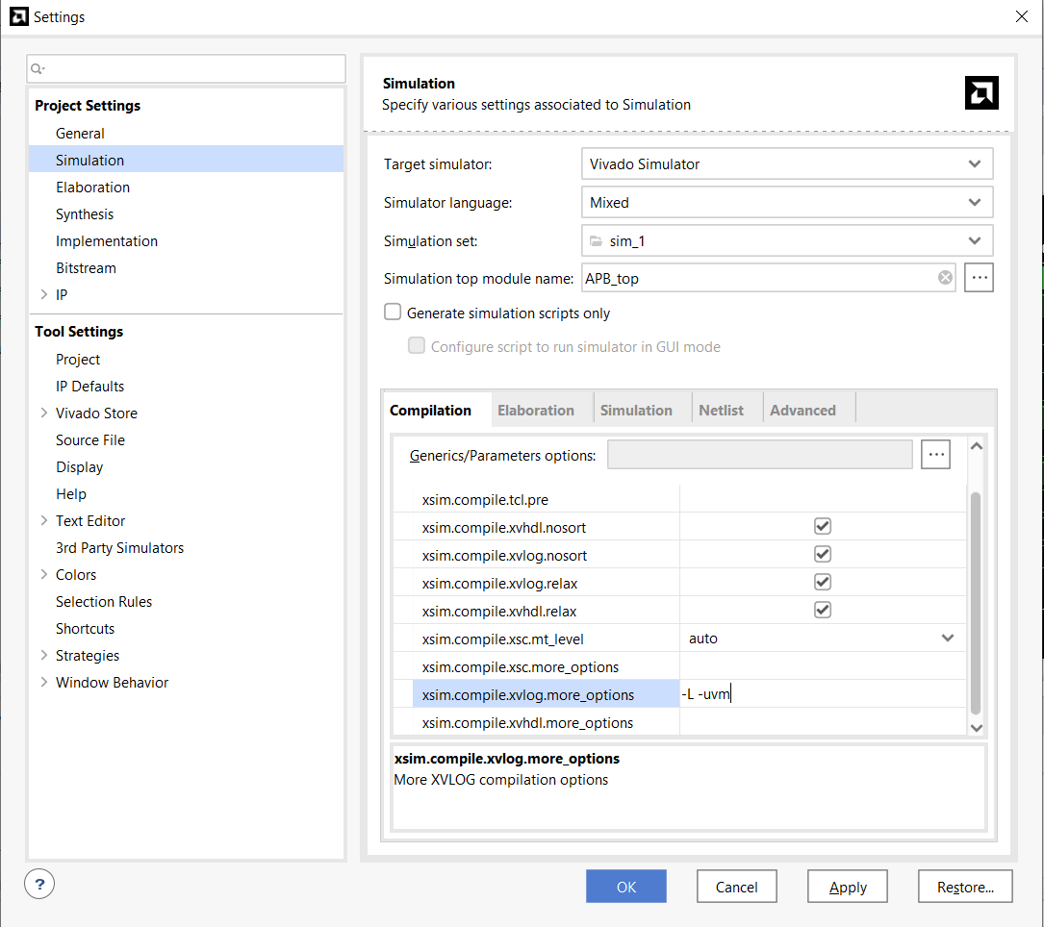

In the Tcl Console, type the following command:

export_xsim_coverage -cov_db_name cov_report -cov_db_dir ./ -output_dir cReport -open_html true

The coverage report can be found at the following path.
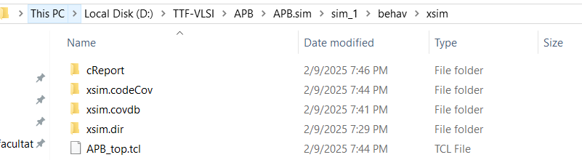

The coverage report is an HTML page

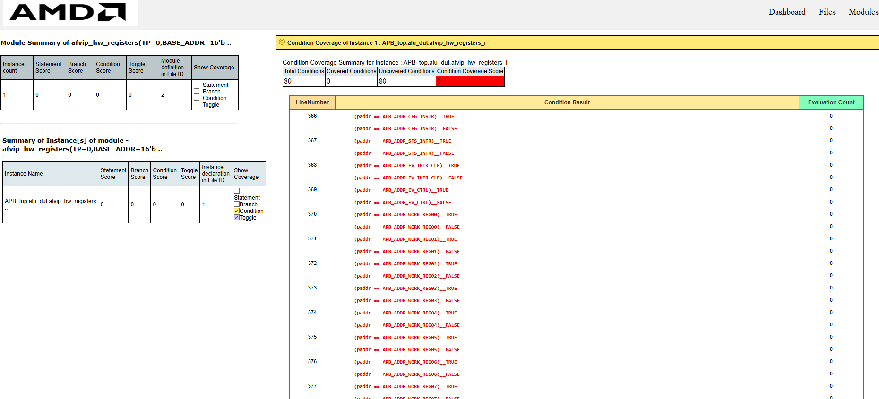

Using this guide with template_with_checker
When you add the simulation sources, add only testbench.sv from the template_with_checker folder: it includes all the other files of the template. If Vivado cannot find the included files, add the template_with_checker folder to the include search paths (Settings -> General -> Verilog options).
Set Simulation top module name to top (the module in testbench.sv), not to the DUT.
In the Simulation tab, set xsim.simulate.runtime to -all, so the test runs until UVM ends it; the default stops the simulation after 1000 ns.
At the end of the log you should see the coverage values, the Checker summary and TEST PASS or TEST FAIL.

