Table of Contents

# Dedication

This dissertation is dedicated to an important person in my life. This dissertation is dedicated to an important person in my life. This dissertation is dedicated to an important person in my life. This dissertation is dedicated to an important person in my life. This dissertation is dedicated to an important person in my life. This dissertation is dedicated to an important person in my life. This dissertation is dedicated to an important person in my life. This dissertation is dedicated to an important person in my life. This dissertation is dedicated to an important person in my life. This dissertation is dedicated to an important person in my life. This dissertation is dedicated to an important person in my life. This dissertation is dedicated to an important person in my life.

# Acknowledgments

I’d like to thank my advisor, my committee, my lab mates, my family, my friends, and all the people that gave me money. I’d like to thank my advisor, my committee, my lab mates, my family, my friends, and all the people that gave me money. I’d like to thank my advisor, my committee, my lab mates, my family, my friends, and all the people that gave me money. I’d like to thank my advisor, my committee, my lab mates, my family, my friends, and all the people that gave me money. I’d like to thank my advisor, my committee, my lab mates, my family, my friends, and all the people that gave me money. I’d like to thank my advisor, my committee, my lab mates, my family, my friends, and all the people that gave me money. I’d like to thank my advisor, my committee, my lab mates, my family, my friends, and all the people that gave me money. I’d like to thank my advisor, my committee, my lab mates, my family, my friends, and all the people that gave me money. I’d like to thank my advisor, my committee, my lab mates, my family, my friends, and all the people that gave me money. I’d like to thank my advisor, my committee, my lab mates, my family, my friends, and all the people that gave me money. I’d like to thank my advisor, my committee, my lab mates, my family, my friends, and all the people that gave me money. I’d like to thank my advisor, my committee, my lab mates, my family, my friends, and all the people that gave me money. I’d like to thank my advisor, my committee, my lab mates, my family, my friends, and all the people that gave me money.

# Abstract

This is a quick summary of what I found. This is a quick summary of what I found. This is a quick summary of what I found. This is a quick summary of what I found. This is a quick summary of what I found. This is a quick summary of what I found. This is a quick summary of what I found. This is a quick summary of what I found. This is a quick summary of what I found. This is a quick summary of what I found.

# 1 My Chapter Title

## 1.1 Introduction

General background information and your literature review goes here. General background information and your literature review goes here. General background information and your literature review goes here. General background information and your literature review goes here. General background information and your literature review goes here. General background information and your literature review goes here. General background information and your literature review goes here. General background information and your literature review goes here. General background information and your literature review goes here. General background information and your literature review goes here. General background information and your literature review goes here.

## 1.2 Methods

This is how I did the thing with this data (Table 1.1)

Table 1.1: Summary of the mtcars data.

speed

dist

Min. : 4.0

Min. : 2.00

1st Qu.:12.0

1st Qu.: 26.00

Median :15.0

Median : 36.00

Mean :15.4

Mean : 42.98

3rd Qu.:19.0

3rd Qu.: 56.00

Max. :25.0

Max. :120.00

## 1.3 Results

### 1.3.1 Level 3

#### 1.3.1.1 Level 4

##### 1.3.1.1.1 Level 5

###### 1.3.1.1.1.1 Level 6

### 1.3.2 A Really Long Heading so I see what happens when it takes up more than one line just in case we’re geeting crazy

These are my first results (Figure 1.1).

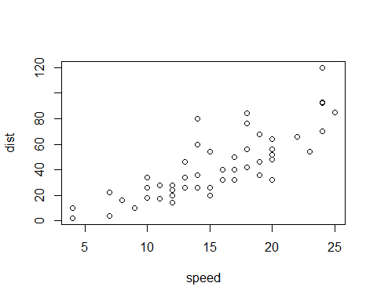

Figure 1.1: The cars data. Sentence two.

And then I also got these results (Figure 1.2).

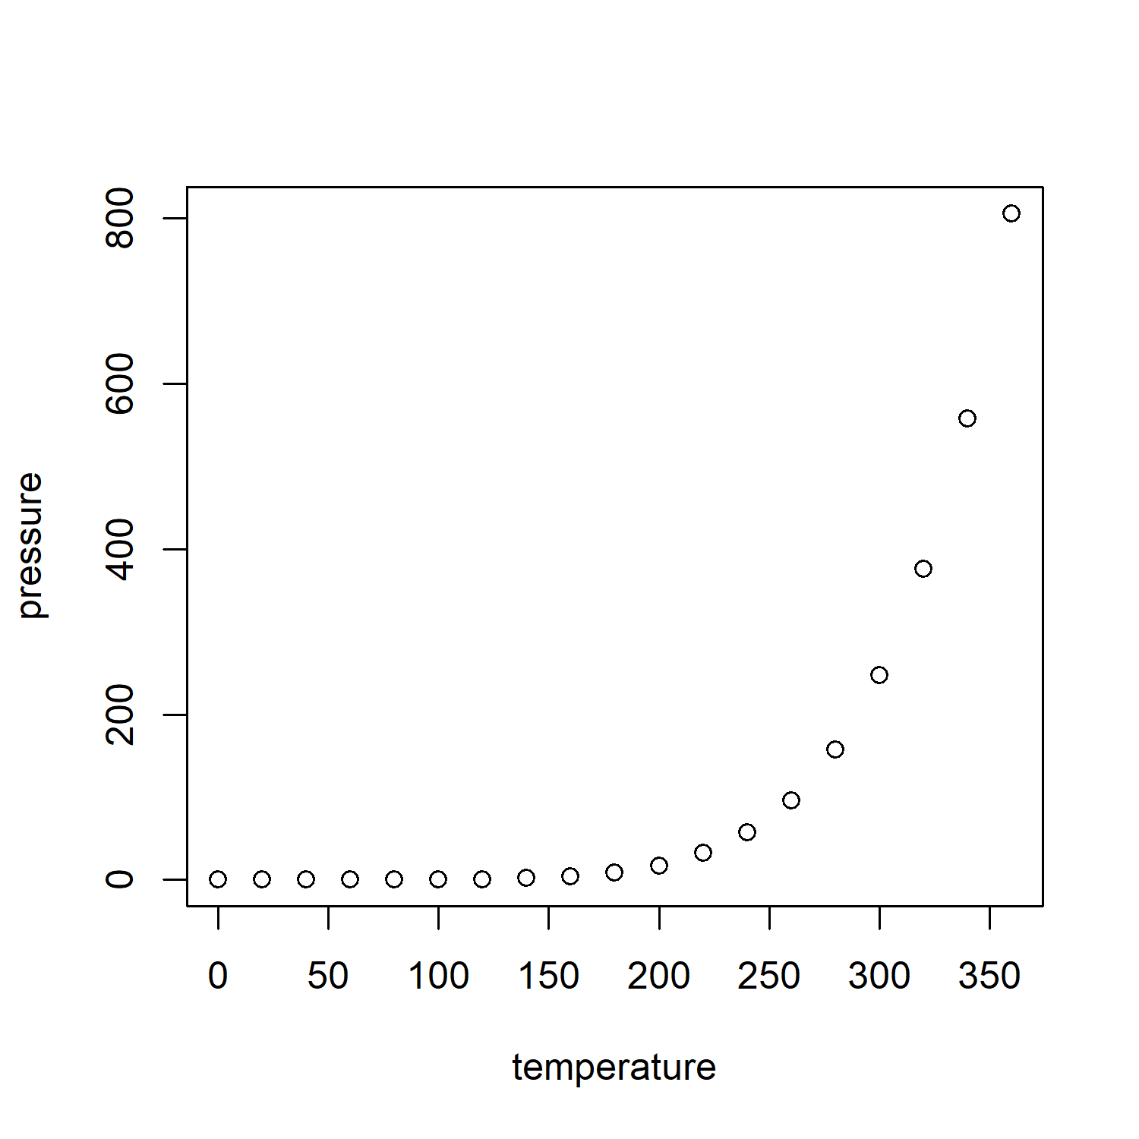

Figure 1.2: A really long figure caption so I see what happens when it takes up more than one line just in case we’re getting crazy

Table 1.2: A really long table caption so I see what happens when it takes up more than one line just in case we’re getting crazy

speed

dist

4

2

4

10

7

4

7

22

8

16

9

10

## 1.4 Discussion

Now I tell you how this fits in the context of my field

# 2 My Chapter Title

## 2.1 Introduction

Here we go again. Here we go again. Here we go again. Here we go again. Here we go again. Here we go again. Here we go again. Here we go again. Here we go again. Here we go again. Here we go again. Here we go again. Here we go again. Here we go again. Here we go again. Here we go again. Here we go again. Here we go again. Here we go again. Here we go again. Here we go again. Here we go again. Here we go again. Here we go again. Here we go again. Here we go again. Here we go again. Here we go again. Here we go again. Here we go again. Here we go again. Here we go again. Here we go again. Here we go again. Here we go again. Here we go again. Here we go again. Here we go again. Here we go again. Here we go again. Here we go again. Here we go again.

## 2.2 Methods

This is how I did the thing

See test 2.1

Table 2.1: Summary of the mtcars data. Sentence two.

speed

dist

Min. : 4.0

Min. : 2.00

1st Qu.:12.0

1st Qu.: 26.00

Median :15.0

Median : 36.00

Mean :15.4

Mean : 42.98

3rd Qu.:19.0

3rd Qu.: 56.00

Max. :25.0

Max. :120.00

## 2.3 Results

These are more results 2.1. Cross-referencing this figure is possible thanks to the bookdown package (Xie, 2016) and we can use the visual markdown editor from Rstudio to make writing in markdown easier (Allaire, 2012).



Figure 2.1: The cars data2.

Let’s reference figure 1.1 from chapter 1 from chapter 2

### 2.3.1 An Equation and some math

Inline math example: $1+1=2$

Display math example:

$$2+2=4$$

This is the equation of a line Equation (2.1)

## 2.4 Discussion

Now I tell you how this fits in the context of my field.

# 3 My Chapter Title

## 3.1 Synthesis

Everything fits together so well!

## 3.2 Future Work

Ok it didn’t fit together so well so I guess we should look at these things, but I have to graduate and there’s no more money but maybe someone some day can look into this.

# References

Allaire, J., 2012. RStudio: Integrated development environment for r. Boston, MA 770, 394.

Xie, Y., 2016. Bookdown: Authoring books and technical documents with r markdown. CRC Press.

# Appendix

# 4 Name of Appendix

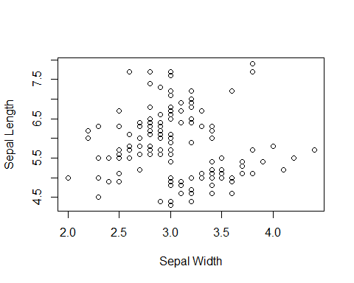

Figure 4.1: sepal length vs sepal width of the iris data.

# 5 Name of Appendix

Table 5.1: The iris data

|  |  |  |  |  |
| --- | --- | --- | --- | --- |
| Sepal.Length | Sepal.Width | Petal.Length | Petal.Width | Species |
| 5.1 | 3.5 | 1.4 | 0.2 | setosa |
| 4.9 | 3.0 | 1.4 | 0.2 | setosa |
| 4.7 | 3.2 | 1.3 | 0.2 | setosa |
| 4.6 | 3.1 | 1.5 | 0.2 | setosa |
| 5.0 | 3.6 | 1.4 | 0.2 | setosa |
| 5.4 | 3.9 | 1.7 | 0.4 | setosa |
| 4.6 | 3.4 | 1.4 | 0.3 | setosa |
| 5.0 | 3.4 | 1.5 | 0.2 | setosa |
| 4.4 | 2.9 | 1.4 | 0.2 | setosa |
| 4.9 | 3.1 | 1.5 | 0.1 | setosa |
| 5.4 | 3.7 | 1.5 | 0.2 | setosa |
| 4.8 | 3.4 | 1.6 | 0.2 | setosa |
| 4.8 | 3.0 | 1.4 | 0.1 | setosa |
| 4.3 | 3.0 | 1.1 | 0.1 | setosa |
| 5.8 | 4.0 | 1.2 | 0.2 | setosa |
| 5.7 | 4.4 | 1.5 | 0.4 | setosa |
| 5.4 | 3.9 | 1.3 | 0.4 | setosa |
| 5.1 | 3.5 | 1.4 | 0.3 | setosa |
| 5.7 | 3.8 | 1.7 | 0.3 | setosa |
| 5.1 | 3.8 | 1.5 | 0.3 | setosa |
| 5.4 | 3.4 | 1.7 | 0.2 | setosa |
| 5.1 | 3.7 | 1.5 | 0.4 | setosa |
| 4.6 | 3.6 | 1.0 | 0.2 | setosa |
| 5.1 | 3.3 | 1.7 | 0.5 | setosa |
| 4.8 | 3.4 | 1.9 | 0.2 | setosa |