pomeroy-2002-v1_database

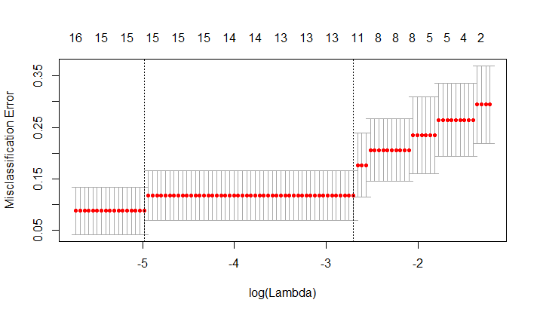

Misclassification rate, Number of genes used: 0.04 15

pomeroy-2002-v2_database

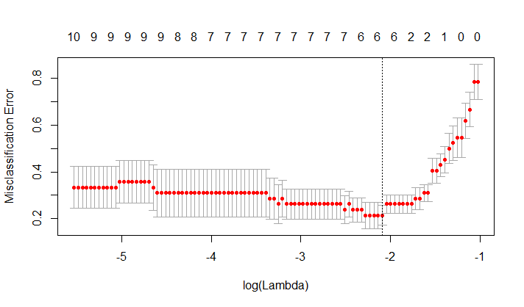

Misclassification rate, Number of genes used: 0.023 6

ramaswamy-2001_database

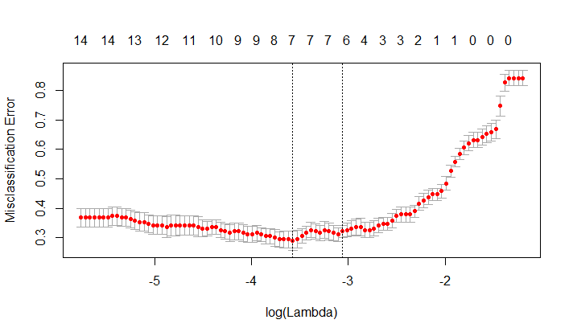

Misclassification rate, Number of genes used: 0.1105263 7

shipp-2002-v1_database

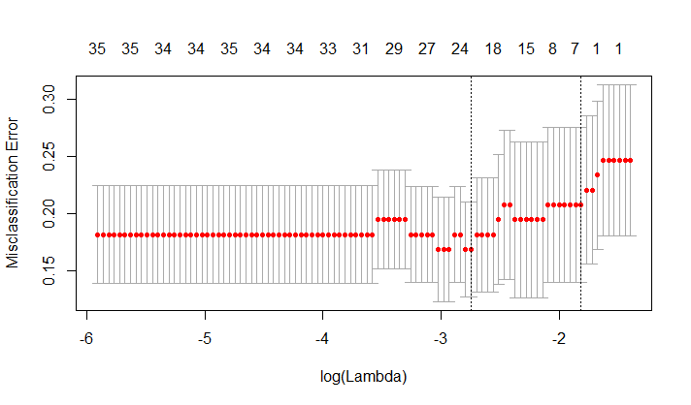

Misclassification rate, Number of genes used: 0.03896 24

Singh.2002_database

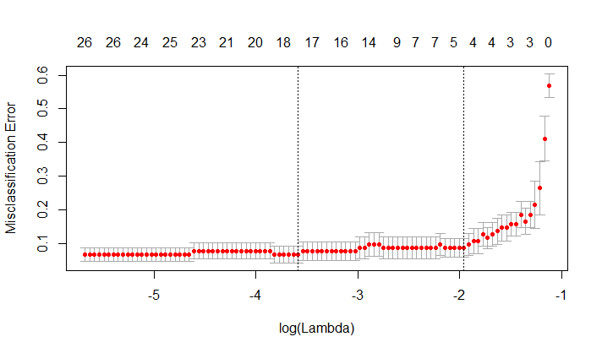

Misclassification rate, Number of genes used: 0.01960784 9

Su.2001_database

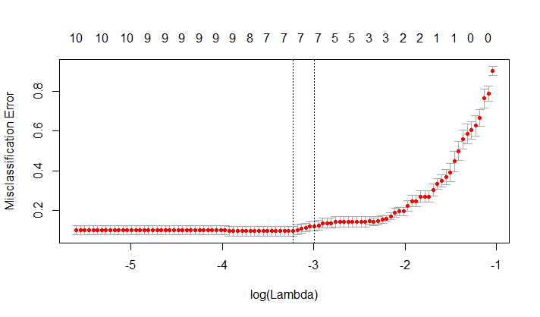

Misclassification rate, Number of genes used: 0.01724138 7

West.2001_database

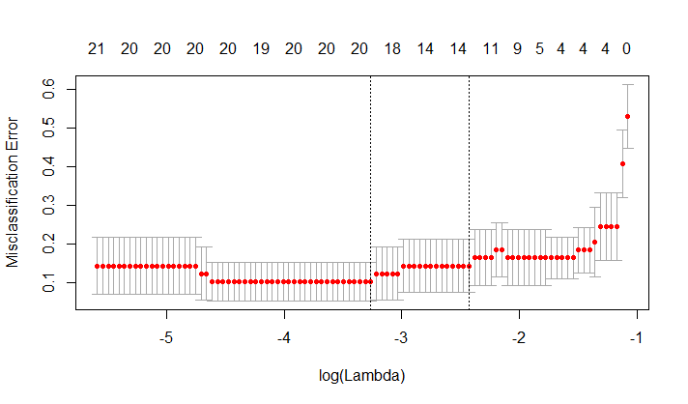

Misclassification rate, Number of genes used: 0.05724138 14

Yeoh.2002.v1_database

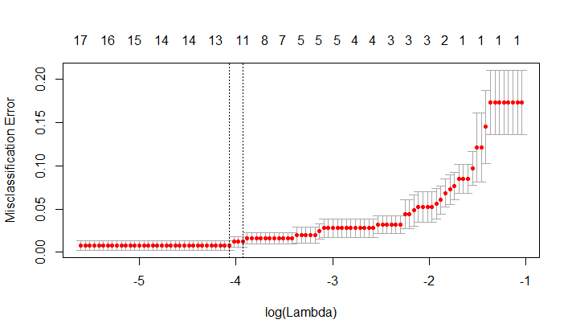

Misclassification rate, Number of genes used: 0.0 12

Yeoh.2002.v2_database

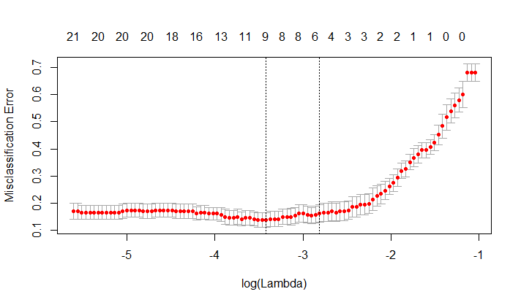

Misclassification rate, Number of genes used: 0.03629032 8