MIS5303 Securing Software
Ashraful Islam | Student ID: 240135
Lab 1: Static Analysis, Secure Coding & Security Design
Findings, fixes, architect review and reflection
Part 1 - Setup & App Familiarisation
A deliberately insecure Flask + SQLite notes application was set up locally in a Python virtual environment, with dependencies installed from requirements.txt.
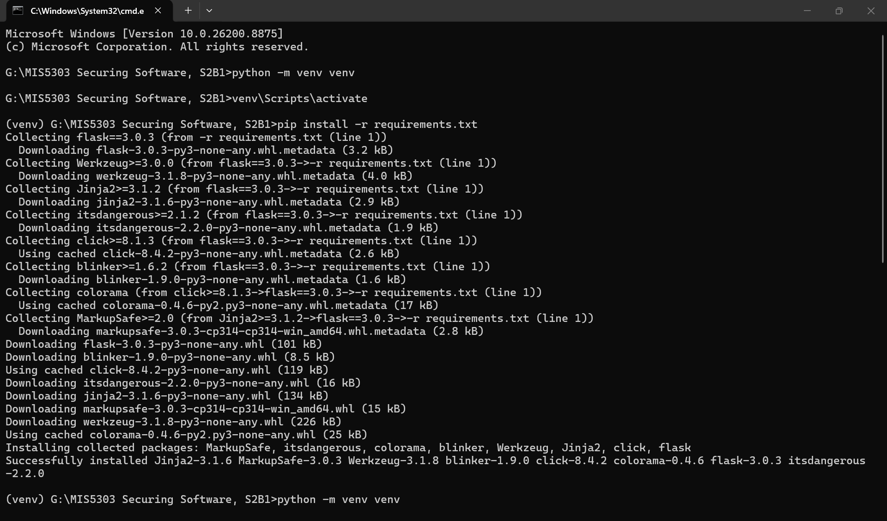
Figure 1 - Virtual environment created and dependencies installed.
The application was started with python app.py. The startup banner itself warns that this is a development server and confirms the interactive debugger is active - both of which appear as findings in the analysis that follows.
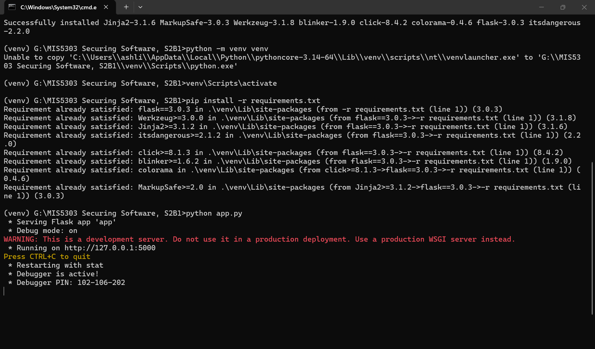
Figure 2 - Application running on http://127.0.0.1:5000 with debug mode enabled.
The app was exercised through the browser to confirm every feature worked: registration, login, note creation, and file upload.
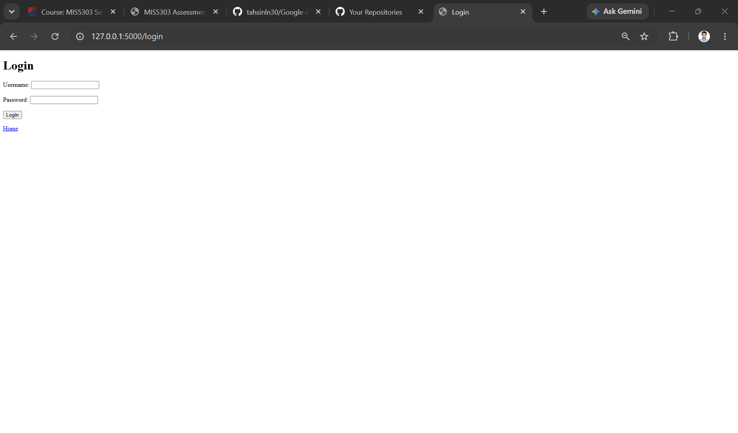
Figure 3 - Login page at /login.
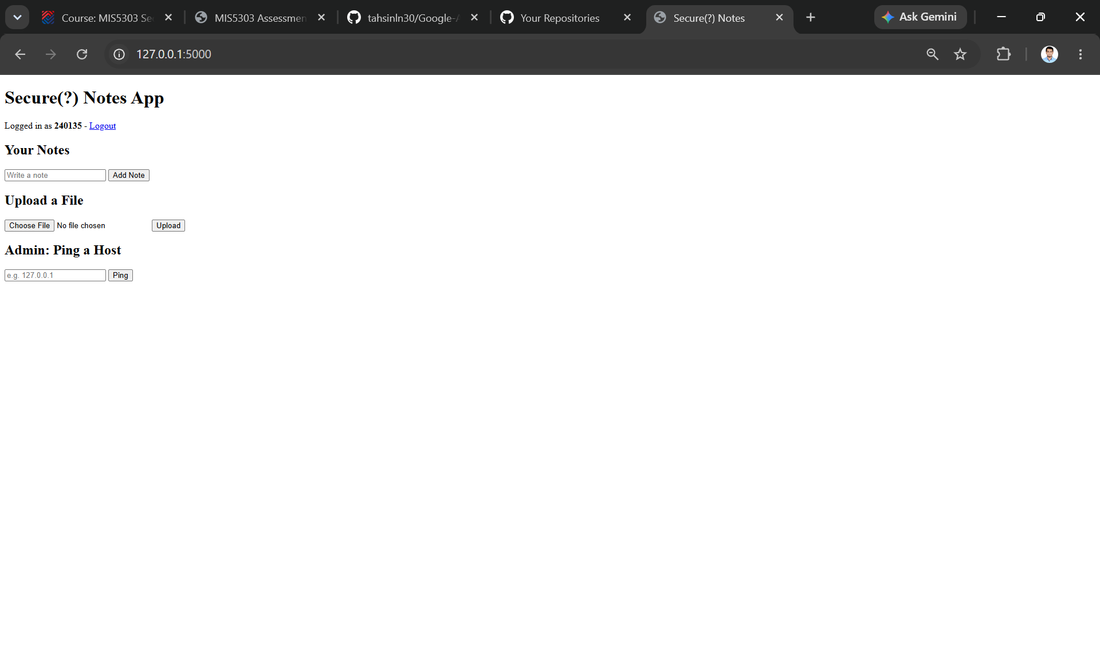
Figure 4 - Authenticated session showing notes, file upload, and the admin ping utility.
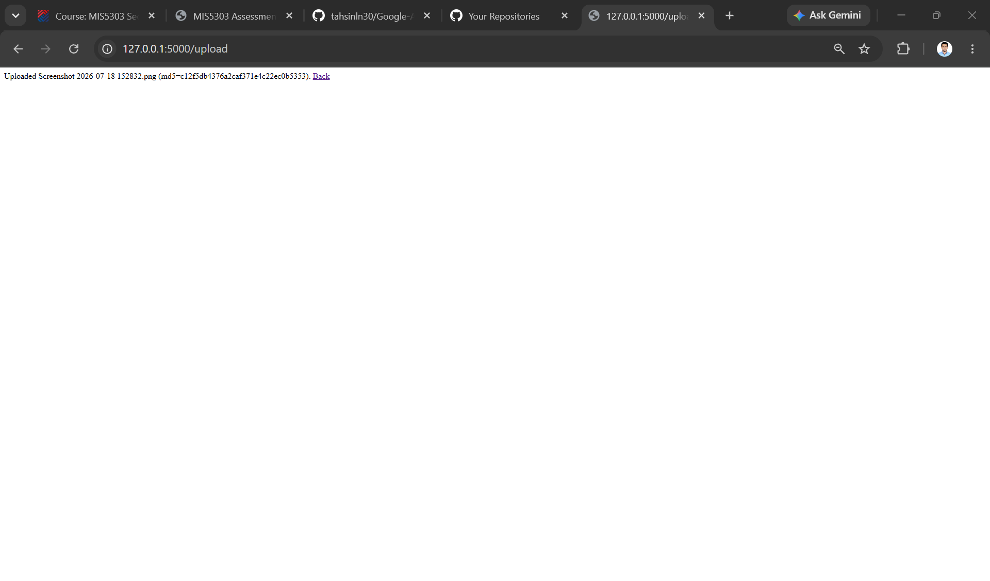
Figure 5 - Upload succeeded, returning the stored filename and its MD5 digest.
Part 2 - Static Analysis: Finding Vulnerabilities
Bandit and Semgrep were installed into the virtual environment with pip install bandit semgrep.
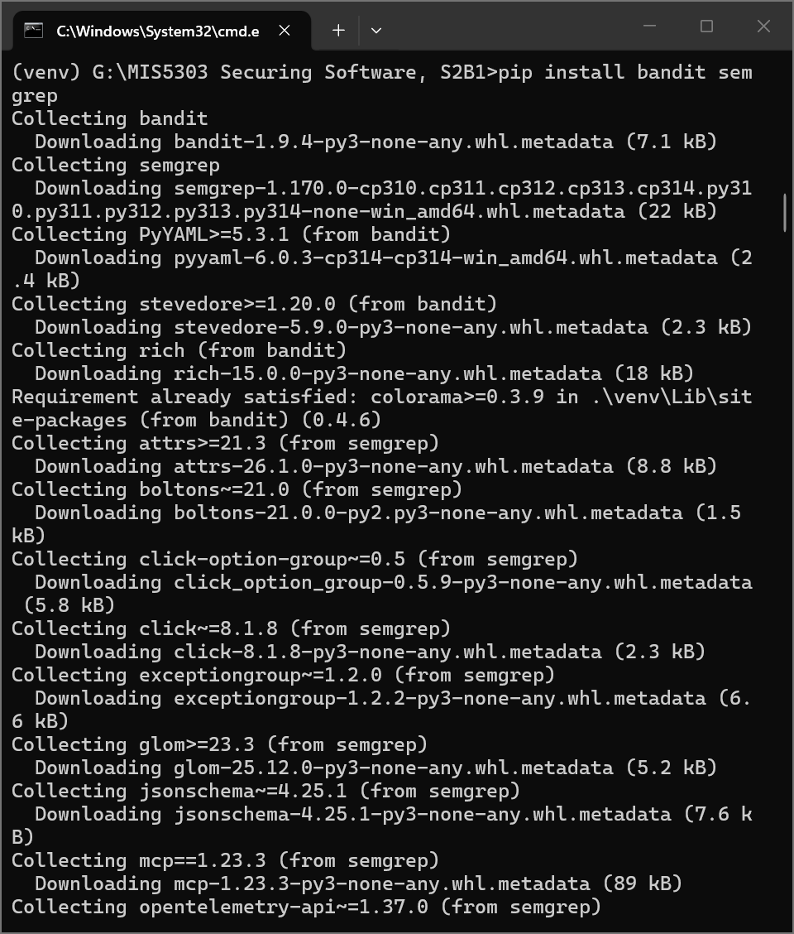
Figure 6 - Installing Bandit and Semgrep.
Running bandit -r app.py > bandit_report.txt scanned 177 lines and produced seven findings. All line numbers, Bandit IDs, and CWE references below are taken directly from that report.
Tool | Line | Vulnerability | ID / CWE | Sev. | Why it is risky
Bandit | 13 | subprocess module imported | B404 / CWE-78 | Low | Informational; flagged here because it feeds a shell command built from user input
Bandit | 26 | Hardcoded secret key 'dev-secret-123' | B105 / CWE-259 | Low | Exposed in source; allows an attacker to forge or decode session cookies
Bandit | 114 | SQL built with an f-string (notes query) | B608 / CWE-89 | Med | SQL injection through string-based query construction
Bandit | 151 | SQL built by concatenation (login query) | B608 / CWE-89 | Med | Authentication bypass, e.g. admin' OR '1'='1
Bandit | 196 | Weak MD5 hash on uploaded files | B324 / CWE-327 | High | MD5 is cryptographically broken and unfit for any security purpose
Bandit | 205 | subprocess.run with shell=True on user input | B602 / CWE-78 | High | Command injection - the ping form passes input straight to the OS shell
Bandit | 215 | Flask started with debug=True | B201 / CWE-94 | High | The Werkzeug debugger permits arbitrary code execution via the browser

Report totals: 2 Low, 2 Medium, 3 High, with 0 files skipped.
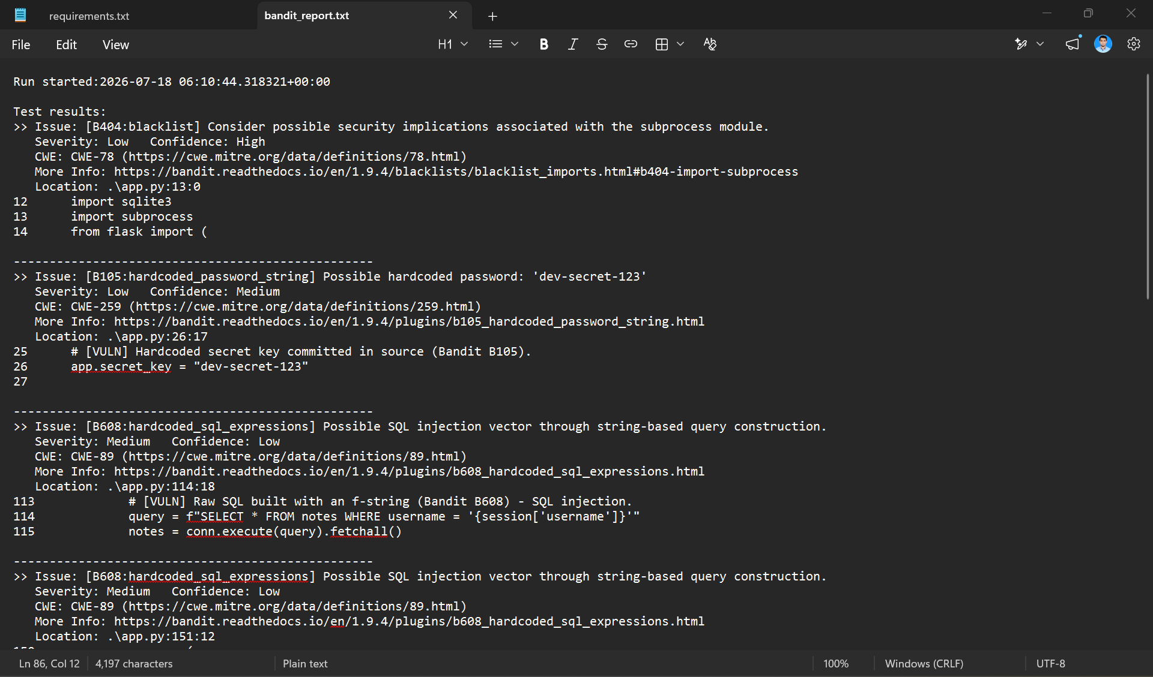
Figure 7 - bandit_report.txt (part 1): B404, B105, and the notes-query B608.
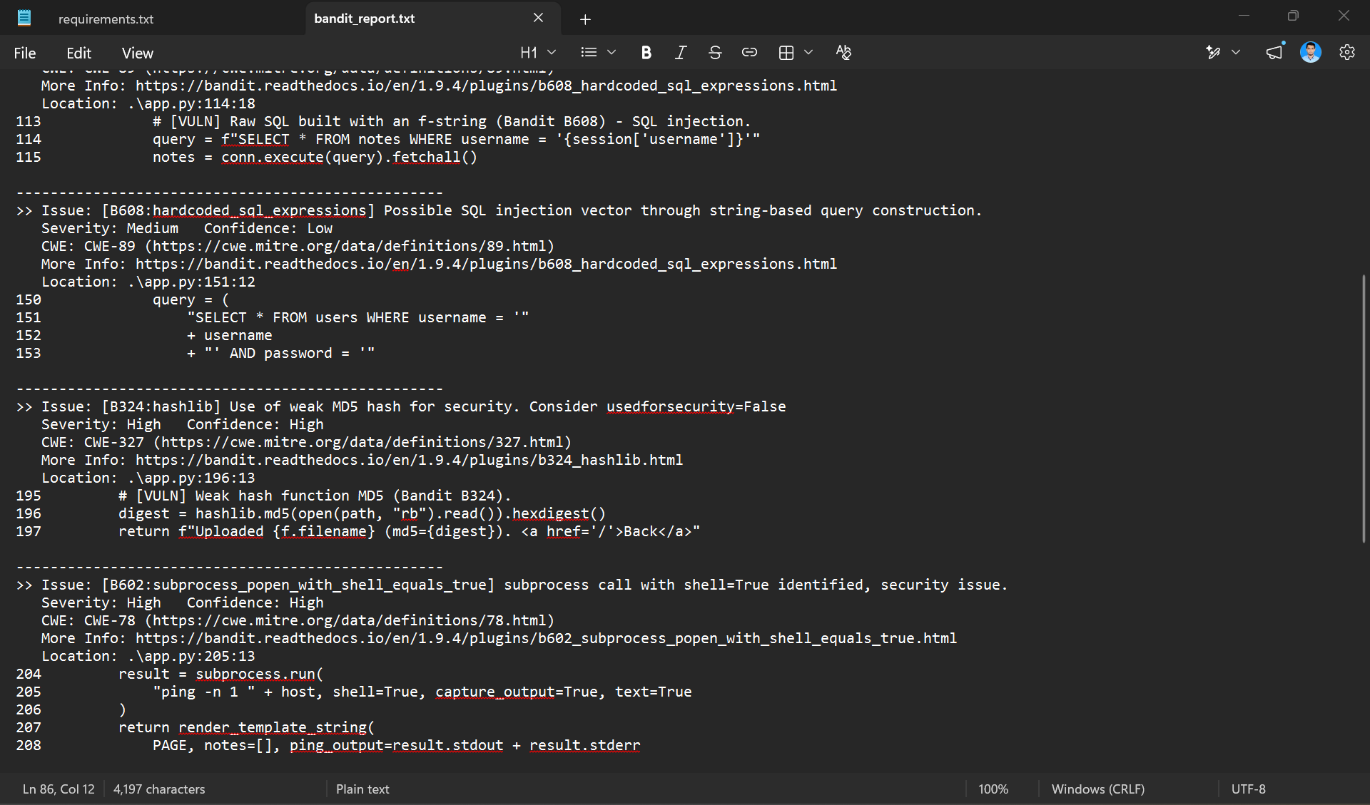
Figure 8 - bandit_report.txt (part 2): the login-query B608, B324 MD5, and B602 shell=True.
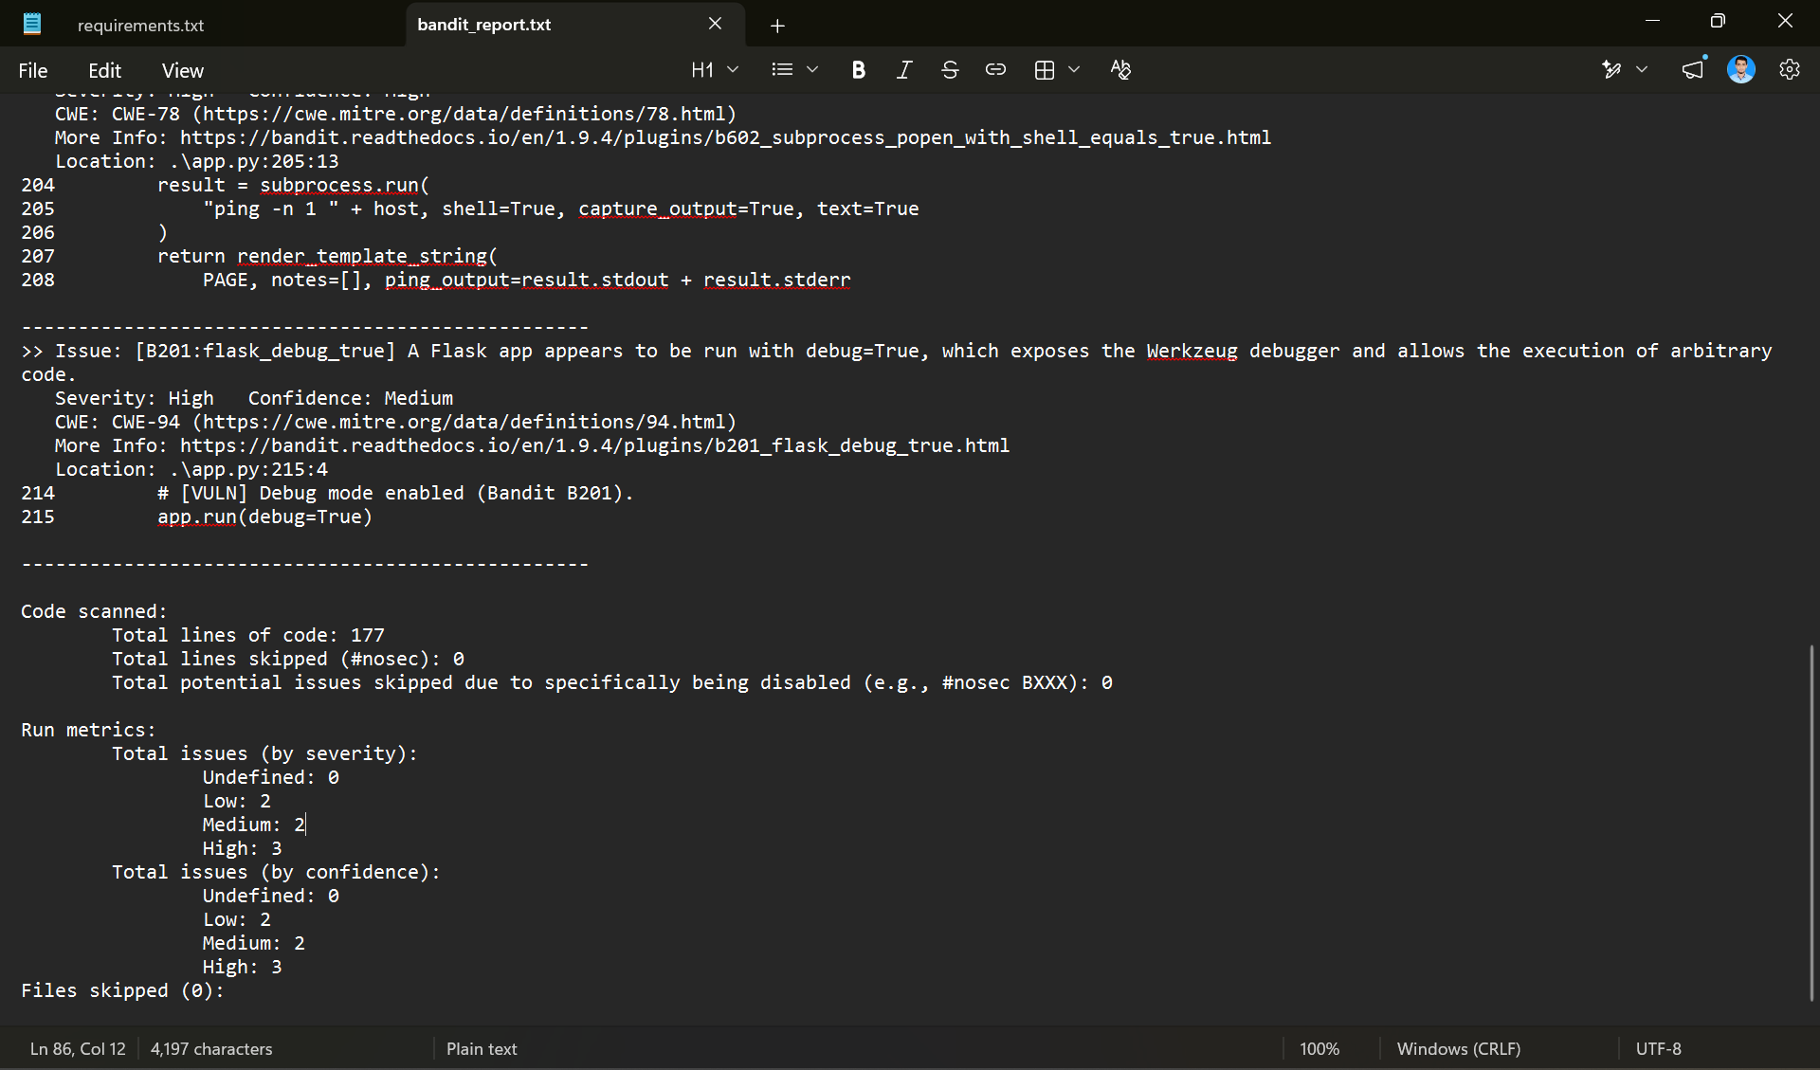
Figure 9 - bandit_report.txt (part 3): B201 debug=True and the run metrics.
Semgrep (semgrep --config=p/ci app.py) corroborated the injection and configuration findings.
Part 3 - Fixing Vulnerabilities
Two representative flaws were selected and remediated in the local copy, then verified by re-scanning.
Fix 1 - Hardcoded secret key (B105, line 26)
- app.secret_key = "dev-secret-123"
+ import secrets
+ app.secret_key = os.environ.get("SECRET_KEY") or secrets.token_hex(32)
The literal secret is removed from source entirely. The key is now supplied by the environment, with a random per-process fallback so development still works without committing a secret.
Fix 2 - SQL injection in the login query (B608, line 151)
- query = ("SELECT * FROM users WHERE username = '" + username
- + "' AND password = '" + password + "'")
- user = conn.execute(query).fetchone()
+ user = conn.execute(
+ "SELECT * FROM users WHERE username = ? AND password = ?",
+ (username, password),
+ ).fetchone()
Placeholders bind the input as data rather than SQL syntax, so a payload such as admin' OR '1'='1 is treated as a literal username and the authentication bypass is closed.
Verification
The file was re-compiled with python -m py_compile app.py and re-scanned to bandit_after.txt. Both remediated findings disappeared:
Scan | Low | Medium | High | Total | Findings present
Before (bandit_report.txt) | 2 | 2 | 3 | 7 | B404, B105, B608 x2, B324, B602, B201
After (bandit_after.txt) | 1 | 1 | 3 | 5 | B404, B608 (notes), B324, B602, B201

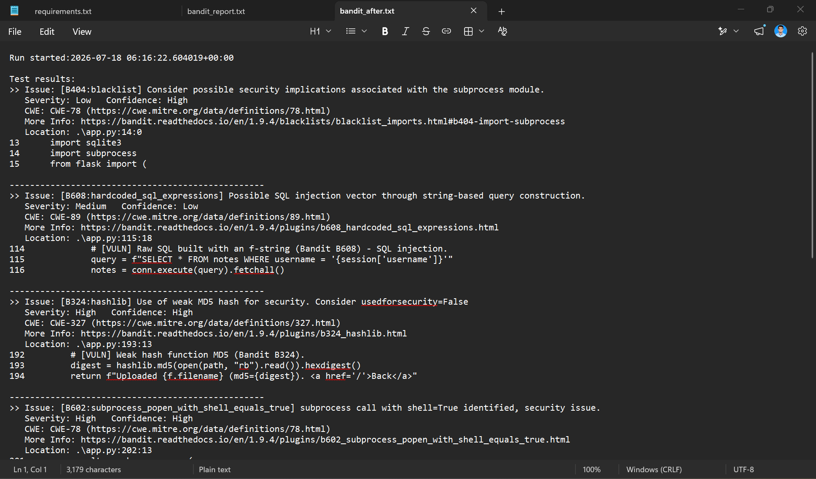
Figure 10 - bandit_after.txt (part 1): B105 and the login B608 are absent.
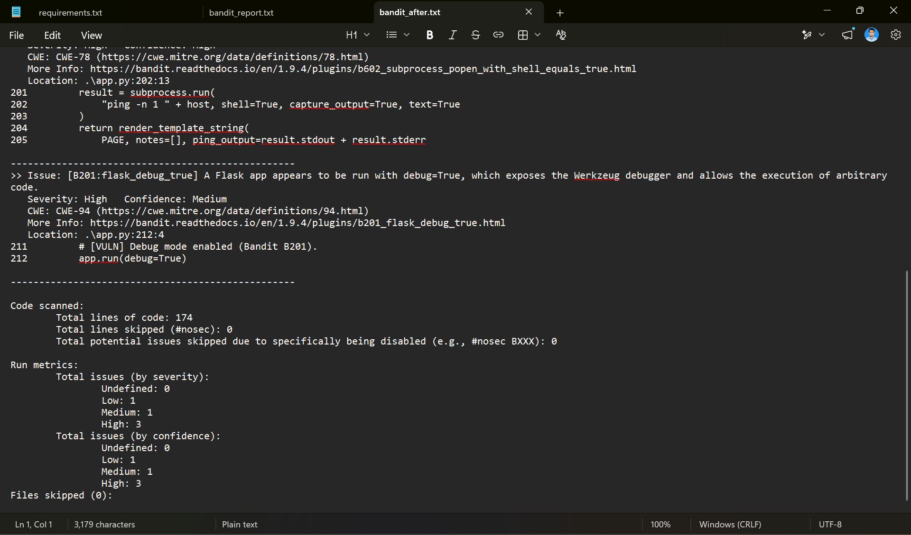
Figure 11 - bandit_after.txt (part 2): revised metrics showing 1 Low, 1 Medium, 3 High.
The three remaining High findings (B324, B602, B201) were left in place deliberately so the exercise documents a realistic partial remediation, with the outstanding items carried into the architecture review below.
Part 4 - Architect's Perspective: Secure Design
Stepping back from individual code fixes, the table below identifies the principal design and security-architecture weaknesses, the recommended control, its implementing technology, and the reasoning behind each choice. The final two rows address flaws that neither scanner detected.
App Flaw / Area | Proposed Improvement | Technology / Algorithm | Reason / Justification
Hardcoded secret key | Load the signing key from an environment variable; never commit it | os.environ / .env + python-dotenv | Keeps secrets out of version control so a leaked repository does not leak the signing key. Rotation becomes a configuration change, and per-environment keys limit the blast radius if one is exposed.
Plaintext passwords | Hash every password with a salted, slow algorithm before storage | Argon2 (argon2-cffi) or bcrypt | A stolen database yields irreversible hashes rather than usable passwords. Per-password salts defeat rainbow tables and the slow work factor makes brute forcing expensive. Argon2 is the current OWASP default.
Insecure session cookies | Enable the protective cookie flags on the session | Flask config: HTTPONLY, SECURE, SAMESITE | HttpOnly blocks JavaScript (and therefore XSS) from reading the cookie, Secure forces HTTPS-only transmission, and SameSite blocks cross-site sending, mitigating CSRF. Together they close the common session-hijacking paths.
SQL injection | Use parameterised queries throughout; adopt an ORM | sqlite3 placeholders (?) / SQLAlchemy | Binding parameters separates code from data so input cannot alter query structure. An ORM makes the safe path the default across the codebase, eliminating the CWE-89 class rather than patching one query at a time.
Command injection | Remove the shell, pass arguments as a list, and validate the host | subprocess.run([...], shell=False) + allow-list | An argument list means input is never interpreted by a shell, removing the vector entirely. Allow-list or IP-format validation rejects unexpected input, and a pure-Python library avoids running an OS command at all.
Weak MD5 hashing | Replace MD5 with an algorithm fit for the purpose | SHA-256 for integrity / Argon2 for secrets | MD5 is broken (CWE-327). SHA-256 is appropriate for file-integrity digests, while anything protecting a secret requires a slow, salted key-derivation function instead.
Debug mode in production | Disable the interactive debugger; run behind a WSGI server | app.run(debug=False) / Gunicorn, Waitress | The Werkzeug debugger allows remote code execution through the browser and leaks full stack traces. Disabling it and serving through a hardened WSGI server removes a critical attack surface.
Unvalidated input / upload | Validate all inputs server-side; constrain uploads by type and size | WTForms / Marshmallow + secure_filename() | Server-side validation enforces expected types and lengths regardless of client behaviour. secure_filename() with an extension allow-list prevents path traversal and executable uploads. Not detected by either scanner.
Stored XSS via |safe | Remove the |safe filter and rely on Jinja autoescaping | Jinja2 autoescape + output encoding | Autoescaping renders note content as text rather than markup, so an injected script tag is displayed instead of executed. Found only by manual review, not by static analysis.
Part 5 - Peer Review & Reflection
What the tools did not find
Bandit and Semgrep proved effective against pattern-based flaws - a hardcoded secret, string-built SQL, shell=True, a weak hash, debug mode - because each has a recognisable signature in the source. They missed several serious issues that depend on context and logic rather than syntax. The stored cross-site scripting vulnerability, where note content is rendered through Jinja's |safe filter, was not flagged, because |safe is legitimate in many situations and the tool cannot know that the data is attacker-controlled. The unrestricted file upload - an attacker-controlled filename joined directly into a path, with no type or size limit - also went undetected, as did the plaintext password storage and the complete absence of CSRF protection. These are design and data-flow weaknesses for which a static scanner has no reliable rule, which is precisely why manual code review and threat modelling remain essential alongside automated tooling.
The most important secure design improvement
Of all the controls proposed, hashing passwords with a salted, slow algorithm such as Argon2 or bcrypt is the single most important. A database compromise is one of the most common and damaging breach scenarios, and because users routinely reuse passwords across services, plaintext storage turns a breach of this one application into a threat to every other account those users hold. Parameterised queries and server-side input validation follow closely, since they neutralise the injection classes that lead to that compromise in the first place. Taken together, these represent a shift from perimeter thinking to defence-in-depth: assume that any single layer can fail, and ensure the damage is contained when it does.
Part 6 - Presentation Summary
Technical fix presented: parameterising the login SQL query to eliminate the injection that enabled a complete authentication bypass, evidenced by the finding disappearing from the post-fix Bandit scan. Architect-level improvement presented: hashing stored credentials with Argon2, so that a database breach does not expose usable passwords. A secure login and data-flow diagram accompanies this submission, showing where each proposed control sits in the request path.

