**Group 5 Project 3**

**Members:**

1. Bhumi Bhusal
2. Artem Iliushin
3. Rafael Tem Pahs
4. Ryan Callaghan
5. Ryan Cheng

In this Project we want to analyze the clean energy production and consumption in different states in united states.

**Data sources:**

1. We will use the following link for webscrapping population data for different states.

<https://en.wikipedia.org/wiki/List_of_U.S._states_and_territories_by_population#cite_note-5>

1. Energy consumption per capita

<https://www.eia.gov/state/rankings/#/series/12>

1. Latitude longitude data for each of the states

<https://www.kaggle.com/datasets/washimahmed/usa-latlong-for-state-abbreviations>

1. Interactive chart will be built using leaflet-choropleth.

[Interactive Choropleth Map - Leaflet - a JavaScript library for interactive maps (leafletjs.com)](https://leafletjs.com/examples/choropleth/)

1. We will create dropdown-menu plotting selecting each stated showing different types and amount of renewable energies it produces. Following data source will be used.

<https://data.world/doe/united-states-renewable-energy>

**Objectives:**

1. We want to show the clean-energy production and consumption state of each of states of united states.
2. We will create the per-capita consumption of clean energy plot using leaflet-choropleth. Something like following picture.

https://leafletjs.com/examples/choropleth/

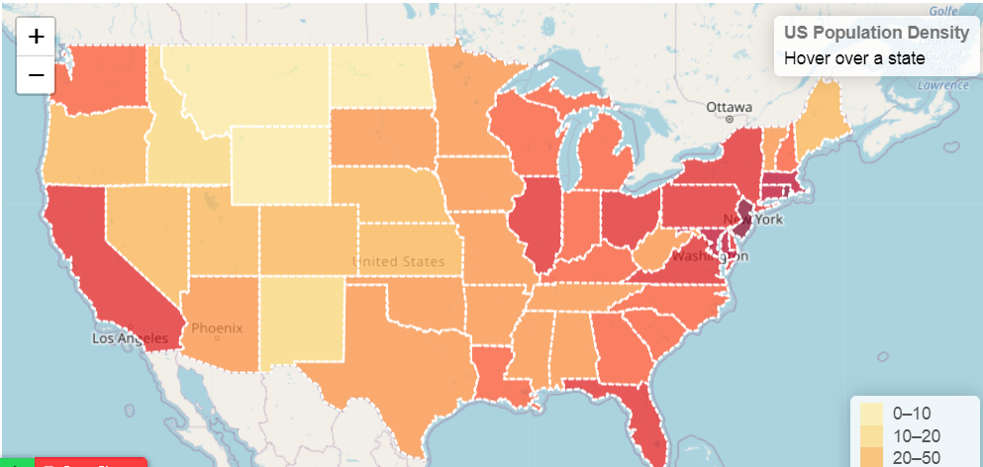

1. We will also Create choropleth maps showing clean energy production distribution for each type of clean energy (with dropdown or layer-select option to choose each type of energy).
2. We will create dropdown-menu plotting selecting each stated showing different types and amount of renewable energies it produces.

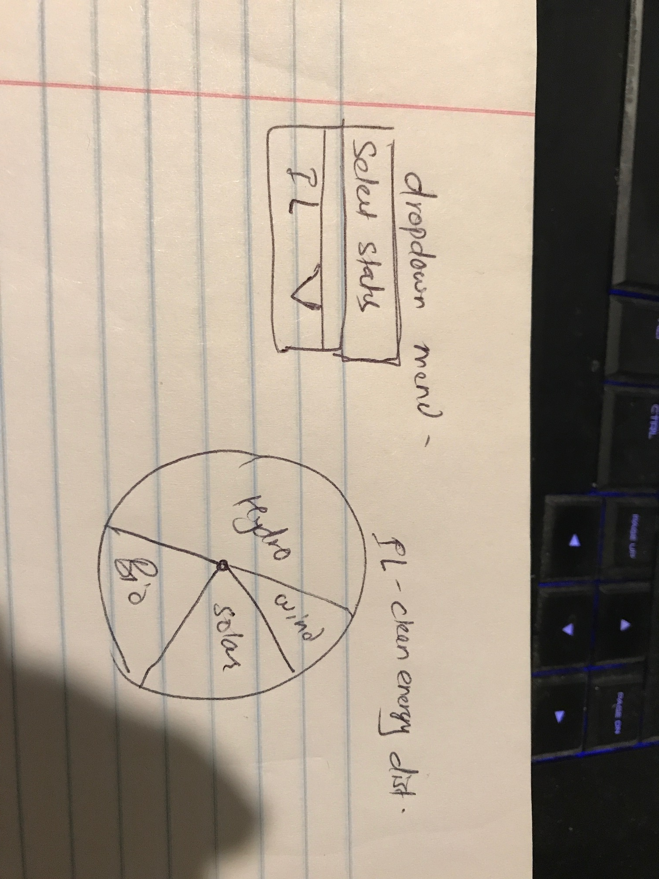

**Work division:**

1. Artem and Rafael: Webscrapping and ETL
2. Bhumi and Ryan: Bring data from Python to postgress database.
3. Artem and Rafael: Flask App and index to publishing the data , choropleth to create state-wise visualization.
4. Bhumi and Ryan: Plotly dropdown visualization and index file.
5. Ryan Cheng: Will be determined. Support for different projects.