# Bug Report for Buggy Cars Rating

**Bug Name:** Author’s name not displayed for user comment.

**Bug ID:** BC-VOT-004-1

**Test case ID:** BC-VOT-004

**Build version:** Version 1

**Report by:** Name on dd/mm/yyy

**Severity: High / Medium / Low**

**Priority: High / Medium / L**

**Environment software / hardware:**

BuggyCars website

Operating system: Windows 11

Browser: Google Chrome Version 111.0.5563.65

**Pre-condition:**

User is logged in to BuggyCars website.

**Steps:**

1. Navigate to BuggyCars website and login.
2. Click on any buggy car.
3. Leave a comment and click on the vote button.
4. Reload the page.
5. Check the comment for the buggy car to see the author's name.

**Expected result:**

* The system should save the users comment for the selected buggy car.
* The comment should be displayed correctly on the buggy car detail page with the author's name.

**Actual result:**

* The system successfully saved the user's comment for the selected buggy car, and the comment was displayed correctly on the buggy car detail page after reloading the page.
* However, the author's name was not displayed correctly as the author row was blank.

**Reproducibility:**

The bug is reproducible 100% of the time

**Analysis:**

During the test, it was found that the author's name was not displayed for the user's comment. This could be due to a coding error or a problem with the database. Further investigation is required to determine the root cause of the issue.

**Attachment UI screenshot / crash log:**

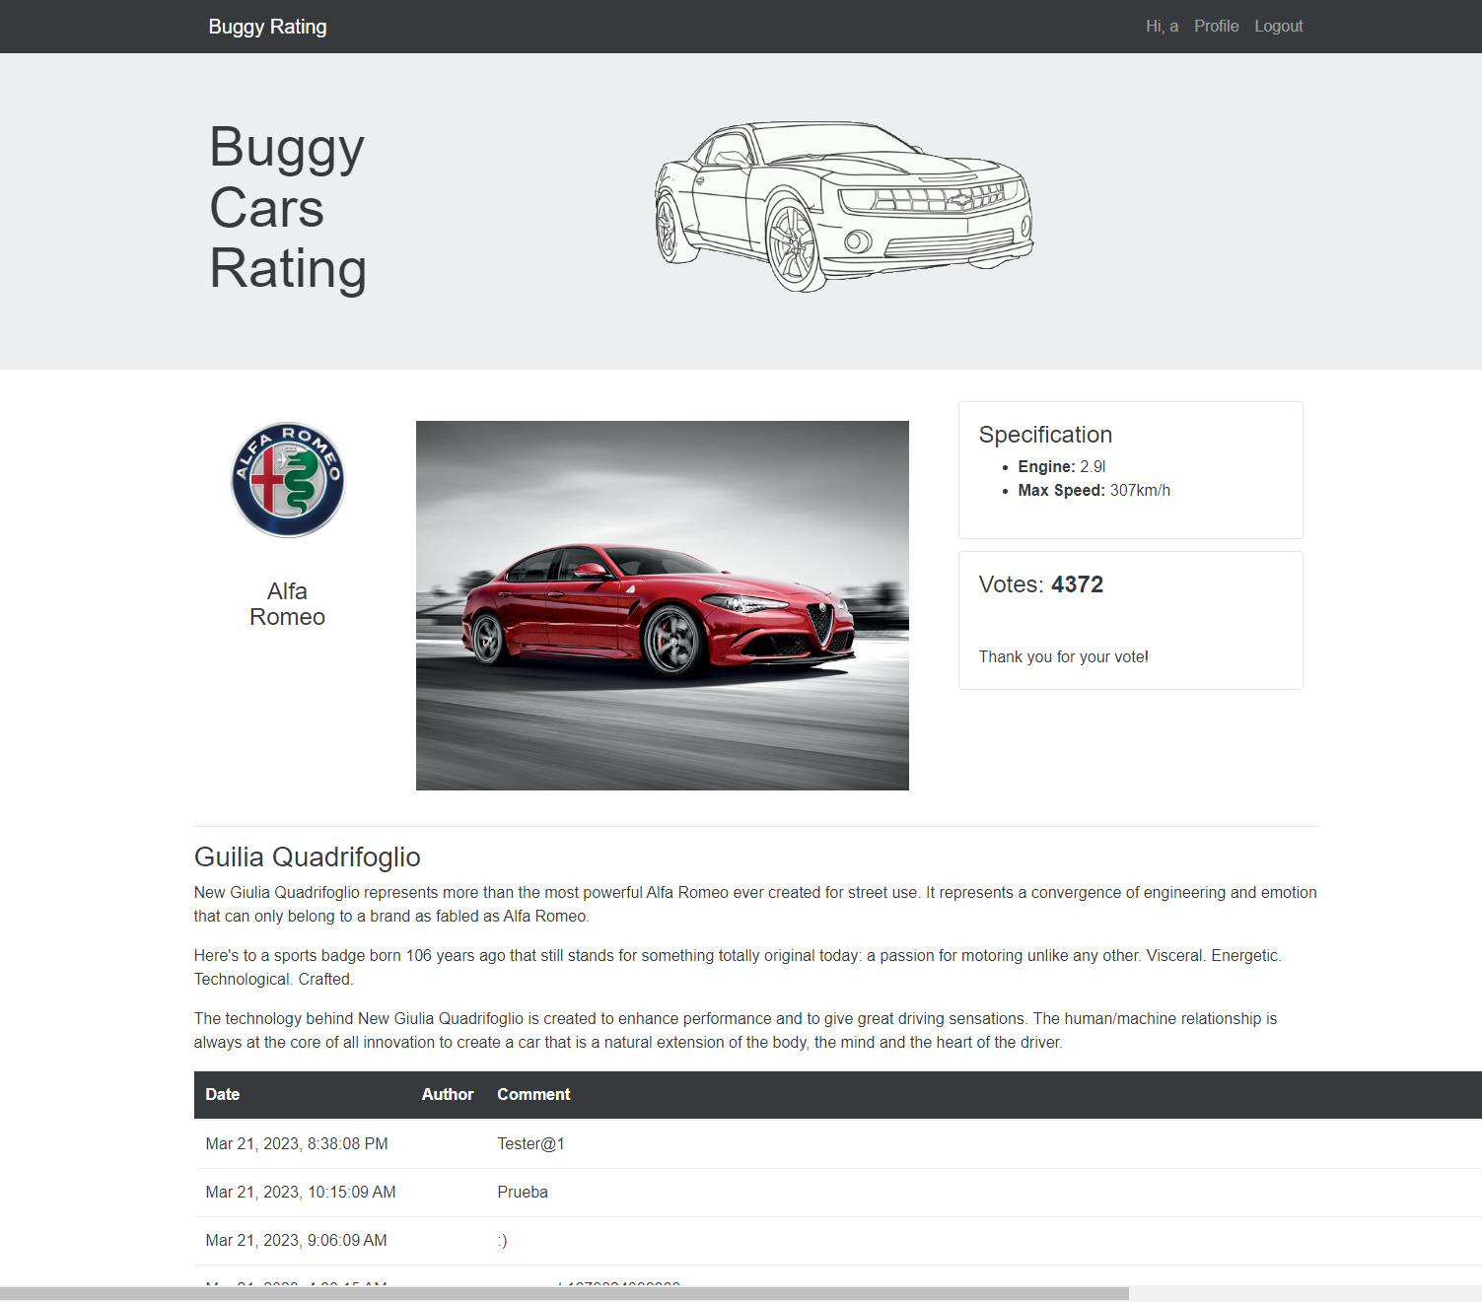

**Bug Name:** Author’s name not displayed for user comment.

**Bug ID:** BC-NAV-001-1

**Test case ID:** BC-NAV-001

**Build version:** Version 1

**Report by:** Name on dd/mm/yyy

**Severity: High / Medium / Low**

**Priority: High / Medium / L**

**Environment software / hardware:**

BuggyCars website

Operating system: Windows 11

Browser: Google Chrome Version 111.0.5563.65

**Pre-condition:**

User is on popular make page of BuggyCars website.

**Steps:**

1. Click on the BuggyCars logo located on the top left corner of the page.
2. Observe the redirection to the homepage.

**Expected result:**

* The user should be redirected to the BuggyCars home page.

**Actual result:**

* The test case has been broken down into four sub-test cases, and all of them pass except for "BC-NAV-001-2" which is for the popular make link.
* The link on the page is incorrect, it does not redirect the user to the homepage.
* The other sub-test cases pass successfully, and the user is redirected to the homepage.

**Reproducibility:**

The bug is reproducible 100% of the time.

**Analysis:**

During testing, it was observed that when the user clicks on the popular car link on the home page, they are not redirected to the homepage. This issue can cause confusion for users and prevent them from easily navigating to the homepage. It needs to be resolved to ensure that the user can navigate to the homepage from any page on the website.

**Attachment UI screenshot / crash log:**

