FINAL YEAR PROJECT — PROJECT RECORD & TECHNICAL DESIGN
KneeWS
Knee Weak Supervision
Noise-Aware Weak Supervision from Multilingual Radiology Reports
for Multi-Label Knee MRI Analysis

Complete conversation record · system architecture · secondary method (Option B)
Primary idea unchanged from the registered submission
9 September 2026

Contents

1. What this document is | 3
2. The registered project — primary and unchanged | 4
2.1 Title and short title | 4
2.2 Project scope, as submitted | 4
2.3 The ten key features | 4
2.4 The twelve target abnormalities | 5
2.5 Complex Computing Problem mapping | 6
3. System architecture | 8
3.1 What the user sees | 8
3.2 The research core | 8
3.3 Four states instead of a binary label | 9
3.4 The four layers | 10
3.5 The experiment that produces the result | 10
4. What the research established | 12
4.1 Dataset facts | 12
4.2 The fifty-eight problem, and how it is solved | 12
4.3 Gold agreement, explained | 13
4.4 Site leakage | 13
4.5 Hardware feasibility | 13
4.6 The prior-art audit | 14
4.7 What is still open | 15
5. Secondary option (B) — confident learning without gold labels | 16
5.1 The question it answers | 16
5.2 How it works, in plain words | 16
5.3 The mathematics | 17
5.4 Step-by-step build order | 18
5.5 The four candidate methods compared | 19
5.6 Weaknesses of Option B, and the answers | 19
5.7 When Option B would be promoted | 20
6. Work plan | 22
6.1 First phase | 22
6.2 Second phase | 22
7. Risks | 23
8. Immediate next actions | 23
Appendix A — Glossary | 24

1. What this document is
This document is the consolidated record of the KneeWS project as it currently stands. It has three jobs. First, it restates the primary idea exactly as it was submitted for registration, so that nothing in the later research is mistaken for a change of direction. Second, it explains how the system is put together, with diagrams for each layer, so that a reader who has never seen the project can follow it from an uploaded MRI study through to a probability, a report and a referral suggestion. Third, it records the deep prior-art research carried out afterwards, which produced a second, more defensive way of estimating the same quantity the primary method estimates. That second method is presented here as a secondary option, held in reserve.
The one thing to hold on to
KneeWS learns to read knee MRI scans from radiology reports that were never written to be training labels. The research contribution is not the image model. It is the honest treatment of how wrong those reports are, and what to do about it.

The primary method estimates report reliability using the small set of expert-labelled studies that come with the dataset. The secondary method, referred to throughout as Option B, estimates the same reliability from the model's own behaviour and never spends a single expert label on fitting. Both produce the same kind of output — a probabilistic training target instead of a hard one — and both plug into exactly the same system. Section 5 sets out Option B in full, including the mathematics and a step-by-step build order, and Section 5.7 states the precise condition under which it would be promoted.
Status of the numbers in this document. Competition figures are transcribed second-hand from participant repositories and host posts rather than read directly from the Kaggle Data tab. They should be re-verified first-hand before they appear in the proposal or the defence. Every such figure is marked where it appears.

2. The registered project — primary and unchanged
Everything in this section is the submitted position. It is reproduced verbatim where it was submitted verbatim, and it is not revised anywhere in this document.

2.1 Title and short title
Project title | Noise-Aware Weak Supervision from Multilingual Radiology Reports for Multi-Label Knee MRI Analysis
Short title | KneeWS — Knee Weak Supervision
Dataset | RSNA Knee Abnormality Detection (multi-series knee MRI + multilingual radiology reports)
Classification | Research-designated FYP; medical-imaging research and decision-support system

The title deliberately carries the research contribution rather than describing the project generically as knee abnormality detection. A panel reading only the title should be able to see that the contribution concerns the quality of supervision, not the choice of network.

2.2 Project scope, as submitted
Registered scope paragraph
KneeWS is a research-oriented medical-imaging system that investigates how multilingual radiology reports can be used as reliable weak supervision for training multi-label knee MRI models when expert-annotated labels are scarce. Instead of treating report-derived labels as perfect binary ground truth, the system will distinguish positive, explicitly negative, uncertain, and unmentioned findings, estimate the reliability of these report states using available expert-labeled cases, and generate noise-aware probabilistic training targets. These targets will be used to train and evaluate an image-based model for twelve knee abnormalities from heterogeneous multi-series MRI examinations. The completed system will support standardized ingestion of multiple MRI formats, perform image-only inference, present the probability of each supported abnormality, generate a structured radiology-style AI analysis report, provide model evidence and uncertainty for review, and offer specialist-category referral guidance where appropriate. It will additionally provide controlled comparison between conventional hard pseudo-label supervision and the proposed noise-aware approach, together with disagreement analysis and research evaluation. KneeWS is intended as a medical-imaging research and decision-support system and not as a clinically validated diagnostic or treatment system.

Two phrases in that paragraph are load-bearing and should not be softened in any later document. The first is the four-state distinction between positive, explicitly negative, uncertain and unmentioned, because that is where the method departs from standard practice. The second is the closing disclaimer, because it is what keeps the project honest about what an FYP can claim in a clinical domain.

2.3 The ten key features
These are system capabilities belonging to one product, not ten small projects. Features three to five implement the central research idea. The rest exist to ingest real data, test the method, analyse its failures, and turn the research into something operable.

# | Feature | What it does
1 | Multi-Format MRI Ingestion and Standardization | Accepts supported medical-imaging formats and converts them into a common internal representation, with DICOM as the primary and mandatory format, NIfTI as a secondary format, and packaged study folders as a system-level convenience.
2 | Multi-Series MRI Processing | Reconstructs and preprocesses the series and slices belonging to one knee examination while handling differences in study structure, orientation and acquisition.
3 | Multilingual Radiology Report Analysis | Processes the training radiology reports and extracts evidence relating to each of the twelve target abnormalities across roughly ten report languages.
4 | Four-State Finding Interpretation | Represents every report and abnormality pair as positive, explicitly negative, uncertain or unmentioned, instead of immediately forcing it into a binary label.
5 | Noise-Aware Weak-Label Generation | Estimates how reliable each report state is and converts uncertain report evidence into calibrated probabilistic training targets. This is the feature Option B would change internally.
6 | Multi-Label Knee MRI Abnormality Analysis | Analyses a new MRI study and produces probabilities for all twelve supported abnormalities using the trained image model, from images alone.
7 | Structured Radiology-Style AI Analysis Report | Generates a structured summary of predicted abnormalities, probabilities, uncertainty and available model evidence. It is a decision-support summary, not a substitute for a radiologist's report.
8 | MRI Evidence and Prediction Review | Lets a user inspect the study alongside predicted findings, confidence information and the slices the model relied on, for case-level analysis.
9 | Specialist Referral Guidance | Uses the detected abnormality profile and prediction confidence to suggest an appropriate specialist category for further professional review, without diagnosis or treatment advice.
10 | Research Comparison, Disagreement and Evaluation | Compares conventional hard pseudo-labelling against the proposed noise-aware method and surfaces disagreements between reports, generated weak labels, model predictions and expert references.

Feature nine was deliberately constrained during design. Recommending a specialist category is defensible; recommending a named doctor at a named hospital would require location data, a practitioner directory, credentialing and availability, and would turn a research system into a healthcare marketplace. That was ruled out.

2.4 The twelve target abnormalities
These are fixed by the dataset. The model predicts a probability for each one, at study level.

Anterior cruciate ligament tear | Medial collateral ligament injury | Medial meniscus tear
Lateral meniscus tear | Medial compartment osteoarthritis | Lateral compartment osteoarthritis
Patellofemoral osteoarthritis | Joint effusion | Synovitis
Baker's cyst | Bone contusion / marrow oedema | Fracture

Twelve findings multiplied by four report states is forty-eight reliability quantities to estimate. Section 4.2 explains why that number is not as alarming as it first appears.

2.5 Complex Computing Problem mapping
The Seoul Accord states that a complex computing problem has some or all of nine characteristics; it does not require all nine, and manufacturing characteristics to look complex is explicitly warned against. The honest mapping for KneeWS is as follows.

# | Characteristic | KneeWS position
1 | Range of conflicting requirements | Strongly applicable. Thousands of report-supervised studies are needed for training, yet report labels are unreliable; uncertain information must be preserved and simultaneously turned into usable targets; enough slices must be processed to preserve diagnostic signal within a fixed compute and storage budget; and the system must automate analysis while exposing rather than hiding uncertainty.
2 | Depth of analysis required | Strongly applicable. There is no standard answer to whether an abnormality absent from a report should be treated as negative, unknown or probabilistic. The project must compare alternatives experimentally, construct a suitable weak-supervision model, prevent validation leakage, and trace how supervision error propagates into the image model.
3 | Depth of knowledge required | Strongly applicable. MRI physics and DICOM handling, computer vision, multi-label learning, noisy-label theory, multilingual clinical language processing, probability calibration, experimental design and deployment all have to be combined.
4 | Familiarity of issues | Strongly applicable. Multilingual clinical terminology, omitted findings, disagreement between reports and expert image review, very limited strong supervision and leakage-sensitive medical evaluation are not issues that arise in routine software development.
5 | Level of problem / beyond standard practice | Strongly applicable. Standard frameworks supply networks, DICOM readers and language models, but none of them decides how naturally noisy report supervision should be modelled or how its effect should be measured.
6 | Extent of stakeholder involvement | Only moderately applicable, and deliberately not exaggerated.  The users are imaging-AI researchers, model developers and, for error review, domain experts. This is not a hospital-wide clinical product with a broad conflicting stakeholder landscape.
7 | Consequences | Applicable, worded carefully. Misleading predictions and poorly characterised supervision matter in a domain where such models may later inform clinical decisions, which is why uncertainty, failure and disagreement are evaluated explicitly. No claim of clinical validation is made.
8 | Interdependence | Strongly applicable. Report interpretation determines label reliability, which determines the training targets, which determine model behaviour, which in turn is what the disagreement analysis inspects. No sub-problem can be solved in isolation.
9 | Innovation and abstraction | Applicable. The four-state representation and the reliability model are abstractions invented for this problem, not selected from a catalogue.

On characteristic 6
Marking stakeholder involvement as weak is a strength, not a gap. It signals to the panel that the mapping was done honestly rather than by inflating every row, which is exactly the failure mode the guidelines warn about.

3. System architecture
The system has a deployed face and a research face. The deployed face takes an MRI study and returns findings. The research face takes reports and produces the training targets that made those findings possible. They share one model and one data layer.

3.1 What the user sees
At inference the system needs images only. No radiology report is required, in any language. This matters for two reasons: it is what makes the system deployable at a site that has no reports for new patients, and it is what keeps the research honest, since the reports are training-time supervision rather than an input the model leans on at test time.
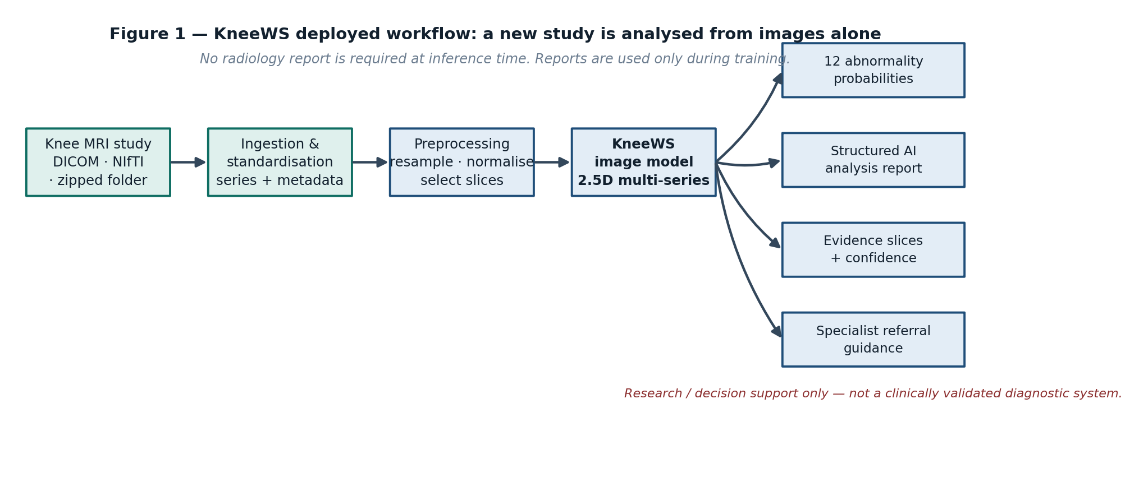
Figure 1 — Deployed workflow. Reports appear nowhere in this path.

3.2 The research core
This is where the contribution lives. Reports arrive in roughly ten languages, are read into a four-state matrix, and are then converted into probabilistic targets using estimated reliabilities rather than assumed ones. The expert-labelled studies sit to one side, and how they are used is precisely the difference between the primary method and Option B.
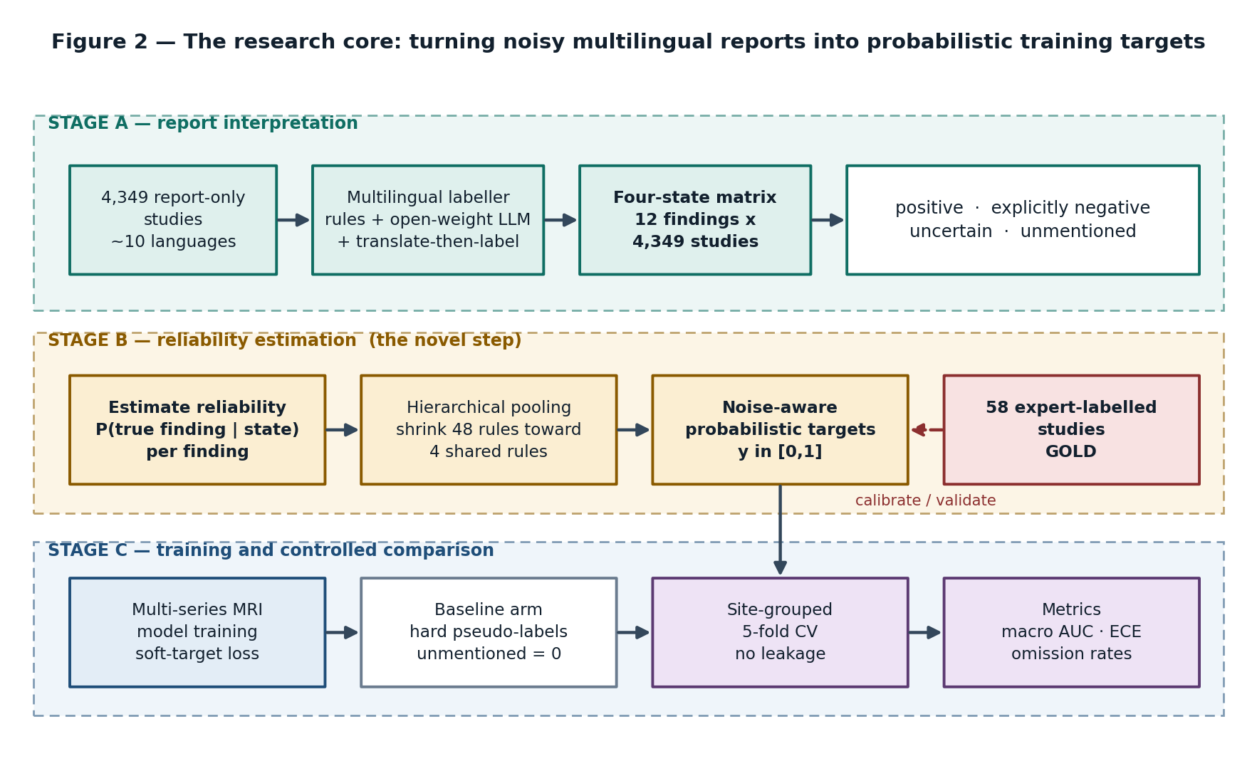
Figure 2 — Stage A reads the reports, Stage B estimates how much to trust them, Stage C trains and measures.
In the primary method the arrow from the expert set into Stage B is a fitting arrow: the reliabilities are calibrated on those studies. In Option B that arrow is severed during fitting and reconnected only for validation, which is the whole point of the alternative.

3.3 Four states instead of a binary label
A radiology report is written to communicate with a treating clinician, not to label a dataset. It says what the radiologist thought worth saying. Four different situations therefore hide behind what a naive pipeline would record as a zero: the finding was looked for and ruled out, the finding was hedged, the finding was simply never mentioned, or the finding was mentioned in a language or phrasing the extractor missed. Collapsing all of those to zero is the single most consequential error available in this project.
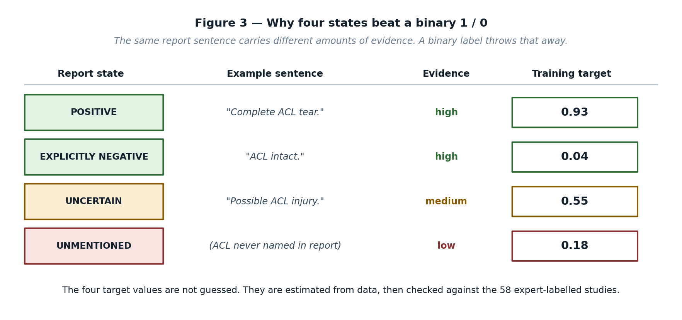
Figure 3 — The same zero can mean four very different things.
Why 'unmentioned' is the interesting state
Explicit negatives are usually trustworthy. Unmentioned findings are not. In the audit of this dataset, synovitis was present in about 46.6% of expert-read studies but appeared in only about 3.3% of reports — a finding radiologists routinely see and routinely do not write down. Training on 'unmentioned means absent' teaches the model that synovitis almost never happens.

3.4 The four layers
The system separates cleanly into a data layer that knows about DICOM and languages, a model layer that knows about tensors, a research layer that knows about experiments, and an application layer that knows about clinicians. Only the research layer is unusual; the other three are conventional and can be built with confidence.
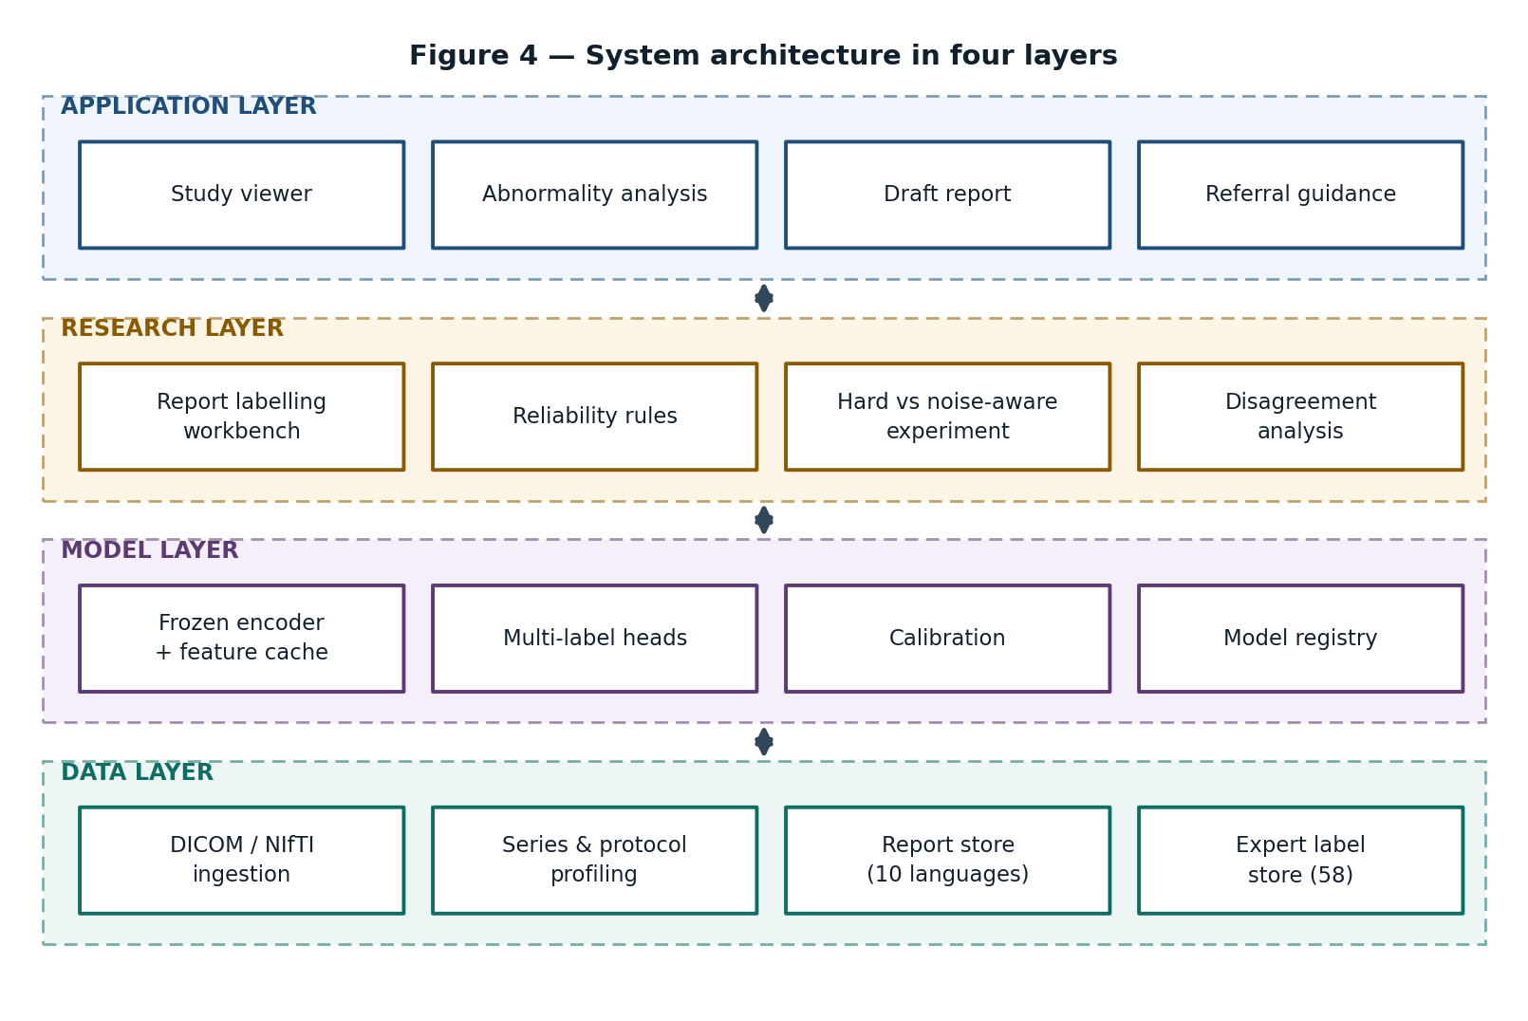
Figure 4 — Layered architecture. The research layer is the only one without an off-the-shelf equivalent.

3.5 The experiment that produces the result
The claim the project ultimately makes is comparative, so the comparison has to be airtight. Every arm uses the same architecture, the same splits and the same seeds, and differs only in how the training targets were constructed. Folds are grouped by site, not drawn at random, because in this dataset language is very nearly a proxy for institution, and random folds have been measured to inflate area under the curve by roughly 0.053 — an inflation larger than the effect the project is trying to detect.
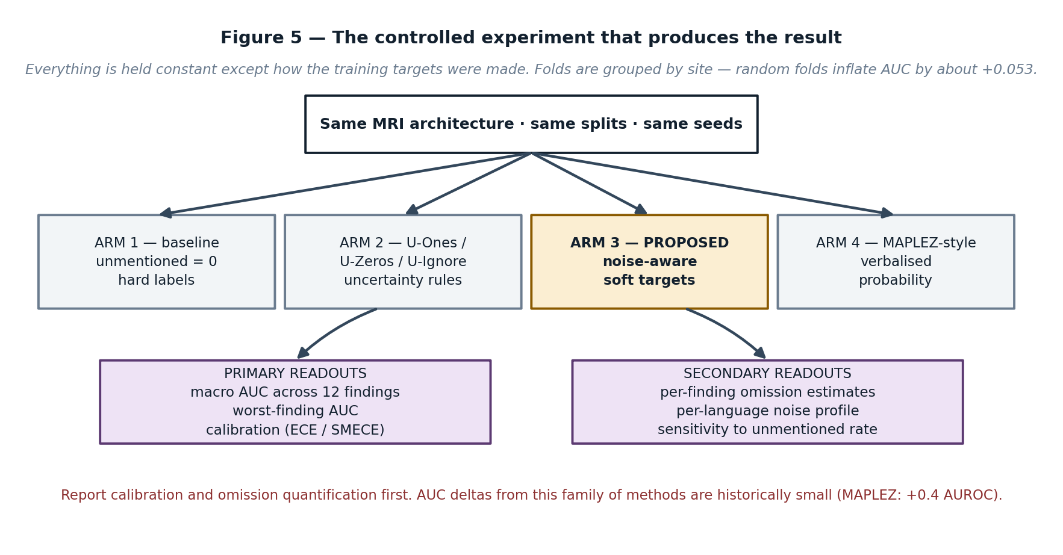
Figure 5 — Four arms, one architecture, site-grouped folds.
Expect a small headline number
The closest published comparator, MAPLEZ, gained about +0.4 AUROC from verbalised probabilistic targets. A project whose entire claim rests on beating a baseline by a fraction of a point is fragile. The defence is to lead with calibration quality and with quantified omission rates, both of which are large, measurable and interesting even when the AUC delta is not.

4. What the research established
This section records the substance of the working sessions behind the project: the dataset facts that constrain everything, the problems that surfaced, and how each was resolved.

4.1 Dataset facts
These figures are transcribed second-hand and must be re-verified on the Kaggle Data tab before they are quoted in the proposal.

Fact | Value
Training studies | 4,407 total
Studies with all twelve expert labels | 58 — the entire strong-supervision budget
Report-only studies | 4,349
Raw imaging volume | approximately 569 GB of DICOM
Hidden test set | approximately 1,300 studies with expert image-read labels
Competition metric | macro area under the ROC curve across the twelve findings
How gold labels were made | two musculoskeletal radiologists reading images, plus an adjudicator; severity thresholds applied; borderline cases resolved to negative
Report versus gold agreement | approximately 82.5% (audit on 20 studies)
Most extreme disagreement | synovitis: about 46.6% gold-positive against about 3.3% report-positive
Report languages | English 39%, Turkish 12%, Spanish 12%, then Croatian, Greek, German, Bulgarian, French and Dutch — about ten in total
Site leakage effect | random folds inflate AUC by about +0.053; language is close to a proxy for site
Rules constraint | hosted language-model APIs are reportedly not permitted for report text, so any model used must be open-weight and run in-notebook
Public baseline / leaderboard top | 0.891 with a multilingual rule extractor and a 2.5D DINOv2-small; top around 0.939

4.2 The fifty-eight problem, and how it is solved
Forty-eight reliability quantities — twelve findings by four states — estimated from fifty-eight studies looks impossible, and taken naively it is. Estimating a separate reliability for, say, the unmentioned state of fracture from fifty-eight cases would produce a number with an interval so wide it carries no information.
The resolution is partial pooling. Rather than treating the forty-eight quantities as independent, they are treated as forty-eight draws from four shared distributions, one per state. Findings that behave like the average are shrunk hard toward the shared estimate; findings with enough evidence to prove they are different are allowed to move away from it, and only as far as the evidence supports. In practice this means the project estimates four well-supported rules with credible intervals, and then permits per-finding deviations that the data pays for. This is standard hierarchical Bayesian practice and it is defensible in front of a panel precisely because it does not pretend the fifty-eight are larger than they are.
The honest framing for the defence
We do not claim to estimate forty-eight reliabilities from fifty-eight studies. We estimate four, with intervals, and let the data decide which findings have earned a deviation. Where a finding has not earned one, it inherits the shared estimate and we say so.

4.3 Gold agreement, explained
The term appears throughout the research findings as, for example, report versus gold agreement of about 82.5%, and it is worth being exact about what it means, because the whole project depends on it.
There are two label sources. Report-derived labels are extracted automatically from the radiology text by rules and language models; they are cheap, they exist for 4,349 studies, and they are noisy. Gold labels are what expert musculoskeletal radiologists recorded after reading the images themselves; they are expensive, they exist for 58 studies, and they are treated as truth.
Gold agreement is simply how often those two sources say the same thing. At about 82.5%, roughly one in six report-derived labels disagrees with what an expert sees on the image. That single number does three things for the project. It proves there is real noise to model, so the research question is not invented. It sets a ceiling: a model trained on report labels alone inherits that disagreement before it makes any errors of its own. And it gives the reliability estimates something to be checked against — the gold set is the referee, not the training signal.
Where the term becomes decisive
The gap between 82.5% overall agreement and the synovitis case — 46.6% against 3.3% — is the evidence that the noise is not uniform. Some findings are reported faithfully and some are almost never written down. A single global correction cannot fix that; a per-finding, per-state reliability model can. That contrast is the strongest single slide in the eventual defence.

4.4 Site leakage
Because language tracks institution in this dataset, a randomly drawn validation fold will almost always contain studies from the same scanner and the same reporting habits as the training fold. The model then partly learns the site rather than the pathology, and the measured score rises by about 0.053 for reasons that have nothing to do with the method. Since the effect the project is trying to detect is likely to be much smaller than that, every experiment must use folds grouped by site. This is a small implementation detail with the power to invalidate the entire result, and it belongs in the methods section of anything written about the project.

4.5 Hardware feasibility
The target machine is a laptop with an RTX 4070 carrying 8 GB of video memory, against 569 GB of DICOM. Running a full 3D network over whole volumes is not possible on that hardware, and pretending otherwise would be the fastest way to a failed project.
The design that fits is two-stage and 2.5D. A frozen pretrained encoder passes over the selected slices once and its feature vectors are cached to disk; from then on, training a lightweight multi-label head runs on cached features in minutes, on the CPU if necessary. Only the feature-extraction pass touches the GPU, it is done once per preprocessing configuration, and it streams. The practical consequence is that the expensive part happens overnight and the research iteration — which is where the actual work is, since the project is about labels rather than architectures — becomes fast enough to run dozens of ablations.

Constraint | How the design absorbs it
8 GB VRAM | 2.5D slice batches through a frozen encoder; no end-to-end 3D training
569 GB of DICOM | stream and cache features; never hold the dataset resident
Many ablation arms needed | arms share the cached features and differ only in target construction, so each arm costs minutes rather than hours
Nine-hour offline notebook limit | inference path must be self-contained with open-weight models only

4.6 The prior-art audit
Two independent prior-art searches were run across roughly a hundred papers from 2018 to 2026. The purpose was not to find support for the idea but to find out which parts of it were already published, before a panel or a reviewer did. The result was uncomfortable and useful.

Component of the idea | Already published
Four-state report labels | CheXpert 2019 and CheXbert 2020 established positive / negative / uncertain / unmentioned. MAPLEZ (MedIA 2025) went further with five states and verbalised probabilities as soft targets. MOSAIC 2025 did it across four languages.
Unmentioned does not mean absent | VisualCheXbert (CHIL 2021) quantified it. Wood 2020 and Benger 2023 measured per-category report sensitivity of 60–78% in brain MRI. Fytas 2026 found 59% of confirmed chest findings absent from reports.
Soft targets with a noise-aware loss | Dunnmon et al., Patterns 2020, using a label model and no gold labels at all.
Per-class reliability from a small expert re-read set | Gündel and Ghesu, MedIA 2021 — reliability estimated on a small expert subset and injected into the loss. This is closest to the registered primary method.
Unmentioned treated as unlabelled (PU learning) | Xiao, IEEE TMI 2024; Kobayashi 2026.
The gold-fitted soft-prior labeller | A competitor in the live competition (the JunhaoLiXD repository) already implements a three-state labeller with state-specific soft priors calibrated on gold folds by hierarchical empirical Bayes. Unpublished, and scoring 0.664 on the leaderboard, but it exists.

Confident learning itself is also established: Northcutt et al., JAIR 2021, with medical applications in Bernhardt et al., Nature Communications 2022 and Lin et al., npj Digital Medicine 2025. Two papers must be read in full before any novelty claim is written down: Ye et al., Expert Systems with Applications 2026, on label-wise reliability in chest radiography, and Xiao, IEEE TMI 2024, on multi-label positive-unlabelled learning.

4.7 What is still open
After the audit, four claims remain defensible. They are narrow, and narrowness is the point — a narrow claim that survives review is worth more than a broad one that does not.
- Gold-free estimation of the four-state noise model. Estimating P(true finding | report state, finding) by confident learning on site-grouped out-of-fold predictions, and validating it against an untouched expert set, has not been published. It has not been done on MRI and it has not been done multilingually.
- Per-finding, per-language omission rates for knee MRI. Quantifying how often each of the twelve findings is present but unmentioned, broken down by report language, is a measurement nobody has made for this modality.
- Hierarchical shrinkage across finding and language for the gold-fitted variant, presented as the comparator that spends the expert labels.
- A controlled comparison of labelling routes — translate-then-label against a native open-weight model against multilingual rules — on roughly ten languages of MRI reports.

The separation nobody could make before
Earlier multilingual medical work, Med-UniC 2023 among it, could not disentangle language bias from institutional bias because each language came from one hospital. This dataset has multiple sites per language, which finally makes the two separable. That is a property of the data, not of our cleverness — but it is ours to exploit.

5. Secondary option (B) — confident learning without gold labels
Read this first
Option B is not a replacement for KneeWS. The title, the scope, the ten features and the CCP mapping are all unchanged by it. Option B changes one thing: the estimator inside Feature 5. It is documented here in full because it is the strongest available answer to the single hardest question a panel can ask, and because it costs almost nothing to keep in reserve.

5.1 The question it answers
The registered method estimates report reliability by comparing report labels against the fifty-eight expert-labelled studies. A panel member, or a reviewer, will eventually ask the obvious question: your entire method is calibrated on fifty-eight cases, so how do you know it generalises, and what independent evidence do you have that it worked?
Under the primary method the honest answer is uncomfortable. The fifty-eight were consumed by the fit. Cross-validation within them helps, and the hierarchical pooling of Section 4.2 keeps the estimates from overfitting badly, but there is no genuinely untouched expert data left to prove the result. Option B removes the question entirely by never spending the expert labels in the first place.

5.2 How it works, in plain words
The insight is that a model trained on noisy labels will disagree with those labels in a systematic, informative way. If the reports say a finding is absent in a thousand studies, and a model trained on those very reports confidently predicts the finding is present in a hundred and eighty of them, that pattern is evidence about the reports, not merely evidence about the model. Confident learning is the formal machinery for turning that pattern into a noise model.
The procedure is: train on the noisy labels as they are; look at where the model confidently disagrees with them; count those disagreements in a structured way; and read off, from those counts, how often each report state actually corresponds to a true finding. No expert label is required at any point in that chain. The expert set is then brought in at the very end for one job only — checking whether the estimate was right.
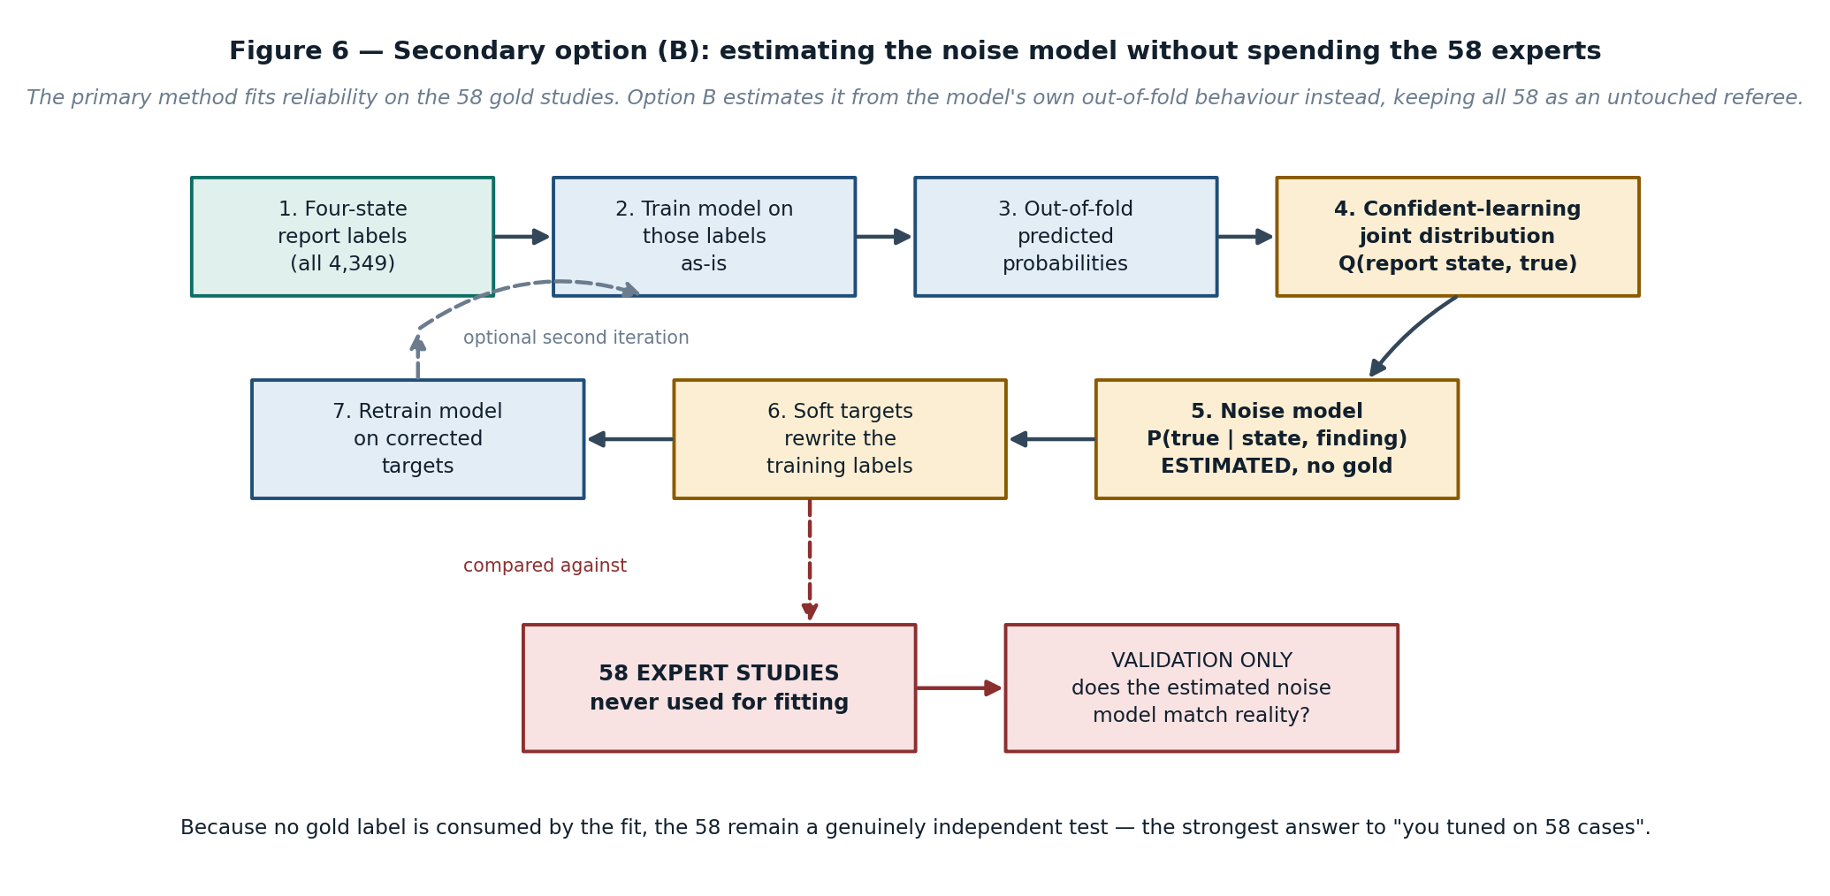
Figure 6 — Option B. The expert set is cut out of the fitting loop and restored as an independent referee.

5.3 The mathematics
Let a single finding be fixed — the procedure runs independently for each of the twelve, with pooling across them for the rare ones. Write s for the observed report state, taking one of four values, and y for the unobserved truth of the finding, taking values present or absent.

Step 1 — out-of-fold probabilities | Train the image model on the report-derived labels as they are, using site-grouped folds, and record for every study a predicted probability p̂(y = present | x) produced by a fold that never saw that study.
Step 2 — self-confidence thresholds | For each class j, set the threshold t(j) equal to the average predicted probability of class j among the studies whose observed state maps to j. Using the model's own average confidence rather than a fixed 0.5 is what makes the estimate robust to a miscalibrated model.
Step 3 — the confident joint | Build the count matrix C[s = i, y = j] as the number of studies whose observed report state is i and whose predicted probability for class j exceeds t(j), assigning to the arg-max class when more than one threshold is exceeded. Studies that exceed no threshold are not counted.
Step 4 — normalise | Scale C to the dataset size to obtain an estimated joint distribution Q(s, y) over report state and truth.
Step 5 — the reliability rules | Read off P(y = present | s) = Q(s, present) divided by the sum of Q(s, ·). This yields one probability per report state per finding — the same forty-eight quantities the primary method estimates, obtained without a single gold label.
Step 6 — shrinkage | For findings whose counts are thin, pool toward the state-level estimate using a Dirichlet prior, exactly as in Section 4.2. The pooling machinery is shared between the primary method and Option B; only the input counts differ.
Step 7 — soft targets | Replace each hard label with the corresponding P(y = present | s, finding) and retrain with a soft-target binary cross-entropy. Optionally iterate once; do not iterate repeatedly, because the model and the noise estimate will begin to reinforce each other.

The property that makes this worth the trouble
Because no expert label enters the fit, the fifty-eight remain statistically independent of everything that was estimated. Comparing the estimated P(present | unmentioned) against the empirical rate observed in the expert set is then a real test with a real chance of failing — which is precisely what makes it convincing when it passes.

5.4 Step-by-step build order
The following is the implementation sequence, written so that each step produces something checkable before the next begins.

- Build the four-state labeller. Multilingual rules first, because they are auditable and fast; then an open-weight language model producing the four states; then a translate-then-label route as the third opinion. Combine by ensemble. Do not use a hosted API — the competition rules reportedly forbid it for report text.
- Produce the four-state matrix. Twelve findings by 4,349 report-only studies. Hand-audit a stratified sample of roughly a hundred report-finding pairs across languages and record the labeller's own error rate. This number will be asked for.
- Quarantine the expert set. Physically separate the fifty-eight studies into a directory that the training pipeline cannot read. Enforce it in code, not by discipline.
- Build site-grouped folds. Five folds grouped by institution. Verify that no site appears in both training and validation of any fold, and record the mapping so results are reproducible.
- Cache image features. One pass of a frozen encoder over selected slices, features written to disk. This is the only GPU-heavy step and it is done once.
- Train the base model on labels as they are. Unmentioned mapped to absent, which is the naive baseline and also Arm 1 of the experiment. Collect out-of-fold predicted probabilities for every study.
- Compute self-confidence thresholds per finding per class, as in Step 2 of Section 5.3.
- Build the confident joint and normalise it, producing the estimated noise model. Inspect it before using it: the estimated P(present | explicitly negative) should be low and the estimated P(present | unmentioned) should be materially above zero for findings like synovitis. If it is not, something upstream is wrong.
- Apply hierarchical shrinkage for findings with thin counts, and record which findings earned a deviation from the shared estimate and which inherited it.
- Rewrite the training targets as soft probabilities and retrain the heads on the cached features. Because the features are cached, this costs minutes.
- Unseal the expert set and validate. Compare estimated reliabilities against the empirical rates in the fifty-eight. Report the agreement and the disagreement. A gap is a result, not a failure — it bounds how far the class-conditional assumption holds.
- Run the remaining arms — uncertainty heuristics, verbalised probability, and the gold-fitted primary method — on identical folds and features, and assemble the comparison table.
- Report calibration and omission first, then AUC. Expected calibration error on the expert set, a smoothed calibration measure on the soft targets, per-finding omission estimates, and per-language noise profiles.

5.5 The four candidate methods compared
Four ways of getting from report text to training targets were evaluated. They are not mutually exclusive; three of them become ablation arms whichever one leads.

Option | Method | Strength | Weakness
A | Gold-fitted reliability. Estimate P(true | state) on the 58 expert cases with hierarchical empirical Bayes. | Direct, interpretable, and closest to the registered scope. Uses the expert labels for exactly what they look like they are for. | Consumes the only strong supervision available, leaving nothing independent to validate against. A competitor already implements it.
B | Confident learning, gold-free. Estimate the noise model from out-of-fold predictions. | Keeps all 58 as an untouched referee. Not published for this setting, not on MRI, not multilingual. Strongest answer to the fifty-eight question. | Assumes noise is class-conditional when it is really severity-dependent. Can only detect what the model can already partly see.
C | Positive-unlabelled learning. Treat unmentioned as unlabelled rather than negative. | Theoretically clean and a natural fit for the omission problem. | Already published for report labels (Xiao 2024, Kobayashi 2026). Needs a class-prior estimate that is itself hard to obtain.
D | Verbalised probability. Ask an open-weight model to state a probability, use it as a soft target. | Simple to implement and already validated in MAPLEZ. | Published. Gained only about +0.4 AUROC. Depends on the language model's own calibration, which is unmeasured for these languages.

5.6 Weaknesses of Option B, and the answers
Every one of these should be pre-empted in the writing rather than conceded under questioning.

Objection | Response
Confident learning assumes noise depends only on the class, but a subtle tear is more likely to go unreported than an obvious one. | Correct, and it is a real limitation. The consequence is that omission is under-estimated for subtle findings, which biases the result in the conservative direction. Measure it against the expert set, state the bias and its direction explicitly, and stratify by severity wherever the reports supply enough detail to do so.
The method can only find noise the model is already capable of seeing. Synovitis is exactly the case where it may fail. | Also correct. Report the circularity plainly and use the expert set to bound it: the gap between estimated and observed omission for synovitis is itself a publishable measurement of the method's limit.
Some findings are too rare for stable counts. | Handled by the same hierarchical pooling as the primary method. Rare findings inherit the state-level estimate and are reported as having inherited it.
The improvement in AUC will be small. | It probably will be. This is why the headline claim is calibration and quantified omission rather than accuracy, and why the omission table is the centrepiece of the results section.
Random folds would look better. | They would, by roughly 0.053, and the result would be worthless. Site-grouped folds throughout, stated in the methods.
Someone has already done this. | For the gold-fitted variant, yes — that is Option A and it is the comparator. For gold-free confident learning over four report states, on MRI, across ten languages, the audit found nothing. Two papers remain to be read in full before the claim is written down.

5.7 When Option B would be promoted
The decision does not need to be taken now, and should not be. It is taken once, at the end of the first phase, on evidence.
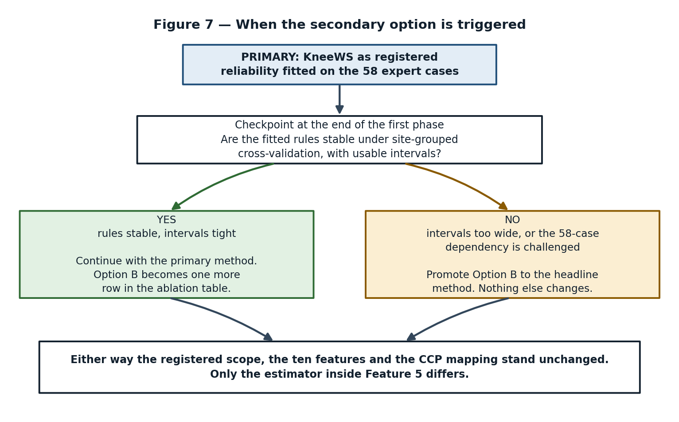
Figure 7 — The switch condition. The system does not change either way.
If the reliability estimates fitted on the expert set turn out to be stable under site-grouped cross-validation, with intervals tight enough to act on, the primary method stands and Option B becomes one more row in the ablation table — which is a good place for it to be, since it costs little and strengthens the paper. If the intervals are too wide to support a claim, or if a supervisor or panel presses hard on the fifty-eight-case dependency, Option B is promoted to the headline method. The registered scope, the ten features and the CCP mapping survive the switch untouched, because the only thing that changes is which estimator sits inside Feature 5.

6. Work plan
The plan is arranged so that the risky, novel work happens early enough to fail safely, and the application layer — which is well understood and low-risk — is built later when the research shape is settled.

6.1 First phase
Weeks | Work | Deliverable
1–2 | Join the competition, verify every dataset figure first-hand on the Data tab, secure storage for 569 GB | A verified facts sheet replacing the second-hand numbers in Section 4.1
2–4 | DICOM and NIfTI ingestion, series reconstruction, protocol profiling | Features 1 and 2 working on real studies
4–7 | Multilingual four-state labeller: rules, then open-weight model, then translate-then-label | Features 3 and 4, plus a hand-audited accuracy figure for the labeller itself
6–8 | Feature caching pipeline and site-grouped fold construction | Cached features and a verified leakage-free split
8–10 | Baseline model, Arm 1, out-of-fold probabilities | A working macro-AUC number to compare everything against
10–13 | Reliability estimation, both the gold-fitted primary and the Option B estimator | Feature 5, with intervals
13–15 | Checkpoint and decision | Written go / no-go on whether Option B is promoted, per Figure 7

6.2 Second phase
Weeks | Work | Deliverable
16–19 | Noise-aware training and the remaining experimental arms | The full comparison table across four arms
19–22 | Disagreement and failure analysis, per-language noise profiling | Feature 10, and the omission table that carries the results section
22–26 | Application layer: study viewer, abnormality analysis, structured report, referral guidance | Features 6 through 9
26–28 | Calibration, evaluation harness, reproducibility packaging | Metrics, model registry, reproducible runs
28–30 | Write-up, defence preparation, paper draft | Thesis and a submittable manuscript

7. Risks
Risk | Severity | Mitigation
The measured improvement is too small to claim | High | Lead the results with calibration and quantified omission, both of which are large and interesting regardless of the AUC delta. Frame the contribution as measurement, not as a leaderboard gain.
Site leakage invalidates the comparison | High | Site-grouped folds enforced in code from week six, with an automated check that no site spans a fold boundary.
A published paper already contains the claim | High | Read Ye et al. 2026 and Xiao 2024 in full before writing the novelty statement. Keep the claim narrow: gold-free, four-state, MRI, multilingual.
Storage or compute proves insufficient | Medium | Two-stage 2.5D design with cached features; the GPU is needed only for one extraction pass. Subset the data if necessary and state the subset.
The multilingual labeller is the real bottleneck | Medium | Ensemble three independent routes and publish the labeller's own audited error rate rather than assuming it is correct.
The fifty-eight figure is wrong | Medium | Verify on the Data tab in week one. Every downstream design decision depends on it, so it is checked before anything is built.
Scope creep into a clinical product | Low | Referral guidance stays at specialist-category level. The disclaimer in the registered scope is repeated in the interface itself.

8. Immediate next actions
- Join the competition and verify the dataset facts in Section 4.1 first-hand on the Kaggle Data tab, in particular the count of fifty-eight fully expert-labelled studies.
- Read Ye et al., Expert Systems with Applications 2026, and Xiao, IEEE TMI 2024, in full, and write a one-paragraph statement of exactly what remains unclaimed after them.
- Restate Feature 5 in the working scope so that it names the estimator as a choice between the gold-fitted and gold-free routes, without changing the registered wording.
- Implement site-grouped five-fold cross-validation before any model is trained, so that no result ever has to be discarded for leakage.
- Build the four-state labeller and hand-audit a stratified sample of roughly a hundred report-finding pairs across languages.
- Implement the confident-learning estimator and validate it against the quarantined expert set.

Appendix A — Glossary
Terms used throughout, in plain language.

Term | Meaning
Weak supervision | Training a model on labels that are cheap and imperfect rather than expensive and correct. Here, the labels come from radiology reports that were written for patient care, not for machine learning.
Gold label | A label produced by an expert reading the image itself. Treated as truth. There are 58 fully gold-labelled studies.
Gold agreement | How often report-derived labels match gold labels. About 82.5% in this dataset, meaning roughly one in six disagrees.
Four-state label | Recording a report finding as positive, explicitly negative, uncertain or unmentioned instead of as a one or a zero.
Omission | A finding that is truly present but never mentioned in the report. The central problem of the project.
Soft target | A training label that is a probability between zero and one rather than a hard zero or one, reflecting how much the label is trusted.
Noise model | The set of probabilities describing how often each report state corresponds to a true finding. Written P(true | state, finding).
Confident learning | A technique that estimates a noise model by counting where a model trained on noisy labels confidently disagrees with them.
Out-of-fold prediction | A prediction for a study made by a model that never saw that study during training. Required for confident learning to be valid.
Partial pooling / shrinkage | Estimating many related quantities together, letting each borrow strength from the others, so that thin evidence produces a cautious estimate rather than a wild one.
Site leakage | Score inflation caused by the same institution appearing in both training and validation folds. Worth about +0.053 AUC here.
Calibration (ECE) | Whether a predicted probability means what it says — whether events predicted at 70% happen about 70% of the time.
2.5D | Processing a volume as a set of two-dimensional slices with some cross-slice context, instead of as a full 3D tensor. Chosen to fit 8 GB of video memory.
Macro AUC | The competition metric: area under the ROC curve computed per finding and then averaged equally across the twelve, so rare findings count as much as common ones.

KneeWS — project record compiled 9 September 2026. The primary idea is the registered submission and is unchanged. Option B is documented as a secondary method held in reserve, to be promoted only on the evidence described in Section 5.7.

