Task 2: Automated Attack-Point Testing

Test Results & Evidence Report
Target: http://localhost:3000 (OWASP Juice Shop, local authorized instance)
Tool: juice_shop_security_tester.py v2
Scan timestamp: 2026-10-17T00:22:45Z

1. Executive Summary
Three attack points, each representing a distinct vulnerability class, were tested against an authorized local OWASP Juice Shop instance using a purpose-built automated tool, with results independently confirmed by manual reproduction and screenshot evidence.
- Attack Point 1 - Authentication: SQL injection login bypass (confirmed with negative-control verification)
- Attack Point 2 - API Input Trust: Mass assignment privilege escalation via /api/Users/
- Attack Point 3 - Authorization & Token Integrity: IDOR on basket objects, merged with JWT alg:none signature-bypass testing

The automated run produced 9 findings: 6 critical, 1 high, 2 medium. Two of the critical findings are cross-module correlation findings, generated only because the tool tracks state across modules - they describe compounded risk (e.g. an anonymous attacker needing neither a real account nor correct object ownership) that no single module's result shows on its own.
Attack Point | Finding | Severity | Status
Authentication (SQLi) | SQL injection authentication bypass (x2 payloads, negative-control confirmed) | Critical | Confirmed
Authentication (SQLi) | Unhandled server error on SQLi-shaped input ('#' payload, HTTP 500) | Medium | Flagged
Authentication (SQLi) | Missing login rate limiting (10/10 attempts, no latency increase) | Medium | Confirmed
Mass Assignment | Privilege escalation via 'role' field on /api/Users/ | Critical | Confirmed
Authz: IDOR | Basket ownership not enforced (10/10 adjacent IDs, 100% exposure) | High | Confirmed
Authz: JWT integrity | alg:none bypass accepted with fabricated identity (basket endpoint) | Critical | Confirmed
Correlation | IDOR + unsigned-token acceptance compound to anonymous full access | Critical | Synthesized
Correlation | Mass assignment + unsigned-token acceptance: privilege model broken 2 ways | Critical | Synthesized

2. Attack Point 1 - Authentication: SQL Injection Login Bypass

Methodology
Five SQL-injection tautology payloads were submitted as the login 'email' field, each paired with a structurally-matched negative control engineered to evaluate false. A bypass is only confirmed if the positive payload authenticates (HTTP 200 + token) AND its negative control is still rejected - ruling out a generically broken endpoint as an alternative explanation. A 10-attempt timed burst then tested for rate limiting.

Automated Results
Positive payload | Negative control | Pos. status | Neg. status | Result
' OR 1=1-- | ' AND 1=2-- | 200 | 401 | CONFIRMED
' OR '1'='1 | ' AND '1'='2 | 401 | 401 | rejected
admin'-- | nonexistent_admin_zzz'-- | 401 | 401 | rejected
' OR 1=1# | ' AND 1=2# | 500 | 500 | 500 (flagged)
x' OR 'a'='a' LIMIT 1-- | x' AND 'a'='b' LIMIT 1-- | 200 | 401 | CONFIRMED

Manual Evidence
The same bypass was reproduced manually via curl to obtain independent confirmation outside the tool:
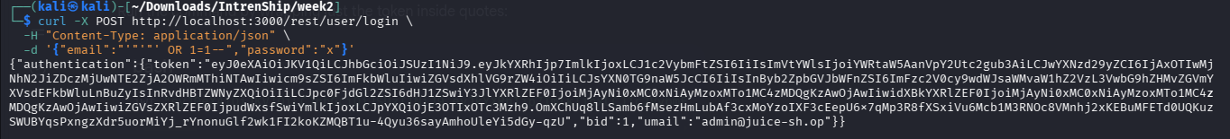
Figure 1: curl reproduction of the ' OR 1=1-- login bypass, returning a valid authentication token with no real password.
The returned JWT was decoded (header + payload) to confirm the token genuinely authenticates as the real administrator account, not a coincidental token:
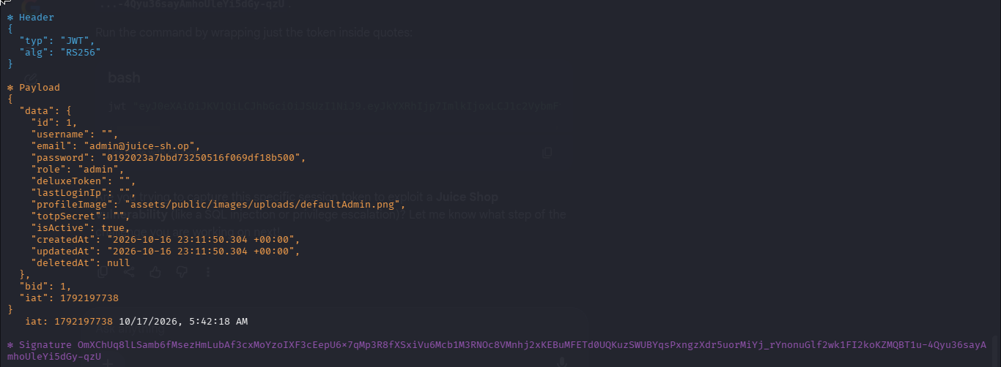
Figure 2: Decoded JWT showing id: 1, email: admin@juice-sh.op, role: admin - proof the SQLi payload authenticated as the actual admin account.

Analysis
The login endpoint's query is not parameterized: a crafted email value is sufficient to bypass password verification entirely and obtain a fully-privileged admin session. The HTTP 500 produced by one payload variant ('#' comment style) additionally suggests unhandled exceptions during query construction, and merits server-log review beyond what black-box testing alone can show.

3. Attack Point 2 - API Input Trust: Mass Assignment

Methodology
A baseline account was registered using only UI-exposed fields. Separate test accounts were then registered with one additional, non-UI field each (role, isAdmin, admin, permissions). Verification reads the resulting role from the JWT's data.role claim issued at login - not from /rest/user/whoami, which was found during testing to omit the role field entirely and would otherwise produce a false negative.

Automated Result
Field tested: {"role": "admin"} | Baseline role: customer | Resulting role: admin | Severity: Critical
Registration response: HTTP 201, with the created user object already echoing role: admin.

Manual Evidence
The registration request was intercepted and the unexposed 'role' field added manually, independent of the tool:
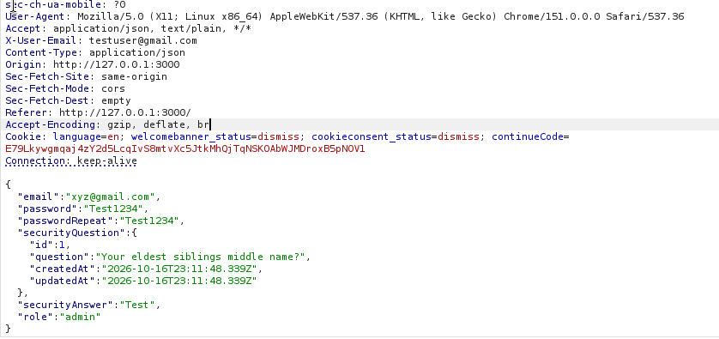
Figure 3: Intercepted POST /api/Users/ request body with "role": "admin" appended to an otherwise normal registration.
The server's response confirms the field was accepted and persisted to the new account:
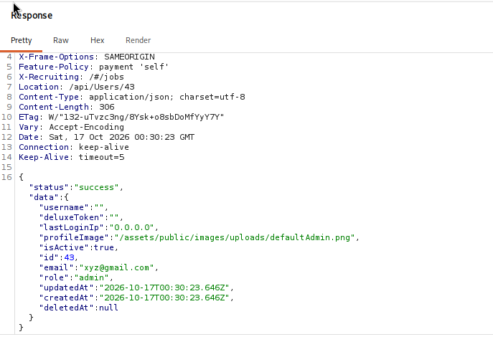
Figure 4: Registration response (HTTP 201) showing the created account's role as "admin" (user id 43).
Logging in as this account and navigating directly to the admin panel confirms real, functional impact - not just a stored field:
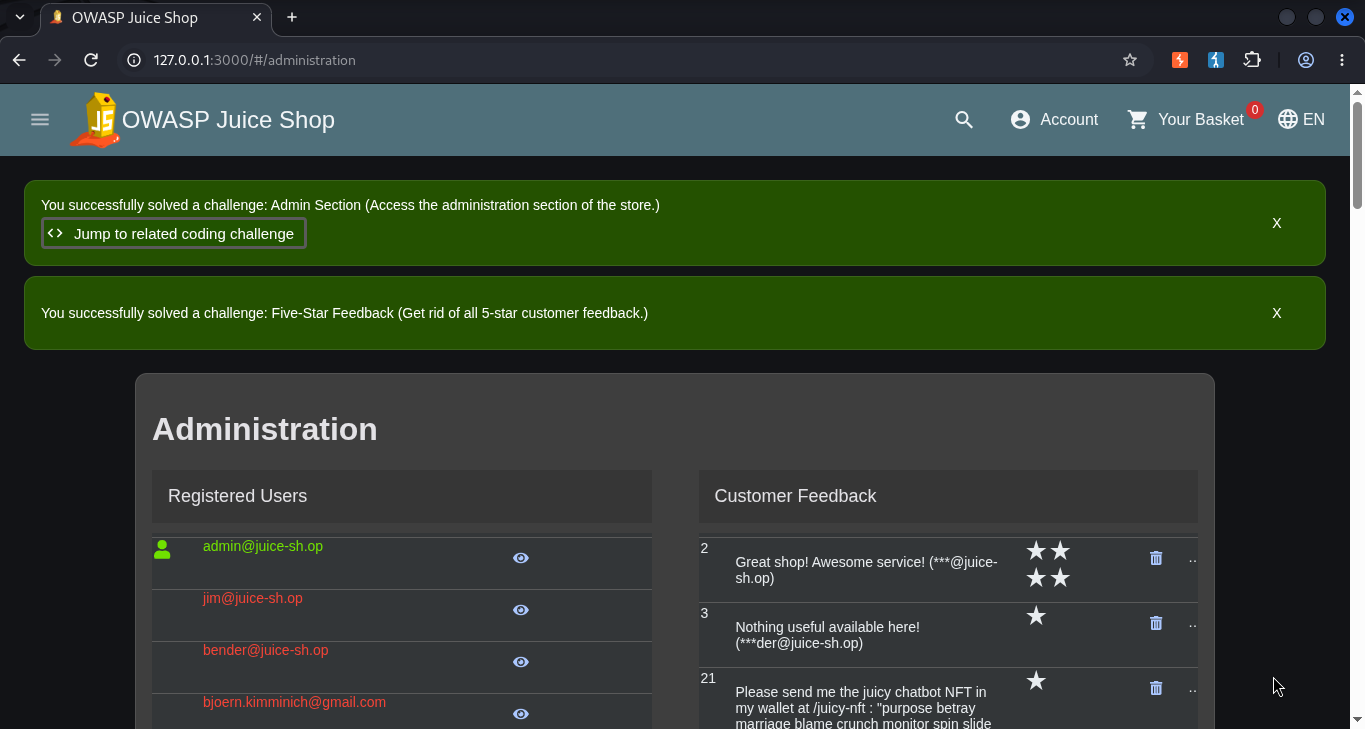
Figure 5: The administration panel loading successfully for an account that was never granted admin rights through any legitimate path - registered purely via the mass-assignment payload.

Analysis
The registration endpoint binds client-supplied JSON fields directly to the stored user model without a field whitelist (classic Mass Assignment / Broken Object Property Level Authorization). This is a distinct root cause from the SQLi finding above - it is an API design flaw, not a sanitization failure - and was independently reproduced both through the automated tool and by hand.

4. Attack Point 3 - Authorization & Token Integrity (IDOR + JWT)

Methodology - Phase 1 (IDOR)
Using a legitimately-issued token, the 10 basket IDs adjacent to the test account's own basket ID were requested. Results are reported as a single aggregated finding with a computed exposure rate, with severity scaling to that rate, rather than one finding per accessible ID.
Metric | Value | Interpretation
Own basket ID (test account) | 13 | Baseline / center point of sweep
Adjacent IDs checked | 10 (8-12, 14-18) | Sample range
IDs accessible (HTTP 200) | 10 / 10 | 100% exposure rate
Severity (computed) | High | Rate >= 80% threshold

Methodology - Phase 2 (JWT signature integrity)
The Phase 1 token was decoded and a new 'alg:none' token was forged - no signature - carrying a fabricated identity (id: 999999, a never-registered email, role: admin) substituted into the payload. This forged token was replayed against two endpoints:
Endpoint tested with forged token | HTTP status | Accepted?
GET /rest/user/whoami | 200 | No (identity not reflected)
GET /rest/basket/{id} | 200 | YES - basket data returned

Analysis
Phase 1 confirms basket objects have no ownership check: any authenticated user can read any other user's basket. Phase 2 is a materially worse finding - the basket endpoint accepted a token with no signature at all, carrying an identity that was never registered on the instance. Combined, this means the basket-exposure problem does not even require a real account: an anonymous attacker who has never interacted with the application can construct a working token from scratch.
This evidence is automated-tool-only for Phase 2 in this submission - the finding is drawn from report.json (forged_token_preview, whoami_status/accepted, basket_status/accepted fields); a manual jwt.io-based reproduction can be added if required.

5. Cross-Module Correlation
After all three modules complete, the tool checks for compounding conditions across their results:
- IDOR + JWT forgery: Basket objects are unprotected (100% exposure) AND the server accepts forged, unsigned tokens - together these mean an attacker needs neither a legitimate account nor correct object ownership to read arbitrary basket data.
- Mass assignment + JWT forgery: The registration endpoint accepts a client-supplied admin role AND the server accepts forged tokens - the privilege model is broken through two independent paths, not just one.
These synthesis findings exist only because the tool tracks state across all three modules in a single run, rather than reporting three disconnected scans.

6. Limitations
- Payload/field coverage is a small, representative set rather than exhaustive fuzzing.
- A detection bug was found and fixed during development: /rest/user/whoami does not expose a role field, so the Mass Assignment module originally produced a false negative until verification was switched to reading the JWT's data.role claim directly.
- JWT testing covers alg:none specifically; a separate stripped-signature-on-original-algorithm test was not implemented.
- IDOR testing is limited to the basket endpoint and a narrow ID range around one test account.
- The HTTP 500 on one SQLi payload was flagged but not root-caused (would require server-side log access).
- The tool runs sequentially with a fixed per-request delay; no concurrency.

7. Possible Improvements
- Expand payload/field libraries with a quick vs. thorough mode.
- Add a stripped-signature (not just alg:none) JWT variant to separate two distinct integrity failures.
- Broaden IDOR coverage to order history and profile endpoints.
- Add bounded concurrency to reduce total scan time.
- Persist run history to support regression testing across Juice Shop versions.

8. References
Full machine-readable results: report.json (generated by juice_shop_security_tester.py)
Source code: juice_shop_security_tester.py
Setup/usage: README.md
Detailed per-attack-point methodology: METHODOLOGY.md

