

WEB BASED APPLICATION DEVELOPMENT
CSE3023

LAB REPORT 2
NAME: MOHAMMAD AIMAN BIN ALIAS
MATRIC: S75686
DATE: 7.4.2026
PROGRAMME: COMPUTER SCIENCE
(SOFTWARE ENGINEERING)

Task 1: Data Sharing in Servlet
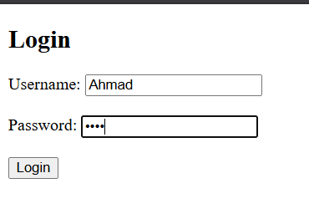
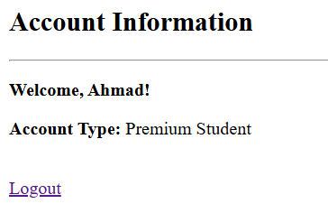
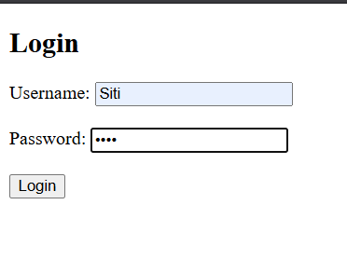
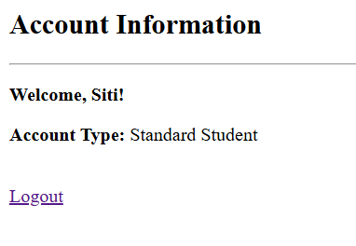
2.5 Task 2: Creating A Table in MySQL Database
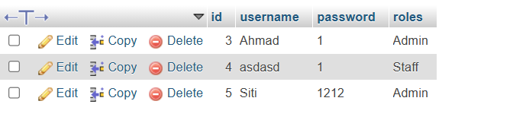
2.6 Task 3: Setting the Environment of Web Application for Database Connection
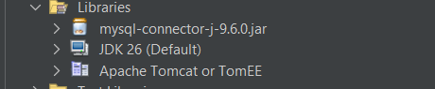
2.7 Task 4: Using Servlets for Database CRUD Operations
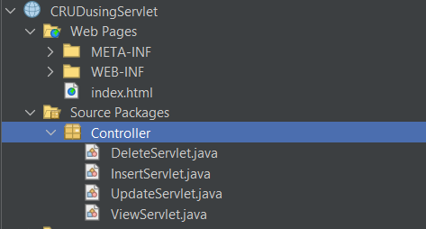
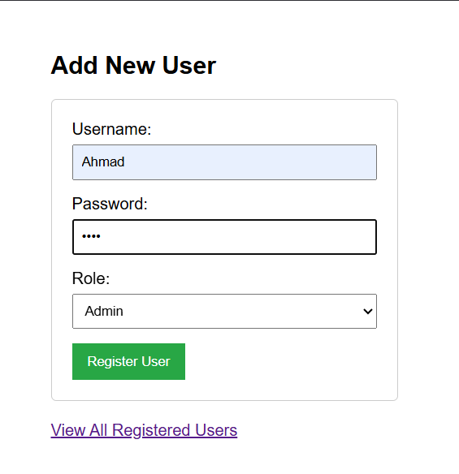
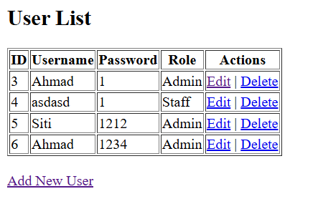
2.8 Task 5: Using Servlets, DAO and Java Beans for Database CRUD Operations
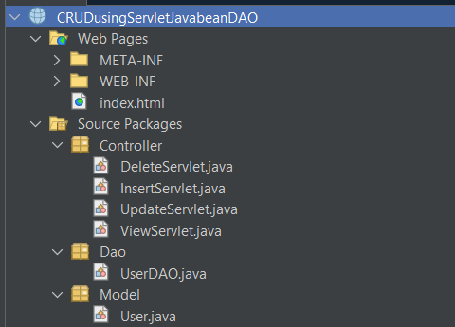
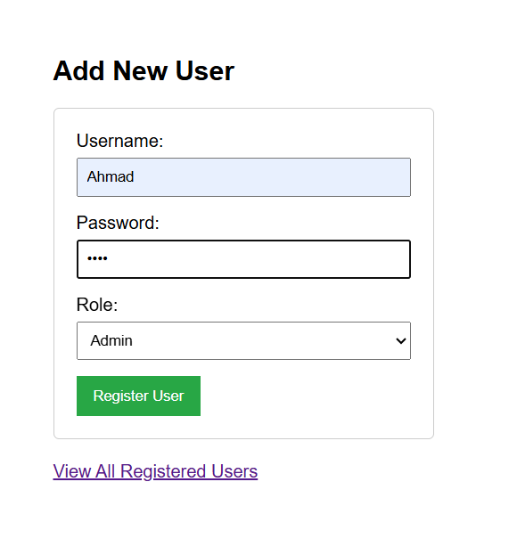
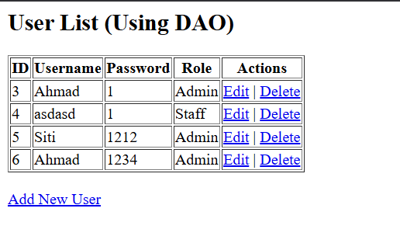
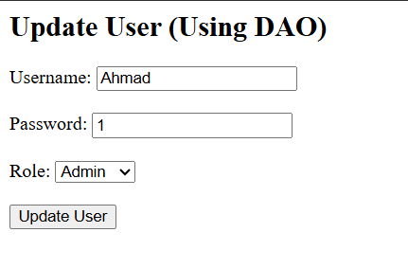
Delete and Update Ahmad
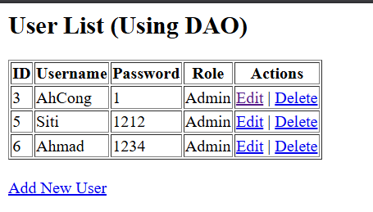
2.9 Exercise
1. Database Setup:
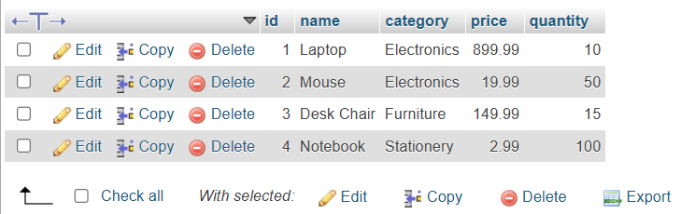
2. JavaBean (Model):
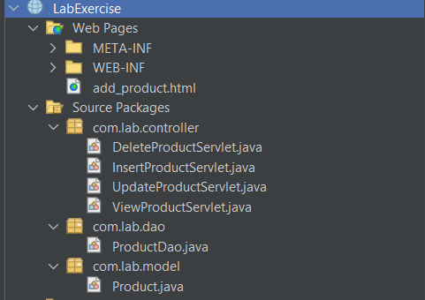
3. Data Access Object (DAO):

4. Servlets (Controller):

5. User Interface (View) add_product.html:

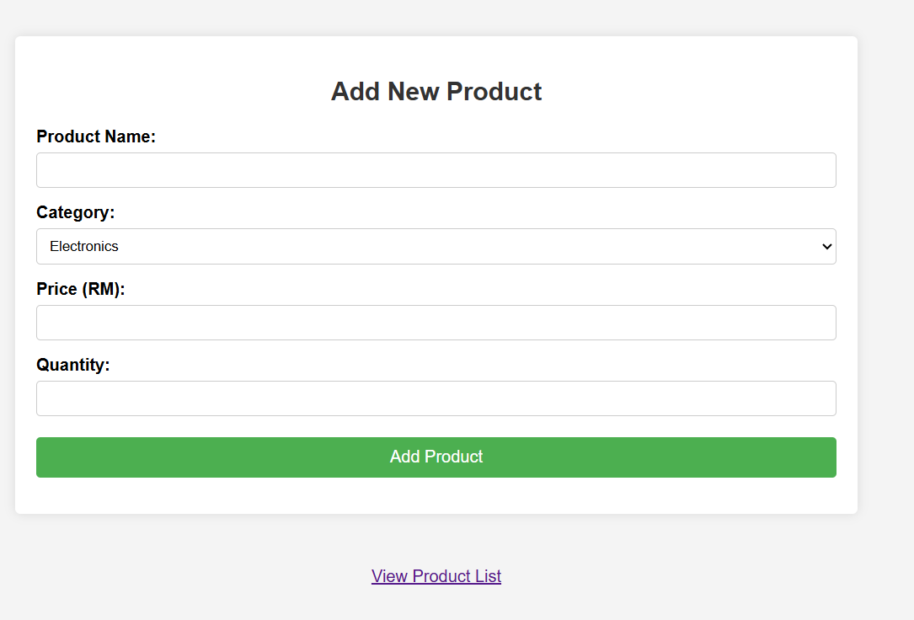
View
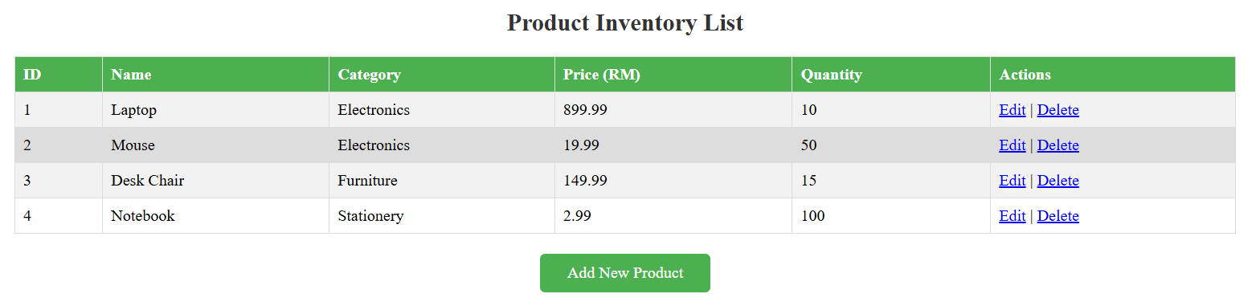
Create
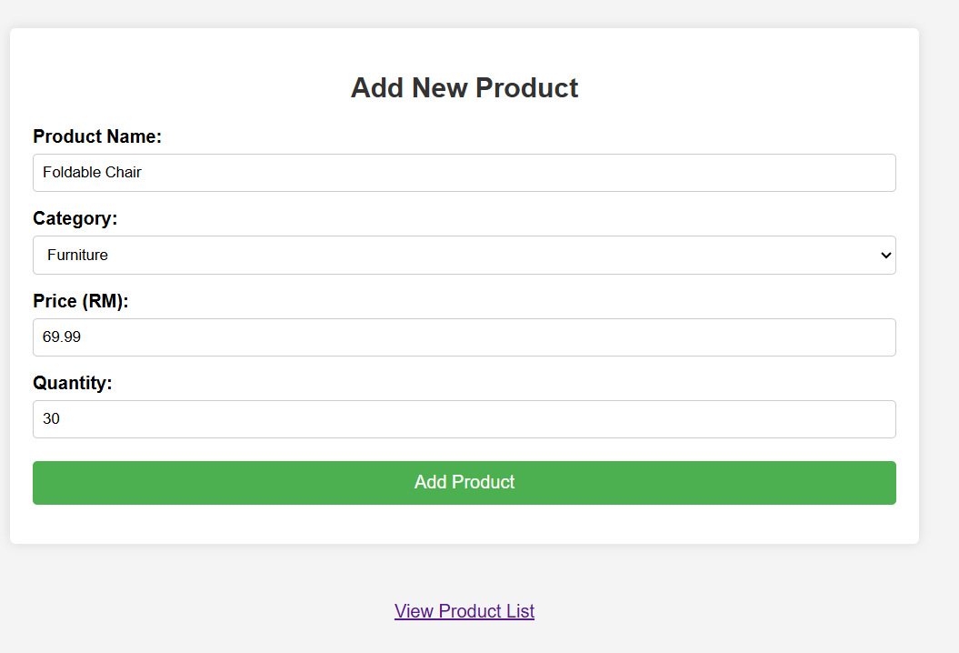
Update
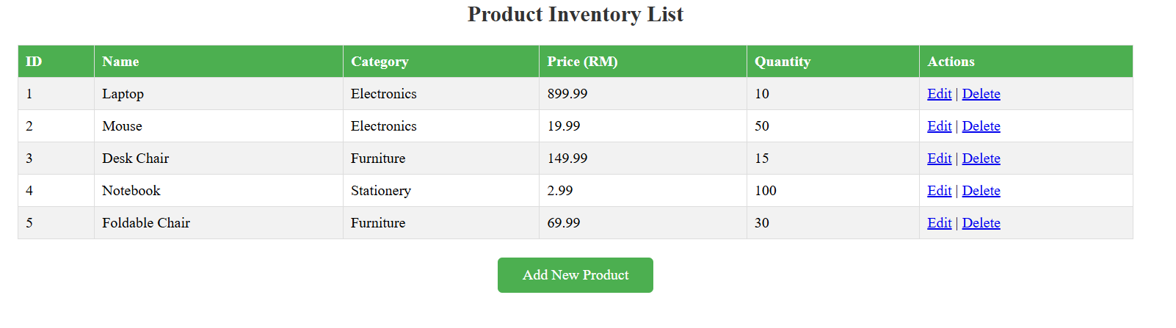
Delete
