

WEB BASED APPLICATION DEVELOPMENT
CSE3023

LAB REPORT 7
NAME: MOHAMMAD AIMAN BIN ALIAS
MATRIC: S75686
DATE: 19.5.2026
PROGRAMME: COMPUTER SCIENCE
(SOFTWARE ENGINEERING)

7.8 Exercise: Student Subject Management System (CRUD)
Session Management: You MUST retrieve the student’s identity (Matric No) from the HttpSession to ensure they only manage their own subjects.
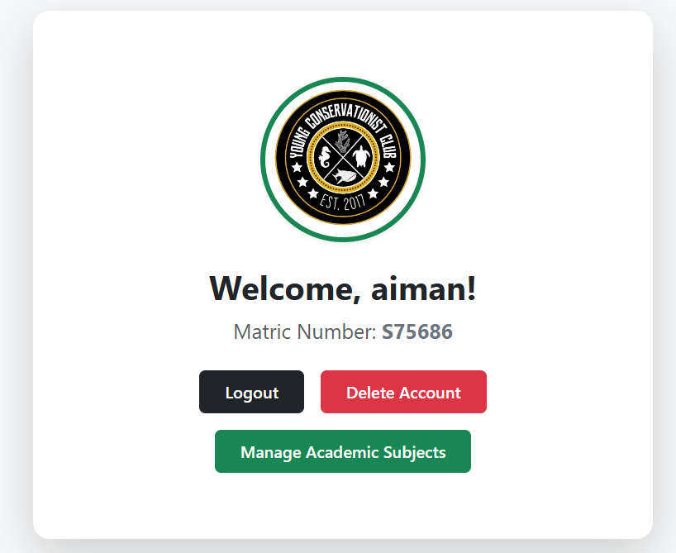
View Subject
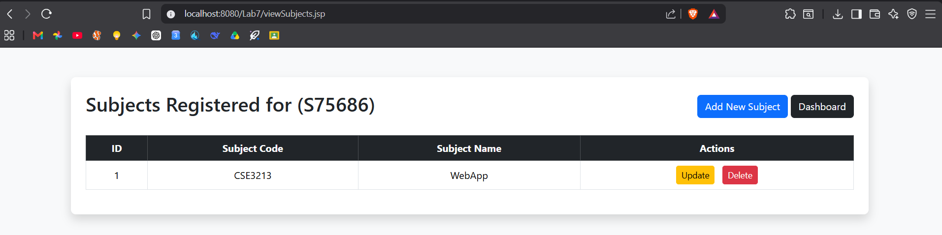

Create Subject
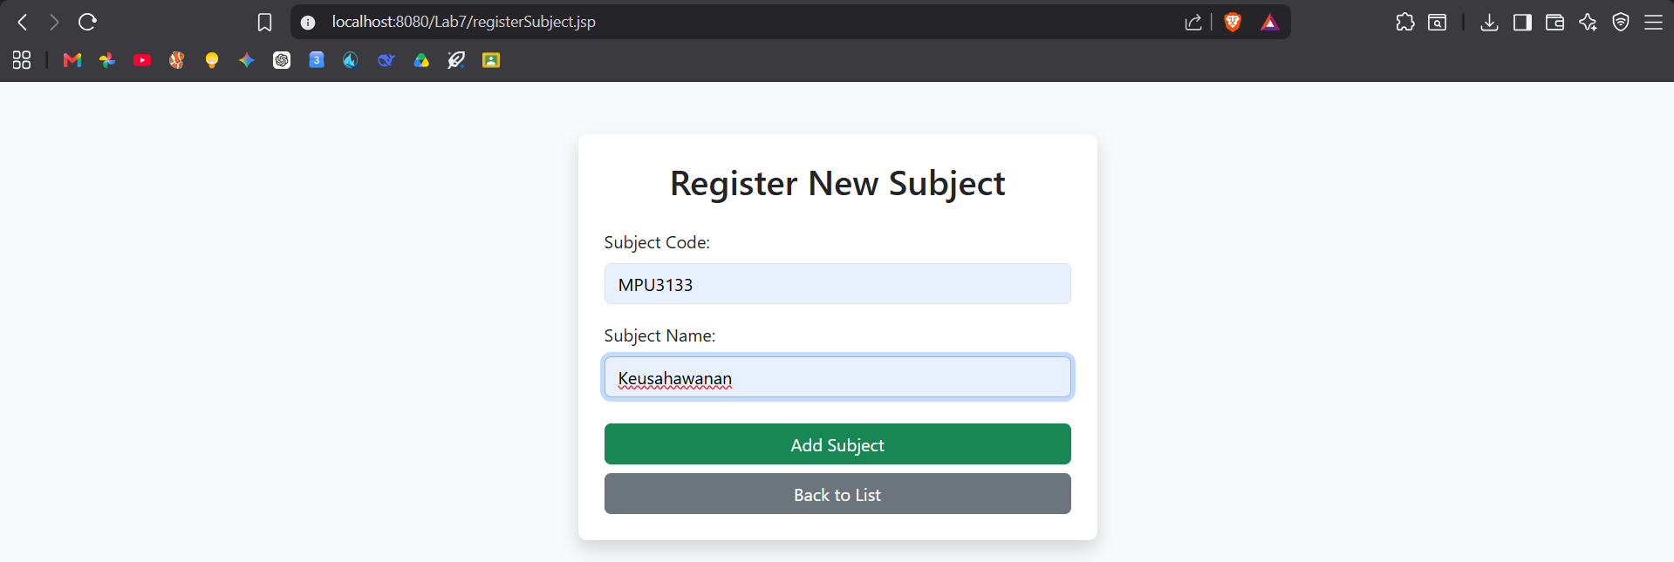
Update Subject
Before
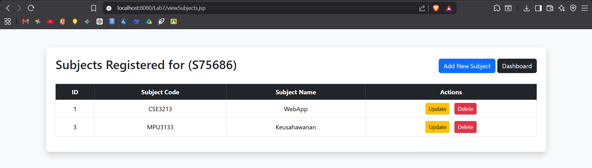
After
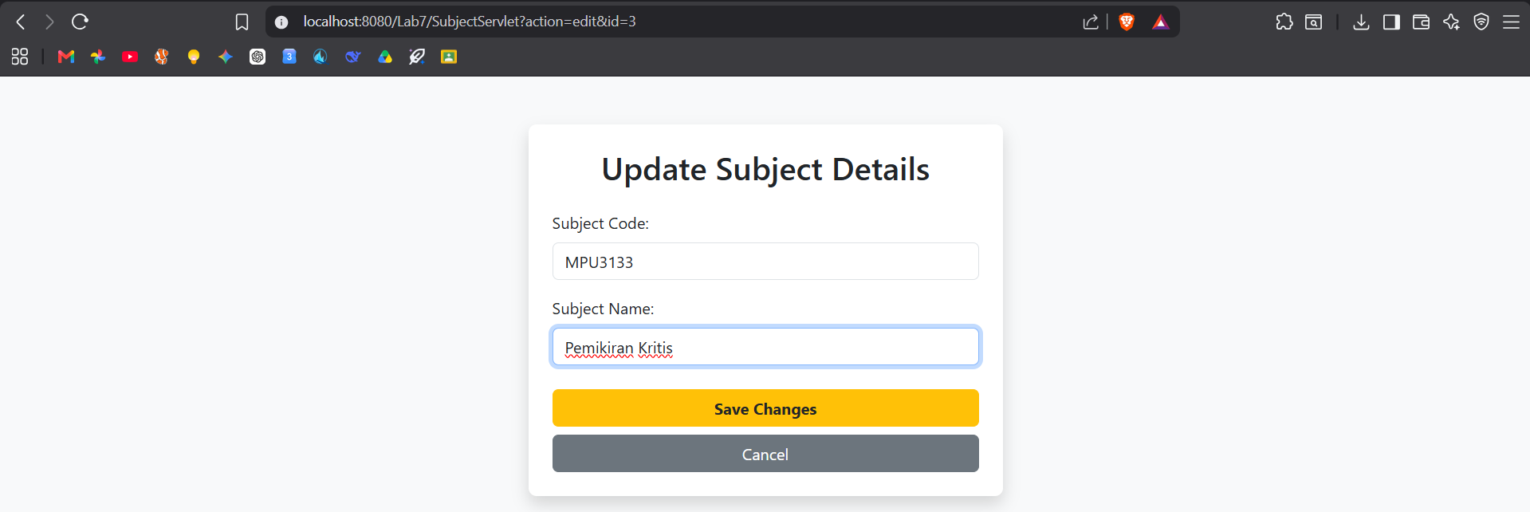
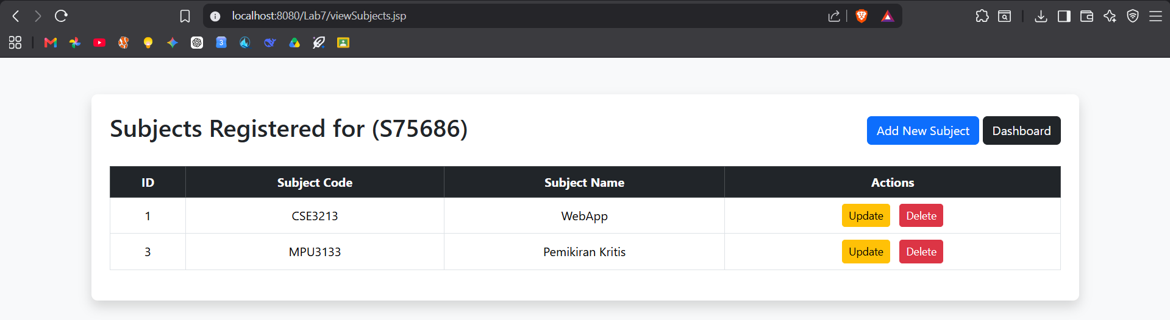

Delete Subject
