

WEB BASED APPLICATION DEVELOPMENT
CSE3023

LAB REPORT 4
NAME: MOHAMMAD AIMAN BIN ALIAS
MATRIC: S75686
DATE: 21.4.2026
PROGRAMME: COMPUTER SCIENCE
(SOFTWARE ENGINEERING)

4.4 Task 1: Using JSP Scripting
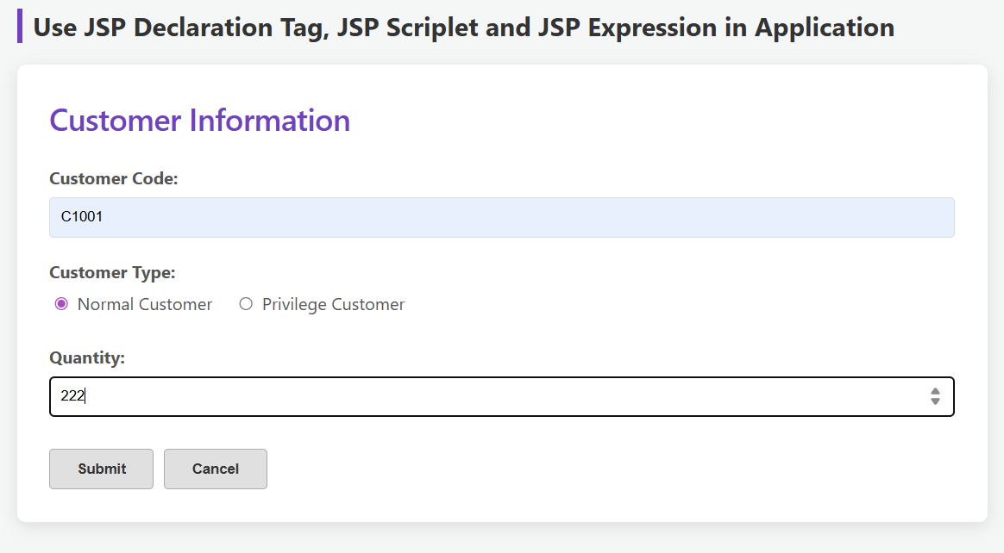
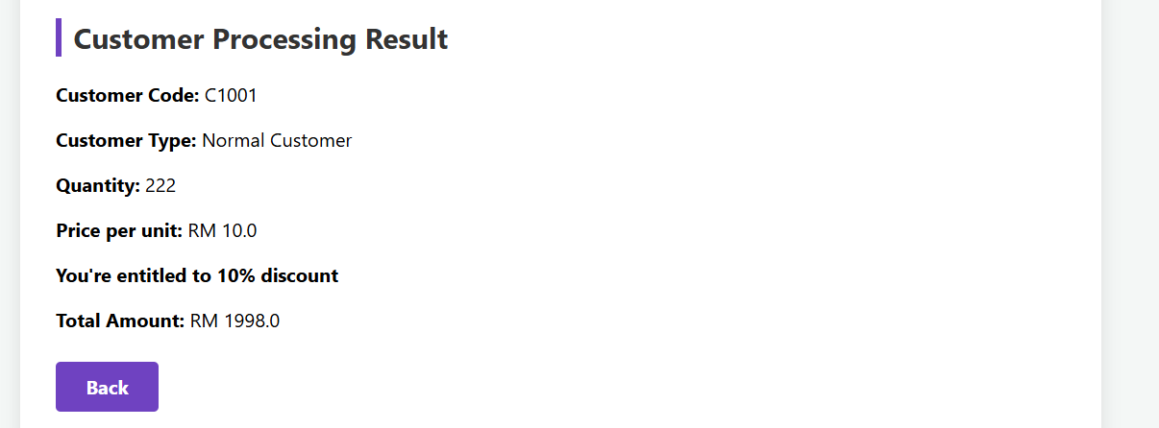
4.5 Task 2: Using JSP (Scripting, Declaration and Expression)
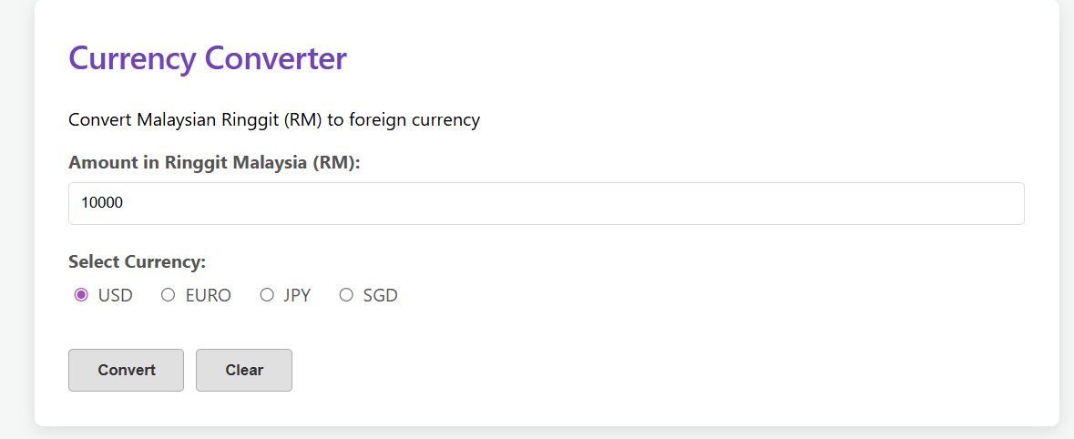
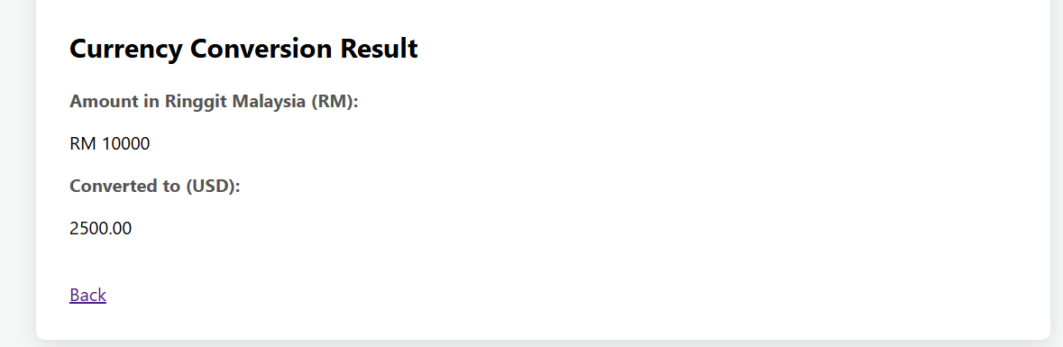
4.6 Task 3: Using JSP Standard Action (Include and Param)
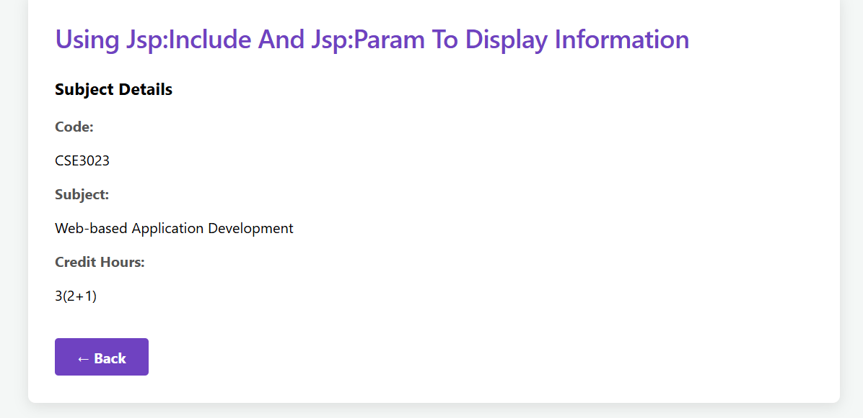
4.7 Task 4: Using JSP Standard Action (Forward)
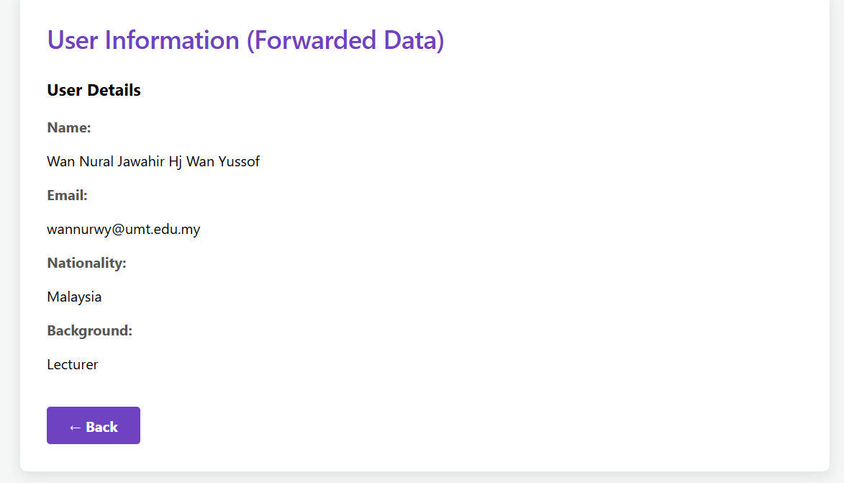
4.8 Task 5: Using JSP Scriptlet to Construct Business Logic
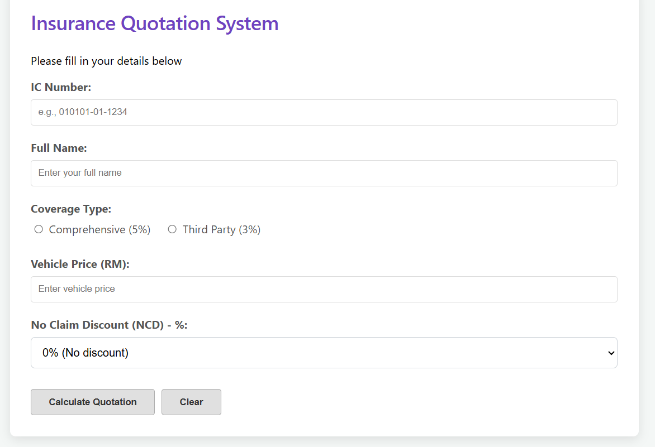
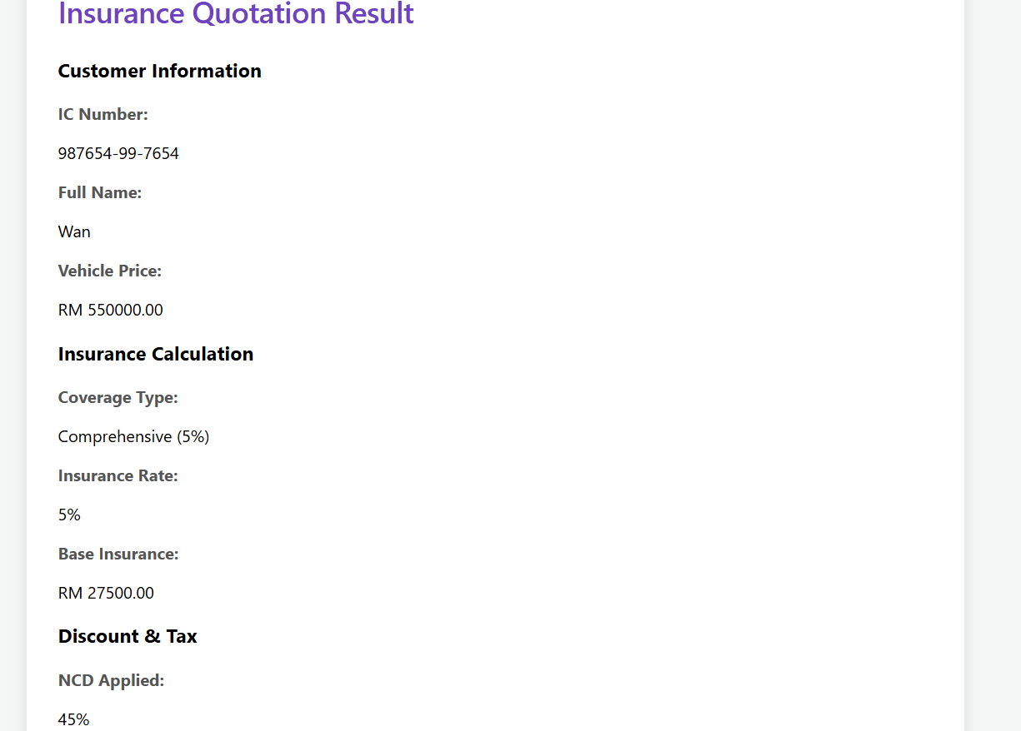
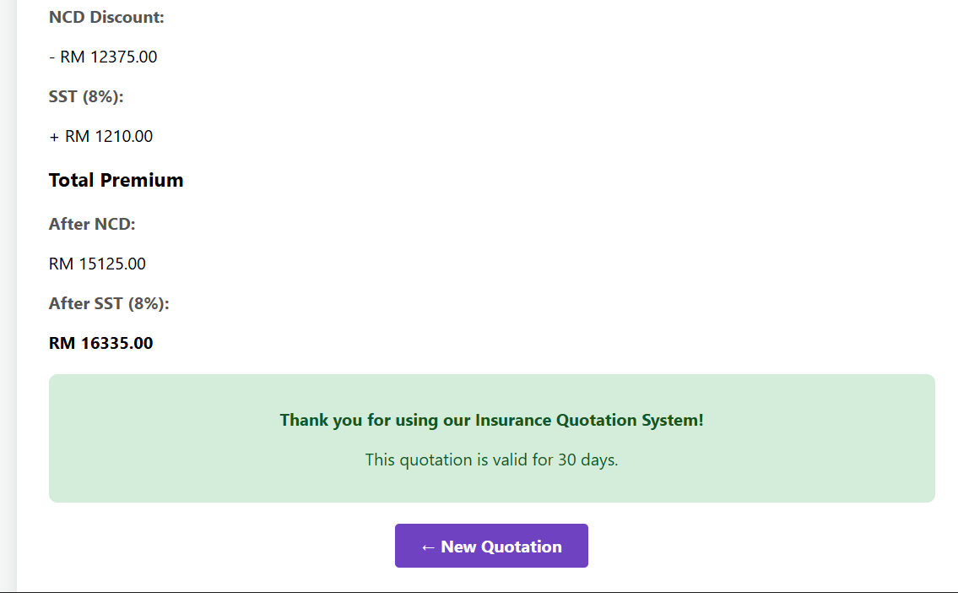
4.8 Exercise
