

WEB BASED APPLICATION DEVELOPMENT
CSE3023

LAB REPORT 3
NAME: MOHAMMAD AIMAN BIN ALIAS
MATRIC: S75686
DATE: 14.4.2026
PROGRAMME: COMPUTER SCIENCE
(SOFTWARE ENGINEERING)

3.4 Task 1: Passing Data from Main JSP’s Page to Other JSP’s Page
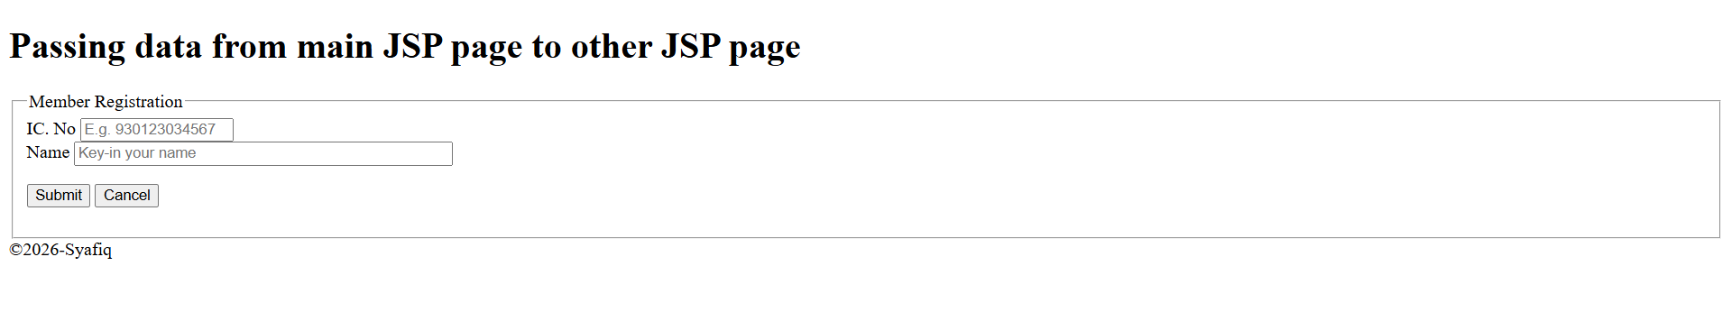
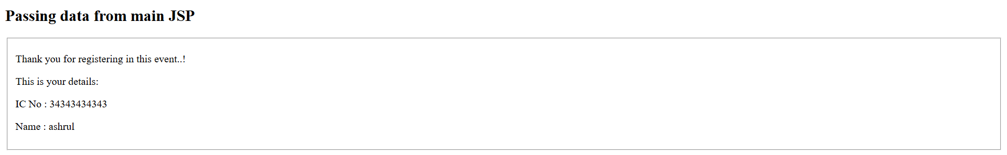
3.5 Task 2: Using Mathematics Operations in JSP


3.6 Task 3: Populate an Array Values into HTML’s Table
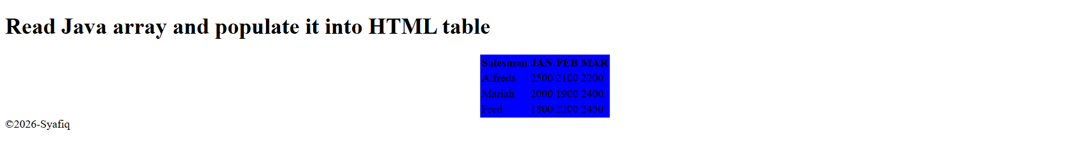
3.7 Task 4: Perform Calculation of Car Loan
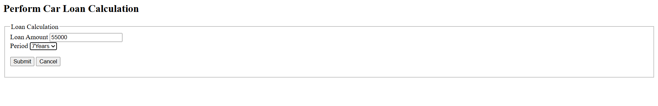
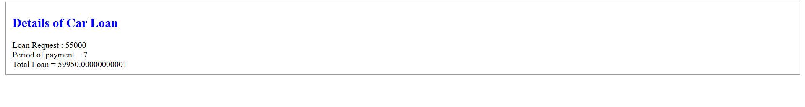
3.8 Task 5: Using JSP Page Directive to Call Java API
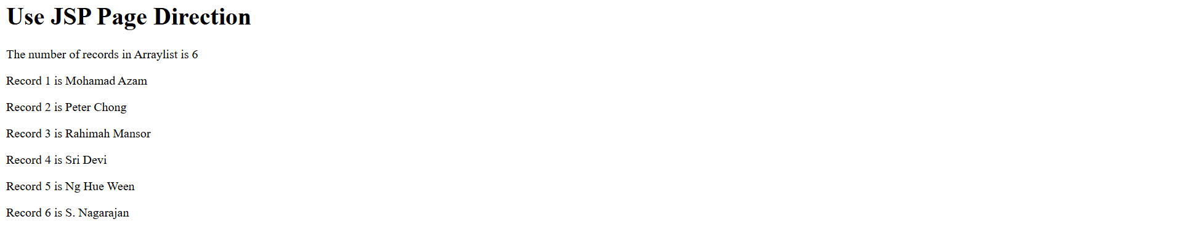
3.9 Task 6: Use JSP Include directive for JSP Page
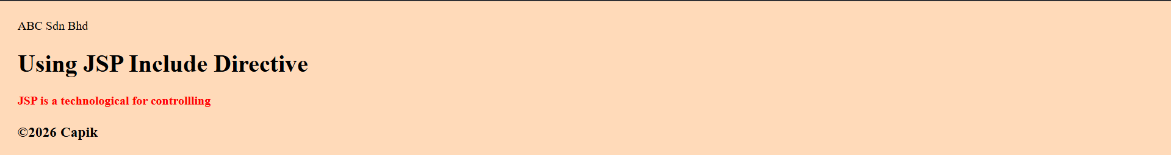
3.9 Exercise
