

WEB BASED INTERFACE DESIGN
CSF3133

LAB REPORT 5
NAME: MOHAMMAD AIMAN BIN ALIAS
MATRIC: S75686
DATE: 4.12.2026
PROGRAMME: COMPUTER SCIENCE
(SOFTWARE ENGINEERING)

5.3 Inline.html
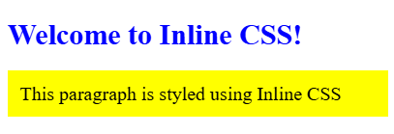
5.4 Internal HTML
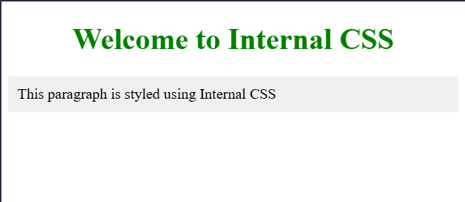
5.5External HTML
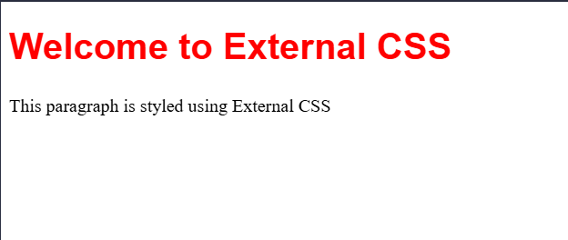

5.6 Link HTML
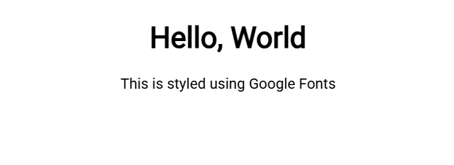
5.7 bgImage HTML
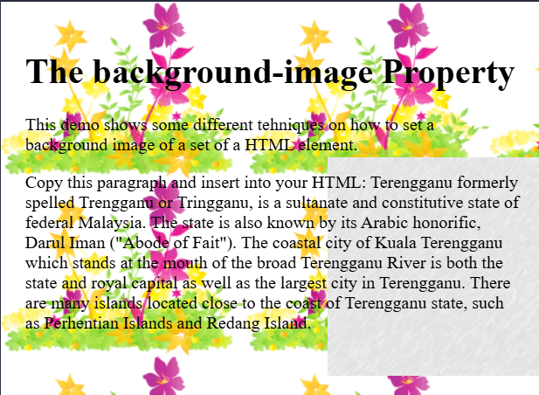
5.8 table HTML
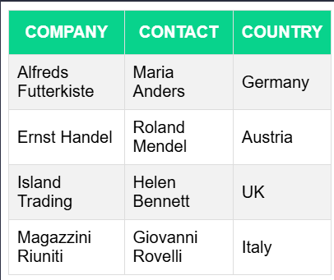
5.9 navigation HTML
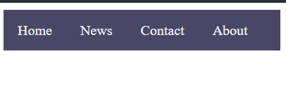

5.10 umt HTML (lab exercise)


