

Name: Aiman Bibi
Reg No: BCSP253013
Assignment 01:
Walkthrough Task:

Walkthrough Task:
Class Task:
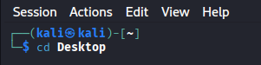

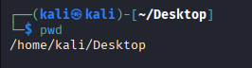

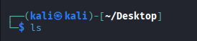



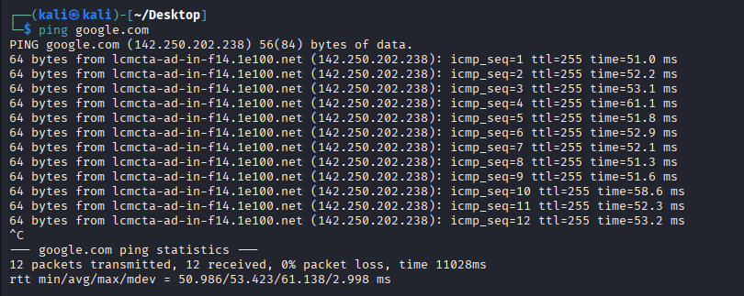

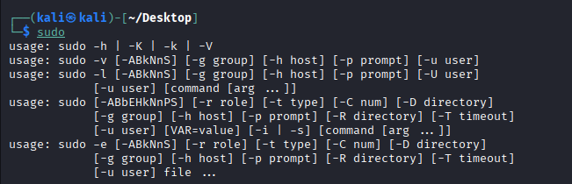

Walkthrough Task — DIKW Applied to auth.log:

Step 2 — Information Extraction with Python (7 minutes)
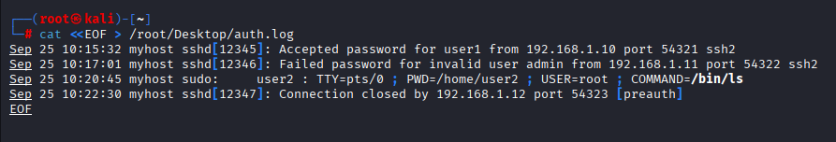
Walkthrough.py
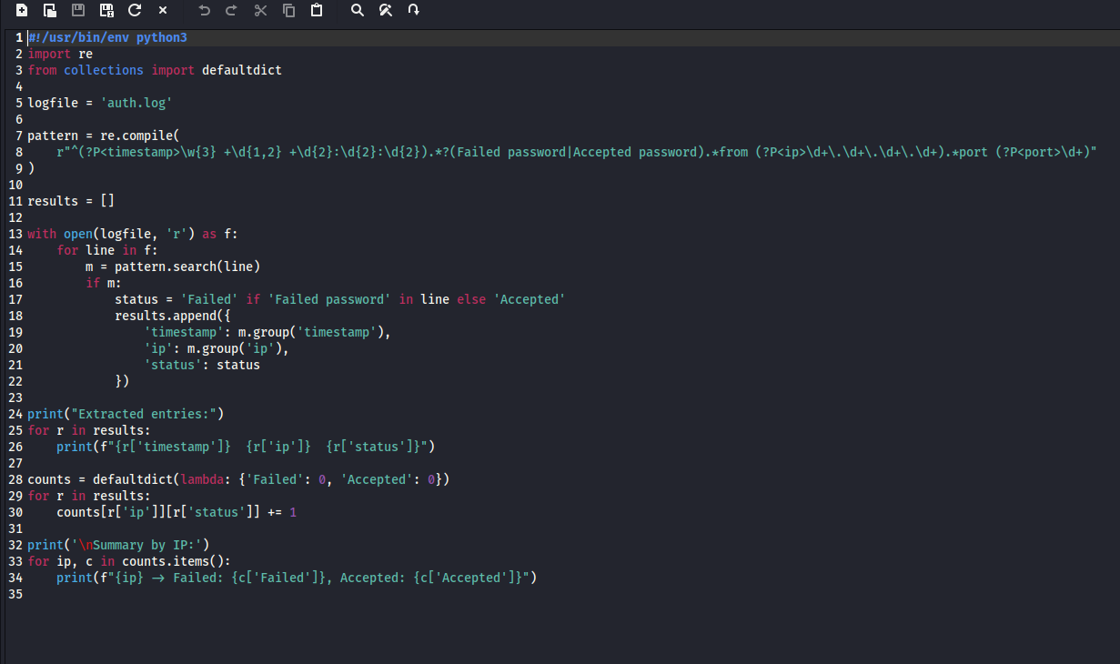
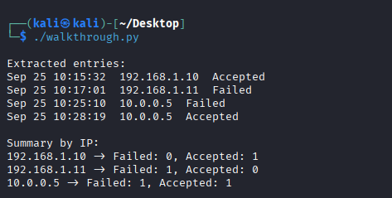

Step 3 — Knowledge Application (5 minutes)
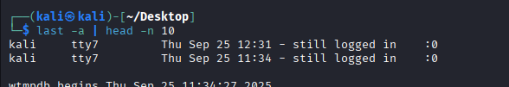

Step 4 — Wisdom (Act to Remediate)
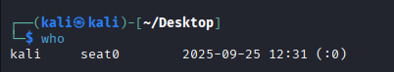
Confidentiallity:
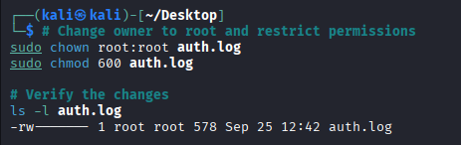

Integrity:
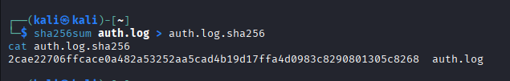
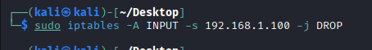
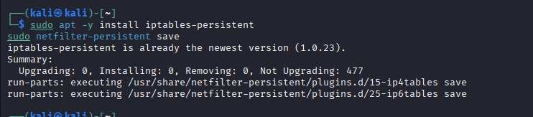

View the iptables rules and confirm the block:
