# **OCCUPATIONAL SAFETY AND HEALTH RESULT**

|  |  |  |  |
| --- | --- | --- | --- |
| **NAME** | **STAFF ID** | **SECTOR** | **DATE** |
| nazreilisyam | 7340 | Governance & Operations Sector | 11-06-2025 |

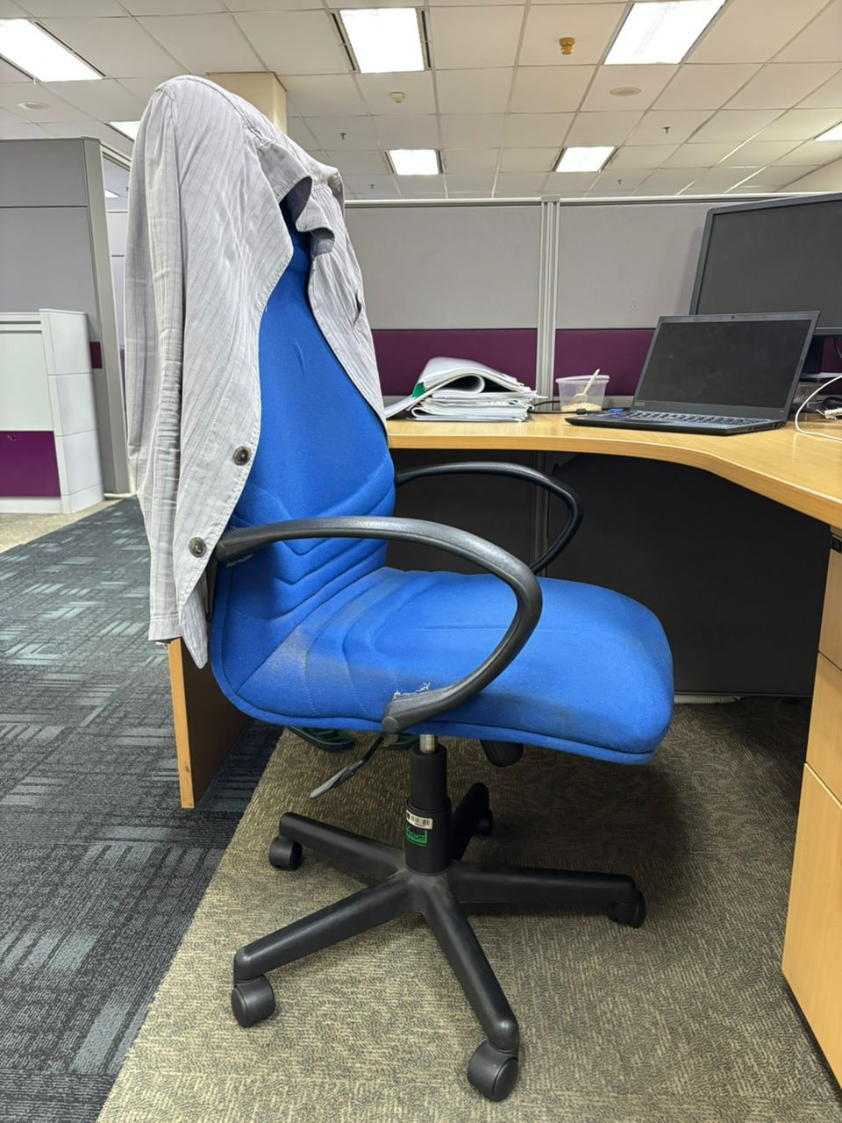

**PROMPT:** "Old chair and not ergonomic"

|  |  |  |  |  |  |
| --- | --- | --- | --- | --- | --- |
| **No.** | **Work Activity** | **Possible Hazard** | **Existing Risk Control (if any)** | **Severity** | **Recommended Control Measures** |
| 1 | Office chair use | Ergonomics | No | Low | Replace the old chair with an ergonomically designed office chair that provides lumbar support and adjustable height. |