# **OCCUPATIONAL SAFETY AND HEALTH RESULT**

|  |  |  |  |
| --- | --- | --- | --- |
| **NAME** | **STAFF ID** | **SECTOR** | **DATE** |
| lala | 0101 | Technology Venture Sector | 12-06-2025 |

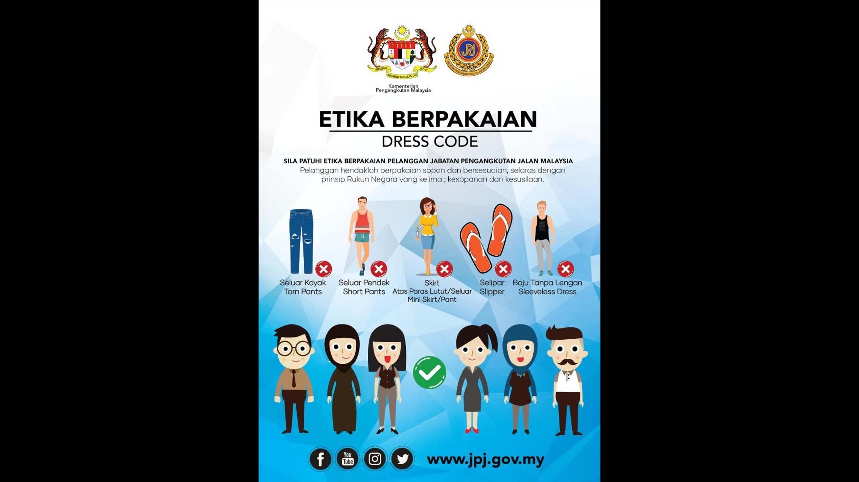

**PROMPT:** "what is this"

|
|  |