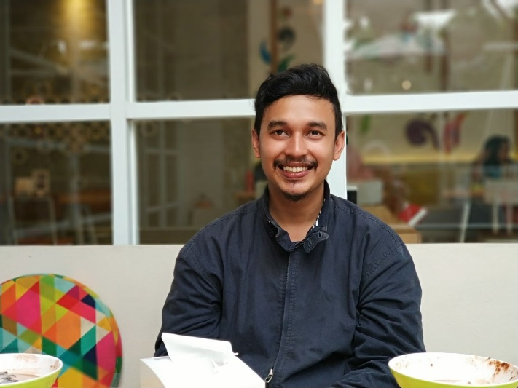

Hello!  
I am Fadhil

I’ve been working as web programmer for 3 years

Daily I spoke with bahasa  
To see detail you can see at my [SITE](http://aimanfadhil.com/)

**Address**

Jl. Sentosa Raya Blok D No 2 Perum Bukit Kencana, Jatimakmur, Pondok Gede, Bekasi, Jawa Barat, Indonesia - 17413

CONTACT

**Website**

Aimanfadhil.com

**E-mail**

Aimanfadhil038@gmail.com

**Date Of Birth**

9 February 1993



**Phone**

+(62) 812 8803 1991











ABOUT ME

Kindness

Smile

Management

Responsibility

Programming

SKILLS

Title : Diploma (III)

Major : Information Technic (IT)

sd

EDUCATION

Pancasila University (2015 > now)

Title : Bachelor degree

Major : Information Technic (IT)

sd

Padjadjaran University (2010 > 2014)

PT Datascrip is a distribution company.Many product are sold by this company. That is Paper One, ASUS, Canon, etc.

I work for this company starting from oct 2014 until may 2015. I work as web programmer.

I have created a Sales Management apps. And this Apps used by 80 stores.

PT Datascrip (oct 2014 > may 2015)

TITAN is a mining company group. Coal is the main production at this company. This Group has its own production, services,and shipping. Many companies contained in this group. Where the company have a businesses of their resprective units.

I work for this company starting from may 2015 until now. I work as web programmer. Many internal apps I have created here.

As an Example : Coal Management Production,Hauling Production, Some HCIS Apps, Company profile,and others.

Sometimes I working as IT Support too. Such as Voip Maintenance, Printer Sharing, and Users Problem.

TITAN GROUP (may 2015 > Now)

WORK EXPERIENCE

+(62)8128803 1991 - aimanfadhil038@gmail.com

PROFILE

SOFTWARE ENGINEER

M AIMAN FADHIL