Homework 2
Dual-LED PWM Control with OLED Monitoring

Field | Details
Student name | Aiman Fatima
Student ID | 24-NTU-CS-FL-1006
Course | Embedded IoT Systems
Date | 28 October 2026
GitHub repository link | https://github.com/aimanfatima-hub/24-NTU-CS-FL-1006
Board / core | ESP32 DevKit (ESP32) • Arduino-ESP32 core 3.x

Task 1 – Dual-LED Fading with Different PWM Frequencies

Design summary
Item | Implementation
LED 1 | GPIO 18 → 330 Ω resistor → LED anode; cathode → GND
LED 2 | GPIO 19 → 330 Ω resistor → LED anode; cathode → GND
PWM frequency LED 1 | 1000 Hz (LEDC channel 0, timer 0)
PWM frequency LED 2 | 5000 Hz (LEDC channel 2, timer 1)
Duty resolution | 10 bits → duty range 0 … 1023 (1024 brightness levels)
Fade method | Non-blocking: +/− 8 counts every 15 ms using millis(); full sweep ≈ 1.9 s
Phase | LED 1 fades up while LED 2 fades down (opposite phase) so both are clearly distinguishable
Duty values for Task 2 | Global variables duty1 and duty2 (raw counts) – converted to % for the OLED

Resolution choice
The LEDC timer clock is 80 MHz (APB). The maximum resolution for a given frequency satisfies f × 2^bits ≤ 80 MHz. At the highest chosen frequency (5 kHz) this allows up to 14 bits; 10 bits is selected because it gives 1024 smooth steps, is far finer than the eye can resolve, and leaves large timing margin on both timers. 1000 Hz × 1024 = 1.02 MHz and 5000 Hz × 1024 = 5.12 MHz, both well inside the limit.

Technical check – LEDC timer sharing
- Two LEDs on channels 0 and 1 would share one timer, so configuring the second frequency would silently overwrite the first.
- To obtain truly independent frequencies, the two LEDs are explicitly assigned to channels 0 and 2, which sit on different timers.
- Any GPIO can be routed to any channel through the GPIO matrix, so the pin choice (18, 19) is not the limiting factor – the timer is.
- Other variants (ESP32-S2/S3/C3) have different channel/timer counts and only low-speed mode; the pairing rule should be re-checked in the core source (esp32-hal-ledc.c) when changing chip or core version.
- The API used is the Arduino-ESP32 core 3.x one (ledcAttachChannel / ledcWrite(pin, duty)). On core 2.x the equivalent is ledcSetup(channel, freq, res) + ledcAttachPin(pin, channel) + ledcWrite(channel, duty).
- Limitation documented: with 4 timers only 4 distinct frequency/resolution pairs can exist per speed group at once. This project needs two.

How duty cycle and frequency affect the output
Duty cycle and apparent brightness. PWM switches the LED fully ON and OFF. Duty cycle is the fraction of each period the output is HIGH. Because the switching is faster than the eye can follow, the eye averages the light, so average power – and perceived brightness – rises with duty (average voltage ≈ duty × 3.3 V). Human brightness perception is roughly logarithmic, so a linear duty ramp looks fast at the dark end and slow near full brightness; gamma correction can be applied if a perceptually linear fade is wanted.
PWM frequency and the output signal. Frequency sets the period (1 kHz → 1 ms, 5 kHz → 200 µs) but not the average brightness. A higher frequency gives finer ripple and removes visible flicker or camera banding, but reduces the maximum resolution (f × 2^bits ≤ 80 MHz) and increases switching losses/EMI. Too low a frequency (below ~100 Hz) causes visible flicker. Both 1 kHz and 5 kHz are flicker-free, so the two LEDs look equally smooth although their waveforms differ.

Source code – Task 1 (src/main.cpp, before OLED)
#include <Arduino.h>

// LED GPIO pins
const int LED1 = 18;
const int LED2 = 19;

// Separate LEDC channels
const int CHANNEL1 = 0;
const int CHANNEL2 = 2;

// Different PWM frequencies
const int FREQ1 = 1000;
const int FREQ2 = 5000;
const int RESOLUTION = 8;

// Duty-cycle values: 0 to 255
int duty1 = 0;
int duty2 = 0;

void setup()
{
Serial.begin(115200);

double actualFreq1 = ledcSetup(CHANNEL1, FREQ1, RESOLUTION);
ledcAttachPin(LED1, CHANNEL1);

double actualFreq2 = ledcSetup(CHANNEL2, FREQ2, RESOLUTION);
ledcAttachPin(LED2, CHANNEL2);

Serial.printf("LED1 configured frequency: %.0f Hz\n", actualFreq1);
Serial.printf("LED2 configured frequency: %.0f Hz\n", actualFreq2);
}

void loop()
{
// Fade LED 1 up and LED 2 down
for (int duty = 0; duty <= 255; duty++)
{
duty1 = duty;
duty2 = 255 - duty;

ledcWrite(CHANNEL1, duty1);
ledcWrite(CHANNEL2, duty2);

if (duty % 25 == 0)
{
Serial.printf("LED1 duty: %d, LED2 duty: %d\n",
duty1, duty2);
}

delay(10);
}

// Fade LED 1 down and LED 2 up
for (int duty = 255; duty >= 0; duty--)
{
duty1 = duty;
duty2 = 255 - duty;

ledcWrite(CHANNEL1, duty1);
ledcWrite(CHANNEL2, duty2);

delay(10);
}
}

Task 1: Wokwi verification
Both LEDs fade smoothly between 0 % and 100 % and back; LED 1 and LED 2 move in opposite directions. Insert the Task 1 Wokwi screenshot here (this is the state committed as “task1 completed”).
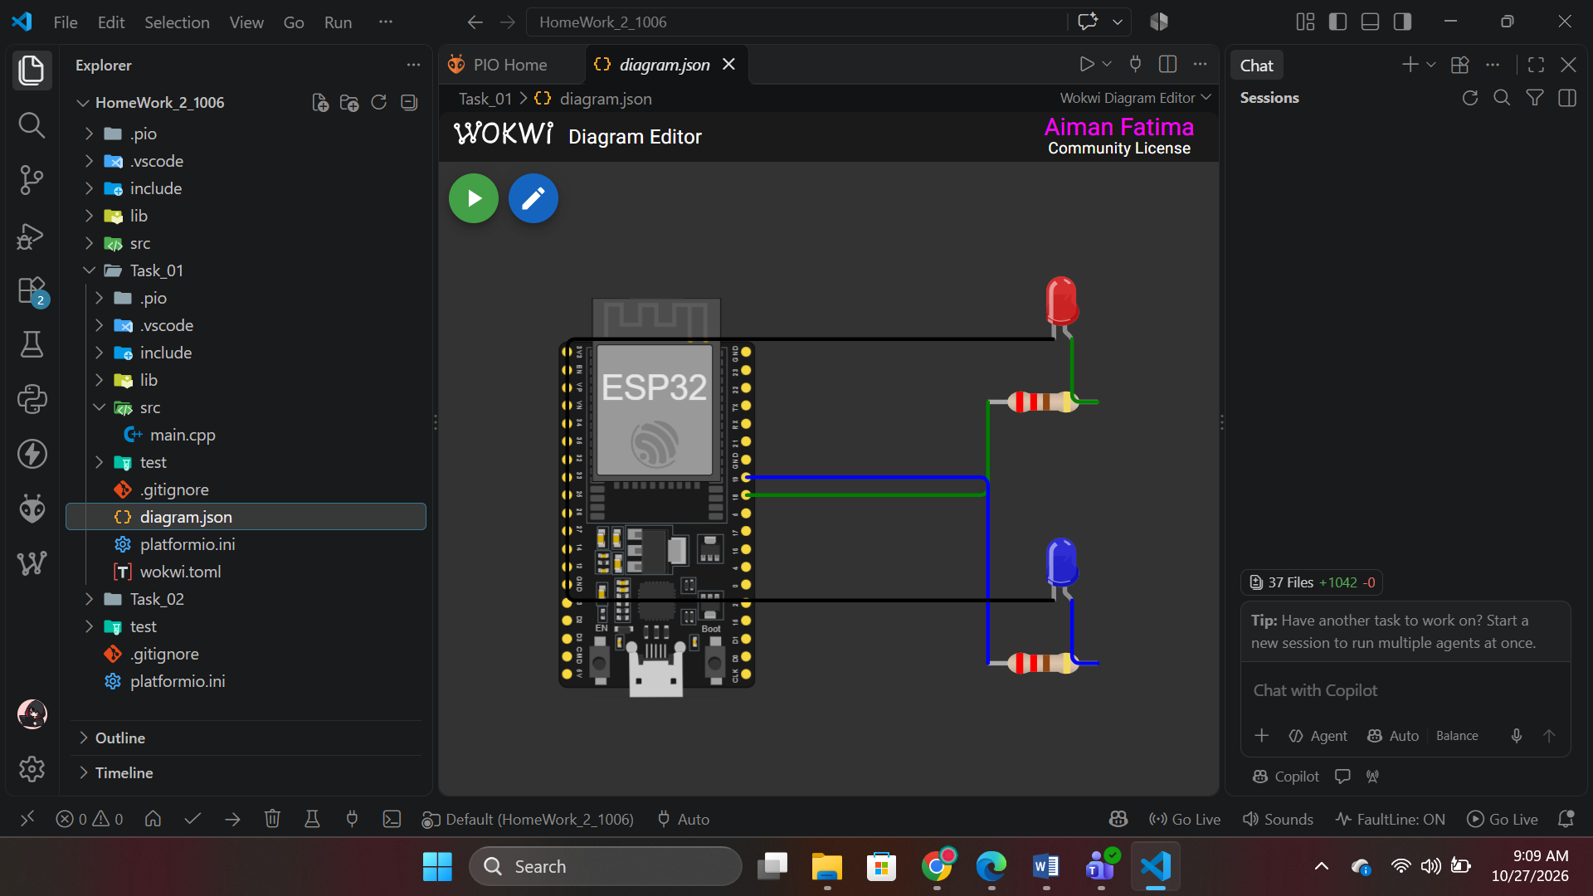
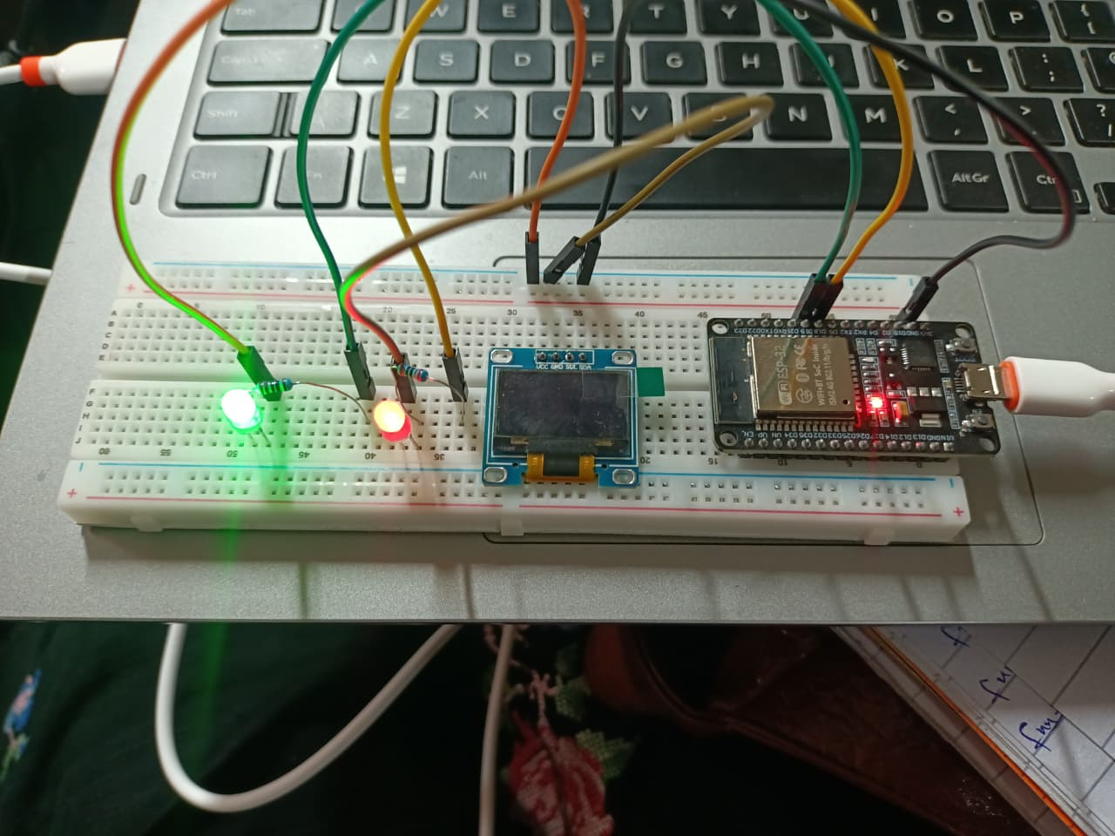

Task 2: Display PWM Parameters on an OLED
An SSD1306 128×64 I²C OLED (address 0x3C) was added on GPIO 21 (SDA) and GPIO 22 (SCL), powered from 3V3. The Adafruit SSD1306 and Adafruit GFX libraries are used.
Requirement | How it is met
LED 1 duty cycle (%) | toPercent(ledcRead(LED1_PIN)) – read back from the LEDC peripheral
LED 1 frequency | ledcReadFreq(LED1_PIN) → 1000 Hz
LED 2 duty cycle (%) | toPercent(ledcRead(LED2_PIN))
LED 2 frequency | ledcReadFreq(LED2_PIN) → 5000 Hz
Refresh as duty changes | Screen redrawn every 100 ms (10 Hz) – I²C is slower than the 15 ms fade step
Values match program | Display reads the duty/frequency actually programmed in the hardware; Serial Monitor prints the program variables for cross-checking

OLED layout (actual values change continuously):
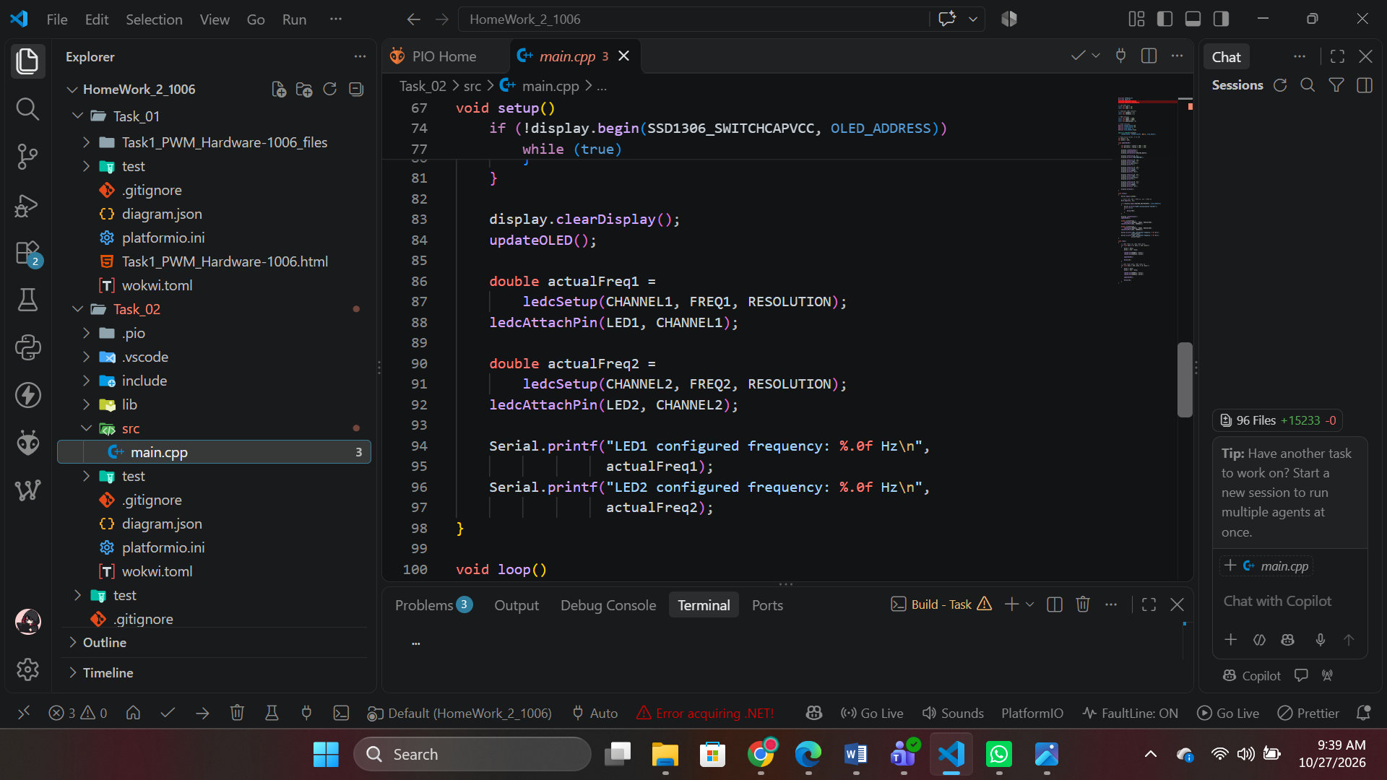

Final source code (src/main.cpp)
#include <Arduino.h>
#include <Wire.h>
#include <Adafruit_GFX.h>
#include <Adafruit_SSD1306.h>

// LED GPIO pins
const int LED1 = 18;
const int LED2 = 19;

// Separate LEDC channels
const int CHANNEL1 = 0;
const int CHANNEL2 = 2;

// PWM settings
const int FREQ1 = 1000;
const int FREQ2 = 5000;
const int RESOLUTION = 8;

// OLED settings
#define SCREEN_WIDTH 128
#define SCREEN_HEIGHT 64
#define OLED_RESET -1
#define OLED_ADDRESS 0x3C

Adafruit_SSD1306 display(
SCREEN_WIDTH, SCREEN_HEIGHT, &Wire, OLED_RESET);

// Duty-cycle values: 0 to 255
int duty1 = 0;
int duty2 = 255;

void updateOLED()
{
int percent1 = (duty1 * 100) / 255;
int percent2 = (duty2 * 100) / 255;

display.clearDisplay();
display.setTextSize(1);
display.setTextColor(SSD1306_WHITE);

display.setCursor(0, 0);
display.println("PWM MONITOR");

display.setCursor(0, 18);
display.print("LED1: ");
display.print(percent1);
display.print("%");

display.setCursor(0, 28);
display.print("Freq: ");
display.print(FREQ1);
display.println(" Hz");

display.setCursor(0, 42);
display.print("LED2: ");
display.print(percent2);
display.print("%");

display.setCursor(0, 52);
display.print("Freq: ");
display.print(FREQ2);
display.println(" Hz");

display.display();
}

void setup()
{
Serial.begin(115200);

// Start I2C: SDA = GPIO 21, SCL = GPIO 22
Wire.begin(21, 22);

if (!display.begin(SSD1306_SWITCHCAPVCC, OLED_ADDRESS))
{
Serial.println("OLED initialization failed!");
while (true)
{
delay(100);
}
}

display.clearDisplay();
updateOLED();

double actualFreq1 =
ledcSetup(CHANNEL1, FREQ1, RESOLUTION);
ledcAttachPin(LED1, CHANNEL1);

double actualFreq2 =
ledcSetup(CHANNEL2, FREQ2, RESOLUTION);
ledcAttachPin(LED2, CHANNEL2);

Serial.printf("LED1 configured frequency: %.0f Hz\n",
actualFreq1);
Serial.printf("LED2 configured frequency: %.0f Hz\n",
actualFreq2);
}

void loop()
{
// LED1 fades up; LED2 fades down
for (int duty = 0; duty <= 255; duty++)
{
duty1 = duty;
duty2 = 255 - duty;

ledcWrite(CHANNEL1, duty1);
ledcWrite(CHANNEL2, duty2);

updateOLED();

delay(10);
}

// LED1 fades down; LED2 fades up
for (int duty = 255; duty >= 0; duty--)
{
duty1 = duty;
duty2 = 255 - duty;

ledcWrite(CHANNEL1, duty1);
ledcWrite(CHANNEL2, duty2);

updateOLED();

delay(10);
}
}

Part A: Wokwi Simulation

Project files
diagram.json (ESP32, two LEDs, two separate resistors, SSD1306 I²C OLED):
{
"version": 1,
"author": "Aiman Fatima - 1006",
"editor": "wokwi",
"parts": [
{
"type": "board-esp32-devkit-c-v4",
"id": "esp",
"top": 0,
"left": 0,
"attrs": {}
},
{
"type": "wokwi-led",
"id": "led1",
"top": -50,
"left": 250,
"attrs": {
"color": "red"
}
},
{
"type": "wokwi-resistor",
"id": "r1",
"top": 0,
"left": 220,
"rotate": 90,
"attrs": {
"value": "220"
}
},
{
"type": "wokwi-led",
"id": "led2",
"top": 80,
"left": 250,
"attrs": {
"color": "blue"
}
},
{
"type": "wokwi-resistor",
"id": "r2",
"top": 130,
"left": 220,
"rotate": 90,
"attrs": {
"value": "220"
}
},
{
"type": "wokwi-ssd1306",
"id": "oled",
"top": 180,
"left": 250,
"attrs": {
"i2cAddress": "0x3c"
}
}
],
"connections": [
["esp:18", "r1:1", "green", []],
["r1:2", "led1:A", "green", []],
["led1:C", "esp:GND.1", "black", []],
["esp:19", "r2:1", "blue", []],
["r2:2", "led2:A", "blue", []],
["led2:C", "esp:GND.1", "black", []],
["esp:3V3", "oled:VCC", "red", []],
["esp:GND.1", "oled:GND", "black", []],
["esp:21", "oled:SDA", "green", []],
["esp:22", "oled:SCL", "blue", []]
],
"dependencies": {}
}
"value": "220"
}
}
],
"connections": [
["esp:18", "r1:1", "green", []],
["r1:2", "led1:A", "green", []],
["led1:C", "esp:GND.1", "black", []],
["esp:19", "r2:1", "blue", []],
["r2:2", "led2:A", "blue", []],
["led2:C", "esp:GND.1", "black", []]
],
"dependencies": {}
}

platformio.ini:
[env:esp32dev]
platform = espressif32
board = esp32dev
framework = arduino
monitor_speed = 115200
lib_deps =
adafruit/Adafruit GFX Library
adafruit/Adafruit SSD1306

wokwi.toml:
[wokwi]
version = 1
firmware = '.pio/build/esp32dev/firmware.bin'
elf = '.pio/build/esp32dev/firmware.elf'

Wiring table
From (ESP32) | To | Notes
GPIO 18 | R1 (330 Ω) → LED1 anode | Own resistor for LED 1
GPIO 19 | R2 (330 Ω) → LED2 anode | Own resistor for LED 2
GND | LED1 and LED2 cathodes | Common ground
GPIO 21 | OLED SDA | I²C data
GPIO 22 | OLED SCL | I²C clock
3V3 | OLED VCC | SSD1306 modules accept 3.3 V
GND | OLED GND

Complete circuit screenshot
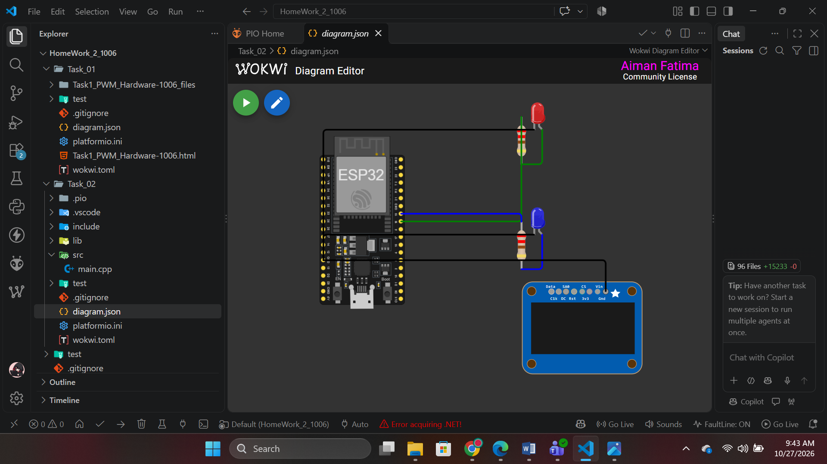

Running simulation with OLED visible
Both LEDs fade and the OLED shows live duty cycles and frequencies (LED 1: 1000 Hz, LED 2: 5000 Hz).
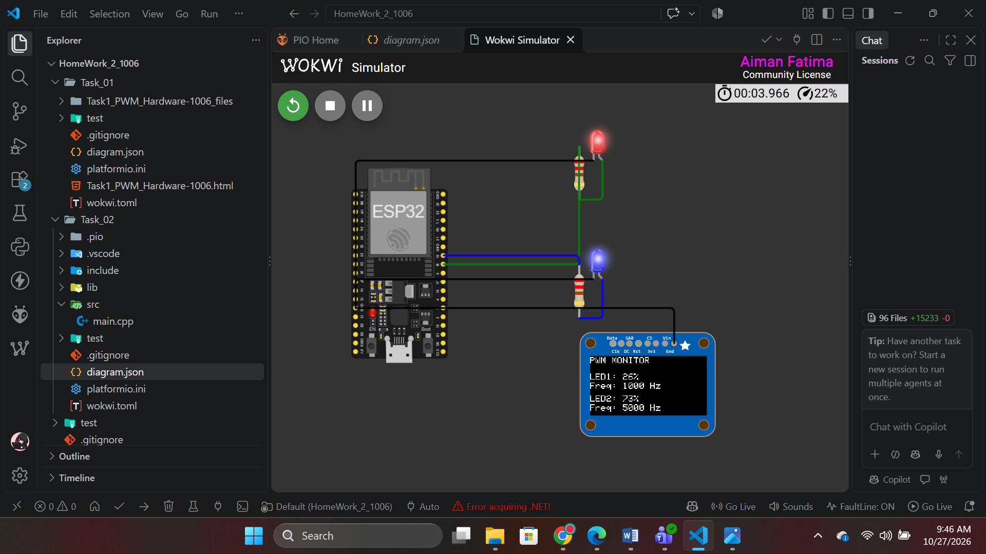

Working Wokwi project link
Item | Link
Wokwi project | C:\ESP32-IoT-Labs\HomeWork_2_1006\Task_02\diagram.json

Part B: Physical Hardware Implementation

Components
- ESP32 development board (from the course kit)
- 2 × LEDs (e.g. green and red)
- 2 × 330 Ω current-limiting resistors (one per LED)
- SSD1306 128×64 I²C OLED (4-pin: GND, VCC, SCL, SDA)
- Breadboard and jumper wires
- USB cable

Hardware pin mapping
Function | GPIO used | Comment
LED 1 | 18 [confirm] | Change if your board does not expose this pin
LED 2 | 19 [confirm] | Avoid boot-strapping pins (0, 2, 12, 15) and input-only pins (34–39)
I²C SDA | 21 [confirm] | Default I²C pins on most ESP32 DevKit boards
I²C SCL | 22 [confirm]
OLED address | 0x3C [confirm] | Some modules use 0x3D – scan the bus if the display stays blank

Hardware circuit photograph
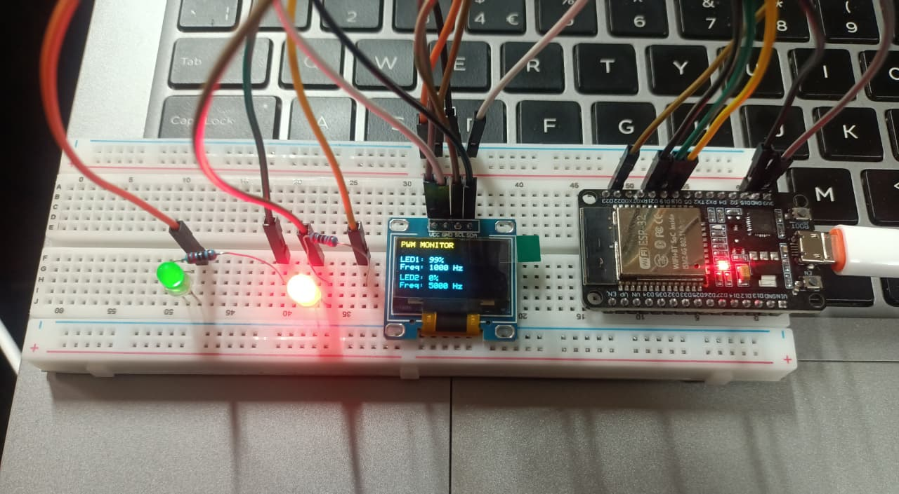

Hardware OLED output photograph
Photograph taken while the system is running, showing the OLED with changing duty cycles and configured frequencies and the LEDs lit.
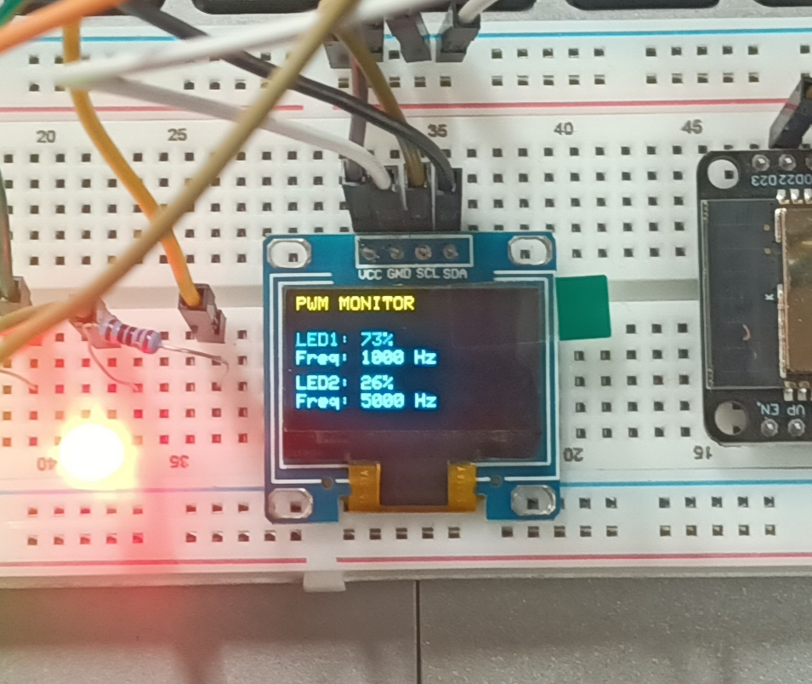

Wokwi vs hardware
Edit this table to reflect what you actually observed; typical differences are pre-filled as a starting point.
Aspect | Wokwi simulation | Physical hardware
Pins | Fixed by diagram.json (18, 19, 21, 22) | [Same / changed to … because …]
LED brightness | Idealised, perfectly smooth | Depends on LED colour and resistor; low-duty region looks relatively brighter (non-linear eye response)
PWM frequency | Ideal; no visible difference between 1 kHz and 5 kHz | Both flicker-free by eye; a phone camera may show banding, especially at 1 kHz
OLED | Always found at 0x3C, instant refresh | Needs correct address and wiring; refresh limited by I²C speed (≈100 kHz default)
Timing | Simulated clock may run slower than real time on busy PCs | Real-time; fade sweep ≈ 1.9 s as designed
Power / wiring | No electrical noise or loose contacts | Breadboard contacts and USB supply can affect stability; check connections if the OLED blanks

Repository link and commit history
Item | Value
GitHub repository link | https://github.com/aimanfatima-hub/24-NTU-CS-FL-1006
Commit 1 message | task1 completed
Commit 2 message | complete homework

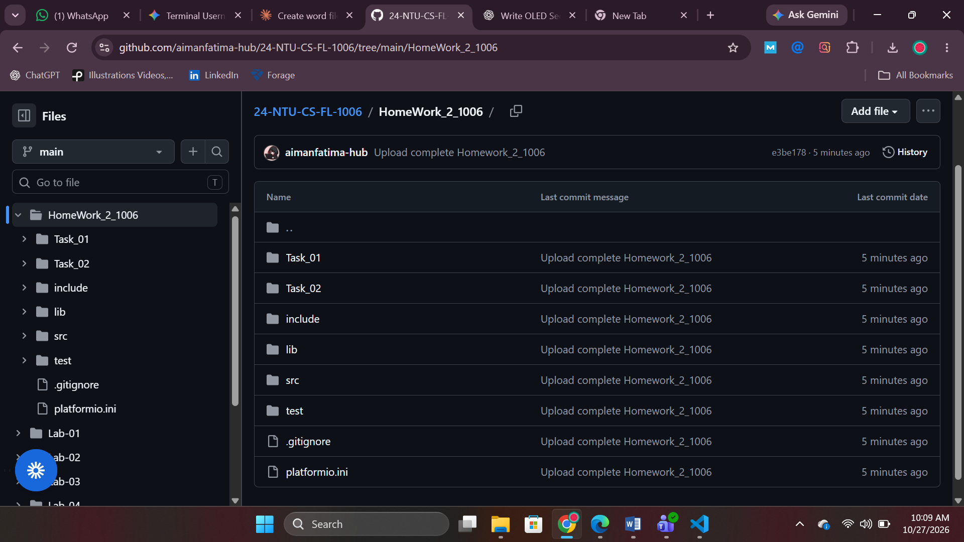

README.md
# Homework 2 – Dual-LED PWM Control with OLED Monitoring

**Course:** Embedded IoT Systems
**Name:** <Your Name> | **ID:** <Your ID>

An ESP32 fades two LEDs using two different PWM frequencies (LEDC peripheral) and shows each LED's live duty cycle and configured frequency on an SSD1306 I²C OLED. Tested in Wokwi and on physical hardware.

## Links
- **Wokwi project:** <paste working Wokwi link>
- **GitHub repository:** <paste repository link>

## Project structure
```
Homework-2/
├── diagram.json
├── wokwi.toml
├── platformio.ini
├── src/
│ └── main.cpp
├── screenshots/
│ ├── wokwi_circuit.png
│ ├── wokwi_running_oled.png
│ ├── hardware_circuit.jpg
│ └── hardware_oled_output.jpg
└── README.md
```

## Wiring

| Signal | ESP32 GPIO | Connection |
|--------|-----------|------------|
| LED 1 | GPIO 18 | 330 Ω resistor → LED 1 anode; cathode → GND |
| LED 2 | GPIO 19 | 330 Ω resistor → LED 2 anode; cathode → GND |
| OLED SDA | GPIO 21 | SSD1306 SDA |
| OLED SCL | GPIO 22 | SSD1306 SCL |
| OLED VCC | 3V3 | SSD1306 VCC |
| OLED GND | GND | SSD1306 GND |

- Each LED has its **own** current-limiting resistor.
- OLED I²C address: `0x3C`.
- Hardware pins: <same as simulation / list any changes and why>.

## PWM frequencies

| LED | Frequency | Resolution | LEDC channel | LEDC timer |
|-----|-----------|-----------|--------------|-----------|
| LED 1 | 1000 Hz | 10-bit (0–1023) | 0 | 0 |
| LED 2 | 5000 Hz | 10-bit (0–1023) | 2 | 1 |

**Resolution choice:** the LEDC timer clock is 80 MHz, so frequency × 2^bits must be ≤ 80 MHz. 10 bits gives 1024 smooth brightness levels, well within the limit at both frequencies (1 kHz × 1024 ≈ 1 MHz, 5 kHz × 1024 ≈ 5 MHz).

**LEDC timer-sharing limitation:** the ESP32 has only 4 LEDC timers per speed group, and every channel on a timer shares its frequency and resolution. The Arduino-ESP32 core pairs channels onto timers (channels 0 and 1 share a timer, 2 and 3 share the next, and so on). Using channels 0 and 1 would force both LEDs to the same frequency, so LED 1 uses channel 0 and LED 2 uses channel 2, which sit on different timers. Other chip variants (S2/S3/C3) have different channel/timer layouts and should be re-checked. API used: Arduino-ESP32 core 3.x (`ledcAttachChannel`, `ledcWrite(pin, duty)`).

## How PWM affects the LEDs
- **Duty cycle** is the fraction of each period the output is HIGH. The eye averages the fast switching, so a higher duty cycle means more average power and a brighter LED.
- **Frequency** sets the period (1 kHz = 1 ms, 5 kHz = 200 µs) but not the average brightness. Both frequencies are fast enough to look flicker-free; a higher frequency reduces the maximum possible resolution.

## Duty-cycle control
- Non-blocking fade using `millis()`: duty changes by 8 counts every 15 ms (one full sweep ≈ 1.9 s).
- LED 1 fades 0 % → 100 % → 0 %; LED 2 runs in the opposite phase (100 % → 0 % → 100 %).
- The duty values are kept in the global variables `duty1` and `duty2`, and percentage = duty / 1023 × 100.

## OLED output
The 128×64 SSD1306 shows:

```
PWM MONITOR
LED1: 25% F:1000Hz
LED2: 75% F:5000Hz
```
(plus a progress bar under each row). The values change continuously. The display reads the duty and frequency back from the LEDC hardware (`ledcRead()`, `ledcReadFreq()`), so it shows what is actually in use. The screen refreshes every 100 ms, and the Serial Monitor (115200 baud) prints the same values for cross-checking.

## Build and run
- **Wokwi / PlatformIO:** open the project, build, and start the simulation.
- **Libraries:** Adafruit SSD1306, Adafruit GFX (see `platformio.ini`).
- **Hardware:** upload `src/main.cpp` to the ESP32 and open the Serial Monitor at 115200 baud.

## Screenshots and photos

**Wokwi circuit**
![Wokwi circuit](screenshots/wokwi_circuit.png)

**Wokwi simulation running with OLED**
![Wokwi running](screenshots/wokwi_running_oled.png)

**Hardware circuit**
![Hardware circuit](screenshots/hardware_circuit.jpg)

**Hardware OLED output**
![Hardware OLED](screenshots/hardware_oled_output.jpg)

## Test results

| Test | Expected | Wokwi | Hardware |
|------|----------|-------|----------|
| LED 1 fades 0 → 100 % → 0 | Smooth, ≈1.9 s per sweep | [Pass/Fail] | [Pass/Fail] |
| LED 2 fades in opposite phase | Rises while LED 1 falls | [Pass/Fail] | [Pass/Fail] |
| LED 1 frequency on OLED | 1000 Hz | [Pass/Fail] | [Pass/Fail] |
| LED 2 frequency on OLED | 5000 Hz | [Pass/Fail] | [Pass/Fail] |
| OLED duty % updates live | Changes ~10×/s | [Pass/Fail] | [Pass/Fail] |
| OLED matches Serial Monitor | Same values | [Pass/Fail] | [Pass/Fail] |

## Wokwi vs hardware

| Aspect | Wokwi | Hardware |
|--------|-------|----------|
| Pins | <what you used> | <what you used> |
| LED brightness | <observation> | <observation> |
| OLED | <observation> | <observation> |
| Other differences | <observation> | <observation> |

<

---------------------------------------------

