Predicting and Interpreting Kindergarten Outcomes: Econometrics and Machine Learning Analysis

Executive summary
This report examines the educational outcomes of 4,638 kindergarten students from the Tennessee Project STAR experiment. It uses both traditional economic models and modern machine learning methods to find the main factors that influence academic performance in reading and mathematics.

Six predictive models were tested using five-fold cross-validation. These included four traditional econometric models: Ordinary Least Squares (OLS), Ridge, LASSO, and Elastic Net regression as well as two machine learning models: Random Forest and Neural Network. Their performance was assessed by out-of-sample Mean Squared Error (MSE). Random Forest was chosen as the best model because it predicted both reading and maths scores most accurately (average MSE: 1,266.83).

The analysis found that school-level characteristics, socioeconomic factors, teacher experience, and class size are the main drivers of academic performance. Random Forest had the lowest MSE for both reading and maths scores and significantly outperformed the other models at predicting maths scores, which suggests that math performance is more complex.

The report highlighted equitable school funding, teacher retention programmes, socioeconomic support, and strategic class reduction as key policies to prioritise and improve academic performance in early education. However, the report also has limitations, including the fact that the model was trained on data collected in the 1980s and does not account for contemporary school settings. Certain factors absorb unmeasured institutional factors, and random assignment only applies to class size, complicating causal interpretation. Lastly, omitted variables would introduce bias and may falsely increase the magnitude of certain key performance drivers.

To conclude, while the Project STAR experiment demonstrates class-size effects, this report shows that school quality, teacher experience, and socioeconomic factors also play significant roles in kindergarten-level academic achievement. Thus, creating effective policies would require taking into account structural factors beyond classroom changes, emphasising institutional improvement, educator retention, and equity among students, and ensuring improvement in early education.

Exploratory Data Analysis
Our analysis utilises a dataset of 4,638 kindergarten students from the Project STAR experiment. Students and their teachers from 79 schools across 42 districts were randomly assigned to one of three classroom environments: small class (13-17 students, n=1,386), regular class (22-25 students, n=1,614), or regular class with a teacher's aide (n=1,638). The dataset includes student demographics (gender: 2,376 male, 2,262 female; free-lunch eligibility: 2,249 eligible), teacher characteristics (years of experience, education: 3,004 bachelor's, 1,473 master's, 112 master's+, 30 specialist), and school type (rural: 2,200, inner-city: 1,023, suburban: 998, urban: 417), allowing us to model the drivers of reading and math scores.

In order to begin modelling, several data cleaning measures were undertaken to prepare the dataset for analysis. Foremostly, the student birth variable, originally in a year-quarter string format, was split into two separate integer features, birth_year and birth_quarter, to enhance data accessibility for modelling. Furthermore, to address the high cardinality and sparsity existing in the ethnicity variable, the minority categories were consolidated into a single 'ethnicity_other' group. This decision was justified by their low frequency (each representing less than 1% of all observations), preventing the creation of high-variance dummy variables. Additionally, the school and district identifiers were confirmed to have a near-perfect correlation and justify the subsequent removal of schooldistrict_id to mitigate multicollinearity in linear models. Then all categorical variables were transformed into dummy variables with the first category dropped to avoid the dummy variable trap. Overall, these measures aim to enhance the dataset's quality, reduce dimensionality, and ensure the reliability of subsequent model estimation.

Following data cleaning, descriptive statistics, see Appendix A, were computed to characterise the sample and identify key variables. The average math scores, 485.4, are higher than the average reading scores despite the math scores experiencing greater variability. Another poignant feature of the dataset is the lack of diversity among the observed students, with 67% of the sample Caucasian; notably, though, there is socioeconomic diversity, with nearly half (48.5%) eligible for free lunch. Teacher characteristics show an overall experienced staff, with the vast majority, approximately 64.8%, holding a bachelor's degree. Geographically, the sample is dominated by rural schools (47.4%), followed by inner-city (22.1%) and suburban (21.5%) settings. This may be a disproportionate representation of rural schools, as only 25% of Americans were considered to be living in rural areas at the time of the study (Hunter et al., 2020). These statistics confirm there exists substantial variation across key outcome variables, providing a decently robust foundation for analysing predictors.

Furthermore, utilising interquartile range, we found that the dataset contains a modest number of outliers in both academic subjects, with 114 outliers (2.46%) in reading scores and 162 outliers (3.49%) in math scores. This slightly higher proportion of outliers in math suggests greater variability in math performance distribution. While their inclusion could potentially influence model performance, the relatively low percentage suggests they are unlikely to substantially distort the overall analysis, and their limited presence suggests there is no strong justification for applying weighted regression techniques (Tangjuang, 2013).
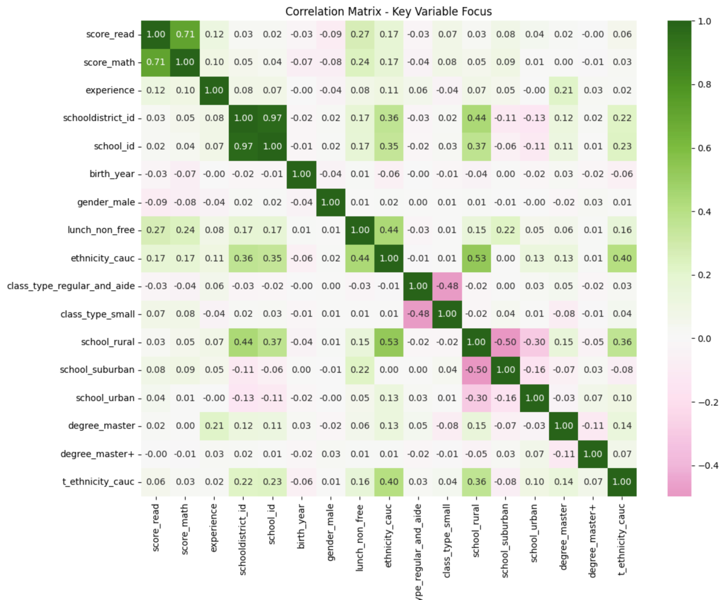
Figure 1: Correlation Matrix Plot

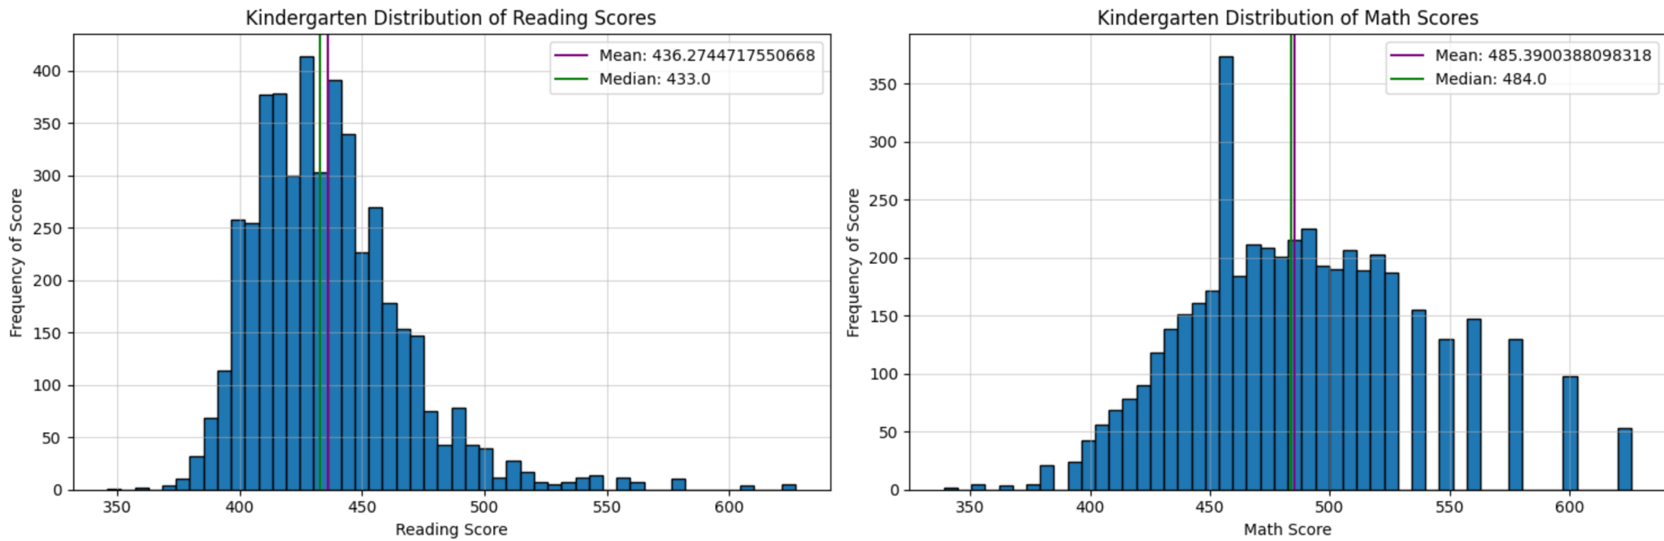
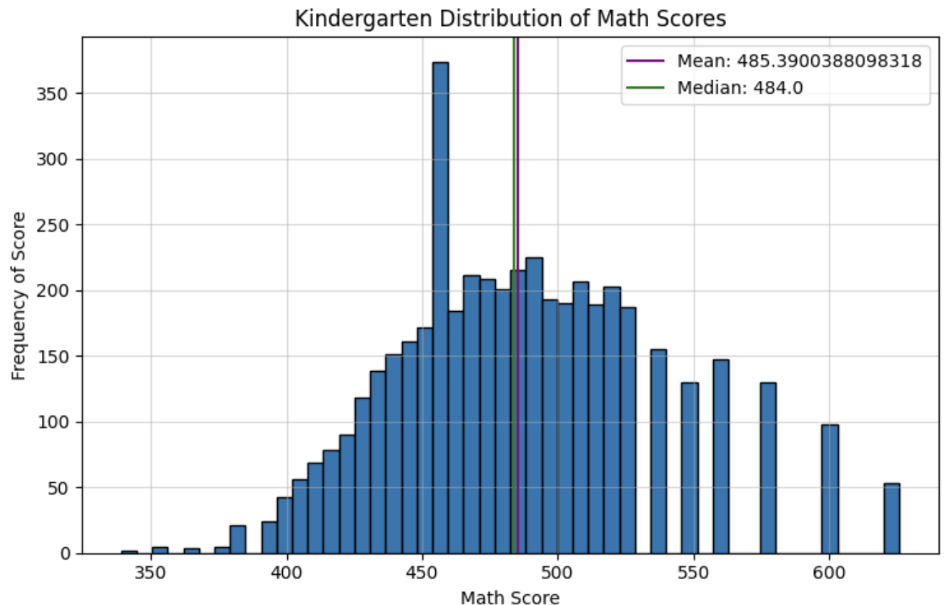
An analysis of variable correlations was conducted to uncover initial relationships and inform variable selection. The correlation matrix, shown in Figure 1, demonstrates that math scores and reading scores are fairly highly correlated, r = 0.71, suggesting that drivers of academic performance are largely interconnected. Another key feature of the correlation matrix is the almost perfect, r = 0.97, correlation between school id and school district id, indicating multicollinearity. Meanwhile, the school location types are inherently mutually exclusive. Elsewise, there exists a smaller positive relationship between free-lunch eligibility (socioeconomic background) and academic outcomes; all other variables experience a low correlation with test scores (r < 0.2). Overall, the measures of class size variables have very weak direct correlations with scores, implying that the effect of class size on test scores may be non-linear or dependent on other interacting factors.
Furthermore, in Figure 2 we examine the distribution of the dependent variables, analysing their variance and central tendency. The reading scores’ histogram (right figure) holds a right skew, with a large cluster between 420 and 450. There is a small right-sided tail, reflecting a smaller proportion of students excelling beyond their peers, as evidenced by the mean score (436) being slightly higher than the median (433). Alternatively, the math scores histogram (left figure) holds a fairly symmetrical distribution over a wider range of scores than for the reading score histogram. The median and mean scores are also very similar, 484 and 485.4, respectively. Hence, overall reading performance is lower with a few high-performing outliers, whereas maths scores display a wider distribution, reflecting greater variability in performance.

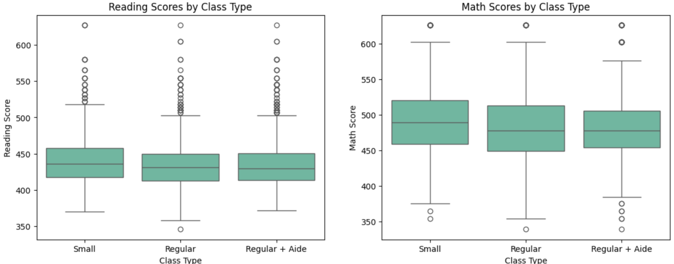
Figure 3: Class Type Box Plot Figure

Another consideration we would like to account for is whether or not small classes show meaningful performance differences. Figure 3’s plot conveys that small classes demonstrate a slight but consistent advantage, with higher median scores in both reading and math compared to regular-sized classes. However, the addition of a teacher's aide to regular-sized classes shows no discernible improvement in test scores, as the performance distributions for regular and regular classes with an aide are nearly identical. The similar spread of scores across all three class types indicates that student performance variability remains consistent regardless of classroom configuration, with each setting containing a variety of academic outcomes.

Based on the exploratory analysis, there are several data characteristics that will be considered when modelling. Firstly, the higher variability in maths scores suggests different predictive patterns may emerge for maths versus reading outcomes. Secondly, the over-representation of rural schools could introduce regional biases. Finally, the small outlier presence (2.46-3.49%) is unlikely to substantially distort models. Several variables appear likely to be meaningful predictors for academic outcomes. Socioeconomic background (free-lunch eligibility) shows consistent relationships with both reading and maths scores. Class size demonstrates nuanced effects, with small classes showing modest advantages that may be better captured through non-linear modelling approaches.

Model Selection

OLS Regression
The Ordinary Least Squares (OLS) model is a linear regression framework for predicting students’ achievements in our Project STAR experiment. It estimates the relationship between reading and mathematics scores and a set of explanatory predictors representing student characteristics, socioeconomic background, classroom type, and teacher attributes. The model assumes that the outcome can be expressed as a linear combination of the predictor variables plus an error term capturing unobserved influences.
We include OLS in our modelling framework for many reasons. Firstly, it is demonstrated as a transparent benchmark against which other regularised linear and machine learning models can be compared. Secondly, the estimated coefficients give us insight into the direction and relative importance of the predictors. Lastly, OLS estimation is computationally efficient and straightforward to validate. Although OLS does not capture complex non-linear relationships or interactions, it remains an essential ‘starting point for all spatial regression analyses’ (ArcGIS, n.d.).
For our OLS model evaluation, a 5-fold cross-validation is used to evaluate predictive performance and avoid overfitting. This approach provides us a more reliable estimate of our model’s out-of-sample performance compared to a simple train/validation split. By utilising multiple training and validation subsets, it helps reduce variability that can arise from relying on a single split.
Metrics | Reading | Math
AIC | 44 420 | 48 340
BIC | 44 560 | 48 490
R-squared | 0.117 | 0.103
Adjusted R-squared | 0.113 | 0.099
Out-of-Sample MSE | 880.31 | 2062.81
Table 1 - Key findings from Ordinary Least Squares (OLS) model
The OLS model explains a modest portion of variation in student outcomes, with R-squared values of 0.117 for reading and 0.103 for math (adjusted R²: 0.113 and 0.099). This indicates that classroom, teacher, and student characteristics account for only a small part of score variation, with much influenced by unobserved factors. AIC and BIC values are higher for math than reading, suggesting the model fits reading scores slightly better relative to its complexity. This aligns with out-of-sample MSEs, which are lower for reading (880.31) and higher for math (2,062.81), indicating math performance is less predictable from the included covariates. Although OLS is unlikely to be the best-performing predictor in terms of out-of-sample mean squared error, it still provides a clear and interpretable foundation for understanding the determinants of student performance.

LASSO Regularisation
LASSO regression enhances regularisation by applying coefficient shrinkage and automatic variable selection through the L1 penalty, which can reduce coefficients to zero. This allows the model to identify the most predictive features, improving interpretability without sacrificing predictive performance. In educational research, LASSO provides a data-driven way to distinguish key predictors, such as teacher experience and class composition, from those with minimal impact.
The model creates 100 penalty values, α, ranging from 0.001 to 1000, then tests each penalty through the five-fold cross-validation. Each model systematically tries all 100 α values, splitting the data into five folds, four for training and one for validation, then rotating. It then selects α with the lowest cross-validation error and refits LASSO on the full training set using the optimal α.
Metrics | Reading | Math
Optimal α | 0.35 | 0.04
Out-of-sample MSE | 943.30 | 2001.75
AIC | 24 980.59 | 28 198.07
BIC | 25 067.58 | 28 340.99
Effective Degree of Freedom (EDF) | 14 | 23
Table 2: Results of the LASSO regression model
The procedure selected α = 0.35 for reading and α = 0.04 for mathematics, where the cross-validation error is minimised. This reflects LASSO’s more aggressive coefficient reduction, in which more predictors are eliminated rather than merely shrunk, especially for reading scores. The model’s predictive accuracy was assessed using out-of-sample MSE, and the model parsimony was evaluated using the Akaike Information Criterion (AIC), Bayesian Information Criterion (BIC), and Effective Degrees of Freedom (EDF).

The model demonstrates different behaviours from the two outcomes. For reading scores, the relatively high penalty removed many coefficients from the model, reducing the model to 14 effective degrees of freedom. This achieved strong predictive performance with an out-of-sample mean of 943.30. The favourable outcomes of AIC and BIC confirm that LASSO successfully identified a parsimonious set of predictors. In contrast, the mathematics model required substantially less regularisation, retaining 23 effective degrees of freedom. This suggests that math scores have more complex relationships that a sparse linear model cannot capture, or the available factors lack significant predictive power.

The top predictors for reading reveal socioeconomic factors (lunch_non_free: 7.08) and teacher experience (2.78) are the strongest positive contributors to reading scores; meanwhile, gender (gender_male: -2.76) and rural school settings (school_rural: -1.01) are significant negative factors. Additionally, smaller class sizes (class_type_small 1.85) show moderate positive influence. This suggests that resource allocation and teacher quality play a significant role in reading scores. The retained factors for mathematics scores with school and district identifiers (school_id: -12.30; schooldistrict_id: 12.08) dominating, indicating substantial variations between the institutions. While socioeconomic factors remain important (lunch_non_free: 9.76), the mathematics model showcases stronger negative associations with male gender (gender_male: -4.28) and birth timing (birth_year: -4.89); this suggests maturation or stages of development may play a more prominent role in learning mathematics than in reading.

All in all, the contrast between the model for reading scores and mathematics scores showcases that though LASSO was able to identify a model with a parsimonious set of factors for reading, mathematics scores may require an alternative modelling approach to capture their complexity.

Ridge Regularisation
Ridge regression was employed as a regularised extension of the Ordinary Least Squares (OLS) model to address multicollinearity and improve out-of-sample predictive performance. In many educational datasets, predictors such as teacher qualifications, class size, and school characteristics tend to be highly correlated. OLS estimation under such conditions may produce unstable coefficient estimates and inflated variances, leading to overfitting. Ridge regression overcomes this limitation by introducing an L2 penalty on the magnitude of coefficients, which shrinks parameter estimates towards zero, stabilising model behaviour and enhancing generalisation (Goldstein & Smith, 2018).
The model was estimated through a five-fold cross-validation procedure designed to select the optimal penalty parameter (α) that minimises predictive error. A grid search of 200 logarithmically spaced α values ranging from 0.001 to 1000 was tested. The dataset was divided into five folds of approximately equal size; in each iteration, four folds were used for training and one for validation. This process was repeated until all folds served as validation sets once, ensuring that each observation contributed to both training and validation.
Metrics | Reading | Math
Optimal α | 215.44 | 11.50
Out-of-sample MSE | 934.63 | 2001.1
Training MSE | 858.53 | 2049.01
AIC | 24 981.57 | 28 197.48
BIC | 25 109.85 | 28 339.04
Effective Degree of Freedom (EDF) | 20.64 | 22.78
Table 3 - The results of Ridge regression model
The optimal α values were determined to be 215.44 for the reading model and 11.50 for the mathematics model, where the mean squared error (MSE) across folds reached its minimum. These parameters were then used to re-estimate the model on the full training sample and subsequently evaluated on the held-out test data. The model’s predictive accuracy was assessed using the out-of-sample MSE, while model parsimony was evaluated using the Akaike Information Criterion (AIC), Bayesian Information Criterion (BIC), and Effective Degrees of Freedom (EDF).
The Ridge model demonstrates a strong overall fit with a stable bias–variance trade-off. The out-of-sample MSE values indicate that Ridge generalises effectively, achieving minimal loss of accuracy relative to the training set. The consistency between training and test performance validates the reliability of cross-validation and confirms that overfitting has been successfully mitigated (Hastie et al., 2009).
Moreover, as in Appendix C, positive coefficients for lunch_non_free, class_type_small, and teacher experience emphasise the importance of socioeconomic support, classroom environment, and instructional quality in promoting student learning outcomes. Conversely, negative coefficients for gender_male and school_rural highlight structural disparities that may warrant targeted interventions. From a policy standpoint, these findings align with experimental literature showing that smaller classes and higher teacher qualifications yield sustained benefits. Ridge regression’s robust performance further validates the model as a reliable predictor of educational outcomes and an interpretable tool for informing resource allocation and teacher development strategies.

Elastic Net Regularisation
The Elastic Net model is a combination of the L1 (LASSO) and the L2 (Ridge) penalties to build a linear model that is robust to multicollinearity between features/variables. It regularises the model coefficients by reducing overfitting, as well as providing a mechanism to shrink selected model features/variables.
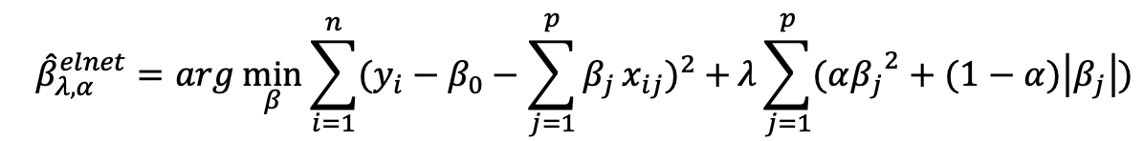
The assumptions made are that the model has a linear conditional mean with independently and identically distributed errors, resulting in the following objective function. The Elastic Net estimator has the following mathematical definition:

Where $λ≥0$ controls the overall penalty strength and$0<α<1$ governs the balance between Ridge and LASSO components. The combined penalty encourages sparsity by shrinking the coefficients of less relevant features toward zero.
A grid search was conducted for $λ$ in the range of ${10}^{-3}$ to ${10}^{3}$ (100 logarithmically spaced values) and $α$ (L1_ratio) in the range of 0.1 to 0.9 (9 evenly spaced values). The optimal parameters were 0.31 and 0.9 for the reading model and 0.01 and 0.9 for the math model. Both models favour a high L1_Ratio, suggesting the presence of redundant or correlated predictors in the dataset.
For model performance, the Elastic Net model gave a lower out-of-sample MSE value for the reading score (941.64) than the maths score (2001.93). It suggests that the reading performance is more predictable from the available covariates. The AIC and BIC values (24986.30/25098.15 for Reading; 28197.84/28340.76 for Math) are consistent with this observation, suggesting the fit achieved by the model parameters in the case of the Reading outcome is better given its lower number of effectively estimated parameters (18 vs. 23).

Target | Lambda | L1_Ratio | Effective DF | Non-zero Features | AIC | BIC | MSE (test)
Reading | 0.31 | 0.9 | 18 | 17 | 24986.30 | 25098.15 | 941.64
Math | 0.01 | 0.9 | 23 | 22 | 28197.84 | 28340.76 | 2001.93

Table 4 - The results of Elastic Net regression model

One of the major advantages of the Elastic Net is that it balances Ridge and LASSO regression. The technique addresses multicollinearity, prevents overfitting, and automatically selects the features, hence creating a model that is understandable and accurate. Despite all this, the Elastic Net regression model has a number of disadvantages. First, tuning two hyperparameters ($λ$ and $α$) will increase computational cost and unstable results. Second, the shrinkage penalty causes bias to the coefficient estimates of the parameters, rendering the statistical inference invalid. Third, when predictors are small and uncorrelated, the advantage gained by the model over Ordinary Least Squares (OLS) will be reduced, as the penalty now incorporates bias due to the penalty term. Lastly, the model makes a fixed assumption that the features are related to the target feature via a straight line, hence may not perform well when faced with actual non-linear patterns or interaction between features.

Random Forest Regression
We selected the random forest regression model to predict kindergarten reading and math scores and identify key drivers of academic performance. A key advantage of the method is that there is no requirement for linearity, homoskedasticity, or normality of errors (Speiser et al., 2019). Furthermore, we can effectively capture non-linear relationships and interaction effects between student, teacher, and institutional characteristics. Additionally, the model is robust to multicollinearity, which is especially beneficial given the data’s high correlation between institutional identifiers. As an initial measure, decision trees were computed in order to provide a benchmark against which the random forest method's performance could be measured. We will utilise the Mean Squared Error (MSE) with standard errors calculated through bootstrapping to evaluate the performance of the model.

 | Initial Decision Tree |  | Pruned Tree |  | Random Forest |  | Best Alpha
 | MSE | SE | MSE | SE | MSE | SE
Reading | 953.870 | 76.6015 | 930.4511 | 81.8915 | 815.7401 | 78.1203 | 0.823
Math | 2052.8061 | 102.5228 | 1983.4702 | 98.0771 | 1717.9169 | 86.7647 | 7.190
Table 5: Key Findings from the Random Forest Regression

For reading scores, the Random Forest achieved an out-of-sample MSE of 815.7, significantly outperforming both the initial (MSE of 953.87) and pruned (MSE of 930.45) decision trees (as shown in Table 5). This pattern was even more pronounced for math scores, where the Random Forest (MSE of 1717.9169) showed a great improvement over the corresponding decision tree models. Another key finding was the superior predictability of reading scores compared to math. This is likely attributable to the greater inherent variability observed in maths scores, suggesting that numeracy skills at the kindergarten level may be influenced by a wider array of unmeasured factors or hold less consistent pathways than reading development.

The Random Forest's feature analysis, as shown in Appendix D, provides nuanced insights into the drivers of student achievement, effectively addressing the assignment's core objective. The feature importance analysis suggested that for both subjects, the most influential predictors were the specific school (school id), teacher experience, and socioeconomic background (free-lunch eligibility). Overall, this indicates that the quality of the specific school a child attends and the experience of their teacher are more powerful predictors of higher academic performance than structural changes to class size or the addition of a teacher’s aide. However, it still holds that when interacting with other student and teacher characteristics, class type has a meaningful, non-linear, influence on outcomes.

The Random Forest model does have several limitations. While the model indicates predictive relationships, it does not establish causality, a limitation partially mitigated by the original experiment's random assignment. Computationally, the model is intensive, requiring significant resources to undergo hyperparameter tuning. Overall, the model's high predictive accuracy and identification of key drivers make it a good candidate for selection.

Neural Network
The Neural Network (NN) was implemented as a flexible, nonlinear modelling approach capable of capturing complex relationships between kindergarten characteristics and student achievement. Unlike linear models such as OLS or Ridge regression, which assume additive and linear effects, NNs can learn interaction patterns and nonlinearities that are common in educational settings. This makes NNs well suited for environments where the combined influence of teacher characteristics, school context, and class structure may produce non-linear effects on learning outcomes.

A feedforward neural network was constructed using the Keras API with TensorFlow as the backend. All predictors were standardised prior to training to ensure stable optimisation. The network architecture consisted of two hidden layers (64 and 32 neurons) with ReLU activation functions, followed by two output neurons corresponding to reading and mathematics scores. The model was trained using the Adam optimiser (learning rate = 0.001) with MSE as the loss function. To prevent overfitting, early stopping was applied with a patience of 10 epochs, halting training once validation loss no longer improved. The dataset was split into 80% training and 20% testing sets to ensure comparability with all other models.

The NN achieved strong predictive performance, with low in-sample and out-of-sample MSE for both outcomes. Table 6 summarises the results.

Metric | Reading | Mathematics
Training MSE | 761.59 | 1743.26
Out-of-sample MSE | 919.76 | 1857.55

Table 6: NN performance for reading and mathematics.

The training and validation loss curves (Appendix E) show stable convergence with no signs of overfitting, as the validation MSE closely tracks the training MSE across epochs. The joined out-of-sample MSE of 1388.66 places the NN among the strongest performing models in this study.

As in Appendix F, saliency analysis revealed that variables related to school environment and teacher ladder progression were consistently influential. For reading scores, the most sensitive predictors included ladder_probation, ladder_level1, school_urban, school_rural, and school_suburban. For mathematics, important features included school_rural, school_suburban, ethnicity_cauc, class_type_regular_and_aide, and class_type_small. These patterns indicate that both school context and classroom structure substantially shape student achievement.

SHAP analysis largely confirmed these findings. The SHAP summary plot (Appendix G) highlighted schooldistrict_id, school_id, lunch_non_free, ladder_level1, and class_type_regular_and_aide among the most impactful features. Positive SHAP values for lunch_non_free reinforce the strong role of socioeconomic status, while the influence of class_type_small and class_type_regular_and_aide aligns with evidence from Project STAR that classroom structure meaningfully affects early academic outcomes. Negative SHAP contributions for gender_male and school_rural suggest persistent demographic and geographic disparities.

Comparative Analysis
In selecting the most suitable model for our data analysis, we evaluated and compared the predictive performance of all candidate models relying on the out-of-sample MSE, averaged from both the reading and mathematics outcomes. Table 7 summarises these results.

Model | Type | Reading MSE | Mathematics MSE
Ordinary Least Squares (OLS) | Linear | 880.31 | 2062.81
LASSO Regression | Regularised Linear | 943.30 | 2001.75
Ridge Regression | Regularised Linear | 934.63 | 2001.1
Elastic Net | Regularised Linear | 941.64 | 2001.93
Random Forest | Non-Linear ML | 815.74 | 1717.92
Neural Network | Non-Linear ML | 919.76 | 1857.55

Table 7: MSE Comparison for Reading and Mathematics Across Models
For reading scores, the Random Forest model achieved the lowest MSE of 815.74, indicating it to have the strongest predictive accuracy compared to the other models tested. This performance shows that the relationship between reading scores and predictor variables may involve non-linear patterns or complex interactions that aren’t traditionally in linear models.
However, the results show that the OLS model outperforms not only the other linear models but also the non-linear Neural Network, achieving an MSE of 880.31 for reading scores. The weaker performance of the Neural Network may reflect its sensitivity to hyperparameters and reliance on large sample sizes. Overall, these results suggest that while there is some non-linear structure in the data, a simple linear relationship sufficiently captures the variation in reading scores. The OLS model’s outperformance relative to the regularised linear models indicates that coefficient penalisation had little impact on predictive accuracy, implying that reducing multicollinearity or shrinking coefficients did not meaningfully reduce overfitting for this outcome.
For mathematics scores, Random Forest achieved the lowest MSE of 1,717.92, substantially outperforming all linear models. This suggests that non-linear patterns and interactions play a larger role in math outcomes compared to reading scores.
All linear models performed similarly with only marginal improvements from regularised linear models. This indicates that whilst there is a presence of multicollinearity, it is not a major driver of prediction error. The Neural Network model performed better than linear but not as great as Random Forest with an MSE of 1857.55. This marginal difference again may be a result of Neural networks requirement for larger datasets and parameter adjustments. Therefore, the gap between the MSEs of non-linear models in comparison to linear models thus shows that mathematical scores are formed by non-linear factors.

In making our final selection on the most suitable model for our data analysis, we looked at both the individual performance of reading and mathematics MSE results as well as the average MSE of reading and mathematics averaged together, following the formula:
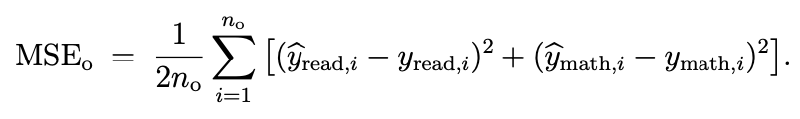
Table 8 summarises the average out-of-sample MSE for both reading and math scores for all six models.
Model | Type | Average Out-of-sample MSE
Ordinary Least Squares (OLS) | Linear | 1471.56
LASSO Regression | Regularised Linear | 1472.53
Ridge Regression | Regularised Linear | 1467.865
Elastic Net | Regularised Linear | 1471.79
Random Forest | Non-Linear ML | 1266.83
Neural Network | Non-Linear ML | 1388.655

Table 8: Average MSE Comparison Across Models
Based on predictive accuracy and the average out-of-sample MSE, Random Forest is the optimal model, achieving the lowest MSE both individually for reading and mathematics and together with an average MSE of 1,266.83. This demonstrates its superior performance compared to all linear models and the Neural Network. Whilst the Neural Network performed reasonably well, the smaller difference in MSE highlights Random Forest’s stronger ability to capture both non-linear relationships and complex interactions among predictors, particularly for mathematics scores where linear models struggled to perform.
Although stronger in predictive accuracy, Random Forest is more costly computationally and less interpretable than linear models. Unlike OLS and regularised linear models, it does not easily produce interpretable coefficients, making it harder to directly understand the impact of individual predictors. The choice of random forest therefore reflects the trade-off between predictive accuracy and interpretability; however, we choose to prioritise accurate predictions, sacrificing interpretability.

Drivers of Performance
Across all five modelling approaches, a consistent set of predictors emerged as the dominant drivers of both reading and mathematics scores. Although the magnitude and ranking vary across models, the most influential variables broadly fall into four categories, which are socioeconomic background, teacher attributes, classroom environment, and school-level characteristics.

The significance of socioeconomic status, best reflected by the lunch_non_free indicator, is a prominent finding across all modelling frameworks. Across linear, regularised, and non-linear models, students who do not need lunch subsidies routinely perform better in reading and maths. This variable is highly significant in Random Forests and Neural Networks, and it shows up as one of the best predictors in penalised regressions. The strength and constancy of this effect support the long-standing finding that one of the best indicators of academic success is still socioeconomic status. The outcome is also in line with the larger body of research showing the effects of childhood economic disadvantage on learning opportunities, long-term educational attainment, and early cognitive development (Chetty et al., 2011).

In addition to socioeconomic factors, school-level influences play a substantial role. Both Random Forest and Neural Network models identify school_id and schooldistrict_id as among the most influential features. Because these identifiers absorb a wide range of unobserved institutional factors such as leadership quality, peer composition, resource allocation, and local school culture, their importance highlights the extent of performance variation across schools. These findings are aligned with work by Rivkin, Hanushek, and Kain (2014), who emphasise that school-wide characteristics and neighbourhood context contribute meaningfully to achievement differences. The fact that these variables dominate in non-linear models suggests that school effects may operate through complex, interacting pathways that linear models cannot fully capture.

Teacher characteristics also emerge as central drivers of performance. In particular, teacher experience consistently contributes positively to student outcomes across linear and non-linear models. Regularised models (Ridge, LASSO, and Elastic Net) assign substantial weight to teacher ladder indicators, such as ladder_level1, ladder_level2, and ladder_level3. This reflects teacher expertise and professional progression. The Neural Network similarly ranks several ladder variables among the most important features in predicting reading scores. These patterns closely mirror empirical findings in the education economics literature showing that teacher experience, pedagogical skill, and accumulated instructional effectiveness significantly shape student learning. The presence of these variables among the top predictors across multiple models strengthens confidence in the validity of this relationship.

The classroom learning environment also plays a notable role in driving student performance. class_type_small, which captures the effect of smaller class sizes, appears prominently in the LASSO, Elastic Net, and Ridge models. Its influence is especially strong for reading scores, reflecting the importance of one-on-one instructional time and reduced classroom crowding in supporting early literacy. This aligns closely with results from the Tennessee STAR experiment, where small class sizes were shown to significantly improve early academic outcomes, with long-term benefits persisting into adulthood. Classrooms with additional instructional support (class_type_regular_and_aide) similarly show positive associations with performance, reinforcing the broader argument that instructional capacity within the classroom matters.

Demographic characteristics, including gender, ethnicity, and relative age (birth year and quarter), also contribute to performance outcomes, although their effects are more modest compared to SES, teacher quality, and school-level influences. The negative association between male students and reading scores, for instance, replicates widely observed gender gaps in early literacy development. Similarly, the positive association between Caucasian ethnicity and performance is consistent with persistent achievement patterns documented in national assessments. These variables capture structural demographic patterns but do not exhibit the same predictive stability or magnitude as socioeconomic or school-level factors.

The Tennessee STAR experiment also showcased random assignment to be crucial in ensuring the validity of the class type. It ensures observed differences in outcomes can be attributed to class size and not pre-existing characteristics of the students, as it eliminates selection bias. As class type is a significant factor across many models, causal interpretation is valid only when there is random assignment. However, the models still face bias even with random assignment of class type, as many important factors were not measured. This includes the home learning environment of students, teaching style, and school resources, all of which could give significant insights into factors of academic performance. This is especially crucial as school_id and schooldistrict_id are influential in the Random Forest and Neural Network model, which suggests these identifiers absorb a wide range of unobserved institutional factors.

Not taking into account these variables causes biased coefficient estimates; if the omitted variables are correlated with the predictors, then they may overestimate certain coefficients. For example, if better teachers are assigned to certain schools, then school_id would partially reflect teacher quality rather than purely being school effects. The models themselves have diversified effects, which help with capturing the most suitable predictors along with capturing certain unobserved variables, but no statistical method can fully eliminate bias from the truly unobserved variables. Thus, the magnitudes of the coefficient and causal interpretation of these variables should be interpreted cautiously, especially for non-randomised variables.

Discussion

Interpretability Trade-offs
A key consideration in the modelling approach is the trade-off between interpretability and predictive accuracy. For the OLS regression, each coefficient can be interpreted separately, with each other coefficient held constant. This format supports hypothesis testing and causal inference. Alternatively, the Random Forest regression utilises a non-linear system where the effect of any single predictor depends on its interactions with others, limiting interpretation and removing our ability to make parametric statements about variable magnitudes (McAlexander et al,. 2020). However, Random Forest's importance provides a clear hierarchy of influential predictors, consistently highlighting school-level differences, teacher experience, and socioeconomic status as primary drivers of performance. Therefore, although the Random Forest trades some interpretive precision relative to OLS, it offers superior predictive stability and still yields actionable insights which can be used to inform institutional decisions.

Policy Implications
Firstly, let us interpret the key findings of the regression and their implications for kindergarten performance. Our results showed that the specific school was a major driver for both reading and maths scores. This suggests that school-level differentials, including funding and resources, play a critical role in shaping early academic outcomes. At a national level in the US, these disparities continue to grow, with the average funding differences between the highest and lowest funded states persistently between $13,000-$14,000 per pupil, dramatically influencing the resources available to students in different areas (Krengel, 2024). To ensure academic success across all schools, it is important to provide support for disadvantaged schools. By implementing policy to promote equitable funding models and prompt targeted intervention for underperforming schools, overall performance would likely improve more than the structural changes to class size suggested in Project STAR.

Another key determinant of academic performance is the teacher’s experience. In the long term, rather than focusing solely on the impact of classroom structure, a focus on ensuring the retention of high-quality experienced teachers would be more beneficial for early development academic performance. The US SC Teacher Exit Survey found that two-thirds would consider returning under different working conditions, where retirees ranked salary increase as their number one return incentive (Byrd, 2025). This highlights the importance of fair pay and improved working conditions to elevate teacher retention levels, which have been on the decline over the last 10 years (Byrant et al., 2023). Additionally, implementing structured mentorship and ongoing professional development programmes can help strengthen instructional quality in kindergarten classrooms.

The high relevance of lunch_non_free highlights that achievement gaps are apparent as early as kindergarten. Students from lower-income households consistently face structural barriers that can hinder early learning. This finding reinforces the need for policies that address these broader inequalities, within and beyond the institution. Initiatives such as school-based nutrition programmes and family support could potentially help offset the economic disadvantage inciting academic performance disparities. Outside of the school, children from lower-income backgrounds could be supported through policies to promote early childhood services such as technology and internet access programmes which provide low cost digital support or the subsidisation of preschool/school supplies (Whitehurst, 2017). Overall, these interventions would play a critical role in narrowing early achievement gaps and supporting more equitable educational outcomes.

Furthermore, the model does confirm, on a smaller scale, the Project STAR finding that smaller classroom sizes are a meaningful positive driver of kindergarten performance. Meanwhile, the presence of a teacher's aide had a comparatively negligible impact. Consequently, the investment in additional teachers to help reduce class size is a more effective use of resources than hiring aides for existing larger classes. However, given the Random Forest model’s key drivers, further experimentation is required to test whether policies to train and retain teachers, reallocate funding or alleviate socioeconomic differences would have an overall greater positive impact on early education outcomes than structural changes.

Model Interpretation Caveats
While the original Project STAR was a randomised experiment that aimed to mitigate omitted variable bias for class-type effects, the Random Forest predictive model operates under different conditions. The school and district identifiers utilised to capture heterogeneity, could be introducing bias into other predictors if potentially uncorrelated with other unmeasured features. Given the significant amount of performance variation driven by school level differences, we must also consider other unobserved school-level differences influencing this result, including school funding, resource quality and community initiatives.

Moreover, the Project STAR experiment’s external validity is limited, as it is trained on data from Tennessee in the 1980s, which prevents generalisability in contemporary American and Australian educational settings. It is also important to note the changes to curriculum, teaching practices and demographics since the data collection. Broader interpretability implications, such as those for teachers and schools, are likely to remain relevant; the precise structure and magnitudes of the model are not directly transferable to current society.

Additional experimentation could further enhance model interpretability. Foremostly, a more extensive hyperparameter tuning process, for example, the implementation of Bayesian optimisation, could help refine tree depth, sample size, and the number of estimators, further improving predictive accuracy and reducing variance (Zhu et al,. 2025). Additionally, through the inclusion of additional geographic or socioeconomic data linked to each school, such as neighbourhood income, local funding allocations or community demographic profiles, we could break down the school_id variable to develop a more nuanced understanding of the in-school differences driving academic outcomes.

Conclusion
In conclusion, the random forest regression model robustly identifies school quality, teacher experience and socioeconomic background as the key drivers of kindergarten achievement. While small class sizes confer a measurable benefit, their impact is smaller. These findings suggest effective educational policy must be multifaceted; combining investments in teacher retention and targeted school support extending beyond the structural change.

References
Bryant, J., Ram, S., Scott, D. and Williams, C. (2023). US K-12 educators are thinking of leaving their jobs | McKinsey. [online] www.mckinsey.com. Available at: https://www.mckinsey.com/industries/education/our-insights/k-12-teachers-are-quitting-what-would-make-them-stay [Accessed 14 Nov. 2025].
Byrd, A. (2025). Understanding Teacher Retention Data Through Teacher Mobility. [online] Education Commission of the States. Available at: https://www.ecs.org/understanding-teacher-retention-data/ [Accessed 14 Nov. 2025].
Chetty, R., Friedman, J.N., Hilger, N., Saez, E., Schanzenbach, D.W. and Yagan, D. (2011). How Does Your Kindergarten Classroom Affect Your Earnings? Evidence from Project Star. The Quarterly Journal of Economics, [online] 126(4), pp.1593–1660. https://academic.oup.com/qje/article-abstract/126/4/1593/1923939?redirectedFrom=fulltext&login=false
Goldstein, M. and Smith, A.F.M. (1974). Ridge-Type Estimators for Regression Analysis. Journal of the Royal Statistical Society: Series B (Methodological), 36(2), pp.284–291. doi:https://doi.org/10.1111/j.2517-6161.1974.tb01006.x.
Hastie, T., Tibshirani, R. and Friedman, J. (2009). The Elements of Statistical Learning. Springer Series in Statistics. New York, NY: Springer New York. doi:https://doi.org/10.1007/978-0-387-84858-7.
Hunter, L.M., Talbot, C., Connor, D., Counterman, M., Uhl, J., Gutmann, M. & Leyk, S. (2020). Change in U.S. Small Town Community Capitals, 1980–2010. Population Research and Policy Review, 39(5), 913–940. doi: 10.1007/s11113-020-09609-4. Available at: https://www.ncbi.nlm.nih.gov/pmc/articles/PMC8650091/ [Accessed 12 Nov. 2025].
Krengel, S. (2024). Making the Grade 2024: Education Funding Disparities Persist as Some States Prioritize Tax Cuts and Privatization - Education Law Center. [online] Education Law Center. Available at: https://edlawcenter.org/making-the-grade-2024-education-funding-disparities-persist-as-some-states-prioritize-tax-cuts-and-privatization/ [Accessed 15 Nov. 2025].
McAlexander, R.J. and Mentch, L. (2020). Predictive inference with random forests: A new perspective on classical analyses. Research & Politics, 7(1), p.205316802090548. doi:https://doi.org/10.1177/2053168020905487.
pro.arcgis.com. (n.d.). How OLS regression works—ArcGIS Pro | Documentation. [online] Available at: https://pro.arcgis.com/en/pro-app/latest/tool-reference/spatial-statistics/how-ols-regression-works.htm [Accessed 13 Nov. 2025].
Rivkin, S.G., Hanushek, E.A. and Kain, J.F. (2014). Corrigendum to ‘Teachers, Schools, and Academic Achievement’. Econometrica, 82(4), pp.1543–1543. doi:https://doi.org/10.3982/ecta12211.
Speiser, J.L., Miller, M.E., Tooze, J. and Ip, E. (2019). A Comparison of Random Forest Variable Selection Methods for Classification Prediction Modeling. Expert Systems with Applications, 134(1), pp.93–101. https://pmc.ncbi.nlm.nih.gov/articles/PMC7508310/
Tangjuang, P. (2013). OUTLIER DETECTION AND PARAMETER ESTIMATION IN MULTIVARIATE MULTIPLE REGRESSION (MMR) Paweena Tangjuang A Dissertation Submitted in Partial Fulfillment of the Requirements for the Degree of Doctor of Philosophy (Statistics) School of Applied Statistics National Institute of Development Administration 2013. [online] Available at: https://libdcms.nida.ac.th/thesis6/2013/b184491.pdf [Accessed 12 Nov. 2025].
Whitehurst, G. (2017). Why the federal government should subsidize childcare and how to pay for it. [online] Brookings. Available at: https://www.brookings.edu/articles/why-the-federal-government-should-subsidize-childcare-and-how-to-pay-for-it/ [Accessed 14 Nov. 2025].
Zhu, T., Zhou, H., Jin, K., Xu, X., Yuan, Q. and Ji, L. (2025). Bayesian Optimization by Kernel Regression and Density-based Exploration. [online] arXiv. Available at:
https://arxiv.org/pdf/2502.06178 [Accessed 14 Nov. 2025].

Appendix
Appendix A: Reduced Descriptive Statistics
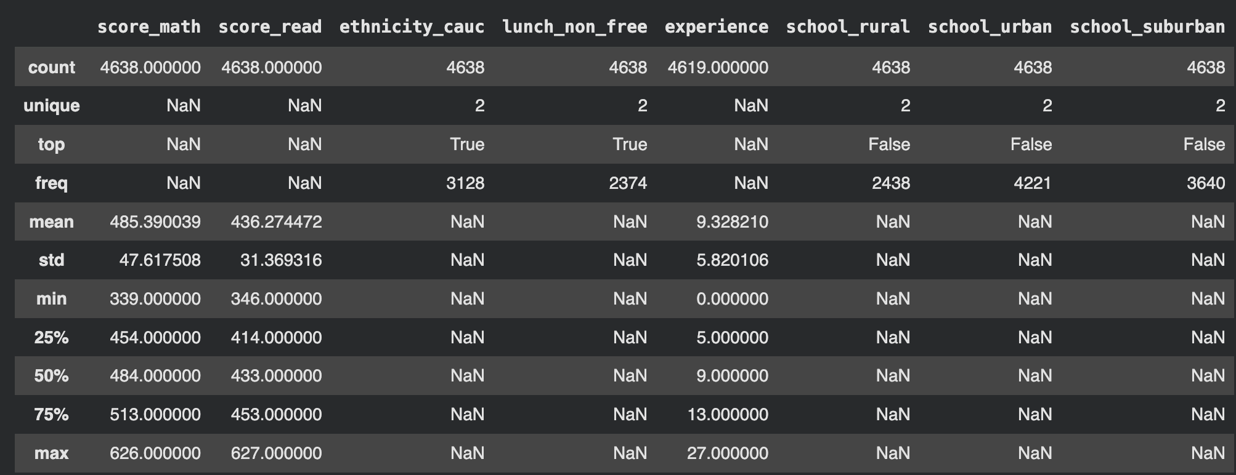

Appendix B: Influential predictors for LASSO Regression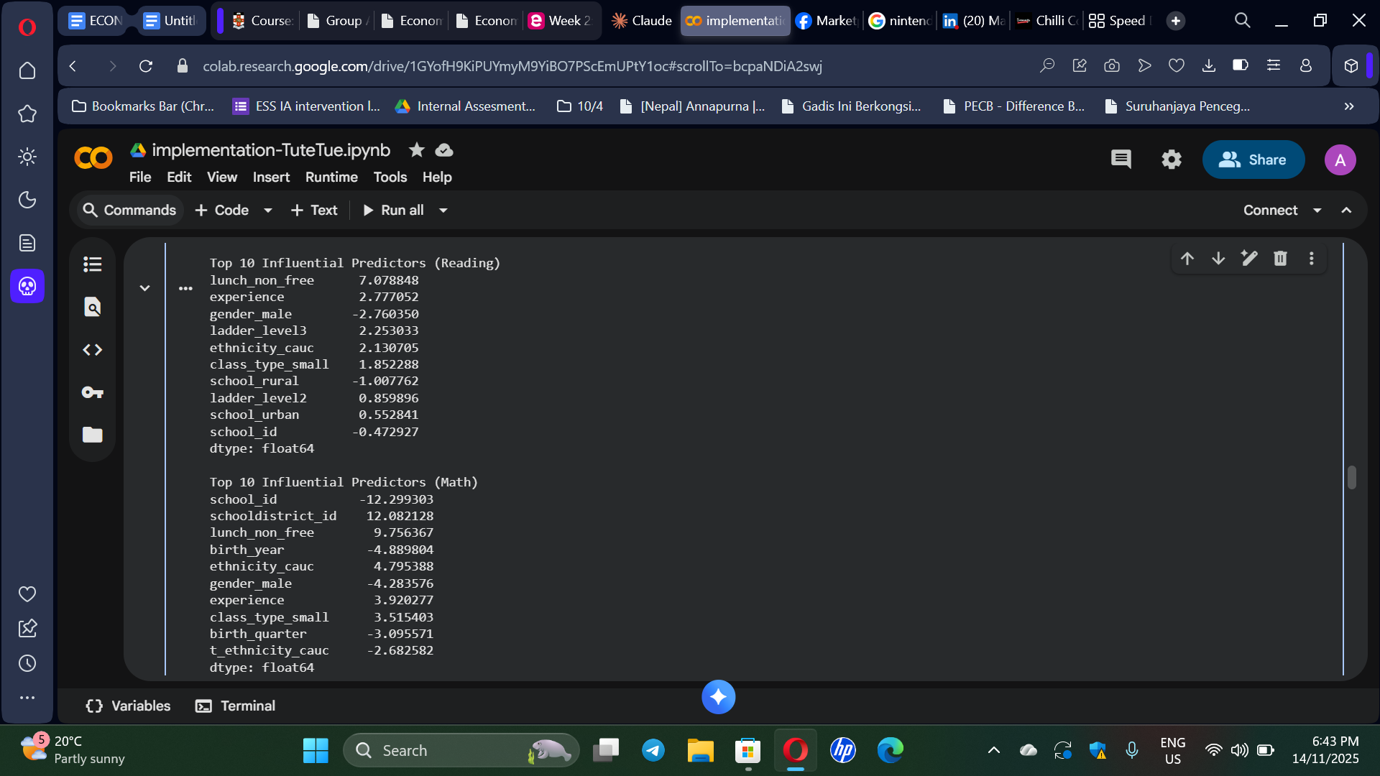

Appendix C: Features Importance for Ridge Regression model
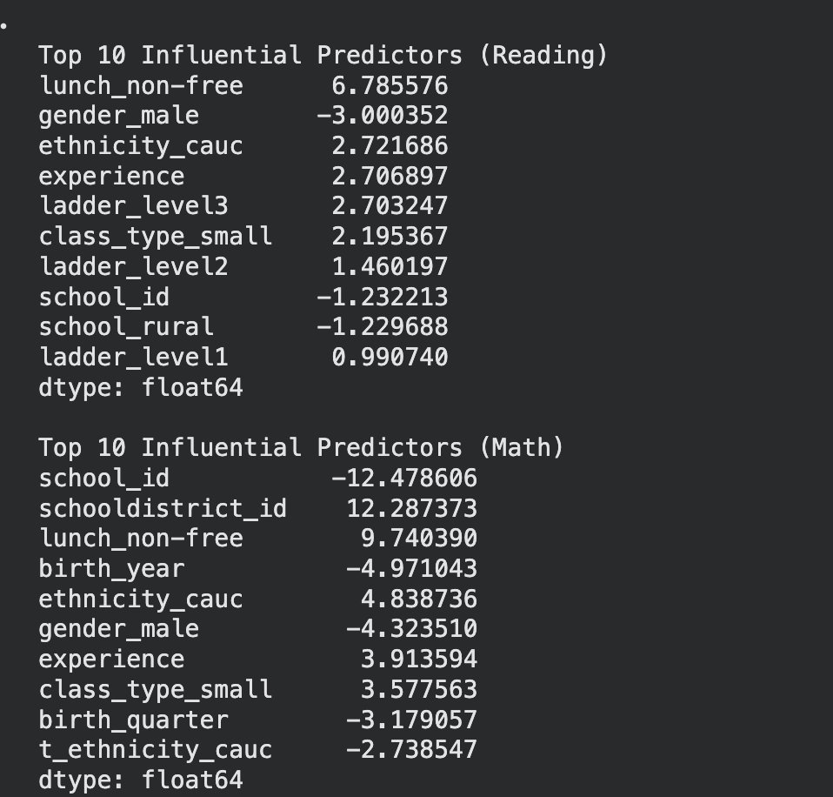

Appendix D: Feature Importance for Random Forest Model
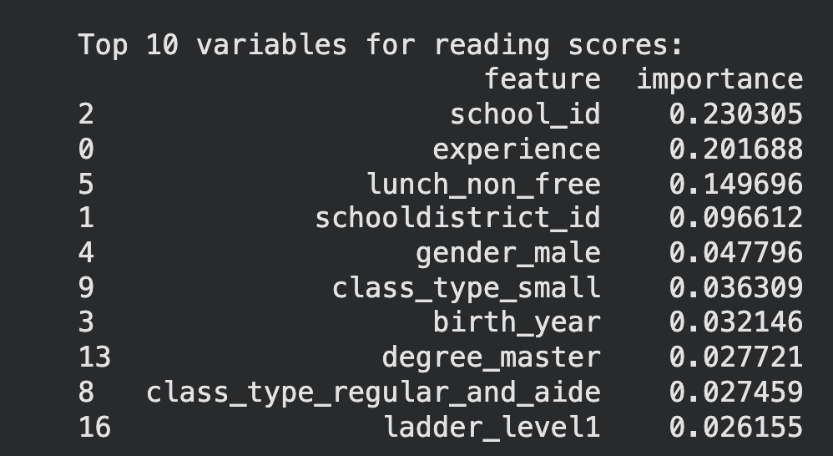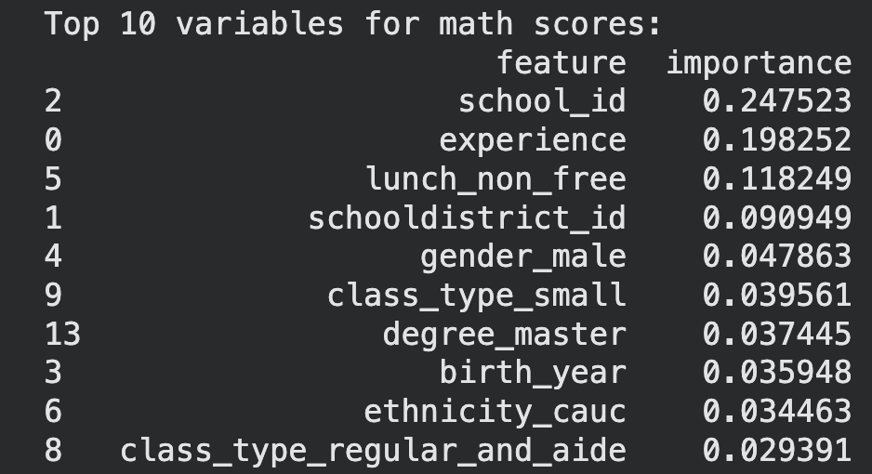

Appendix E: Neural Network Training and Validation Loss
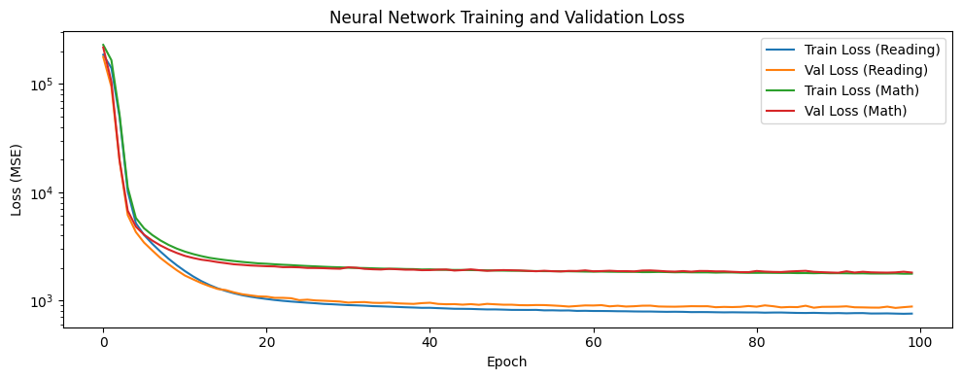
Appendix F: Feature Importance of Neural Network Model

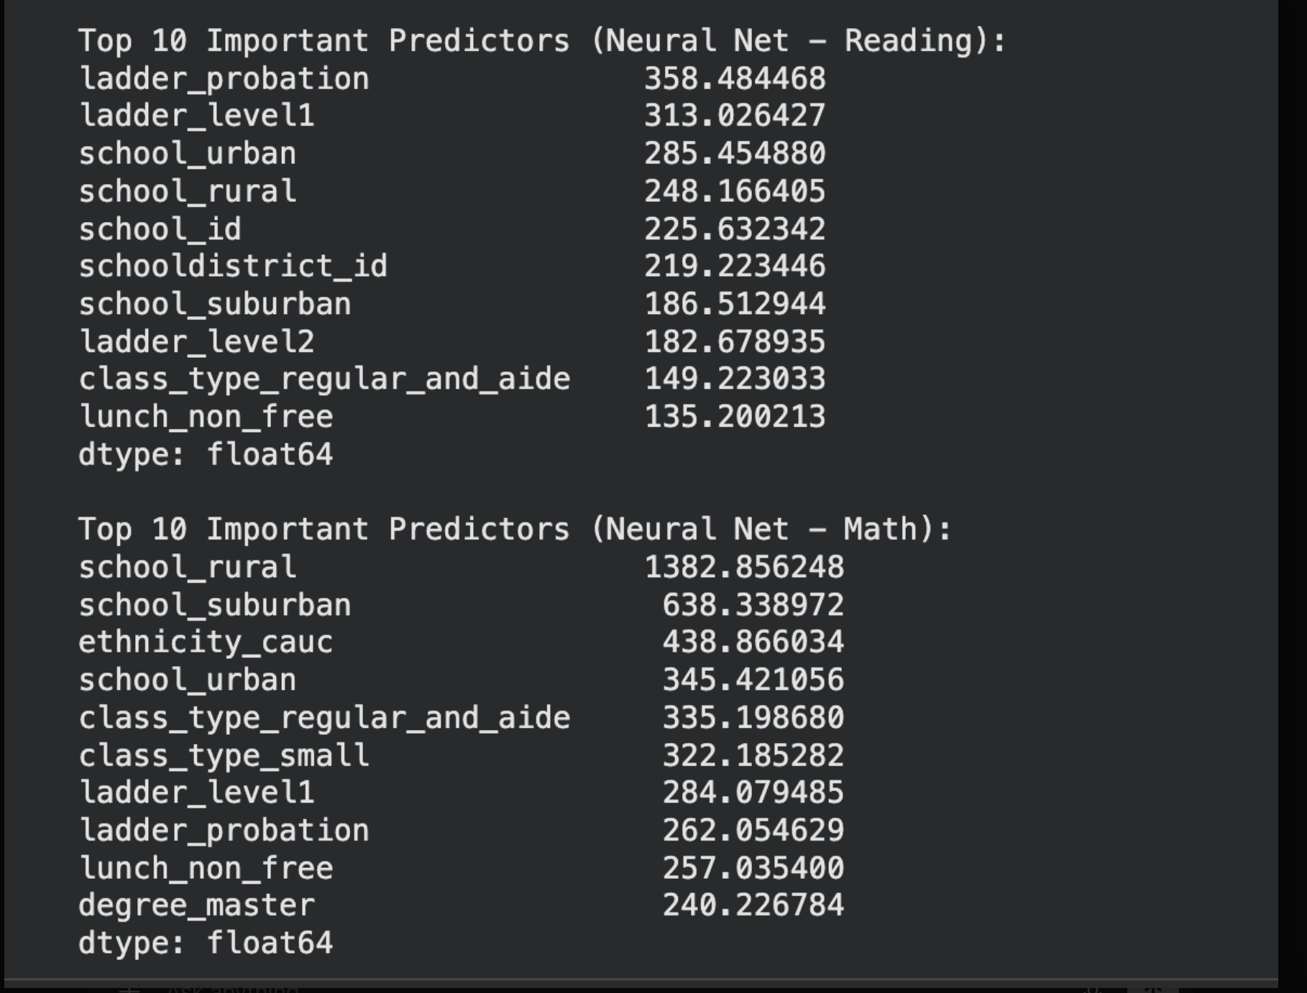

Appendix G: SHAP Value for Neural Network Figure

