BetaVest: Part B Funds, Sentiment and App
Fins3645 Financial Market Data Design and Analysis - T2 2026

FINS3645 Project B. Data Factory Floor Stations 3-4
Name: Aiman Haikal Bin Ahmad Norzi
zID: z5532834
Word Count:
Streamlit URL:
GitHub Public Repository Link:

Introduction
BetaVest is an evidence-based fund comparison dashboard for young retail investors. Part A created the clean data foundation: 50 US equities, 10 cryptocurrencies, and equity news headlines aligned to trading dates over 2020-2023. Part B turns that foundation into a set of investable fund tests, a standalone sector sentiment index, a sentiment-fusion portfolio, and a Streamlit app that lets a user inspect the evidence behind each fund.
The report follows the Part B brief by moving from fund construction to investor use. It first explains the funds and out-of-sample backtest, then compares the fund results and fact sheets. It next evaluates the sector sentiment index, sentiment fusion, and robustness tests before examining the Streamlit investor journey and the improvements that remain.
The main finding is that Combined Risk Parity is the most credible core BetaVest fund in the live backtest. It does not have the highest raw return, but it has the strongest risk-adjusted result and a more acceptable drawdown profile than the crypto-only funds. The sentiment extension also adds value, but only as a controlled equity tilt. Equity The finance-lexicon tilt selected on 2021-2022 improves the Equity Risk Parity Sharpe ratio from 0.944 to 1.003 in the untouched 2023 holdout. The gain is useful, but it is not strong enough to replace diversification or risk control.
This framing is important for the target user. A young retail investor may be attracted to high-return crypto strategies, but the evidence shows that return alone can be misleading. The report and app therefore present funds by investor use case: core, aggressive, defensive, or speculative. The goal is not to claim that one strategy will win in the future. The goal is to make the trade-off between return, drawdown, cost, diversification, and sentiment visible.
A second purpose of BetaVest is to make technical fund evidence usable for a non-technical investor. The target user may understand returns but may not naturally check volatility, drawdown, turnover, concentration, or sentiment quality before choosing a fund. The app therefore starts with the strongest evidence, supports comparison and detailed fund inspection, and then lets the investor test an allocation after fees. Sentiment and method evidence remain close to the decision so the user can see why a result should be treated cautiously.

Funds and Backtest Design

Funds and Optimisation Methods
BetaVest tests twelve funds across three groups of permitted assets which are equity-only, crypto-only, and combined equity-plus-crypto. Each group is tested using four methods: equal weight, minimum variance, maximum Sharpe, and risk parity. This satisfies the required combined-fund minimum and adds equity-only and crypto-only sleeves, which helps the report explain whether crypto is best used alone or as part of a diversified fund.
Each asset-family and method pair is treated as one fund because this is what the investor would choose in the app. For example, Combined Risk Parity is a different fund from Equity Risk Parity because it is allowed to invest in different assets and has a different risk profile and holding set. This structure also makes the fact sheets clearer: each fund has its own growth path, drawdown history, performance metrics, current holdings, and suggested investor use.
The four methods represent different investment philosophies. Equal weight is the transparent benchmark because it does not estimate expected returns or covariances. Minimum variance targets lower realised volatility and drawdown. Maximum Sharpe targets return per unit of estimated risk, but it is more sensitive to noisy historical means. Risk parity uses scipy.optimize.minimize to solve a long-only equal-risk-contribution problem, with weights constrained to be non-negative and to sum to one. The risk parity fund is therefore included as a more stable optimisation method, not only as another return-maximising rule.
Using several methods is useful because each one can fail in a different way. Equal weight can over-allocate to volatile assets because it ignores risk. Minimum variance can become too conservative if it avoids assets with useful, expected returns. Maximum Sharpe can chase assets that looked strong in the estimation window but do not continue to outperform. Risk parity can still be exposed to common market shocks, but it is less dependent on unstable return forecasts. Comparing these methods side by side gives a stronger answer than choosing one optimiser in advance.
The permitted-asset split is also part of the design. Equity-only funds show what could be achieved using the 50-stock dataset. Crypto-only funds show the standalone risk of digital assets. Combined funds test whether crypto improves a broader portfolio once the optimiser is allowed to manage risk across both families. This matters because the investor decision is not simply whether crypto has high returns; it is whether crypto improves the portfolio after accounting for volatility, drawdown, and diversification.

Data Alignment and Investable Timing
The backtest uses the cleaned Part A return panel. Equity returns are calculated from adjusted-close prices on the US equity trading calendar. Crypto returns are calculated on their native daily calendar and then aligned to equity trading dates for combined funds. This avoids turning weekend crypto moves into artificial weekday equity trades and ensures that the combined funds are evaluated on a common investable calendar.
The backtest is walk-forward and out of sample. At each month-end rebalance, the model estimates weights using the previous 252 trading days. The first live backtest date is therefore after the initial estimation window rather than the first date in the dataset. Weights are formed using information available before the rebalance date, then the following returns are used to calculate realised performance. This timing rule is the main protection against look-ahead bias.
Sharpe ratios use a zero risk-free rate, which is stated as a simplifying assumption. Performance is reported after a 10-basis-point transaction cost on turnover. Including turnover matters because some optimisers improve gross return by trading more frequently. A retail-facing fund product should not rank funds only by pre-cost performance if the implementation cost changes the final investor experience.
The rebalance design deliberately favours interpretability over overfitting. Monthly rebalancing is frequent enough for the funds to respond to changing risk and sentiment, but not so frequent that the project becomes a daily trading strategy. The 252-day lookback window approximates one trading year, giving the optimiser enough observations to estimate risk while still adapting to recent market conditions. These choices are simple, but they are defensible and easy for a marker or investor to audit.
The main backtest risk is that historical estimates can look precise even when they are not. To reduce this risk, the report does not rely on one metric. Annualised return shows growth potential, volatility shows day-to-day risk, Sharpe ratio combines return and risk, maximum drawdown captures the worst investor pain point, turnover shows implementation intensity, and transaction cost shows whether trading reduces the practical result. A fund only earns a strong recommendation when the full set of measures is consistent.

Out-of-Sample Results and Fund Fact Sheets

Main Results
The strongest out-of-sample fund is Combined Risk Parity. It records an annualised return of 13.65%, annualised volatility of 16.04%, a Sharpe ratio of 0.851, a maximum drawdown of -19.79%, and a total return of 46.57%. This is the main fund-design answer: the best core BetaVest fund is not the most aggressive crypto portfolio, but a combined fund that controls how much each asset contributes to risk.
Combined Maximum Sharpe has the highest annualised return among the main combined funds at 16.18% and the highest total return at 56.52%. However, it also has higher annualised volatility of 22.39%, a deeper maximum drawdown of -26.01%, and total transaction cost of 1.80%. It is therefore better described as an aggressive growth sleeve than as the default core fund. Combined Equal Weight also performs well, with 14.94% annualised return and a 0.703 Sharpe ratio, but the -28.75% drawdown is less attractive for a young investor who may not understand large peak-to-trough losses.
The equity-only funds provide useful benchmarks. Equity Equal Weight delivers a 12.61% annualised return and a 0.780 Sharpe ratio, making it a strong transparent benchmark. Equity Risk Parity produces a lower annualised return of 9.80%, but it has lower volatility of 14.58% and a smaller maximum drawdown of -18.68%. Equity Minimum Variance is more defensive, with 12.77% volatility and a -15.55% maximum drawdown, but its annualised return falls to 4.25%. These funds show the return-risk trade-off clearly: lower volatility is useful, but it can come at a large opportunity cost.
The crypto-only funds are not suitable as core BetaVest funds in this sample. Crypto Minimum Variance has the highest annualised return in the full results table at 22.61%, but annualised volatility is 64.95% and maximum drawdown is -75.13%. Crypto Equal Weight has a weak Sharpe ratio of 0.040 and a maximum drawdown of -84.85%. Crypto Maximum Sharpe performs worst, losing 49.53% over the live period. These results support a clear product message: crypto can be used as a satellite exposure or a controlled part of a combined fund, but crypto-only products should be labelled speculative.
The 2022 drawdown is especially important for interpretation. A fund can look attractive in a full-sample table if strong recovery periods offset one severe loss period. However, a real investor experiences the path, not only the final average. The drawdown view shows whether the investor would have needed to tolerate large losses before the fund recovered. This is why Combined Risk Parity is preferred even though Combined Maximum Sharpe and Crypto Minimum Variance produce higher raw return numbers in some summaries.
The results also show why BetaVest should avoid a purely mechanical ranking table. If the app ranked funds only by annualised return, a user could select Crypto Minimum Variance without recognising that it lost more than half its value in the 2022 period. If the app ranked funds only by minimum drawdown, the user might select a defensive fund that gives up too much upside. The better decision rule is to combine performance, risk, role, and investor suitability.

Fact-Sheet Interpretation
The fact sheets translate these results into investor-facing decisions. Combined Risk Parity should be presented as the core growth candidate because it balances return, volatility, drawdown, and cost better than the other funds. Equity Equal Weight should be presented as the simple equity benchmark. Combined Maximum Sharpe should be presented as an aggressive growth sleeve because it raises return but also increases volatility, drawdown, and turnover. Equity Minimum Variance should be presented as a defensive stabiliser because it reduces risk but gives up too much return to be the main offer.
This use-case framing is more useful than a single performance ranking. A young retail investor may incorrectly select the highest-return fund without understanding drawdown or volatility. The fact sheet design avoids this by showing growth of one-dollar, annualised return, annualised volatility, Sharpe ratio, maximum drawdown, total return, current holdings, asset-class exposure, sector exposure, holding concentration, turnover, and transaction cost. These are the key checks needed before treating any fund as a core allocation.
The current holdings section is included because a fund label can hide concentration. Two funds with similar Sharpe ratios may expose the investor to very different assets or sectors. Showing the latest holdings, asset-class split, sector exposure, top five weight, and top ten weight makes the fact sheet closer to a real fund document. It helps the user ask whether the fund is diversified, whether crypto exposure is material, and whether one sector is driving too much of the result.
The fact sheets also connect the report to the Streamlit app. In the report, the fact-sheet evidence supports the written recommendation. In the app, the same evidence becomes an interactive decision page where the user can choose a fund from a dropdown and immediately see its risk profile. This link between written analysis and dashboard workflow is important because the deliverable is not only a report; it is a report, codebase, and investor-facing application.
The out-of-sample evidence therefore supports a balanced product recommendation. BetaVest should lead with Combined Risk Parity, retain Equity Equal Weight as the simple benchmark, offer Combined Maximum Sharpe for users who explicitly accept higher risk, and treat crypto-only funds as satellite exposure only. This recommendation follows from risk-adjusted evidence rather than from the fund with the most eye-catching return.

Sentiment Index

Construction
The sentiment index converts the Part A headline dataset into a standalone equity-sector news signal. The input data contains headline text, ticker labels, sector labels, and aligned trading dates. The model is deliberately transparent. It is designed as a finance headline-tone index rather than a black-box article-level classifier. Sentiment is applied only to equities because the project news data covers the permitted equities, not the crypto assets.
The Streamlit app also summarises the sector sentiment index through a Fear-Greed Gauge. The gauge takes the latest 21-day average of market-wide sector sentiment and converts it into a 0-100 percentile score against BetaVest’s own 2020-2023 sentiment history. A low score indicates that current news sentiment is weak compared with history, while a high score indicates stronger market mood. This makes the sentiment signal easier for a non-technical investor to interpret before checking the detailed sector index.
The scoring model uses a finance-lexicon baseline. Positive words include terms such as beat, buy, growth, upgrade, gain, strong, profit, outperform, rally, and record. Negative words include miss, sell, downgrade, risk, loss, weak, decline, lawsuit, cut, warning, debt, and probe. Before scoring, headlines are lowercased and punctuation is removed so finance terms can be matched consistently. Numbers and ticker symbols are not treated as sentiment words because the model is a transparent lexicon signal rather than a full language classifier.
For each ticker-day, the score is positive word counts minus negative word counts, scaled by the number of sentiment-bearing terms. Sector sentiment is then calculated by averaging ticker-day scores across the five stocks in each sector. Ticker-days with no headlines are treated as neutral. This is a conservative choice because it avoids allowing one heavily covered firm to dominate the sector index when the other firms have no news. The signal is lagged by one trading day before investment use, so day t sentiment can only affect a day t+1 decision or later.
The neutral treatment for missing headlines is a judgement call, but it is appropriate for this project. Dropping missing ticker-days would make the index depend only on firms that received coverage, which could exaggerate event-driven news. Carrying sentiment forward would assume yesterday's tone remains valid even when there is no new information. Neutral scoring is conservative: it says that no observed headline should not automatically become positive or negative evidence. This choice makes the sentiment index less dramatic but more suitable for a controlled portfolio tilt.
The one-day lag is the most important implementation detail. Headlines must be available before they can be used in a trading decision. A same-day signal would risk using information that was published after the portfolio decision or after market close. By lagging the score, the project treats sentiment as information known before the next rebalance. This keeps the text signal consistent with the out-of-sample backtest logic used for the return-based funds.

Findings and Investment Use
The sentiment summary shows that news tone differs across sectors. Consumer has the highest average sentiment at 0.521, followed by Technology at 0.485 and Healthcare at 0.396. Materials have the lowest average sentiment at 0.164. Coverage also differs: Technology has 26,632 aligned headlines and Consumer has 25,877, while Materials has 5,393 and Real Estate has 5,339. These differences mean the index should be read as both a sentiment measure and a coverage-aware signal.
The useful investment signal is the lagged sector sentiment index. It can tilt an equity portfolio toward sectors with stronger recent news tone, flag sectors where the news tone is weakening, and help explain why the equity sleeve changes over time. It should not be read as a guarantee that positive news causes positive returns. Sentiment is noisy, and a small lexicon can miss negation and context. The index is therefore most credible when it supports an existing risk-controlled portfolio process.
This design answers the sentiment requirement in the brief. The project applies a sentiment model to the assembled headlines, builds a sector-level sentiment index, equal-weights ticker-day scores within sectors, treats missing ticker-days neutrally, and lags the signal before trading. These choices make the signal reproducible and reduce the risk of overstating what the text model can know at the time of investment.
The sector sentiment figure is useful because it shows persistence and disagreement across sectors rather than only a final average. A sector with high average sentiment but unstable weekly movement may be less useful for allocation than a sector with a smoother signal. The selected-sector table in the app helps with this interpretation by updating to the sectors chosen by the user. This makes the sentiment section more than a static exhibit: it becomes a way to inspect where the news signal is strongest, weakest, and most reliable.

Extensions and Innovations
The main extension is a sentiment-fusion fund that adds the lagged sector sentiment signal to Equity Risk Parity. The base fund first estimates long-only risk-parity weights using the previous 252 trading days. At each monthly rebalance, each equity then receives a sector sentiment multiplier based on one-day-lagged sentiment. The multiplier is capped between 0.70 and 1.30, and weights are renormalised to sum to 100%. This keeps the fund long-only and prevents the sentiment signal from overwhelming the optimiser.
The full-sample fusion result is positive but modest. Equity Risk Parity has annualised return of 9.80%, volatility of 14.58%, a Sharpe ratio of 0.672, a maximum drawdown of -18.68%, and total transaction cost of 0.23%. Equity Sentiment Tilt improves annualised return to 10.08%, Sharpe to 0.690, and maximum drawdown to -18.27%, while total transaction cost rises to 0.46%. The full-sample Sharpe lift is 0.018, so the evidence supports sentiment as an incremental tilt rather than a complete investment model.
The tilt-strength grid is separated from the final test. The 2021-2022 discovery period selects a finance-lexicon tilt of 0.15, where Sharpe rises from 0.572 for Equity Risk Parity to 0.576 for the tilt. That choice is frozen before evaluating 2023. In the untouched holdout, annualised return rises from 11.53% to 12.23% and Sharpe rises from 0.944 to 1.003, a lift of 0.059 after transaction costs. This separation reduces the risk that the reported result comes from selecting a parameter that happened to fit the full sample.
A key point is that the sentiment fusion is intentionally constrained. If the model allowed large sentiment bets, the portfolio could look innovative but become fragile. The cap on the multiplier, the long-only constraint, and the monthly rebalance rule keep the signal inside an investable fund design. This is why the result is reported as a Sharpe lift rather than as a claim that sentiment can forecast every stock return. The value is incremental, measured, and linked to a baseline fund.
The project compares the finance lexicon with standard VADER before treating sentiment as reliable. The finance lexicon has mean ticker-day sentiment of 0.436, compared with 0.279 for VADER. Their score correlation is only 0.337, and they agree on positive, neutral, or negative direction for 58.8% of ticker-days. The finance lexicon classifies 41.3% of ticker-days as neutral, while VADER classifies 24.1% as neutral. Model choice therefore materially changes the measured news signal.
Both models produce a positive 2023 holdout result after their tilt strengths are selected on 2021-2022. The finance lexicon raises holdout Sharpe by 0.059, while VADER raises it by 0.037. The finance model remains the selected BetaVest signal, but the result is reported beside the VADER benchmark and a reproducible sample of the largest model disagreements. The disagreement sample is a review tool rather than labelled ground truth; a production model would still require independent human coding of headline tone.
The second extension is a robustness test across market periods. The backtest is split into the full sample, the 2021 recovery, the 2022 drawdown, and the 2023 recovery. Combined Risk Parity remains a strong core candidate because it performs well in the recovery years while limiting downside in 2022 better than more speculative alternatives. Its Sharpe ratio is 2.501 in 2021, -0.354 in 2022, and 1.224 in 2023. Crypto Minimum Variance has strong upside in favourable years, but its 2022 return of -57.58% and maximum drawdown of -62.91% confirm that crypto-only exposure fails the stability test for core use.
The third extension is sentiment regime analysis which explains the days are grouped into negative, neutral, and positive regimes using terciles of the one-day-lagged sector sentiment signal. Equity Sentiment Tilt improves Equity Risk Parity Sharpe in the negative regime from 0.516 to 0.527 and in the positive regime from 0.200 to 0.261. It underperforms in the neutral regime, where Sharpe falls from 1.445 to 1.406. This result is balanced: the sentiment signal helps in some regimes, but it is not a universal return predictor.
Together, these extensions address the higher-band requirement in the brief. The project adds equity-only and crypto-only funds, implements an extra optimisation method through long-only risk parity, adds transaction costs and turnover, builds a sentiment-fusion fund, selects tilt strength on a discovery period, tests an untouched holdout, compares two text models, reports robustness by market period, and analyses performance across sentiment regimes. The result is not just a larger set of funds; it is a more honest evaluation of when each fund should and should not be used.
The robustness work is also important because it prevents the innovation section from becoming only a feature list. The project does not simply add a new signal and stop after one full-sample result. It asks whether the signal survives different market conditions and whether the best fund remains credible during stress. That makes the extension more evidence-based and closer to the standard expected in a fund research note.

App and Investor Journey

Dashboard Structure
The Streamlit app converts the modelling outputs into an investor-facing dashboard. It does not recompute the raw data pipeline at runtime. Instead, it reads precomputed result files from the project results folder, which keeps the deployed app fast, reproducible, and easier to audit. The app includes an Overview tab, Compare tab, Fact Sheet tab, Allocation tab, Sentiment tab, and Method tab.
The Overview tab explains what BetaVest does, reports the main findings, summarises the number of funds and assets covered, shows a featured fund, displays a small sentiment pulse, and explains the risk-tier labels.
Next, the Compare tab then lets the user select funds to overlay and switch between growth of one dollar, drawdown, and rolling Sharpe. A global date-range control in the sidebar lets the same sample window flow through the dashboard, and the app uses consistent fund colours so the same fund is recognisable across tabs.
The Fact Sheet tab supports deeper inspection of one fund. It shows return, volatility, Sharpe ratio, drawdown, total return, turnover, cost, worst drawdown period, benchmark comparison, holdings, asset-class exposure, sector exposure, and holding concentration.
The Allocation tab then lets the user combine selected funds using sliders and exact percentage inputs. A management-fee control compares gross and net growth of the selected mix, making the cost of the product visible. The Sentiment tab exposes the sector sentiment index, model comparison, discovery grid, 2023 holdout, and sentiment regime analysis.
And lastly, the Method tab explains the formulas and caveats, so the app is not a black box.
Several app choices are designed to improve usability rather than add unnecessary decoration. The sidebar keeps global settings such as chart horizon, date range, data status, and theme in one place. Fund, factsheet, and sector selectors sit on the relevant pages, so they are visible when the user needs them. A consistent colour is assigned to each fund across charts, allocation views, and comparison tables. The dark theme is included for readability, while download buttons let the user export the underlying evidence.

Investor Journey
The intended investor journey has four steps. First, the user starts on Overview to see what BetaVest offers and what the headline result is. Second, the user moves to Compare to test whether the featured fund is still attractive under different performance views and date ranges. An then, the user opens the Fact Sheet to inspect holdings and risks before choosing the fund. Finally, the user tests a simple allocation and checks the Sentiment and Method tabs to understand whether the recommendation is supported by both market data and headline evidence.
This journey matters because the target user is a young retail investor, not a portfolio research team. The app therefore uses risk labels, suggested uses, readable cards, a light/dark theme option, global controls, downloadable tables, and concise subtitles under each tab. These features help the user understand the analysis without reading the code. They also make the app closer to a product: it guides fund discovery, evidence checking, allocation building, fee evaluation, and method review in one place.
The investor journey is deliberately ordered. Overview gives orientation, Compare helps the user decide which funds deserve attention, Fact Sheet checks whether one fund is acceptable, Allocation turns fund choices into a portfolio mix, Sentiment explains the text signal behind the equity tilt, and Method documents the assumptions. This sequence reduces cognitive load because the user is not asked to understand optimisation formulas before seeing the practical fund evidence.
The app still avoids pretending to be personalised financial advice. It presents evidence from historical simulations and makes the caveats visible. This is why drawdown, volatility, turnover, transaction cost, and robustness are shown beside returns. The app's strongest design feature is that it slows down the decision process: before selecting a fund, the user can see what the fund owns, how it behaved in the 2022 drawdown, and whether sentiment evidence adds anything meaningful.

Critical Reflection and Recommendations

Reflection
The first limitation is estimation error. Maximum-Sharpe and mean-variance methods use historical expected returns and covariances, which are noisy in a short sample. The 2020-2023 period contains pandemic stress, high-growth technology repricing, inflation pressure, and large crypto cycles. These events make optimiser inputs unstable. Risk parity reduces this problem because it focuses on risk contribution rather than estimated mean returns, but it does not remove estimation error entirely.
The second limitation is sentiment measurement. A transparent finance lexicon is useful because the scoring rule is easy to inspect, but it can miss negation, sarcasm, multi-word phrases, and context. For example, the same word can have different meanings across sectors or headline formats. The sentiment result should therefore be treated as evidence that a simple signal can add incremental value, not as proof that the current lexicon is production ready. The low cross-model correlation and 58.8% direction agreement confirm that the measured signal depends on the scoring model.
The third limitation is deployment realism. The app is reproducible because it reads precomputed result files, but the final submission still needs a public Streamlit URL, a public repository link, and a clean AI workflow pack. In a real product, users would also expect more recent data, live monitoring, clearer disclaimers, and stronger stress testing. The current project is a strong coursework prototype, not a regulated investment product.
There are also limitations in the sample period. The live backtest covers 2020-2023 after the initial estimation window, which includes major market stress and recovery episodes but is still short for judging long-term fund behaviour. A different interest-rate cycle, a different crypto regime, or a different equity sector leadership pattern could change the rankings. This is why the conclusion should be read as evidence from this sample, not as a permanent ranking of investment strategies.

Three Concrete Recommendations
First recommendation is to strengthen the optimiser inputs. The next version should add shrinkage covariance estimates, maximum holding caps, and concentration diagnostics. This would reduce the chance that one noisy return window drives unrealistic weights. It would also make the fact sheets more credible because users could see whether a fund is diversified or dependent on a small number of assets.
Moreover it is recommended to complete independent headline validation. The project now compares the finance lexicon with VADER and produces a targeted disagreement sample, but model agreement is not accuracy. A human-coded sample should identify false positives, false negatives, and sector-specific language before the lexicon is expanded. The revised signal should then repeat the same 2021-2022 discovery and 2023 holdout test.
Recommendation 3 is to complete the product and hand-in deployment checklist. The final version should include the live Streamlit app URL, public GitHub repository link, standard app entrypoint, updated Word fields, exported PDF, and AI workflow pack. The app should also retain the gross-versus-net fee view and include clear disclaimers that results are historical simulations and not personalised financial advice.
These recommendations are concrete because each one can be implemented and evaluated. Shrinkage covariance and holding caps can be tested by rerunning the same walk-forward backtest. Sentiment validation can be measured by comparing labelled headline samples with model scores and by retesting the tilt after lexicon changes. Deployment improvements can be checked directly through the app URL, repository structure, downloadable files, and user journey. This makes the reflection actionable rather than only descriptive.
Overall, BetaVest answers the Part B brief by building systematic funds, testing them out of sample, creating a sector sentiment index, fusing sentiment with an equity optimiser, adding robustness checks, and presenting the evidence in a usable app. The strongest result is Combined Risk Parity as the core fund candidate. The most useful innovation is not that sentiment wins every test, but that the project shows where sentiment helps, where it does not, and how it can be controlled inside a disciplined investment process.

References
Baker, M., & Wurgler, J. (2007). Investor sentiment in the stock market. The Journal of Economic Perspectives, 21(2), 129–151. https://doi.org/10.1257/jep.21.2.129
DeMiguel, V., Garlappi, L., & Uppal, R. (2007). Optimal Versus Naive Diversification: How Inefficient is the 1/NPortfolio Strategy? Review of Financial Studies, 22(5), 1915–1953. https://doi.org/10.1093/rfs/hhm075
Hutto, C., & Gilbert, E. (2014). VADER: A Parsimonious Rule-Based Model for Sentiment Analysis of Social Media Text. Proceedings of the International AAAI Conference on Web and Social Media, 8(1), 216–225. https://doi.org/10.1609/icwsm.v8i1.14550
Maillard, S., Roncalli, T., & Teïletche, J. (2010). The properties of equally weighted risk contribution portfolios. The Journal of Portfolio Management, 36(4), 60–70. https://doi.org/10.3905/jpm.2010.36.4.060
Markowitz, H. (1952). Portfolio Selection. The Journal of Finance, 7(1), 77–91. https://doi.org/10.1111/j.1540-6261.1952.tb01525.x
Alan Moreira and Tyler Muir. Volatility-managed portfolios. The Journal of Finance, 72(4):1611–1644, 2017.
William F. Sharpe. Mutual fund performance. The Journal of Business, 39(1):119–138, 1966. Part 2: Supplement on Security Prices.
Tetlock, P. C. (2007). Giving content to investor sentiment: The role of media in the stock market. The Journal of Finance, 62(3), 1139–1168. https://doi.org/10.1111/j.1540-6261.2007.01232.x

Appendix

Appendix A: Tables
Table 1. Performance metrics across BetaVest funds, 2021-2023 live backtest.
Annualised return, annualised volatility, Sharpe ratio, maximum drawdown, total return, average daily turnover, and total transaction cost are calculated from walk-forward daily fund returns.
Source: results/tables/performance_metrics_report.csv.
Fund | Ann. return (%) | Ann. volatility (%) | Sharpe | Max drawdown (%) | Total return (%) | Avg daily turnover | Total cost (%)
Combined Risk Parity | 13.65 | 16.04 | 0.851 | -19.79 | 46.57 | 0.003 | 0.24
Equity Equal Weight | 12.61 | 16.17 | 0.780 | -20.32 | 42.58 | 0.001 | 0.10
Combined Max Sharpe | 16.18 | 22.39 | 0.722 | -26.01 | 56.52 | 0.024 | 1.80
Combined Equal Weight | 14.94 | 21.25 | 0.703 | -28.75 | 51.60 | 0.001 | 0.10
Equity Risk Parity | 9.80 | 14.58 | 0.672 | -18.68 | 32.23 | 0.003 | 0.23
Crypto Min Variance | 22.61 | 64.95 | 0.348 | -75.13 | 84.00 | 0.007 | 0.55
Combined Min Variance | 4.32 | 12.80 | 0.338 | -15.83 | 13.48 | 0.013 | 1.00
Equity Min Variance | 4.25 | 12.77 | 0.333 | -15.55 | 13.25 | 0.013 | 0.99
Equity Max Sharpe | 4.85 | 17.17 | 0.283 | -25.60 | 15.21 | 0.024 | 1.81
Crypto Risk Parity | 6.25 | 72.62 | 0.086 | -83.60 | 19.88 | 0.002 | 0.18
Crypto Equal Weight | 2.98 | 74.19 | 0.040 | -84.85 | 9.19 | 0.001 | 0.10
Crypto Max Sharpe | -20.43 | 70.50 | -0.290 | -88.16 | -49.53 | 0.020 | 1.48

Table 2. Sector sentiment summary, 2020-2023.
Average sentiment is the equal-weight sector average of ticker-day finance-lexicon scores; total headlines reports the number of aligned headlines used in each sector.
Source: results/tables/sector_sentiment_summary.csv.
Sector | Average sentiment | Total headlines | Avg tickers with headlines
Consumer | 0.521 | 25,877 | 4.696
Tech | 0.485 | 26,632 | 4.323
Healthcare | 0.396 | 14,697 | 4.179
Energy | 0.343 | 19,365 | 4.221
Comm | 0.324 | 11,783 | 3.783
Financials | 0.298 | 18,269 | 4.375
Industrials | 0.291 | 13,156 | 3.759
RealEstate | 0.255 | 5,339 | 2.779
Utilities | 0.211 | 6,319 | 2.964
Materials | 0.164 | 5,393 | 2.656

Table 3. Fusion comparison: base equity optimiser versus sentiment-augmented equity optimiser, 2021-2023 live backtest.
The sentiment fund tilts Equity Risk Parity weights at each rebalance using one-day-lagged sector sentiment and caps sector multipliers between 0.70 and 1.30. Both rows include 10 bps transaction costs on turnover.
Source: results/tables/fusion_comparison_report.csv.
Fund | Ann. return (%) | Ann. volatility (%) | Sharpe | Max drawdown (%) | Total return (%) | Avg daily turnover | Total cost (%)
Equity Risk Parity | 9.80 | 14.58 | 0.672 | -18.68 | 32.23 | 0.003 | 0.23
Equity Sentiment Tilt | 10.08 | 14.60 | 0.690 | -18.27 | 33.23 | 0.006 | 0.46

Table 4. Sentiment tilt sensitivity after transaction costs, 2021-2022 discovery period.
Tilt strength controls how strongly sector sentiment changes equity weights; the selected strength is frozen before the 2023 holdout.
Source: results/tables/sentiment_tilt_grid_report.csv.
Tilt strength | Ann. return (%) | Ann. volatility (%) | Sharpe | Max drawdown (%) | Total return (%) | Avg daily turnover | Total cost (%)
0.150 | 9.02 | 15.67 | 0.576 | -18.27 | 18.82 | 0.007 | 0.34
0.200 | 9.02 | 15.69 | 0.575 | -18.18 | 18.81 | 0.008 | 0.39
0.100 | 8.98 | 15.66 | 0.574 | -18.40 | 18.73 | 0.006 | 0.28
0.050 | 8.97 | 15.64 | 0.574 | -18.54 | 18.71 | 0.005 | 0.23
0.250 | 8.98 | 15.70 | 0.572 | -18.10 | 18.72 | 0.008 | 0.42
0.300 | 8.93 | 15.70 | 0.569 | -18.13 | 18.61 | 0.009 | 0.45

Table 5. Robustness by market period, 2021-2023 live backtest.
The table recalculates annualised return, Sharpe ratio, maximum drawdown, and total return for each fund across the full sample, 2021 recovery, 2022 drawdown, and 2023 recovery.
Source: results/tables/robustness_by_period_report.csv.
Period | Fund | Start date | End date | Observations | Ann. return (%) | Ann. volatility (%) | Sharpe | Max drawdown (%) | Total return (%)
Full sample | Combined Max Sharpe | 2021-01-04 | 2023-12-29 | 753 | 16.18 | 22.39 | 0.722 | -26.01 | 56.52
2021 recovery | Combined Max Sharpe | 2021-01-04 | 2021-12-31 | 252 | 56.66 | 29.06 | 1.950 | -12.56 | 56.66
2022 drawdown | Combined Max Sharpe | 2022-01-03 | 2022-12-30 | 251 | -5.62 | 20.63 | -0.272 | -26.01 | -5.60
2023 recovery | Combined Max Sharpe | 2023-01-03 | 2023-12-29 | 250 | 5.88 | 15.15 | 0.388 | -12.23 | 5.84
Full sample | Combined Risk Parity | 2021-01-04 | 2023-12-29 | 753 | 13.65 | 16.04 | 0.851 | -19.79 | 46.57
2021 recovery | Combined Risk Parity | 2021-01-04 | 2021-12-31 | 252 | 36.64 | 14.65 | 2.501 | -7.05 | 36.64
2022 drawdown | Combined Risk Parity | 2022-01-03 | 2022-12-30 | 251 | -7.05 | 19.90 | -0.354 | -19.79 | -7.02
2023 recovery | Combined Risk Parity | 2023-01-03 | 2023-12-29 | 250 | 15.50 | 12.66 | 1.224 | -9.27 | 15.37
Full sample | Crypto Min Variance | 2020-12-31 | 2023-12-29 | 754 | 22.61 | 64.95 | 0.348 | -75.13 | 84.00
2021 recovery | Crypto Min Variance | 2021-01-04 | 2021-12-31 | 252 | 154.61 | 86.76 | 1.782 | -52.97 | 154.61
2022 drawdown | Crypto Min Variance | 2022-01-03 | 2022-12-30 | 251 | -57.57 | 59.61 | -0.966 | -62.91 | -57.43
2023 recovery | Crypto Min Variance | 2023-01-03 | 2023-12-29 | 250 | 71.46 | 38.97 | 1.834 | -19.82 | 70.73
Full sample | Equity Equal Weight | 2021-01-04 | 2023-12-29 | 753 | 12.61 | 16.17 | 0.780 | -20.32 | 42.58
2021 recovery | Equity Equal Weight | 2021-01-04 | 2021-12-31 | 252 | 27.04 | 12.57 | 2.151 | -5.96 | 27.04
2022 drawdown | Equity Equal Weight | 2022-01-03 | 2022-12-30 | 251 | -4.42 | 21.20 | -0.209 | -20.32 | -4.41
2023 recovery | Equity Equal Weight | 2023-01-03 | 2023-12-29 | 250 | 17.55 | 13.33 | 1.317 | -10.39 | 17.40
Full sample | Equity Risk Parity | 2021-01-04 | 2023-12-29 | 753 | 9.80 | 14.58 | 0.672 | -18.68 | 32.23
2021 recovery | Equity Risk Parity | 2021-01-04 | 2021-12-31 | 252 | 23.60 | 11.19 | 2.110 | -6.08 | 23.60
2022 drawdown | Equity Risk Parity | 2022-01-03 | 2022-12-30 | 251 | -4.01 | 19.09 | -0.210 | -18.68 | -4.00
2023 recovery | Equity Risk Parity | 2023-01-03 | 2023-12-29 | 250 | 11.53 | 12.21 | 0.944 | -9.28 | 11.43
Full sample | Equity Sentiment Tilt | 2021-01-04 | 2023-12-29 | 753 | 10.08 | 14.60 | 0.690 | -18.27 | 33.23
2021 recovery | Equity Sentiment Tilt | 2021-01-04 | 2021-12-31 | 252 | 23.74 | 11.25 | 2.109 | -6.02 | 23.74
2022 drawdown | Equity Sentiment Tilt | 2022-01-03 | 2022-12-30 | 251 | -3.99 | 19.10 | -0.209 | -18.27 | -3.98
2023 recovery | Equity Sentiment Tilt | 2023-01-03 | 2023-12-29 | 250 | 12.23 | 12.19 | 1.003 | -9.33 | 12.13

Table 6. Sentiment regime analysis, 2021-2023 live backtest.
Regimes are terciles of the equal-weight average one-day-lagged sector sentiment. The table reports return and risk metrics for each fund in negative, neutral, and positive sentiment regimes.
Source: results/tables/sentiment_regime_analysis_report.csv.
Regime | Fund | Observations | Average lagged sentiment | Average daily return (%) | Positive return days (%) | Ann. return (%) | Ann. volatility (%) | Sharpe | Max drawdown (%) | Total return (%)
Negative | Combined Risk Parity | 212 | 0.205 | 0.06 | 54.72 | 14.77 | 16.62 | 0.888 | -8.81 | 12.29
Neutral | Combined Risk Parity | 256 | 0.328 | 0.09 | 57.42 | 23.90 | 15.39 | 1.554 | -6.54 | 24.33
Positive | Combined Risk Parity | 285 | 0.473 | 0.02 | 52.63 | 4.40 | 16.21 | 0.271 | -17.78 | 4.99
Negative | Equity Risk Parity | 212 | 0.205 | 0.03 | 50.94 | 7.33 | 14.20 | 0.516 | -9.16 | 6.13
Neutral | Equity Risk Parity | 256 | 0.328 | 0.08 | 55.47 | 20.00 | 13.85 | 1.445 | -6.22 | 20.35
Positive | Equity Risk Parity | 285 | 0.473 | 0.02 | 52.63 | 3.11 | 15.52 | 0.200 | -15.90 | 3.52
Negative | Equity Sentiment Tilt | 212 | 0.205 | 0.03 | 50.47 | 7.41 | 14.07 | 0.527 | -9.15 | 6.20
Neutral | Equity Sentiment Tilt | 256 | 0.328 | 0.07 | 54.69 | 19.58 | 13.93 | 1.406 | -6.46 | 19.92
Positive | Equity Sentiment Tilt | 285 | 0.473 | 0.02 | 52.98 | 4.07 | 15.59 | 0.261 | -15.02 | 4.62

Table 7. Sentiment discovery and 2023 holdout validation.
Finance-lexicon and VADER tilt strengths are selected on 2021-2022 and evaluated without retuning on 2023 returns.
Source: results/tables/sentiment_holdout_validation_report.csv.
Sentiment model | Selected tilt | Discovery base Sharpe | Discovery tilt Sharpe | Holdout base return (%) | Holdout tilt return (%) | Holdout base Sharpe | Holdout tilt Sharpe | Holdout Sharpe lift | Holdout tilt drawdown (%)
Finance lexicon | 0.150 | 0.572 | 0.576 | 11.53 | 12.23 | 0.944 | 1.003 | 0.059 | -9.33
VADER | 0.250 | 0.572 | 0.581 | 11.53 | 11.95 | 0.944 | 0.981 | 0.037 | -9.45

Table 8. Finance-lexicon and VADER score comparison.
The table compares score distributions, neutral coverage, cross-model correlation, and directional agreement across ticker-days.
Source: results/tables/sentiment_model_comparison_report.csv.
Model | Mean sentiment | Standard deviation | Neutral ticker-days (%) | Positive ticker-days (%) | Negative ticker-days (%) | Cross-model correlation | Direction agreement (%)
Finance lexicon | 0.436 | 0.574 | 41.30 | 52.53 | 6.17 | 0.337 | 58.82
VADER | 0.279 | 0.428 | 24.08 | 60.92 | 15.00 | 0.337 | 58.82

Appendix B: Figures
Figure 1. Growth of $1 across BetaVest funds, 2021-2023 live backtest.
Values are cumulative returns from the walk-forward fund returns in results/data/fund_returns.csv.
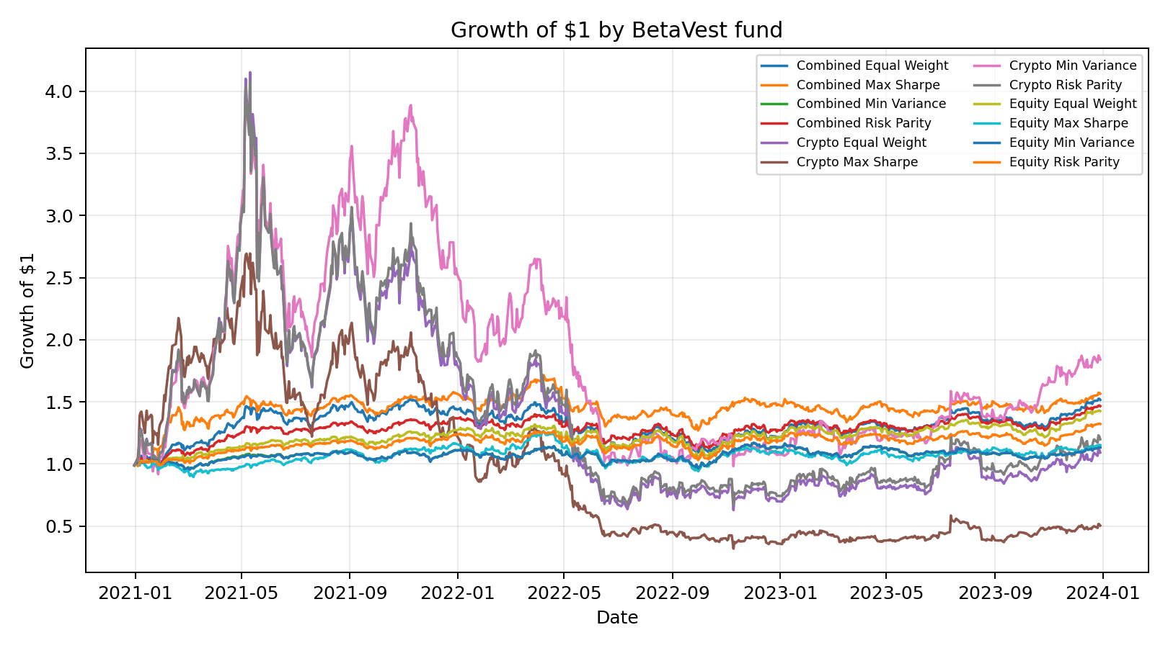

Figure 2. Drawdown for the best-Sharpe BetaVest fund, 2021-2023 live backtest.
Drawdown is measured as the percentage fall from the previous cumulative-return peak.
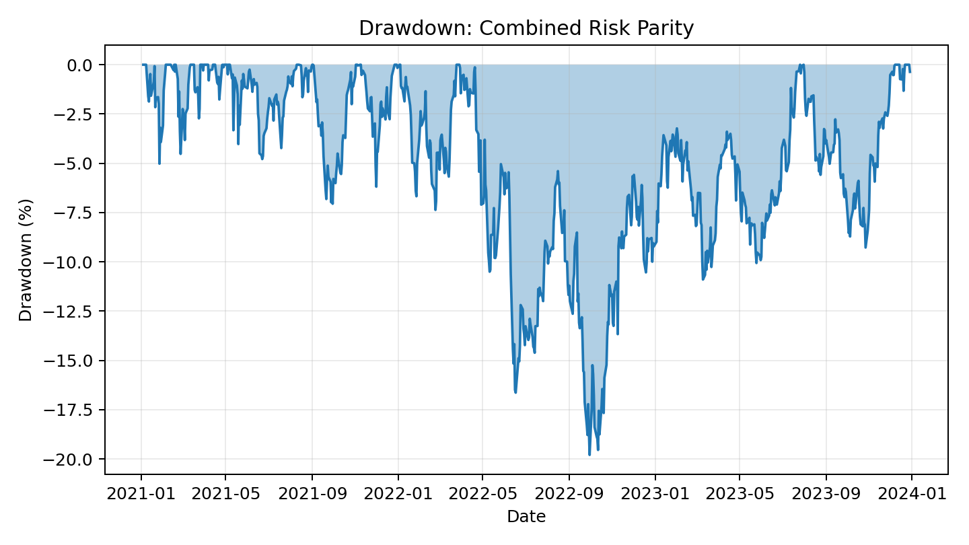

Figure 3. Sector weights over time for the Equity Sentiment Tilt fund, 2021-2023 live backtest.
Weights are daily equity-sector weights after applying the one-day-lagged sentiment multiplier and renormalising the portfolio to 100%.
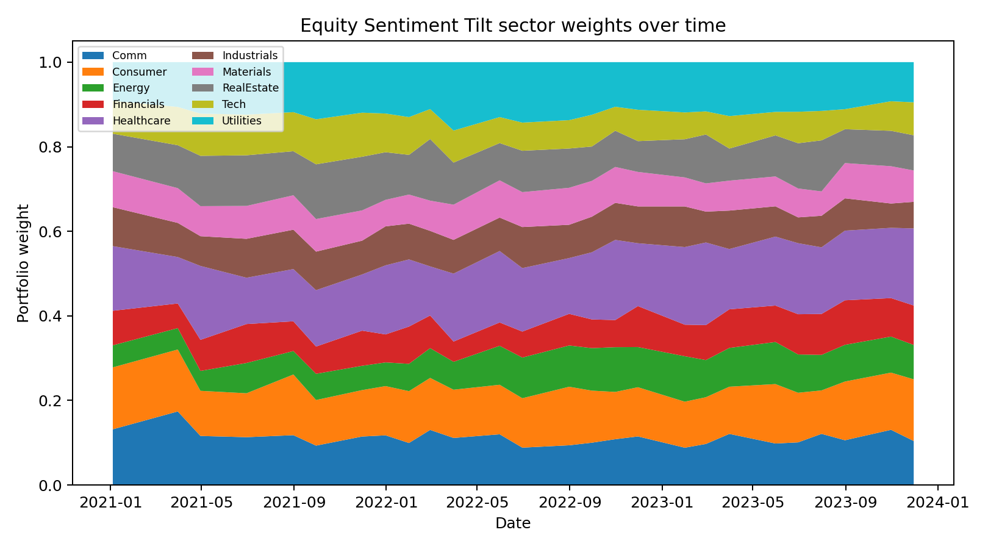

Figure 4. Sharpe ratio comparison across BetaVest funds, 2021-2023 live backtest.
Sharpe ratios assume a zero risk-free rate.
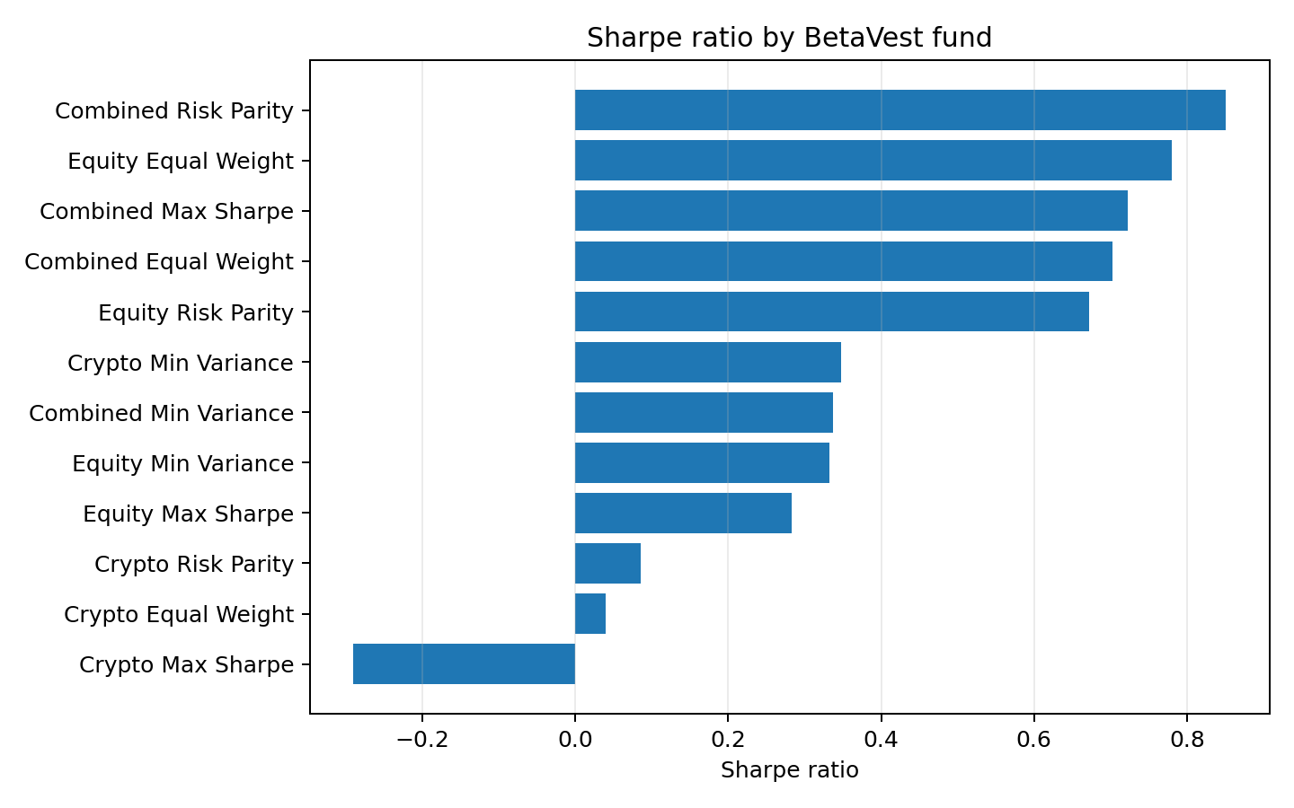

Figure 5. Sector sentiment index time series for equity sectors, 2020-2023.
The figure plots the 21-day moving average of the daily sector finance-lexicon sentiment score.
Source: results/data/sector_sentiment_index.csv and results/figures/sector_sentiment_index.png.
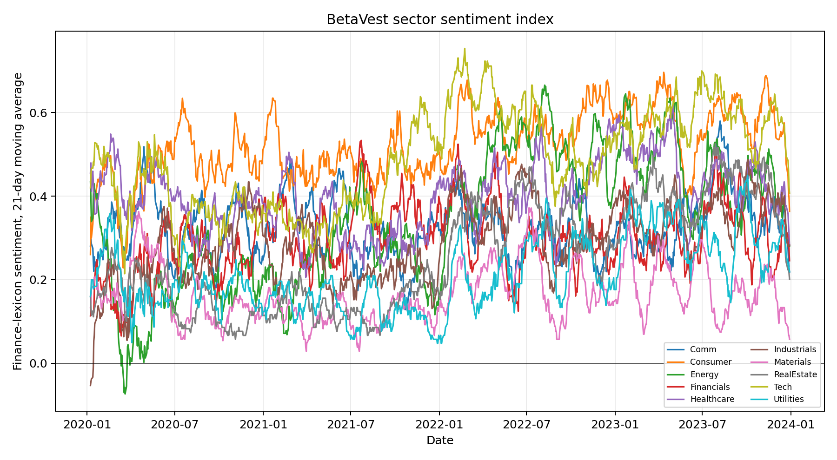

Figure 6. Fusion comparison: growth of $1 for Equity Risk Parity versus Equity Sentiment Tilt, 2021-2023 live backtest.
Values are cumulative returns from results/data/fund_returns.csv and results/data/sentiment_fund_returns.csv.
