- Mobile View – Syncerize App

Platform: Shopify Syncerize app
Viewport: Mobile view (responsive / small screen)
- Sort/Filter Control Misaligned on Mobile – Syncerize Dashboard
On the Syncerize mobile app, the “Sort by Product Sold” control under the Top Suppliers section is misaligned. Instead of appearing at the top where users can easily select it, the sort element/icon is displayed lower down, making it hard to access and confusing for users.
Steps to Reproduce:
- Open the Syncerize dashboard on a mobile device.
- Navigate to the Top Suppliers section.
- Observe the placement of the Sort by Product Sold control.
Expected Result
The sort/filter control should appear at the top of the Top Suppliers section, easily visible and selectable by users.
Actual Result
The control is displayed below the section, making it difficult to access and visually disconnected from the items it is meant to sort.

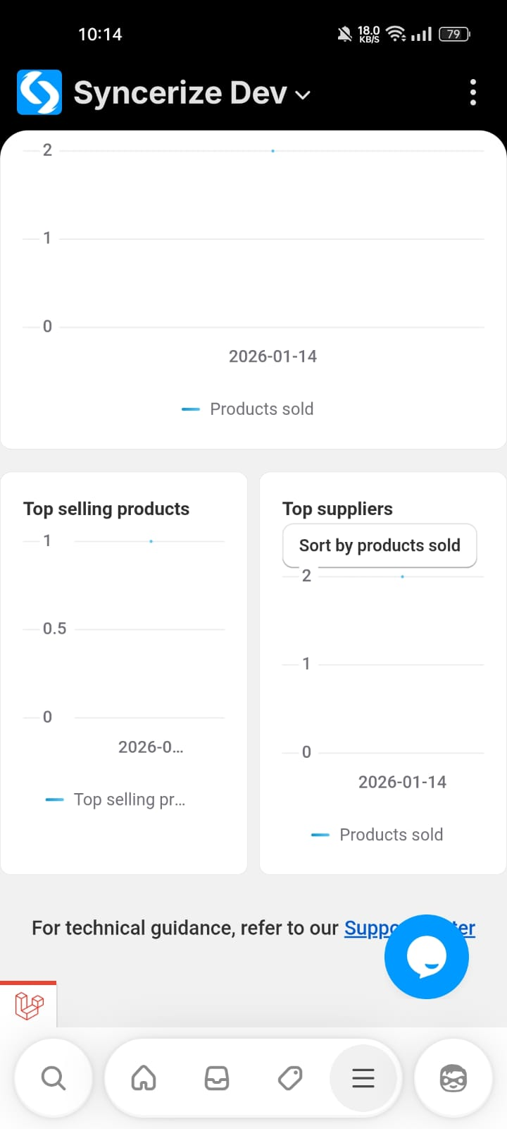
- Dashboard charts show inconsistent / overlapping date labels on mobile view
On the Syncerize mobile dashboard, the date labels displayed under different chart widgets are inconsistent and misaligned. Specifically, the Top Selling Products chart shows a date (2026-01-26) that does not align properly with the chart content and appears visually detached. This creates confusion and impacts readability on mobile devices.

Steps to Reproduce
- Open the Destination store Syncerize app on a mobile device.
- Navigate to the Dashboard.
- Scroll down to the analytics section.
- Observe the Top Selling Products and Top Suppliers charts.

Actual Result
- The Top Selling Products chart displays a date label (2026-01-26) that appears misplaced and visually separated from the chart.
- The layout looks cramped and misaligned on mobile view, reducing clarity.

Expected Result
- Date labels should be consistently aligned within each chart container.
- The chart layout should remain clean, readable, and responsive on mobile devices.

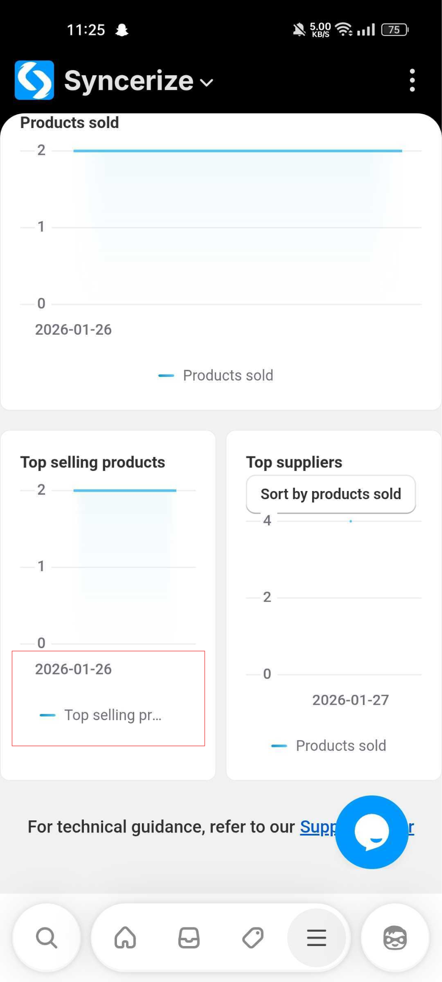

- Product List Columns and Tabs Collapse Incorrectly on Scroll in Destination Store
In the Syncerize app on the destination store, the Products section UI breaks in mobile view when scrolling. The product list columns and tabs (Synced/Unsynced) collapse or shift incorrectly. Additionally, extra blank spacing appears while scrolling, causing layout misalignment and inconsistent product display compared to the desktop (laptop) view.
This issue only occurs in mobile view and affects usability and visibility of product data.

Steps to Reproduce
- Open Destination store on a mobile device (or mobile responsive view).
- Navigate to →apps → Syncerize Dev →Products.
- Open the Synced Products tab.
- Scroll down the product list.
- Observe the layout behavior while scrolling.

Actual Result
- Product list columns collapse or overlap incorrectly.
- Tabs and header alignment break while scrolling.
- Extra empty spacing appears below products.
- UI becomes inconsistent and hard to read.
- Layout does not remain fixed or properly responsive.

Expected Result
- Product list layout should remain properly aligned during scrolling.
- Tabs (Synced / Unsynced) and column headers should stay consistent.
- No extra blank spacing should appear.
- Mobile view should maintain a clean, responsive layout similar to desktop behavior.
- Smooth scrolling without UI distortion.
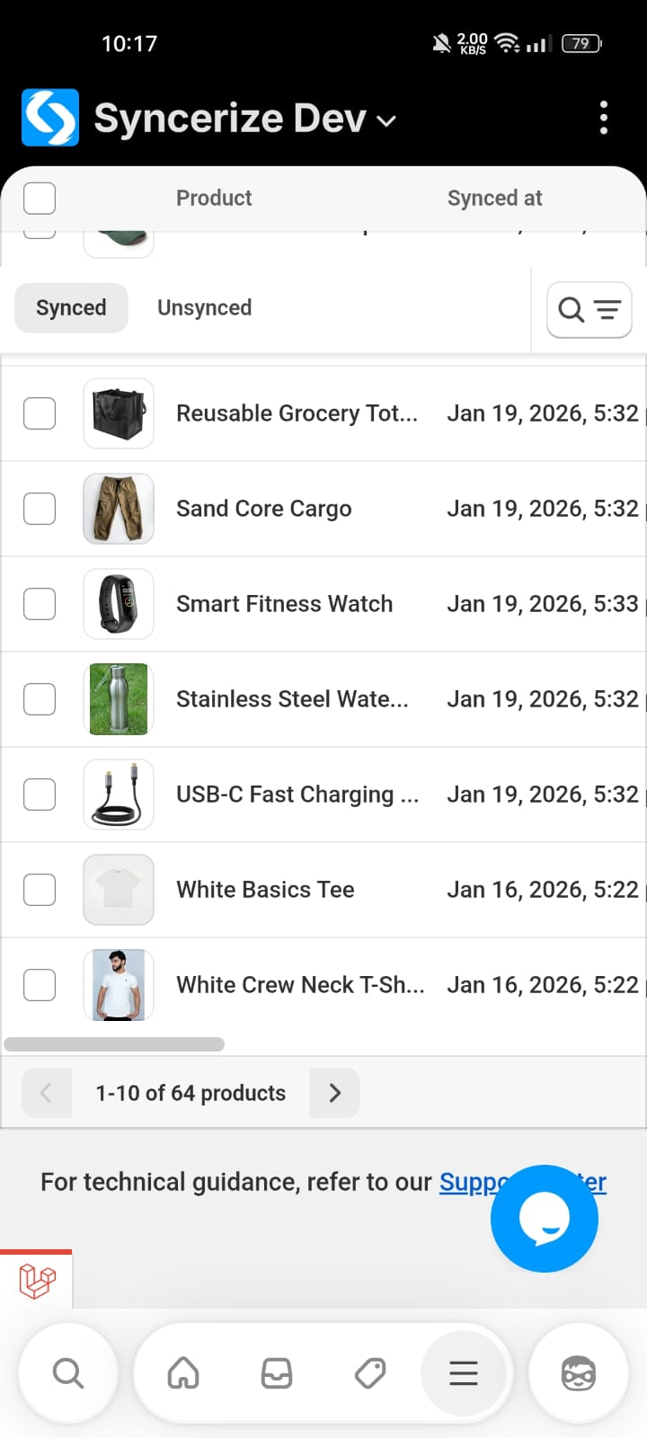

- Chat Widget Overlaps Notification Action/Icon in Notification Detail View (Destination Store)
In the Syncerize app on the destination store, when opening the Notifications section and selecting any notification, the in-app chat support floating button overlaps the notification-related UI element (action/icon area). This causes visual obstruction and makes it difficult for users to clearly view or interact with the notification details.
This issue is only observed in mobile view and affects the usability and layout consistency of the notification screen.

Steps to Reproduce
- Open Destination store on a mobile device.
Navigate to Apps → Syncerize Dev → Notifications.
- Select any notification from the list.
- Observe the notification detail view at the bottom-right area.

Actual Result
- Chat support floating icon overlaps the notification UI element.
- Notification icon/action button becomes partially hidden.
- UI appears cluttered and misaligned.
- User interaction with underlying elements is affected.

Expected Result
- Chat widget should not overlap notification icons or action elements.
- Proper spacing or auto-adjustment should be applied in mobile view.
- Notification details should remain fully visible and accessible.
- Clean and responsive layout without UI obstruction.
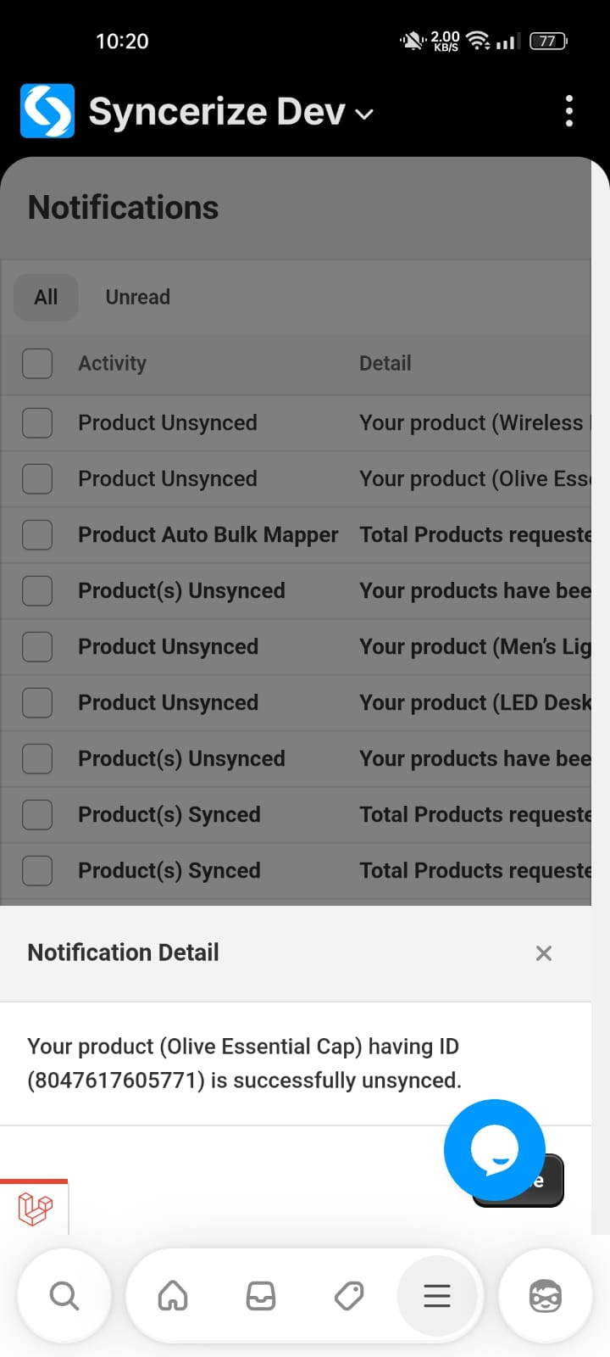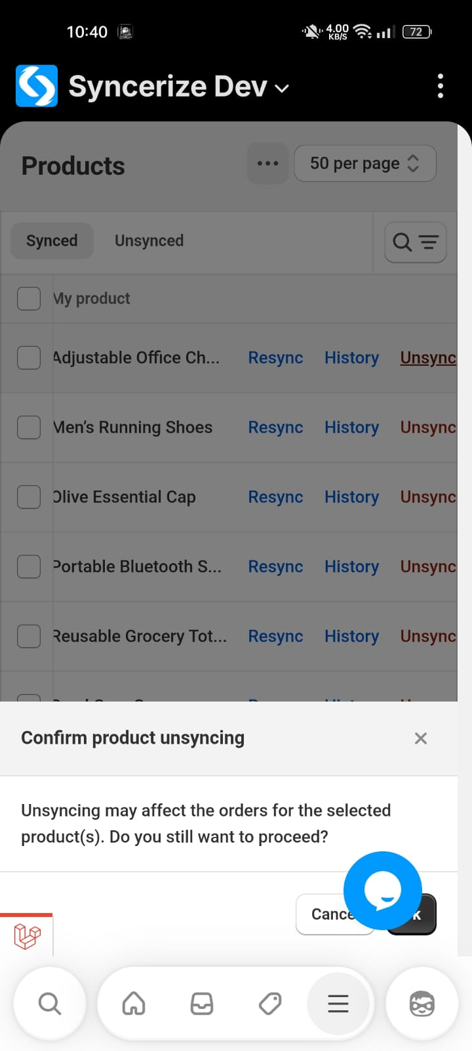

- Plan Buttons Not Visible and Text Overlapping in Plans Tab (Destination Store)
In the Syncerize app on the destination store, the Plans tab layout breaks in mobile view. The action buttons (such as Buy/Upgrade/Select Plan) are not displayed properly, and text content overlaps with plan titles. Additionally, plan names are cut off within their sections, making the information hard to read and interact with.
This issue affects the usability of the pricing and subscription flow on mobile devices.

Steps to Reproduce
- Open Destination store on a mobile device.
- Navigate to Apps → Syncerize Dev → Plans.
- Observe the layout of the pricing plans section.

Actual Result
- Plan action buttons are partially hidden or not visible.
- Text overlaps with plan titles and descriptions.
- Plan names are truncated or cut off.
- Layout appears broken and inconsistent.

Expected Result
- Plan cards should be fully responsive in mobile view.
- Action buttons should be clearly visible and clickable.
- Text should not overlap or be truncated.
- Plan names and details should be displayed properly within their containers.
- Clean and readable pricing layout.
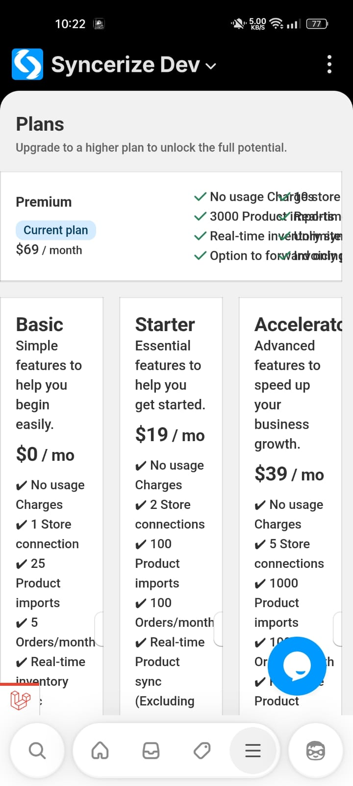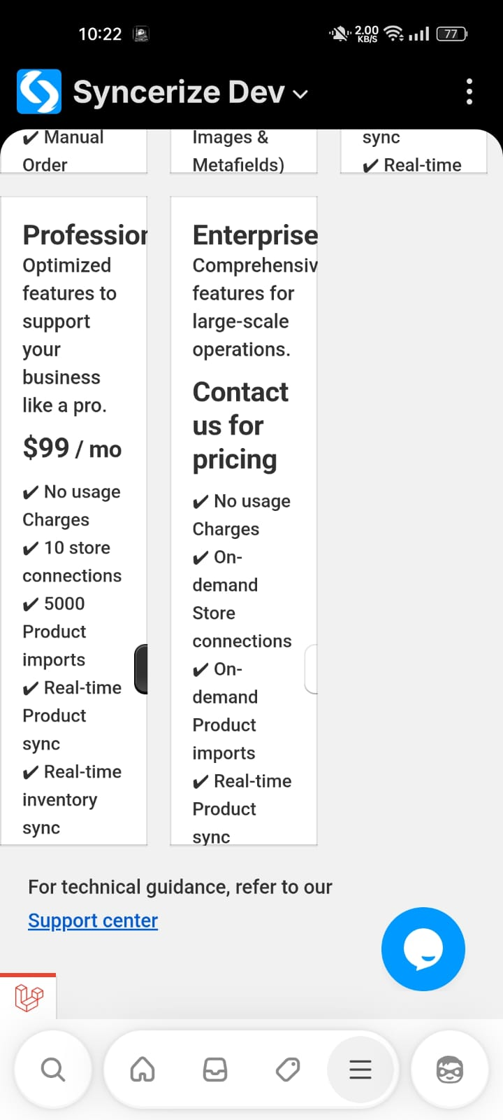

- Settings Description Text Too Close to Screen Edge in Settings Tab (Destination Store)
In the Syncerize app on the destination store, within the Settings tab, the descriptive text sections (such as “Automatic Order Push” description) are not properly padded in mobile view. While the toggle widgets and buttons are aligned correctly, the informational text above these widgets is touching or extremely close to the screen edge.
This creates poor readability and breaks mobile UI spacing consistency.

Steps to Reproduce
- Open Destination store on a mobile device.
- Navigate to Apps → Syncerize Dev → Settings.
- Scroll to any widget section (for example: Auto Push Orders).
- Observe the descriptive text above the toggle widget.

Actual Result
- Description text is too close to the screen edge.
- No proper left/right padding is applied.
- UI looks cramped and unpolished.
- Readability is reduced on smaller screens.

Expected Result
- Description text should have consistent padding from screen edges.
- Text alignment should match the widget container alignment.
- Proper spacing should be maintained for better readability.
- Mobile UI should follow standard responsive spacing guidelines.
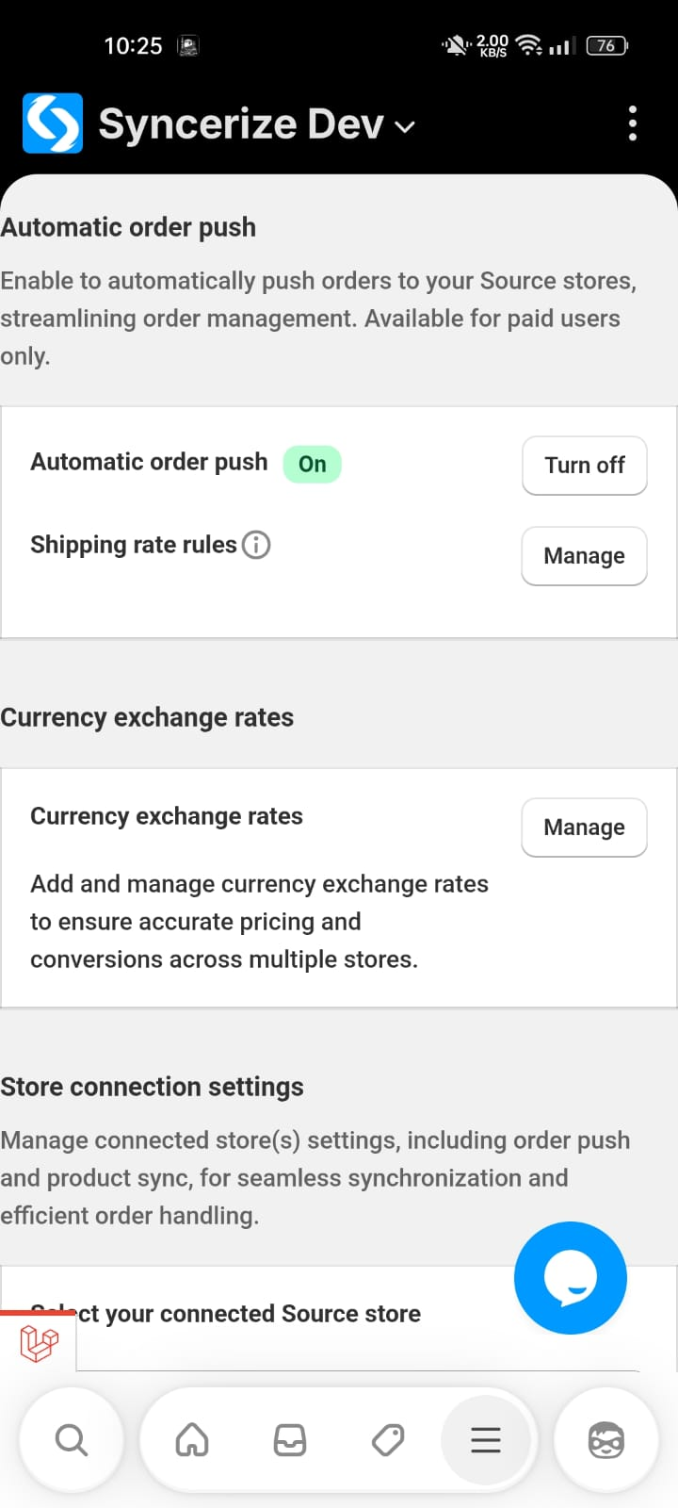

- Missing action Buttons for Currency Exchange Rate Setup in Settings (Destination Store)
In the Syncerize app on the destination store, under Settings → Currency Exchange Rate Setup, there are no action buttons available at all. Neither Add/Create nor Delete options are displayed on the page. The screen only shows the configuration area (or empty state) without any controls to manage currency exchange rate setups.
This makes the feature completely non-functional from the user interface.

Steps to Reproduce
- Open a destination store.
- Navigate to Apps → Syncerize Dev → Settings.
- Open Currency Exchange Rate Setup.
- Observe the available actions on the page.

Actual Result
- No Add, Edit, or Delete buttons are visible.
- Users cannot add, update, or remove currency exchange rate setups.
- Page provides no actionable controls.
- The feature is unusable.

Expected Result
- Proper action buttons should be available (Add/Edit/Delete).
- Users should be able to manage currency exchange rate configurations.
- Clear UI controls should be present for configuration management.
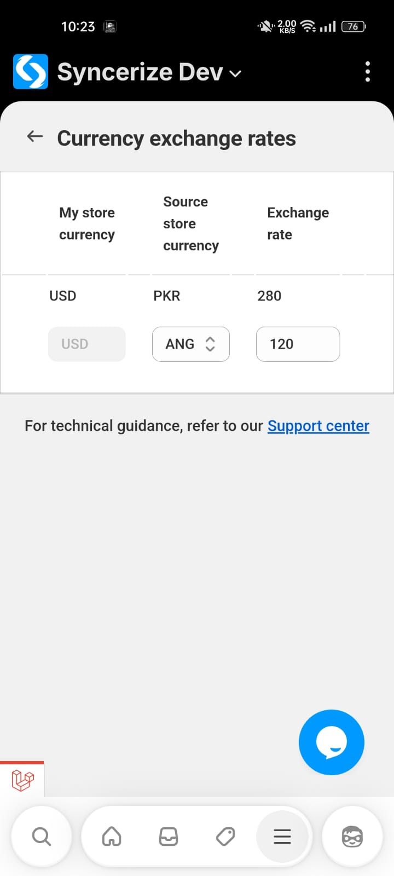

- Orders Tab Layout Breaks on Scroll Similar to Products Tab (Destination Store)
In the Syncerize app on the destination store, the Orders tab shows the same mobile layout issue as the Products tab. When scrolling the orders list in mobile view, the columns, headers, and tabs collapse or shift incorrectly. Extra spacing appears and the layout becomes misaligned, causing readability and usability problems.
This indicates a common responsive layout issue affecting multiple list-based screens.

Steps to Reproduce
- Open Destination store on a mobile device.
- Navigate to Apps → Syncerize Dev → Orders.
- Make sure you are viewing orders on the Destination Store.
- Make sure you have enough orders to scroll down.
- Scroll down the orders list.
- Observe the UI behavior.

Actual Result
- Order list columns collapse or misalign.
- Headers/tabs shift incorrectly while scrolling.
- Extra blank space appears in the list.
- UI becomes unstable and hard to read.

Expected Result
- Orders list layout should remain stable during scrolling.
- Columns and headers should stay properly aligned.
- No unnecessary spacing should appear.
- Smooth and consistent mobile scrolling experience.
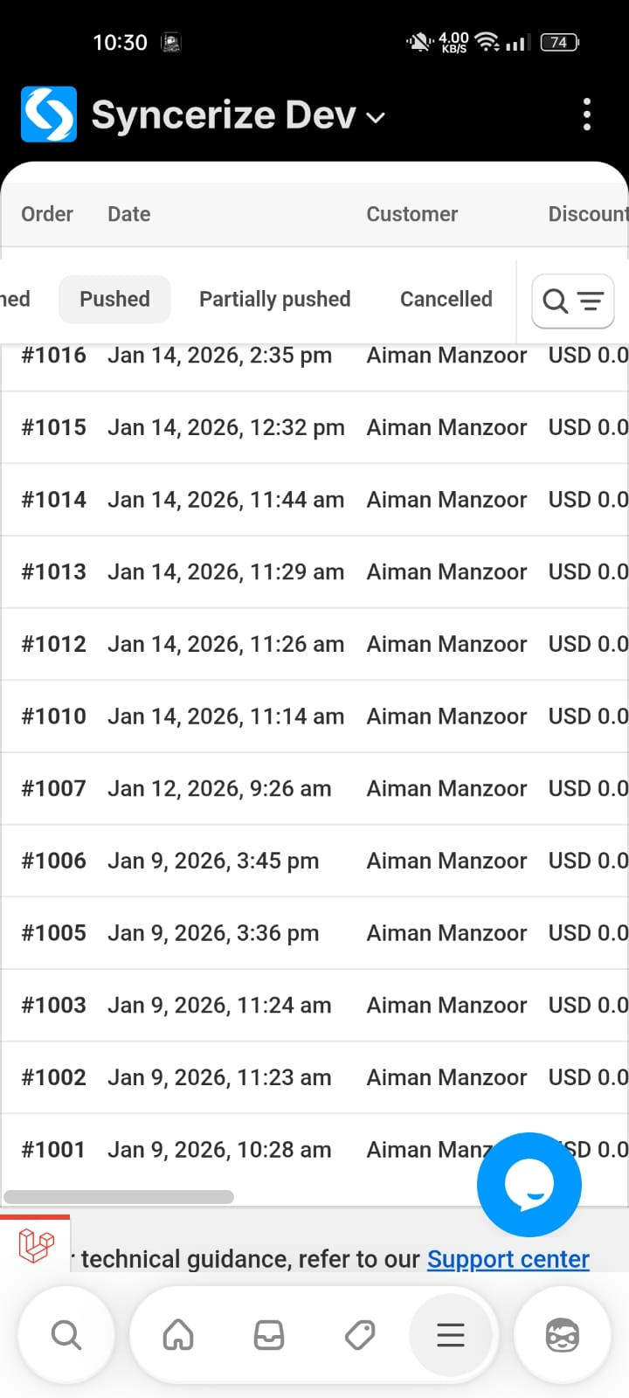
- Loading Indicator Appears Inside Sync/Resync Button Instead of Replacing Button (Destination Store)
In the Syncerize app on the destination store, when clicking the Sync or Resync button, the loading state is not handled correctly. Instead of hiding or disabling the button and showing a separate loader, the loading animation appears inside the button itself, causing visual clutter and unclear action feedback.
This affects user experience and makes it unclear whether the action is properly in progress.

Steps to Reproduce
- Open Destination store.
- Go to Apps → Syncerize Dev.
- Navigate to Products tab.
- Click Resync in Synced tab for any item.
- Observe the button behavior during processing.
- Click Sync in unsynced tab for any item.
- Observe the button behavior during processing.

Actual Result
- Loader appears inside the Sync/Resync button.
- Button remains visible and clickable (or visually active).
- UI looks cluttered and confusing.
- Action state is not clearly indicated.

Expected Result
- Sync/Resync button should be hidden or disabled during processing.
- A proper loading indicator should be shown instead of overlapping the button.
- Button state should clearly indicate action is in progress.
- Prevent multiple clicks while syncing.
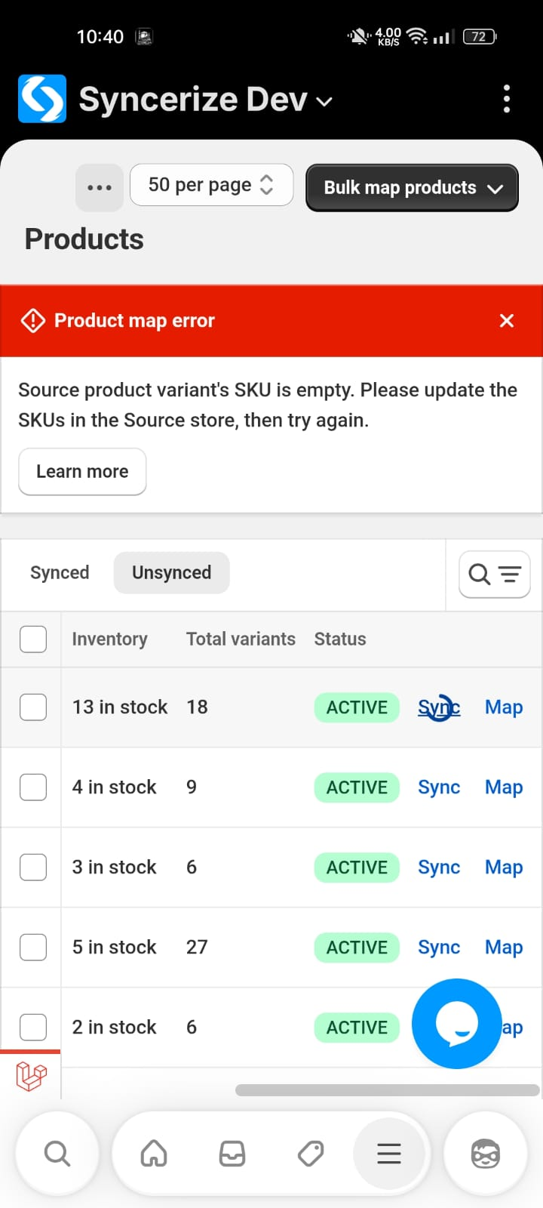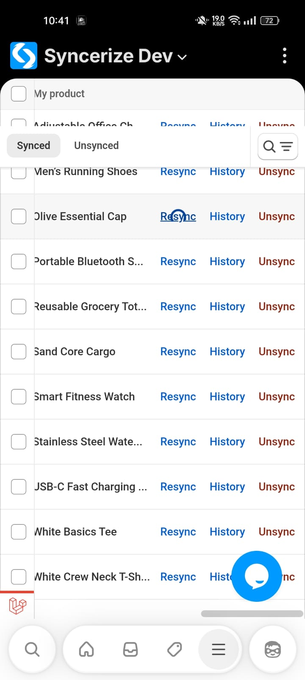

- Product Images Overlapping Checkbox Area in Destination Store (Mobile View)
In the destination store product list , product images are incorrectly displayed under the selection checkboxes in mobile view. This causes UI overlap and makes it difficult to clearly select products.

Steps to Reproduce
- Open Syncerize app on mobile device.
- Go to Destination Store.
- Navigate to Synced Products list.
- Scroll through the product list.

Actual Result
- Product images appear under/behind the checkbox area.
- UI elements overlap.
- Product selection becomes unclear and visually broken.

Expected Result
- Product images should be properly aligned beside the checkbox.
- No overlapping between checkbox and product thumbnail.
- Clean and responsive layout in mobile view.
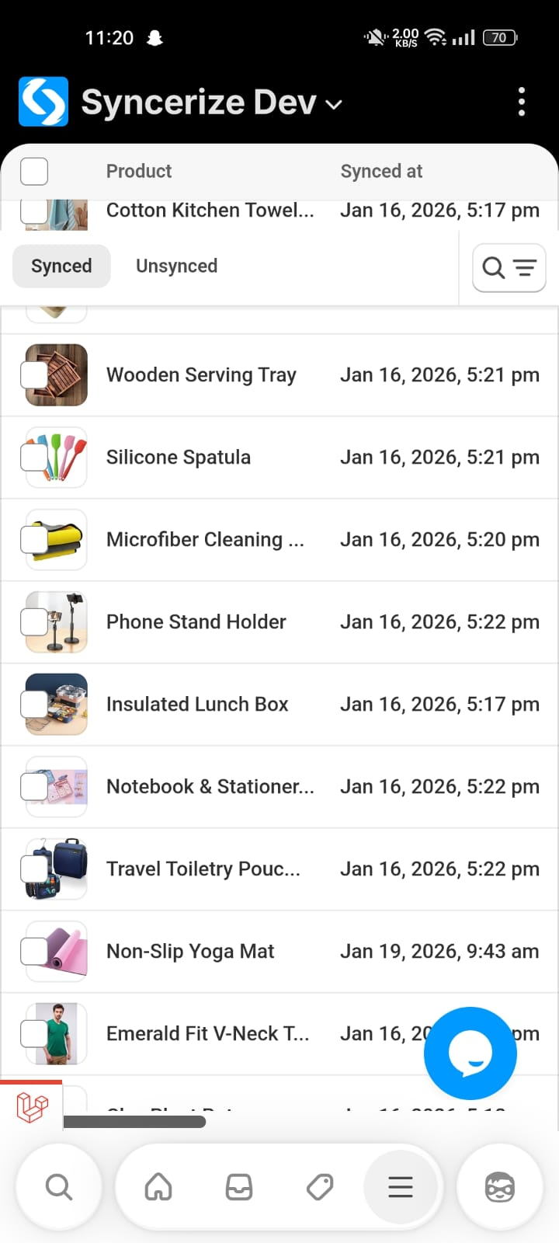
- UI Alignment Issue in Source Store Dashboard (Mobile View)
In the source store dashboard view of the Syncerize app (mobile), multiple UI components such as revenue card, store selector dropdown, and statistics cards are not properly aligned. The layout appears compressed and uneven, affecting readability and visual consistency.

Steps to Reproduce
- Open Source store on a mobile device.
- Navigate to the Dashboard/Analytics section.
Observe the alignment of cards and dropdown sections.

Actual Result
- Stats cards (Synced Products, Orders Received, Revenue) appear crowded and misaligned.
- Spacing between UI components is inconsistent.

Expected Result
- All dashboard components should be properly aligned and responsive.
- Equal spacing between cards and sections.
- Clean layout optimized for mobile screen sizes.
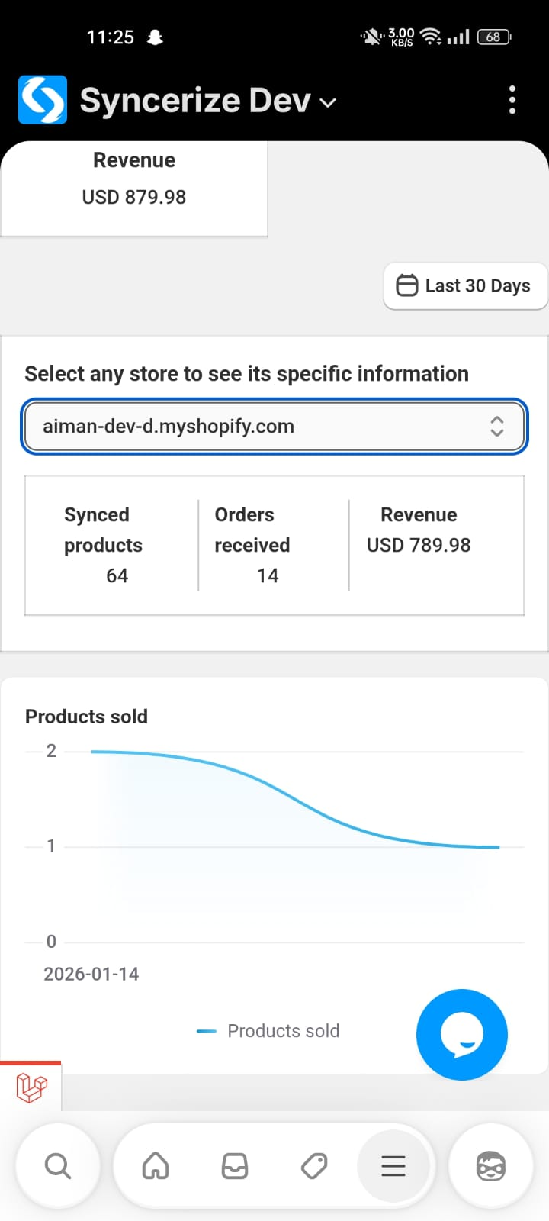

- UI Alignment Issue on Auto Bulk Mapper Screen in Destination Store (Un-synced Products Tab – Mobile View)
On the Destination store, when navigating to Products → Un-synced tab and selecting Auto Bulk Mapper, multiple UI elements are misaligned on mobile view.
The content appears improperly spaced and vertically shifted, resulting in an unbalanced layout and reduced readability.

Steps to Reproduce
- Open Destination store on mobile.
- Open the Syncerize app.
- Go to Products.
- Open the Un-synced tab.
- Select Auto Bulk Mapper.
- Observe the layout and alignment of UI elements.

Actual Result
- UI elements are misaligned.
- Unnecessary spacing appears between sections.
Page layout looks visually broken on mobile.

Expected Result
- All UI elements should be properly aligned within their containers.
- Consistent spacing should be maintained between sections.
- Layout should remain stable while scrolling.
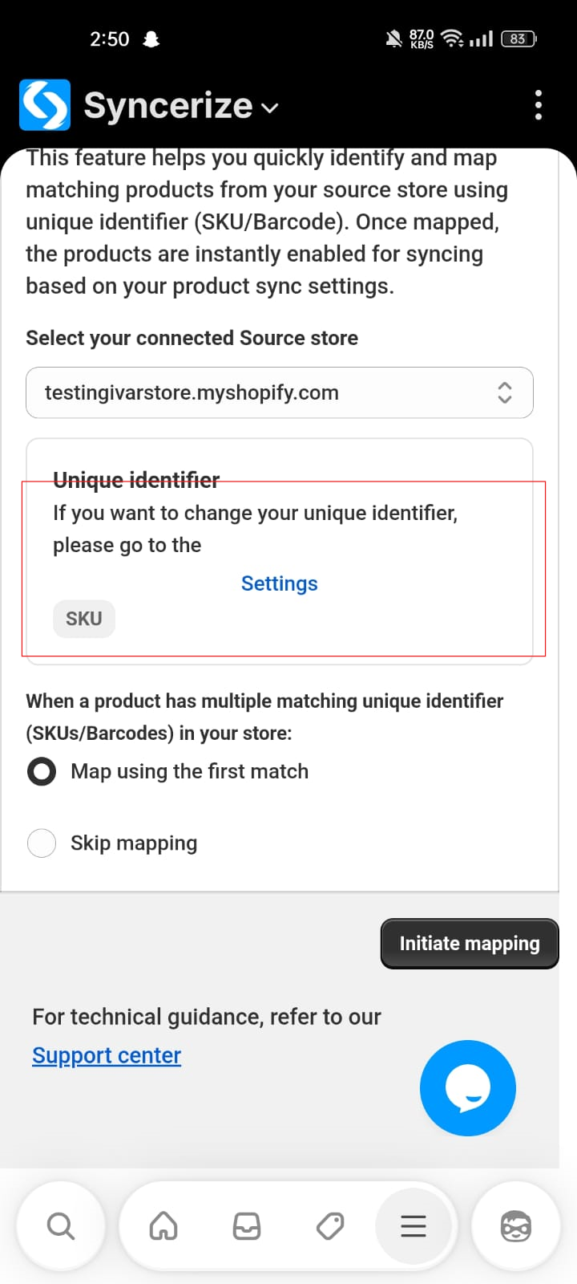

- Forward Button Remains Enabled on last Page of Product List (Mobile View)
On the last page of the product list, the forward or next pagination button remains enabled even though there are no previous pages available in the current navigation context.
This can confuse users and gives the impression that further backward navigation is possible when it should not be.

Steps to Reproduce
- Open Shopify Admin on mobile.
- Launch the Syncerize app.
- Navigate to Products→ Synced tab.
- Scroll to the last page of the product list (e.g., 41–48 of 48 products).
- Observe the pagination controls at the bottom.

Actual Result
- The forward or next button is still enabled.
- Button appears interactive even though no further forward navigation should be allowed.

Expected Result
- The forward button should be disabled or visually inactive when the user is on the last page.
- Pagination controls should clearly reflect available navigation states.
- Disabled button should follow standard UI patterns (greyed out, non-clickable).
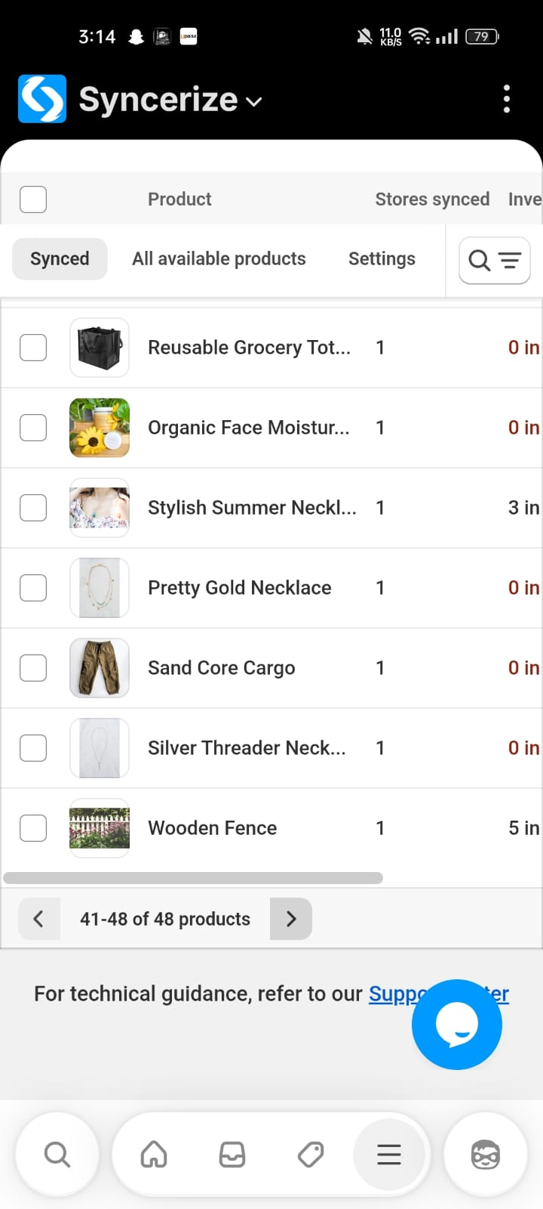
- Back Button Remains Enabled on First Page of Product List (Mobile View)
On the first page of the product list, the Back (Previous) pagination button remains enabled even though there are no previous pages available in the current navigation context.
This can confuse users and gives the impression that further backward navigation is possible when it should not be.

Steps to Reproduce
- Open a destination store on mobile.
- Open Syncerize app.
- Navigate to Products → Synced tab.
- Scroll to the first page of the product list (e.g., 1-10 of 48 products).
- Observe the pagination controls at the bottom.

Actual Result
- The Back (Previous) button is still enabled.
- Button appears interactive even though no further backward navigation should be allowed.

Expected Result
- The Back (Previous) button should be disabled or visually inactive when the user is on the first page.
- Pagination controls should clearly reflect available navigation states.
- Disabled button should follow standard UI patterns (greyed out, non-clickable).
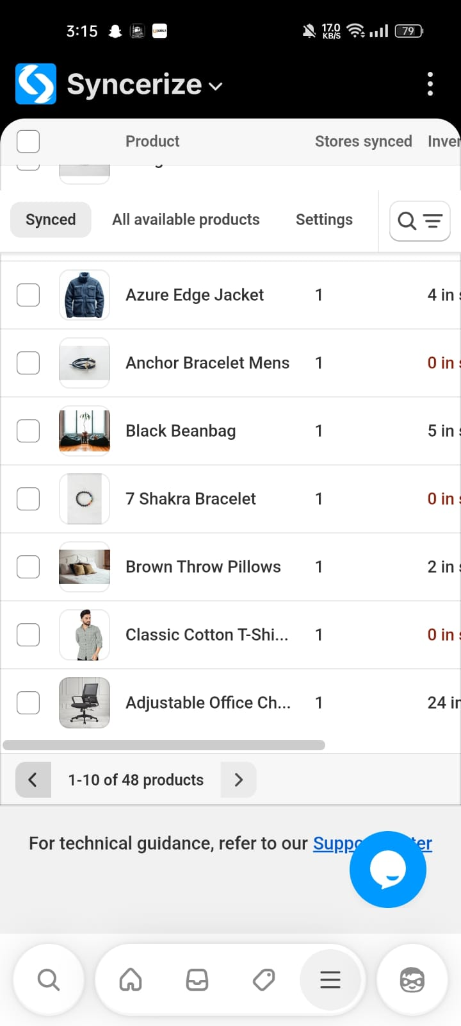

- Product setting options and Tabs Collapse Incorrectly on Scroll in Destination Store
In the Syncerize app on the destination store, the Products setting section UI breaks in mobile view when scrolling. The product list options and tabs (Synced/All available products/ Settings) collapse incorrectly. Additionally, extra blank spacing appears while scrolling, causing layout misalignment and inconsistent display compared to the desktop (laptop) view.
This issue only occurs in mobile view and affects usability and visibility of product data.

Steps to Reproduce
- Open Source store on a mobile device (or mobile responsive view).
- Navigate to →apps→ Syncerize Dev→Products.
- Open the Settings tab.
- Scroll down the list.
- Observe the layout behavior while scrolling.

Actual Result
- Product options and tabs collapse or overlap incorrectly.
- Tabs and header alignment break while scrolling.
- Extra empty spacing appears above tabs.
- UI becomes inconsistent and hard to read.
- Layout does not remain fixed or properly responsive.

Expected Result
- Product options layout should remain properly aligned during scrolling.
- Tabs (Synced/All available products/ Settings) should stay consistent.
- No extra blank spacing should appear.
- Mobile view should maintain a clean, responsive layout similar to desktop behavior.
- Smooth scrolling without UI distortion.

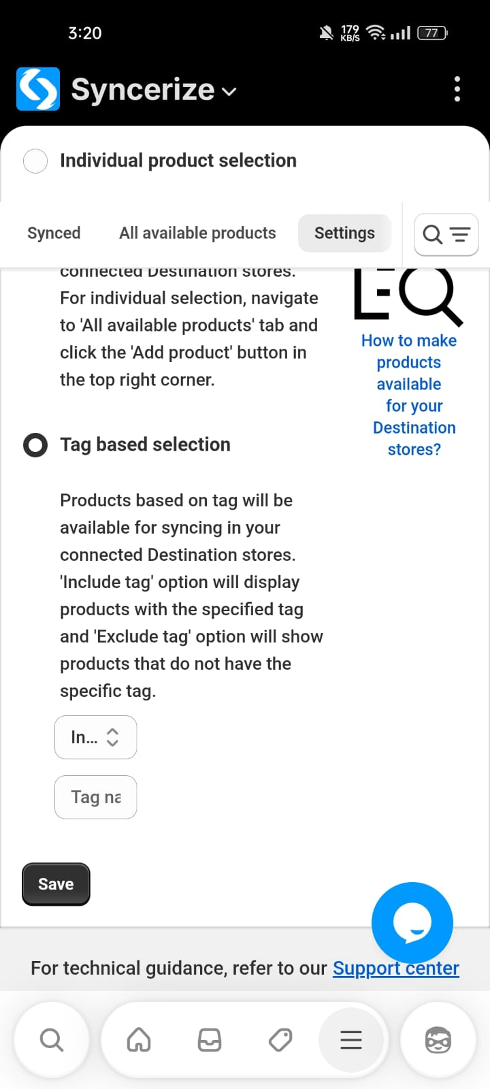

- Invoice download shows white screen on mobile view for paid & fulfilled orders

When accessing a paid and fulfilled order from the source store on a mobile device, the Download Invoice functionality does not work as expected. After selecting Generate Report and tapping Download Invoice, the screen turns completely white and no invoice file is downloaded. There is no error message or feedback shown to the user.
This issue occurs consistently on mobile view, while the same steps work correctly on desktop/web. The problem prevents mobile users from downloading invoices and disrupts order management on mobile devices.
Steps to Reproduce
- Open Shopify Admin on a mobile device.
- Navigate to Apps → Syncerize → Orders→ Fulfilled .
- Open an order with Paid payment status.
- Select the order.
- Click Generate Report.
- Tap Download Invoice.

Expected Result
- The invoice file (PDF) should be generated and downloaded successfully on the mobile device, same as desktop/web behavior.

Actual Result
- The screen turns completely white after tapping Download Invoice.
- No invoice file is downloaded.
- No error message or user feedback is displayed.
- User must navigate back manually to continue.
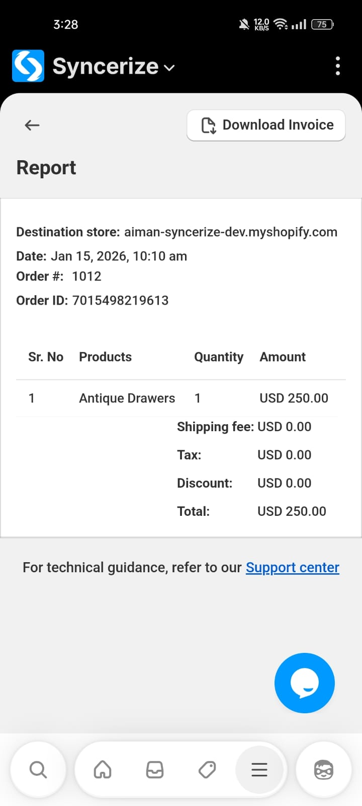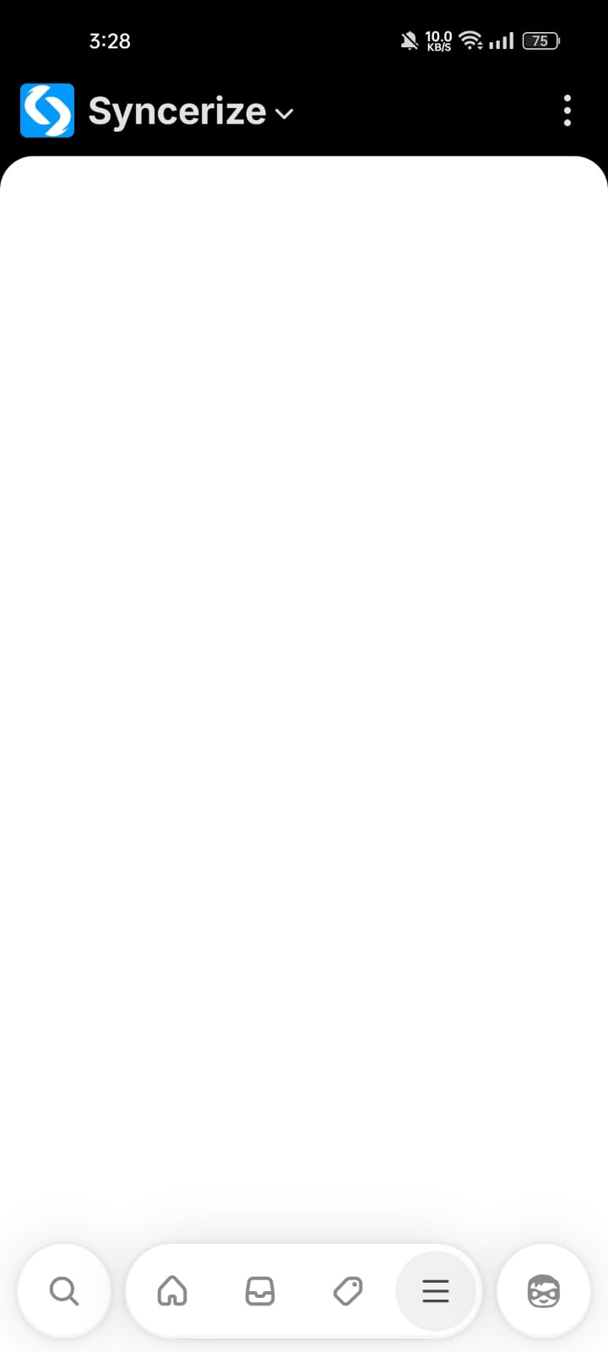

- Carousel navigation arrows (previous/next) are not functional

When using the app on mobile , the horizontal scroll container displays left and right navigation arrows. However, these navigation icons do not function as expected—clicking on them does not scroll the content. Users are only able to access hidden content by manually dragging or using the scrollbar at the bottom. This issue occurs specifically in reduced screen sizes and impacts usability in responsive views.

Steps to Reproduce
- Navigate to the Destination store dashboard page
- Navigate to plan usage container
- Observe that left (<) and right (>) navigation arrows appear on the container
- Click on the left or right navigation arrows

Expected Result
- clicking the left or right navigation arrows should scroll the container horizontally to reveal hidden content.

Actual Result
- clicking the left or right navigation arrows does not trigger any scrolling.
- The container only scrolls when the user manually drags or uses the horizontal scrollbar at the bottom.

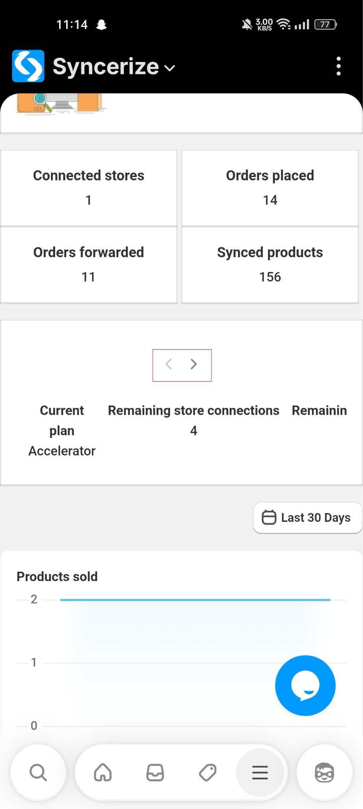
WEB
2. Unsaved Changes Warning Missing on Product Availability Settings Page (Source Store)
In the Syncerize app, there is inconsistent behavior regarding unsaved changes across different settings pages. On the Product Sync Settings page (Destination store), when a user modifies any setting and attempts to navigate away without saving, a confirmation popup appears warning the user about unsaved changes and restricting navigation until the changes are saved or discarded.
However, on the Source Store → Products → Product availability settings page (where users select which products should be available for syncing), no such warning or restriction exists. Users can change settings and freely navigate to other pages without being prompted to save, which can result in accidental loss of configuration changes.
This inconsistency creates a confusing user experience and increases the risk of unintended configuration loss.

Steps to Reproduce
- Log in to Source store.
- Open the Syncerize app.
- Navigate to Source Store → Products.
- Change the product availability option (e.g., switch between All products, Individual product selection, or Tag-based selection).
- Do not click the Save button.
- Navigate to another page (e.g., Stores, Orders, Settings).

Actual Result
- The user is able to navigate away without any warning.
- Changes are not saved.
- No confirmation popup is displayed.

Expected Result
- A confirmation popup should appear warning the user about unsaved changes, similar to other settings pages.
- The user should be prompted to:
  - Save changes, or
  - Discard changes before leaving the page.

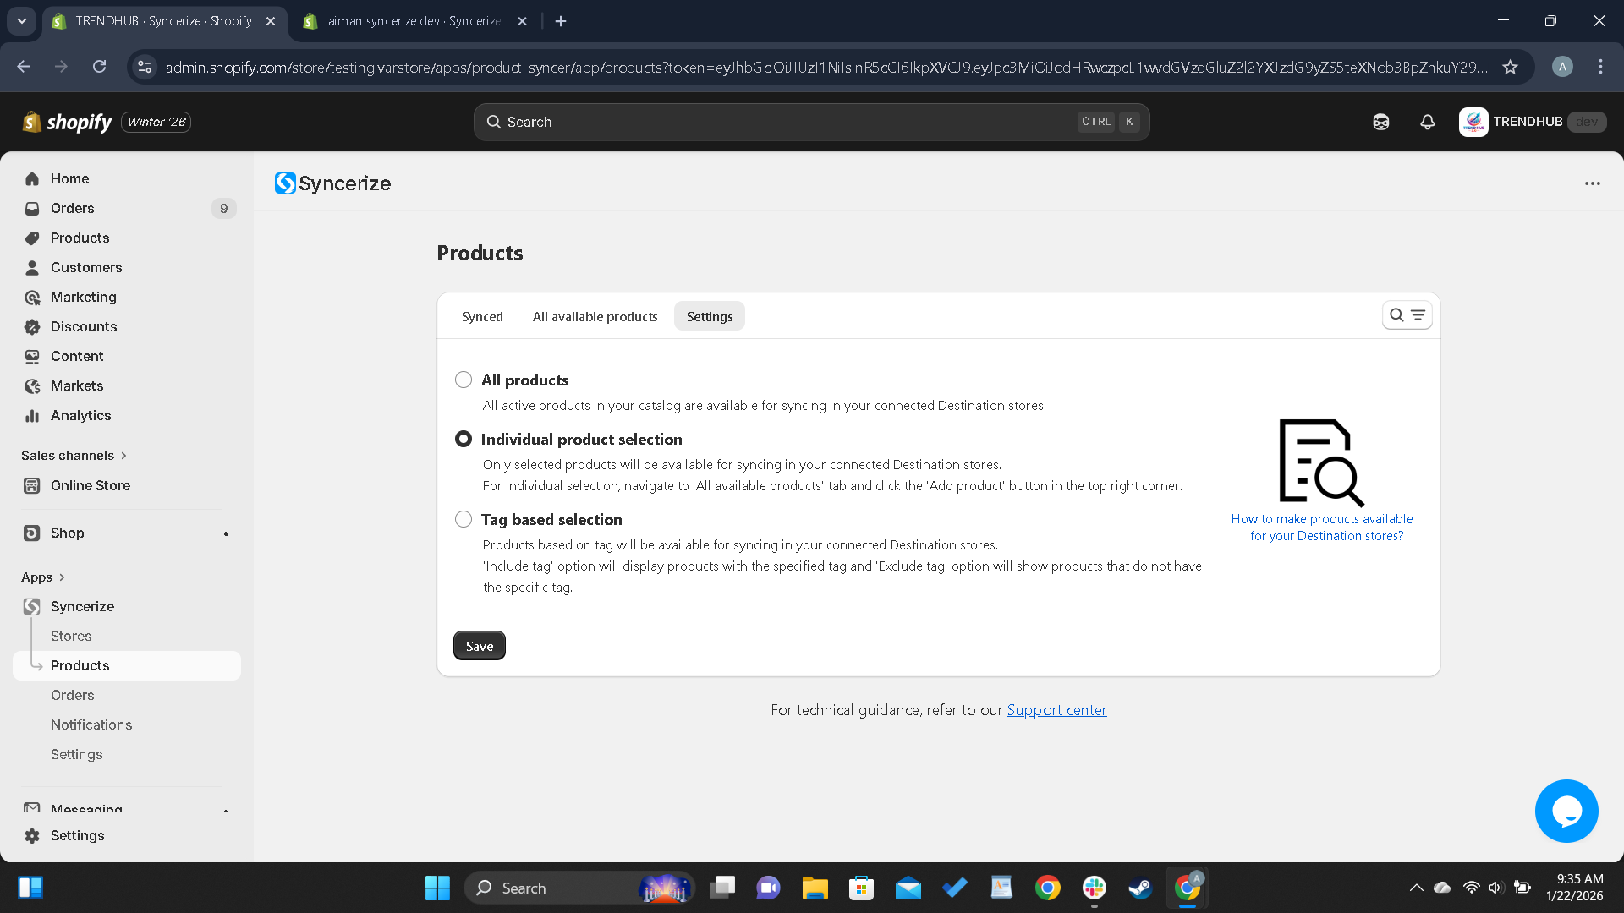
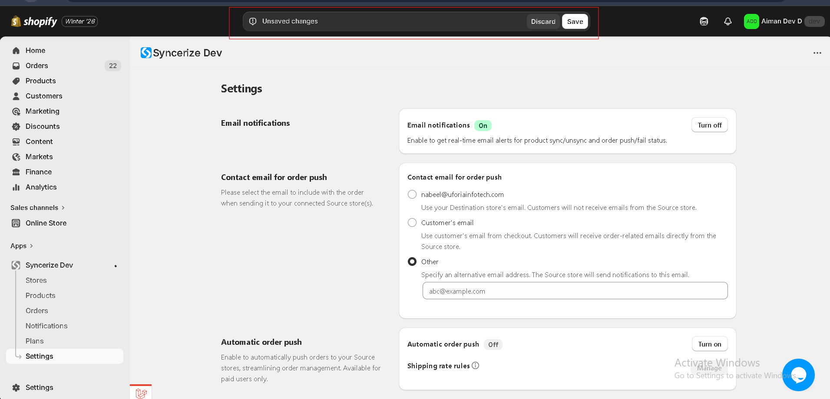

3.Negative Payment Amount Can Be Entered Despite Validation Message in Add Payment Modal

In the Source Store → Orders section, when adding a payment received from a Destination store, the system allows users to enter negative values (e.g., -9) in the payment amount field.
Although an inline validation message appears stating “Value must be greater than or equal to 0”, the input still accepts negative values, creating a contradiction between the UI behavior and validation messaging.
This results in unclear guidance for the user and weakens data integrity safeguards.

Steps to Reproduce
- Log in to Source store.
- Open the Syncerize app.
- Navigate to Source Store → Orders
- Open an order.
- Click Add payment details.
- In the Add payment modal, enter a negative value (e.g., -9) in the amount field.

Actual Result
- The input field allows negative values to be entered.
- A validation banner appears stating:
“Value must be greater than or equal to 0.”
- The UI behavior and validation message are inconsistent.

Expected Result
- The amount field should not allow negative values to be entered.
- Validation should:
  - Either prevent typing negative values entirely, or
  - Disable the Add button until a valid (≥ 0) value is entered.
- UI behavior and validation messaging should be fully aligned.
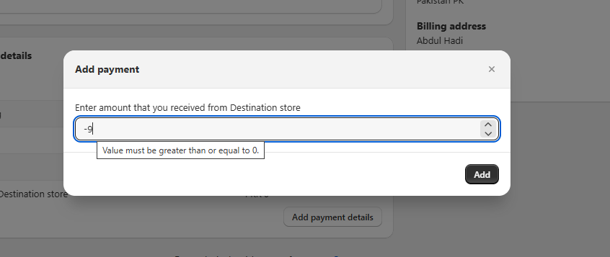

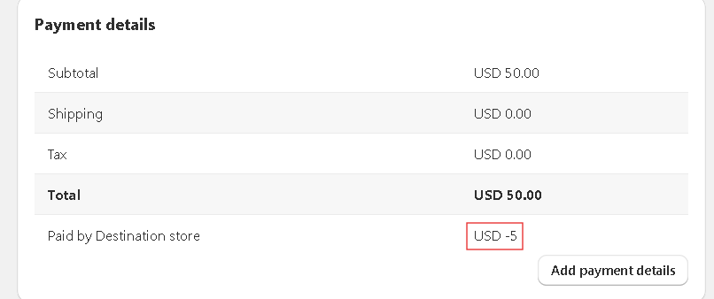

4.Automatic Order Push Feature Not Properly Disabled for Basic Plan Users
According to Shopify Build Requirements, features that are not included in the current subscription plan must be disabled both visually and functionally. However, the Automatic Order Push feature appears enabled in the UI for Basic plan users, even though it is not usable. When the user clicks the button, an error is shown instead of preventing interaction.
This behavior can cause user confusion and may violate Shopify app approval guidelines.

Steps to Reproduce
- Login to Syncerize app using a Basic Plan account.
- Navigate to Settings → Automatic Order Push section.
- Observe the feature toggle/button state.
- Click the Turn On button.

Actual Result
- The feature appears enabled or clickable in the UI.
- User can interact with the button.
- Clicking the button results in an error message.
Feature is not actually usable.

Expected Result (As Per Shopify Requirements)
- Feature should be visually disabled (greyed out).
- Button should be non-clickable.
- Clear indication that this feature is available only on paid plans.
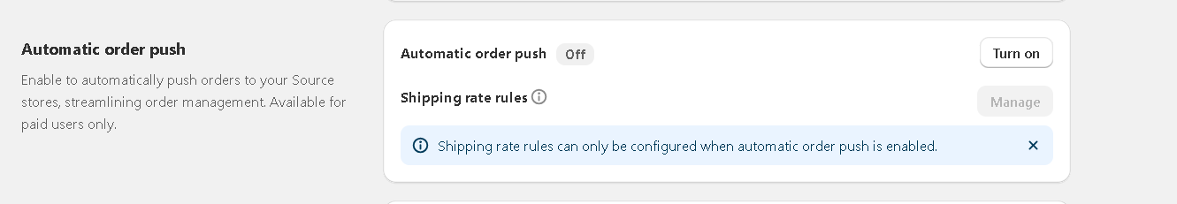

5.“Add new store” Button Remains Enabled Despite Reaching Store Limit on Basic Plan
On the Basic plan, merchants are limited to connecting only one Source store. After a store is successfully connected and the plan limit is reached, the “Add new store” button remains enabled and clickable.
This behavior allows users to attempt actions that are not permitted under their current plan, creating confusion and a poor user experience.

Steps to Reproduce
- Log in to the destination store.
- Open the Syncerize app.
- Ensure the destination store is subscribed to the Basic plan.
- Navigate to Stores.
- Connect one Source store (reaching the plan limit).
- Observe the “Add new store” button in the top-right corner.

Actual Result
- The “Add new store” button remains enabled.
- The user can attempt to add another store despite already reaching the plan limit.

Expected Result
- Once the store limit for the Basic plan is reached:
  - The “Add new store” button should be disabled, or
  - Replaced with a tooltip or message indicating the plan limit has been reached (e.g., “Upgrade your plan to add more stores”).
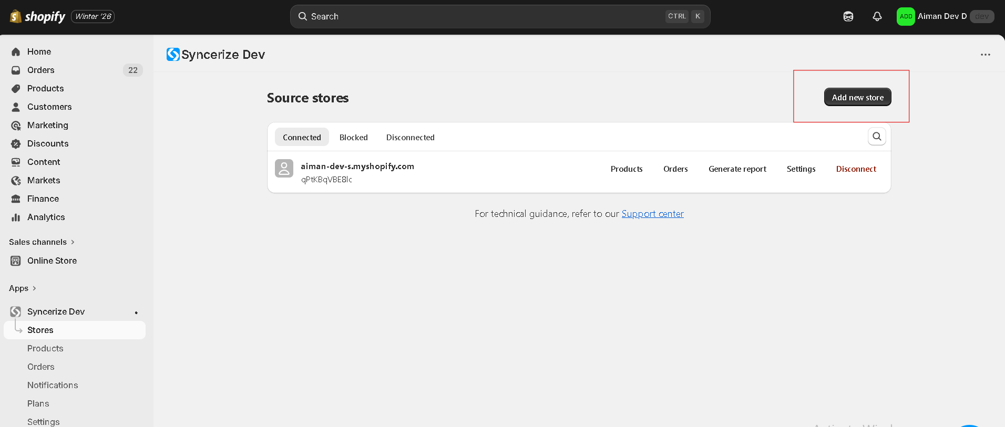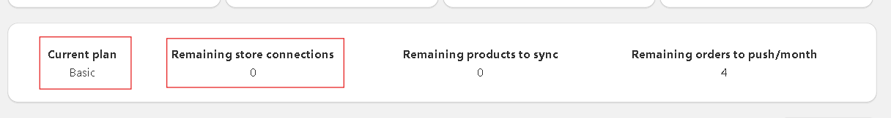

6.Incorrect capitalization in date filter options (sentence case not followed)

The date range filter options use title case (capital “D” in Days and Months), which does not comply with Built for Shopify General Content Guidelines. Shopify requires a sentence case for UI labels, filters, and dropdown options.

Steps to Reproduce
- Open the Syncerize dashboard in the Shopify admin.
- Navigate to the Source store/ Destination store dashboard.
- Click on the date range filter (e.g., “Last 30 Days”) on the right side.
- Observe the capitalization of the date range options in the dropdown.

Actual Result
The date filter options are displayed using title case:
- Last 7 Days
- Last 30 Days
- Last 90 Days
- Last 12 Months

Expected Result
The date filter options should follow sentence case as per Built for Shopify guidelines:
- Last 7 days
- Last 30 days
- Last 90 days
- Last 12 months

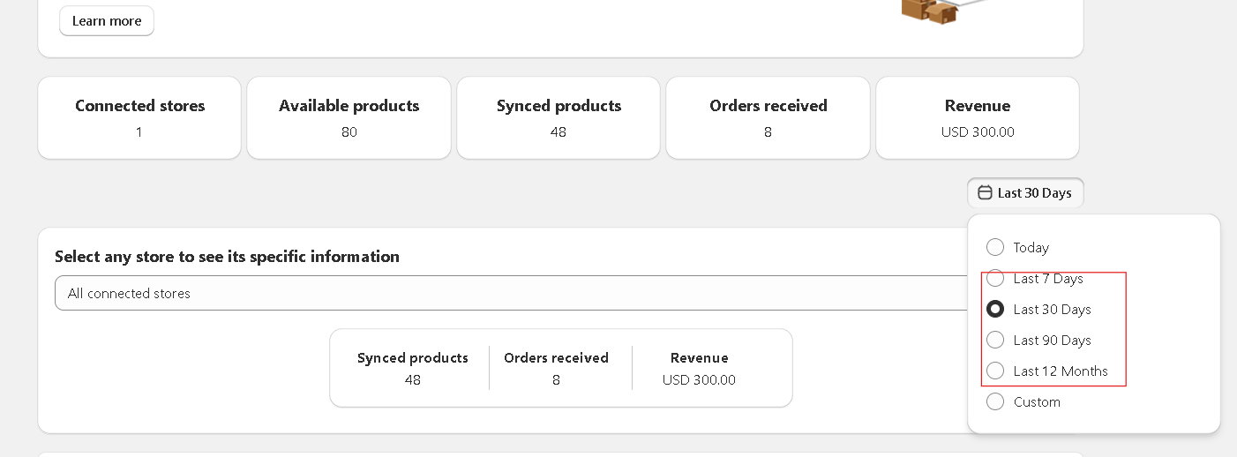

7.Grammatically incorrect bulk action label “Disable for sync”

In the Source Store → Products section, the bulk action label “Disable for sync” is grammatically incorrect and does not follow Shopify UI content guidelines. The wording is unclear and should use a clear verb-first action.

Steps to Reproduce
- Open the Source Store in the Syncerize app.
- Navigate to the Products section.
- Select multiple products using the checkboxes.
- Observe the bulk action button displayed at the top right
Actual Result
The bulk action label is displayed as “Disable for sync”.
Expected Result
The bulk action label should be grammatically correct and action-oriented, such as:
- Disable syncing
or
- Turn off syncing

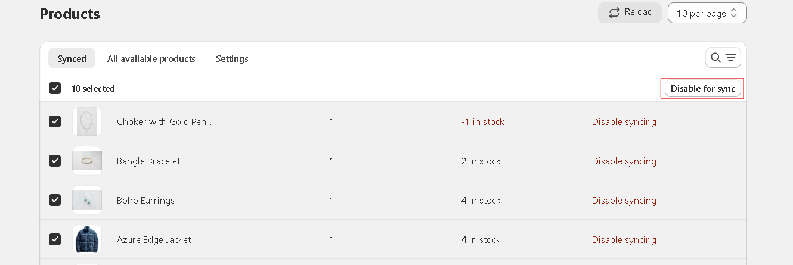

8.Update Notification Column Label from "Detail" to "Details" for BFS Compliance
The Notifications table currently uses the column header "Detail". According to Built for Shopify UI/UX standards and common Shopify interface patterns, plural and descriptive labels are preferred for better clarity and consistency. Using "Details" improves readability, grammar correctness, and merchant experience.

Steps to Reproduce
- Open the Syncerize app dashboard
- Navigate to Notifications section
- Observe the table header labels
- Check the column labeled "Detail"

Actual Result
- Column label is displayed as "Detail" (singular)

Expected Result
- Column label should be displayed as "Details" to follow:
  - Built for Shopify design standards
  - Shopify UI terminology conventions
  - Better UX and readability for merchants

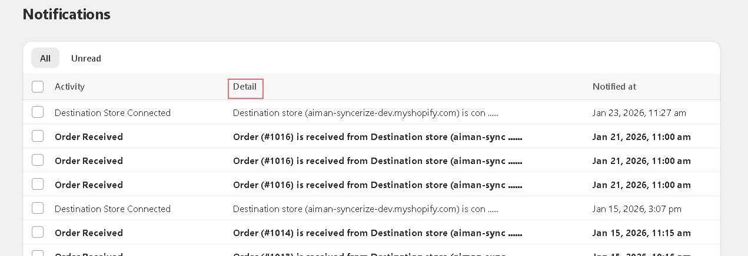

9.Update "Cancelled" to "Canceled" to Follow Shopify American English Standards

The Orders tab in the Destination store currently displays "Cancelled", which follows British English spelling. Shopify and Built for Shopify guidelines require American English terminology across UI elements.

Steps to Reproduce
- Open the Destination store’s syncerize app dashboard
- Navigate to Orders section
- Observe the tab labels
- Check the tab labeled "Cancelled"
Actual Result
Tab label is displayed as Cancelled.
Expected Result
Tab label should be displayed as Canceled.
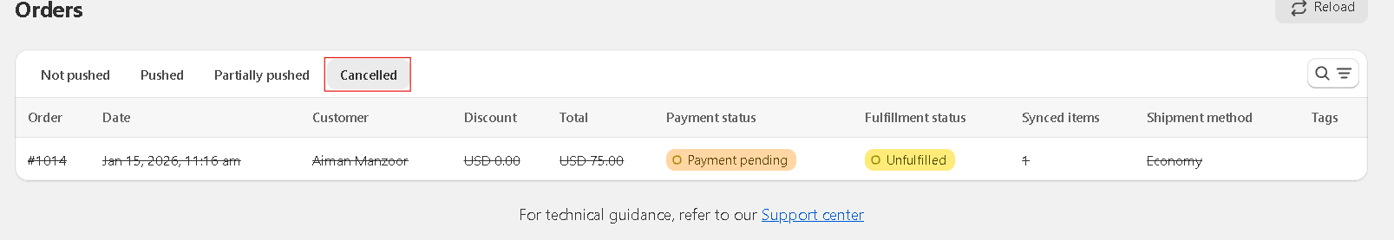
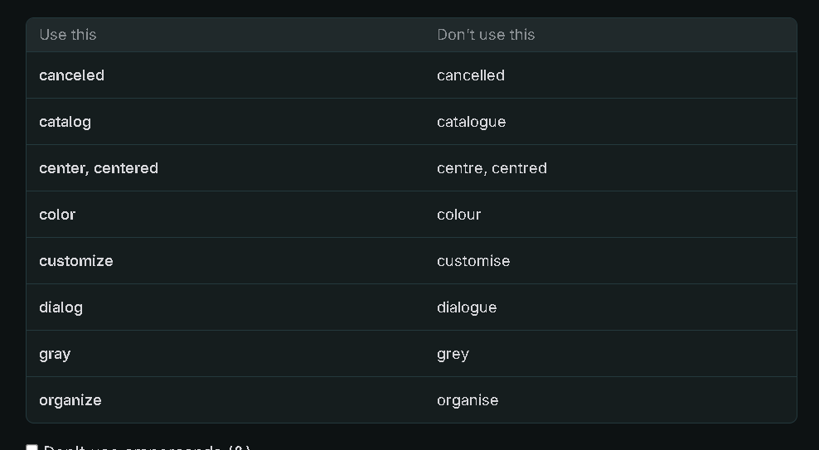

11.Inappropriate Column Label “order #”
When generating a report from the Stores section for a selected time period, the report table includes a column labeled “order #”, which is informal and inconsistent with professional UI and report standards.

Steps to Reproduce
- Go to the source store syncerize dashboard.
- Navigate to stores.
- Choose any store that is connected.
- Click Generate report
- Choose a time period
- View the generated report table

Actual Result
The report includes a column labeled:
order #

Expected Result
Use a clear, formal, and standardized column name.
Recommended options (American English):
- Order ID ✅ (preferred)
- Order Number
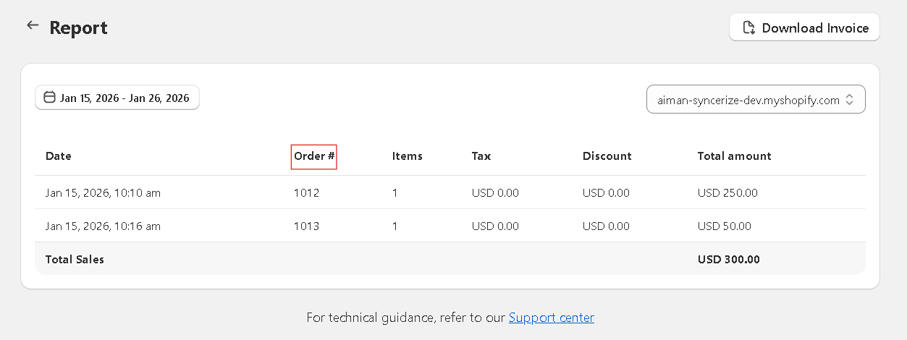
The same issue reflects in the Orders section too , upon selecting any order and generating a report for it .
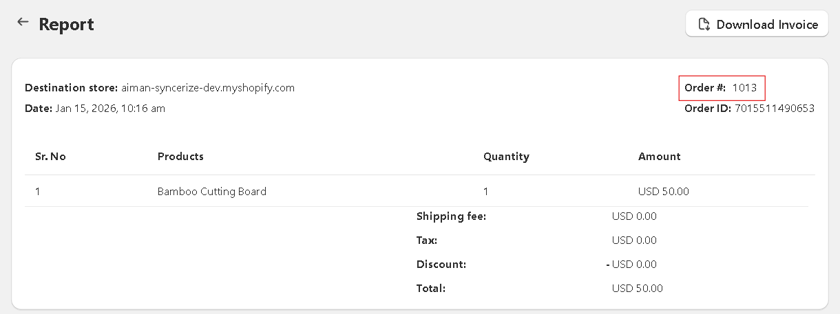

12.Product Sold Filter – Date Selection Issues
In the Products Sold section, when using the custom time period filter, the date selection allows invalid choices:
- Users can select future dates (e.g., March 2, 2026), which should not be allowed.
- Users can select a “From” date later than the “To” date, which is logically incorrect.

Steps to Reproduce
- Navigate to Syncrize Dashboard → Products Sold section.
- Click Filter and choose Custom Time Period.
- Attempt to select a future date for either From or To.
- Attempt to select a From date that is later than the To date.

Actual Result
- Future dates are selectable.
- From date can be later than To date.
- Dashboard does not prevent or warn the user about these invalid selections.

Expected Result
- The date picker should disable future dates beyond today’s date.
- The From date must always be earlier than or equal to the To date.
- Optionally, show an inline validation message if an invalid range is selected:
  - “From date cannot be later than To date”

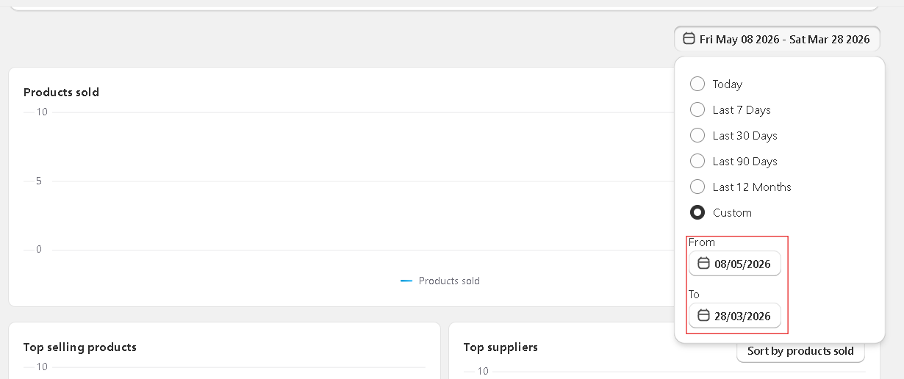

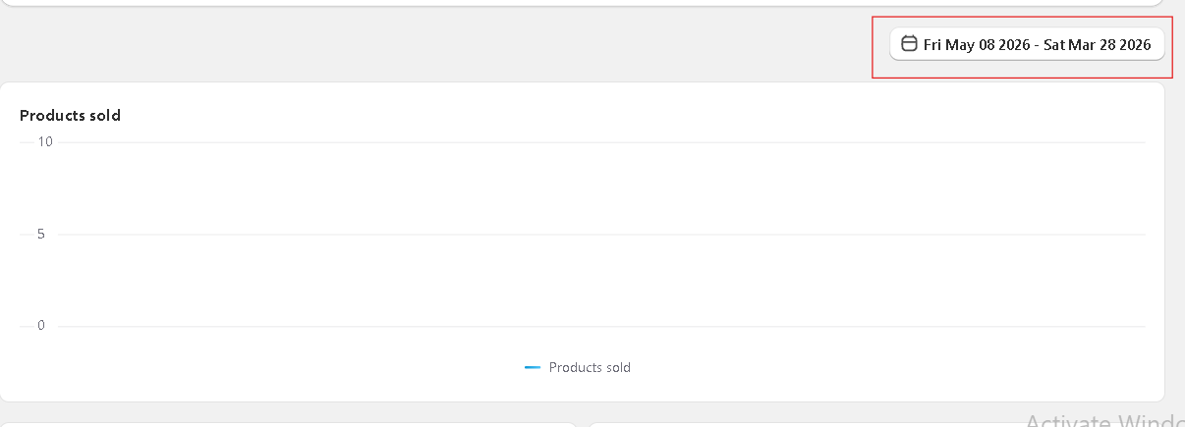

13.Destructive action button “Delete and unsync” is not visually distinguished in confirmation modal

In the Confirm product unsyncing modal, the “Delete and unsync” button represents a destructive action but is not visually distinguished from the non-destructive action. According to Shopify Polaris design guidelines, destructive actions should be clearly indicated (e.g., red styling) to warn users and prevent accidental data loss.

Steps to Reproduce
- Open the Destination store Syncerize app.
- Navigate to Products.
- Select one or more synced products.
- Click Unsync.
- Observe the Confirm product unsyncing modal.

Actual Result
- The “Delete and unsync” button appears as a regular secondary button.
- There is no visual warning indicating that the action will permanently delete products from the store.

Expected Result
- The “Delete and unsync” button should be styled as a destructive action (red color).
- The destructive styling should clearly differentiate it from the “Unsync only” button to reduce the risk of accidental deletion.
- The UI should align with Shopify Polaris destructive action guidelines.

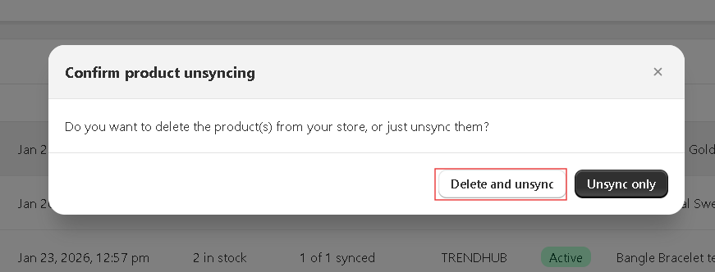

- Shopify makes Destructive styling clearly different using red color.
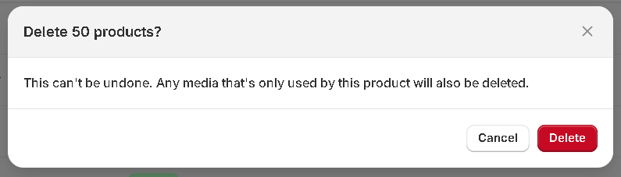
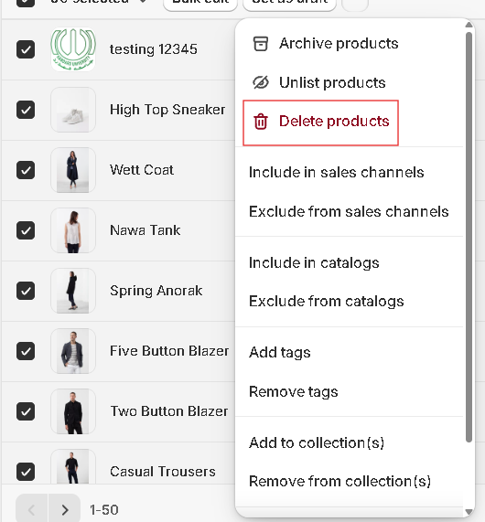

Suggestions
- There should be a delete or clear button for notifications to get rid from the notifications that are too old.

