

BS Artificial Intelligence (BSAI)
Big Data Analytics
REPORT
AIMAN
F2023376387
Section : A2

Big Data Analytics: Project 1
From 2,000 social-media records to a marketing decision
Companion notebook: Project1_Social_Media_Analytics.ipynb (runs in Google Colab)

1. Data source, provenance and course concepts
Source: GitHub repository mrudukp/social-media-sentiment-analysis, file social_media_sentiment_raw.csv (2,260 rows, 13 columns, five platforms, 12 countries, Jan 2023 to Dec 2024).
Provenance and licence note.
- The repository has no LICENSE file, so reuse terms are not stated.
- The data is not verified as coming from Pakistani clothing brands. The post texts are short templated sentences, which suggests synthetic or heavily simulated data. This project teaches the workflow; it makes no claims about Pakistan.
- For Pakistan-specific conclusions, an authorised export or clearly labelled synthetic data is needed.
How the course topics appear in this project.
Course topic | Where it appears
What is Big Data? | 2,000-row file compared with a 1,000x larger workload (Section 6)
Why Big Data? | Runtime, memory, file size and repeat-workflow cost measured at four sizes
Data sources / types | Posts, hashtags and engagement counts; numerical, categorical, text and date fields
EDA and data objects | Each row is one post; columns, missing values and duplicates inspected (Section 2)
Plots and statistics | Counts, mean/median, bar chart, histogram, box plot, scatter plot (Sections 3-4)
Analytics techniques | Classification, clustering and regression previewed (Section 7)

2. Data understanding and quality checks
The observational unit is one social-media post (not a user, comment or campaign).
column | type | meaning | missing values?
post_id | Identifier | One post (observational unit) | No
timestamp | Date/time | When the post was published | No
platform | Categorical | Twitter, Instagram, Facebook, TikTok, LinkedIn (case standardised) | No
user | Text/ID | Anonymised handle | No
followers_count | Numerical | Author's followers; stored as text with commas in raw file | Yes
verified | Categorical | Yes/No account verification | Yes
text | Text | Post content (templated sentences) | No
hashtags | Text | Hashtags; blank = no hashtags | Yes (means none)
country | Categorical | Author's country (whitespace/case standardised) | Yes
likes | Numerical | Likes; negative values invalid -> missing | Yes (invalid)
retweets_shares | Numerical | Shares / retweets | No
comments | Numerical | Comments; blank means not collected, not zero | Yes
sentiment | Categorical | Positive / Neutral / Negative label | Yes

Quality checks on the raw file
- Shape: 2,260 rows x 13 columns.
- Missing cells: hashtags 788, country 126, followers_count 90, comments 46, verified 44, sentiment 33. All other columns are complete.
- Exact duplicate rows: 44. Repeated post_id: 60.
- Negative likes (invalid): 8.
- The platform column holds 10 spellings for 5 platforms (for example Twitter and TWITTER); country has the same problem plus trailing spaces; followers_count is stored as text with commas.
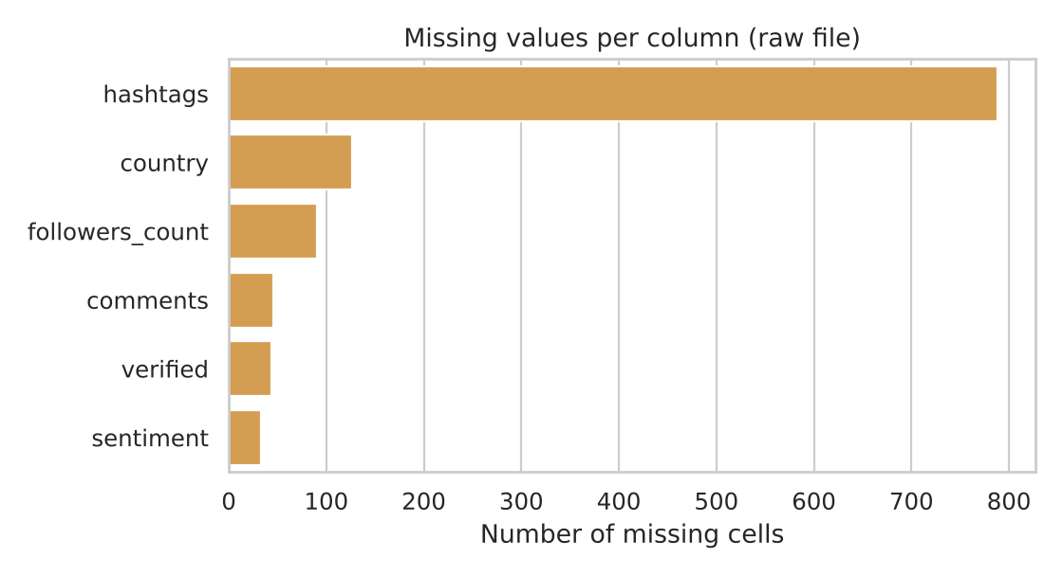
Figure 1. Missing values per column in the raw file.
Cleaning decisions
- Standardised case and whitespace, and converted followers_count to a number.
- Blank hashtags were treated as 'no hashtags' (a genuine zero). Blank comments were left missing: 'not collected' is not the same as zero. Negative likes were set to missing, not zero.
- Removed 60 duplicate posts after standardising. Only 44 were exact duplicates in the raw file; the other 16 were hidden by the case and comma differences. Analysis rows: 2,200.

3. Summary statistics
Platform | Posts (n) | Likes mean | Likes median | Comments median | Engagement mean | Engagement median
TikTok | 390 | 47.35 | 44.0 | 4.0 | 60.32 | 56.0
Instagram | 595 | 39.01 | 37.0 | 3.0 | 50.18 | 46.0
Twitter | 726 | 34.04 | 32.0 | 3.0 | 43.39 | 40.0
Facebook | 370 | 28.32 | 26.0 | 2.0 | 36.24 | 34.0
LinkedIn | 119 | 21.22 | 20.0 | 2.0 | 26.84 | 24.5

Engagement = likes + shares + comments per post.
- Likes: mean 36.09, median 33, skewness 1.32, maximum 126. The mean sits above the median because of a right-skewed tail.
- The top 10% of posts account for 20.6% of all engagement, so a handful of strong posts pull averages up; medians are the safer summary.
- Likes and comments move together (Spearman rho = 0.59, n = 2,148).

4. Charts and interpretation
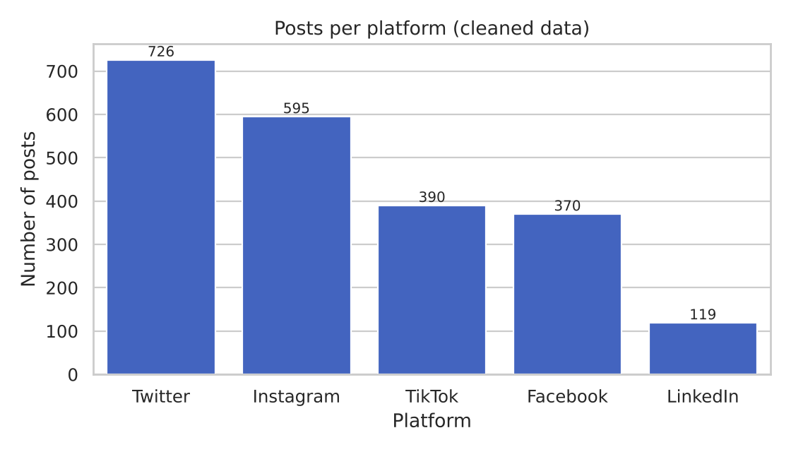
Figure 2. Posts per platform. Twitter and Instagram dominate; LinkedIn has only 119 posts.
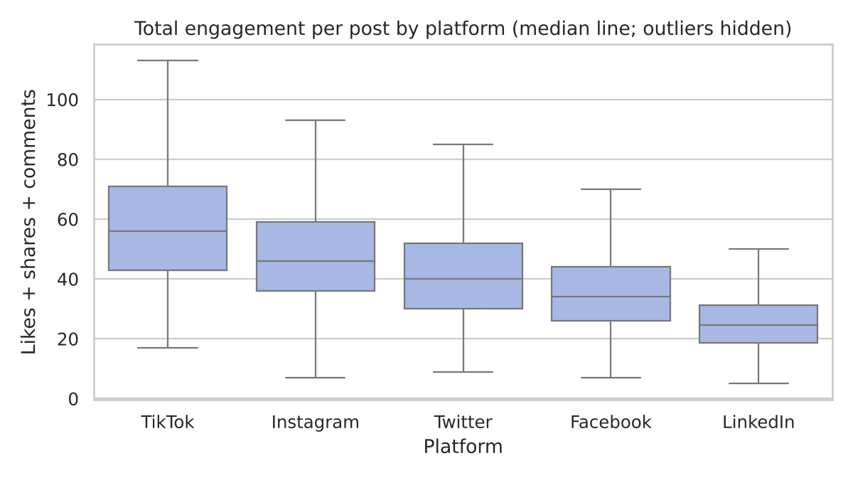
Figure 3. Engagement per post by platform. Medians fall from TikTok to LinkedIn.
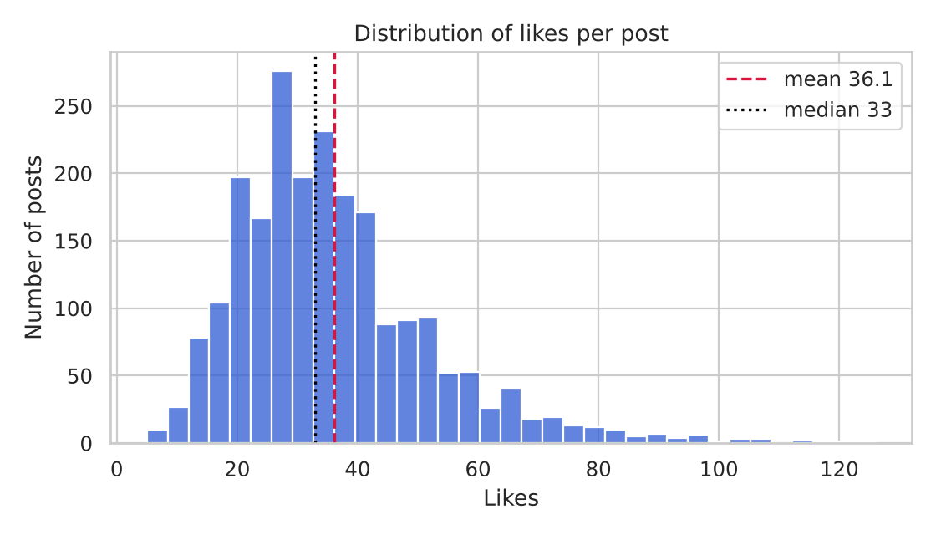
Figure 4. Likes are right-skewed: the mean (dashed) is above the median (dotted).
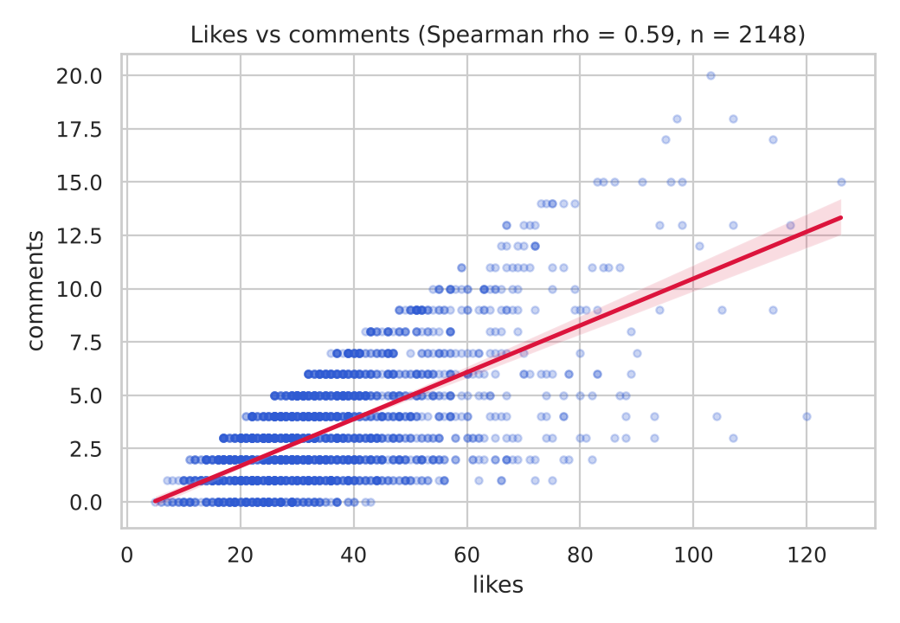
Figure 5. Likes and comments are positively related.
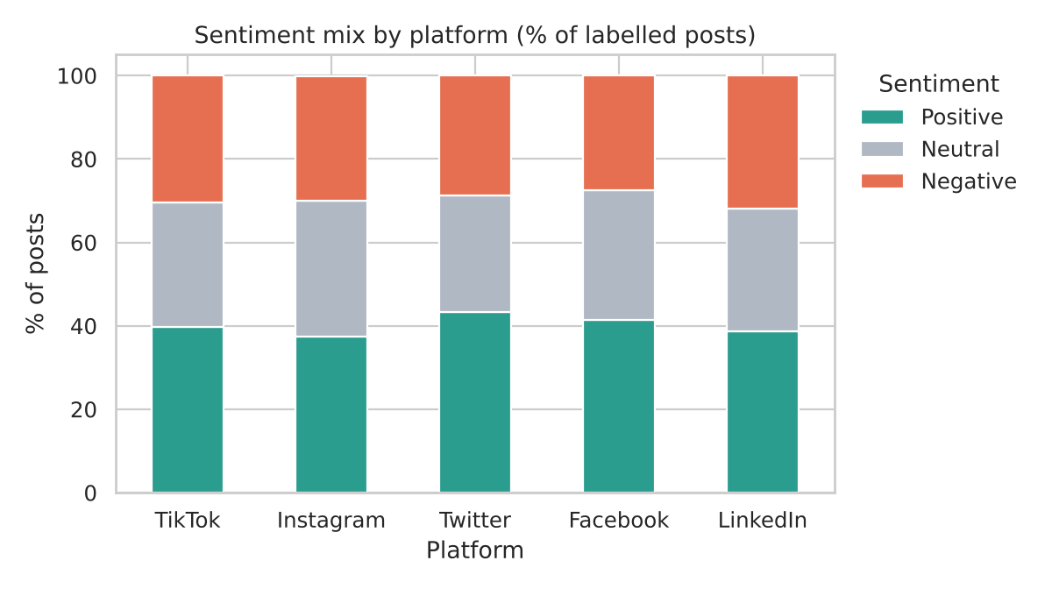
Figure 6. Sentiment mix is similar across platforms (about 38-43% positive).

5. Evidence-based observations and recommendation
Item | Detail
Finding 1 | TikTok posts have the highest typical engagement and LinkedIn the lowest.
Evidence 1 | Median engagement: TikTok 56, Instagram 46, Twitter 40, Facebook 34, LinkedIn 24.5. Kruskal-Wallis across platforms: H = 419.52, p < 0.001. Group sizes: 390, 595, 726, 370, 119.
Finding 2 | Positive-tone posts earn more engagement than neutral or negative posts; negative posts beat neutral ones.
Evidence 2 | Median engagement: Positive 50 (n = 879), Negative 40 (n = 636), Neutral 35 (n = 652); Kruskal-Wallis p < 0.001.
Action | Recommendation: a brand could test moving a share of content effort toward TikTok and toward clearly positive-tone posts for one campaign cycle, and compare results using one consistent metric, rather than assuming the pattern holds.
Limitation | No reach or impressions column, so this is engagement per post, not engagement rate or ROI. The data is unverified, probably synthetic, and the differences are descriptive, not causal. LinkedIn has a small sample (n = 119).

6. Scaling experiment and tool justification
The cleaned 2,200-row file was repeated to reach 1x, 10x, 100x and 1,000x workloads. This is a scaling experiment, not new real-world evidence. Each size ran in a fresh process on a 2-core, 8 GB machine. Operations: load the CSV, group-by mean, value counts, text-length mean, sort, and drop duplicates.
Rows | Workload | File (MB) | Load (s) | Analysis (s) | Dedupe (s) | Peak memory (MB)
2,000 | 1x | 0.4 | 0.007 | 0.008 | 0.004 | 71.6
20,000 | 10x | 3.7 | 0.049 | 0.016 | 0.019 | 88.0
200,000 | 100x | 36.8 | 0.404 | 0.119 | 0.21 | 153.0
2,000,000 | 1000x | 368.0 | 3.755 | 1.249 | 2.097 | 852.6

What this shows
- Cost grows roughly in proportion to rows: loading went from 0.007 s to 3.755 s and peak memory from 72 MB to 853 MB.
- Pandas did not fail at 2 million rows on this machine. There is no universal row count at which it fails; the need for Spark depends on data size, the operation, the hardware and service requirements.
- Where it could start to hurt (extrapolation, not measured): the 368 MB file already needs about 850 MB of memory, so if memory use keeps scaling linearly, a file 10x larger (about 20 million rows) would need roughly 8-9 GB, which is more than many laptops can spare, and repeated daily reprocessing would become slow.
Tool justification: a scalable tool such as Spark is worth investigating when volume, processing time, memory limits or distributed-storage needs justify it, for example full social-media archives across many brands. It is not needed for this 2,200-row file.

7. Preview of analytics techniques
A short conceptual demo only. Safeguards: train/test split (75/25), no engagement columns used as predictors of engagement (avoids leakage), and scaling before clustering.
Technique | Setup | Result (test set)
Classification | High vs low engagement (total engagement above the median of 42) | Accuracy 0.79 / F1 0.78 vs majority baseline 0.508
Regression | Predict likes from platform, followers, verified, sentiment, hashtags, hour | R2 0.683; MAE 7.14 likes vs 12.05 for always guessing the median
Clustering | K-means (k = 3) on scaled likes, shares, comments | Groups of 1173, 781 and 194 posts: low, mid and high engagement

Exit question: which technique helps the marketing question? Classification helps decide whether a planned post is likely to be a strong performer; regression estimates how many likes to expect; clustering segments posts into engagement tiers to study what top-tier posts share. Evidence needed: real reach data, content features beyond templated text, and a held-out time period.

8. Limitations
- Unverified, likely synthetic data with no licence; not representative of Pakistani clothing brands.
- Organic engagement only. ROAS and paid-ad performance cannot be calculated from it.
- Models use 2,200 templated posts and show the workflow, not production-grade accuracy.

