Requirement

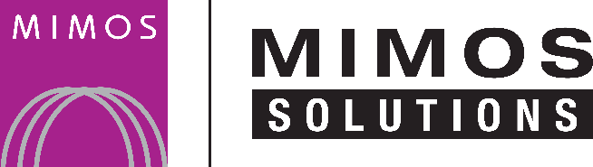
<Insert customer logo>

{section_0}
User Requirement Specification

File Name | {section_1}
Issuance Department | {section_2}
This document contains confidential and sensitive information. The information contained within should not be reproduced or redistributed without prior written consent from MIMOS Solutions Sdn. Bhd. and <Customer>.

- Introduction
  - Purpose
{section_3}
  - Scope
{section_4}
  - Intended Audience
{section_5}
  - References
The following are the reference documents used, for detailing the business requirements for the {section_0} -
No. | References | Provided by
 | {section_6}

Table 1: List of References

  - Standards
<This section shall identify all internal and external standards that will be adhered to in the development of the system. This will also identify those external standards that have been specified by the customer (this can be extracted from contract or tender spec). In case there are corresponding internal standards, this section shall outline the reasons for not using the internal standards.>
No. | Standards | Purpose | Reference
 | {section_7}

Table 2: List of Standards

