Experiment 7
Software Design Document
for
Recruitment System
Prepared by Aiman Raza, Agrim Kansal and Aizanul haque
Delhi Technological University, New Delhi
25th March, 2025
Table of Contents
Table of Contents ii

Revision History iii
1. Introduction 1
1.1 Purpose 1
1.2 Scope 1
1.3 Definitions, Acronyms and Abbreviations 1
1.4 References 1
2. System Overview 2
3. System Components 8
3.1 Decomposition Description 8
3.2 Dependency Description 8
3.3 Interface Description 9
3.4 Module Interfaces 9
3.5 User Interfaces (GUI) 9
4. System Fetaures 9
4.1 Module Detailed Design 9
4.2 Data Detailed Design 9
4.3 RTM 9

Revision History
Name | Date | Reason For Changes | Version
Recruitment System Version 1.0 | 25/03/2025 | Initial Release | 1.0

Introduction

Purpose
The main purpose of this document is to describe how are we going to create a Recruitment System. This system is being developed to help companies manage their hiring process more easily. With this system, companies will be able to post job openings, accept applications, arrange interviews, and select candidates, all from one place. This document is intended for Project Managers, Software Engineers, and anyone else who will be involved in the implementation of the system.

Scope
This Recruitment System will be available through a website. The system will help three types of users:
- HR Staff: They will use it to post new job openings, view and manage applications, and schedule interviews.
- Applicants: They can browse job listings, fill out applications, upload resumes, and check the progress of their applications.
- Interviewers: They will see who they need to interview and give feedback about each applicant.
The goal is to make hiring smoother and quicker. Instead of using emails, phone calls, or spreadsheets, everything will happen in one online system.

Definitions, Acronyms and Abbreviations
Acronym | Meaning
HR | Human Resources – the people in charge of hiring new employees
SRS | Software Requirements Specification – a document that lists all the features the system should have
SDD | Software Design Document – this document, which explains how the system will be built
GUI | Graphical User Interface – the part of the website that users see and click on
RTM | Requirements Traceability Matrix – a table that connects each requirement to the part of the system that fulfills it
DBMS | Database Management System – software used to store and organize the system’s data
API | Application Programming Interface – a way for different parts of the system to talk to each other
SDD | Software Design Document – refers to the whole recruitment system being developed

References
Experiment 1, Experiment 2, Experiment 3
Experiment 4, Experiment 5
Experiment 6

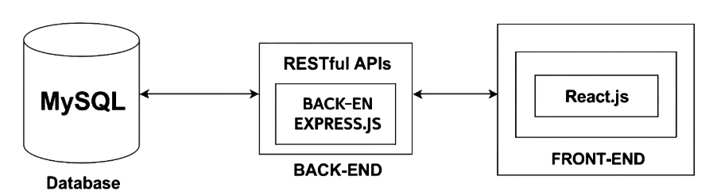
System Overview

The Figure above illustrates the architectural design chosen for the development of the Recruitment System.
For the backend, we have chosen JavaScript, specifically using Node.js with Express.js, due to its event-driven architecture, non-blocking I/O model, and its seamless integration with frontend JavaScript frameworks. This setup allows for faster development cycles, scalability, and easier collaboration between frontend and backend teams since both use the same language.
All user actions — like applying for jobs, posting new listings, or setting up interviews — will go through RESTful APIs built with Express.js. These APIs help the frontend and backend talk to each other smoothly. They also make the system flexible and easy to expand later, whether that means adding features like resume scanning, email alerts, or even chatbot support.
To manage persistent data, the system will use MySQL. It will store critical information such:
- User profiles (applicants, HR, interviewers)
- Job listings with metadata
- Applications and attachments (like resumes)
- Interview schedules and interviewer feedback

The frontend will be built using React.js due to reusable components and state management. This setup ensures that users, whether job seekers or recruiters, enjoy a smooth and efficient interface across web and mobile platforms.
The architecture is designed in a modular format where each module, User Management, Job Posting, Application Handling, Interview Scheduling, and Reporting, operates independently but communicates through APIs. This makes the system easy to maintain, scale, and extend with new features.

System Components

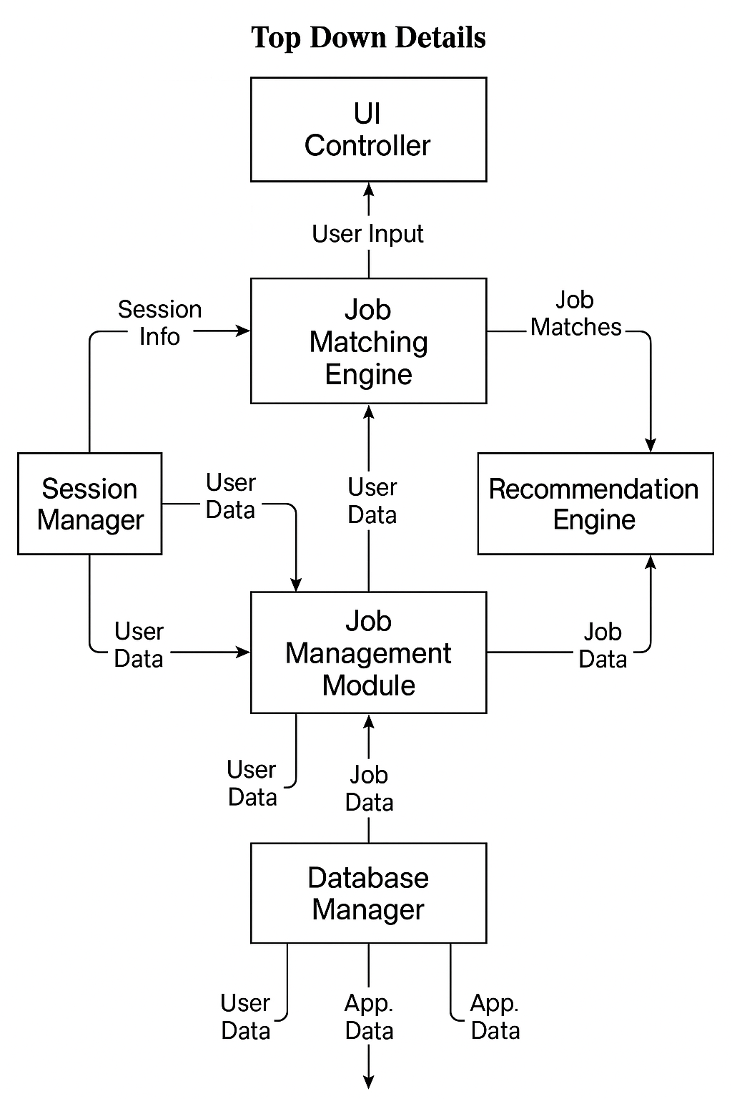
Decomposition Description

At the center of everything is the Job Matching Engine. This is the core part of the system that connects people with the right jobs based on their skills, preferences, and past experiences.
When a user visits the system—whether they are looking for a job or want to post one—they interact first with the UI Controller. This part handles everything the user inputs, like searching for a job or filling in their profile. That input is then passed to the correct internal modules.
The Session Manager is responsible for logging users in and out, making sure only authorized users can access the system. Once someone is logged in, their data is managed by the User Profile Manager. This part stores information like resumes, job preferences, and saved applications.
If the user is a recruiter, their information is handled by the Job Management Module. It allows them to create, update, and remove job listings. These listings are then stored and managed by the Database Manager.
When job seekers search for jobs, the Job Matching Engine steps in. It checks all available job listings and matches them with the user's profile. The engine also uses a Recommendation Engine to suggest jobs based on what users have searched for or applied to in the past.
All these components save and retrieve information from the Database Manager, which keeps track of users, job posts, applications.

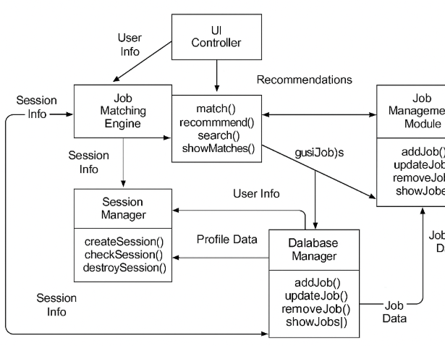
Dependency Description

The figure above represents the component diagram of the Recruitment System and how each module is dependent on another for its functionality.

When a user interacts with the system—either a recruiter or a job seeker—they first pass through the UI Controller. The information provided (such as login credentials, job searches, or job post details) flows into the Job Matching Engine, which acts as the central module responsible for processing these actions.

Before the system proceeds with any operation, it authenticates the user through the Session Manager, which verifies if the session is active and valid. Once verified, the User Profile Manager pulls user-related data, such as saved preferences, resumes, or previously applied jobs. If the user is new, the system prompts them to input their information, which is stored via the Database Manager.
Recruiters are routed to the Job Management Module, where they can add, edit, or remove job listings. These listings are then saved in the system for use in the matching process. On the other hand, job seekers are processed by the Job Matching Engine, which uses their profile and preferences to search the database for suitable job openings.
The Recommendation Engine assists the matching engine by providing additional job suggestions based on user activity, such as past searches or applications. These results are returned to the UI Controller and presented to the user.
Throughout this process, the Database Manager plays a key role by securely storing and retrieving all information. This architecture ensures that each component functions makes the recruitment workflow smooth and data-driven.

Interface Description
To keep things organized, each part of the system talks to the others through defined interfaces. These are basically the 11ways modules share data with each other.

Job Matching Engine – Session Manager
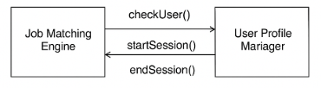
This interface handles things like logging in and checking if the user is valid. It includes:
- Checking user credentials, starting a user session, ending a session when they log out

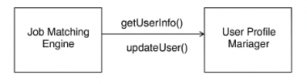
Job Matching Engine – User Profile Manager

This is used to get or update the user’s details, such as:
- Their resume, Preferred job types, Saved searches

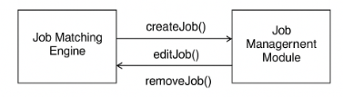
Job Matching Engine – Job Management Module

This one handle job listings:
- Creating new job posts, Editing or updating jobs, Removing old job listings

Job Matching Engine – UI Controller
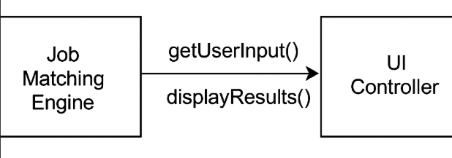
It helps:
- Get input from the user, Show job results and recommendations

Module Interfaces
Each part (or module) of the system has its own job, but they don’t work alone. They talk to each other using what we call interfaces. Think of it like different departments in a company sharing important updates so everyone stays on the same page.
Here’s how the main modules in our Recruitment System connect and communicate:
- User Management Module: This is where everything starts. It connects to:
  - Session Manager (for login/logout and user sessions)
  - Profile Manager (to save user details like name, email, skills)
  - Job Matching Engine (so users can get job recommendations)
- Job Management Module:
  - Works with Recruiters through the UI to post, update, or remove job openings.
  - Sends all job data to the Database Manager so it's stored safely.
  - Shares job info with the Job Matching Engine so the system can show them to job seekers.
- Job Matching Engine:
  - Connects with the Recommendation Engine to suggest jobs based on user history.
  - Pulls data from Profile Manager and Job Management Module.
  - Sends final results to the UI Controller so users can see matching jobs.
- Database Manager:
  - It's the central storage unit. Every module talks to it when they need to save or get information — like profiles, job listings, or applications.
By keeping each of these modules connected but still separate, we make the system easier to manage and update in the future. If one-part changes, we won’t have to rebuild the whole system.

User Interfaces (GUI)

(Insert Screenshots after building prototype or UI Wireframes here (Login Page, Job Search Page, HR Dashboard)

There are three main user interfaces in the Recruitment System:
- Applicant Interface:
  - let’s users create a profile, upload resumes, and search for jobs.
  - They can track their applications and see updates (like interview invites or results).
  - There’s also a "Recommended Jobs" section based on their skills and interests.
- HR/Recruiter Dashboard:
  - Gives full control over job postings — adding, editing, or deleting them.
  - Let’s HR see how many people applied, view resumes, and schedule interviews.
  - They can also assign interviewers and send notifications directly from the system.
- Interviewer View:
  - Shows a list of assigned interviews.
  - Allows interviewers to give feedback and rate applicants after interviews.
The UI is designed to be clean and minimal, using buttons, dropdowns, and search bars so that users can do things quickly without getting lost. Everything is built using HTML, CSS, and JavaScript — with responsive design so it works on both desktop and mobile.

Detailed Design

Module Detailed Design

Schedule Interview Module
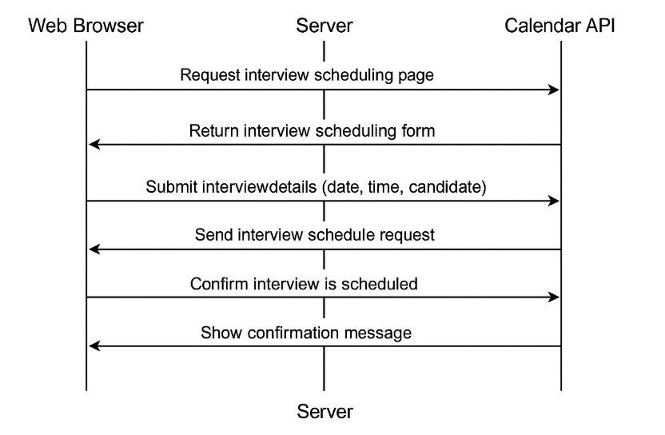

Pseudocode
User opens schedule interview page
→ Browser requests interview form from server
→ Server returns interview form

User fills in interview details and submits
→ Browser sends data to server
→ Server sends scheduling request to calendar API
→ Calendar API confirms scheduling
→ Server responds with confirmation to user
→ Browser shows confirmation

Data Detailed Design
In this module, we define how the essential data is stored and accessed. The data elements involved in the Recruitment System include:
- Candidate Profile Data: Name, email, resume, skills, experience, etc.
- Job Postings Data: Job ID, title, description, requirements, posted by, etc.
- Interview Schedule: Interview ID, candidate ID, interviewer, date, time, location/meeting link.
- Application Tracking: Status updates, feedback, applied jobs list.
Data is stored in structured tables within a relational database and accessed via a backend API layer.

RTM (Requirement Traceability Matrix)

Req. ID | Requirement Description | Design Element | Module/Component | Status
RQ-1 | User Registration & Login with ID verification | Secure Authentication Module | Backend + Frontend | Designed
RQ-2 | Job Posting by verified Employers | Job Management System | Employer Dashboard | Designed
RQ-3 | Resume Upload & Parsing | Resume Parser & Data Extractor | Candidate Profile Module | Designed
RQ-4 | Intelligent Candidate Matching using AI | AI Matching Engine | AI Module | Planned
RQ-5 | Fraud Prevention through Document Verification | External Document Verification API | Verification Service | Designed
RQ-6 | Gamified Skill-based Assessments | Quiz/Assessment Engine | Test & Evaluation Module | Planned
RQ-7 | Application Tracking (real-time updates for employer and user) | Notification & Status Tracking | Job Application Tracker | Designed
RQ-8 | Employer Dashboard with Application Analytics | Dashboard UI + Data Analytics | Employer Frontend | In Dev
RQ-9 | Schedule Interviews Automatically | Scheduler & Calendar Integration | Interview Module | Planned
RQ-10 | Responsive UI for both Employers and Applicants | GUI Screens | Web UI (React/HTML) | Designed

- Req. ID: Unique identifier from your SRS for traceability.
- Requirement Description: A short explanation of what the system needs to do.
- Design Element: The specific design component (e.g., engine, API, service) that addresses the requirement.
- Module/Component: Where in the system this is being handled (frontend, backend, dashboard, etc.).
- Status: Indicates whether it's Designed, In Development (In Dev), or planned.
.

