Name: Aiman Shahbad

Assignment: Swarm

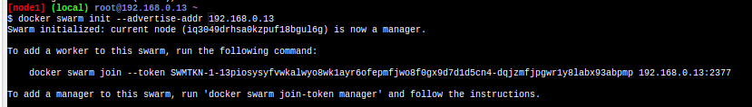

1)Creating a docker swarm

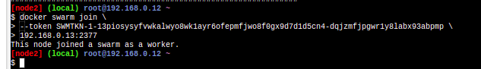2) Adding a worker node to swarm cluster

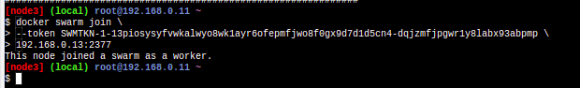

3) 1 manager node which leader, 2 worker node

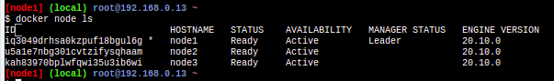

4) run the docker-compose file using docker stack deploy

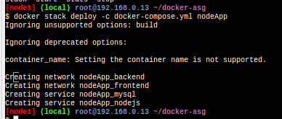

5) Scale the nodeApp_mysql and nodeApp_nodejs service

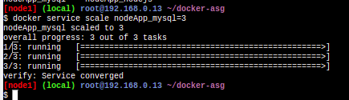

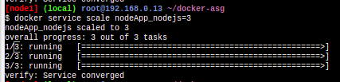

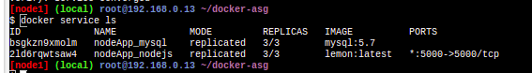6) Three replicas of each service

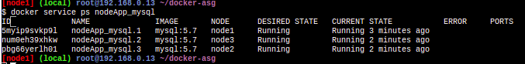

7)the service is running on node1 node2 and node3