

**BEACONHOUSE NATIONAL UNIVERSITY**

**Thrift Store Website**

PRJ-F23/336

**PROJECT PROPOSAL REPORT**

**EXTERNAL SUPERVISOR**

Muhammad Danyal

**INTERNAL SUPERVISORS**

Ms. Shazia Rizwan

Ms. Huda Sarfraz

**GROUP MEMBERS**

Aiman Zahoor F2020-550

Zainab Usama F2020-372

**SCHOOL OF COMPUTER & IT**

**September 2023**

1. **Problem Statement**

In Pakistan, economic challenges are tightening wallets, making it difficult for many to afford new items. Our environment is also in trouble at the same time. We discard a lot of things, creating a huge amount of waste. People frequently purchase items that they use occasionally or never at all. They may have items that don't fit, but rather than fixing the issue, they either keep the items or give them to someone who will never utilize them. People are also being deceived into paying excessive prices for products, particularly in the fashion industry where having a well-known brand is of greater importance than the item itself. Some available platforms make the process of selling and buying pre-used items more difficult than it needs to be. It's like we're stuck in a cycle of problems: not enough money, too much waste, and things not getting better for our country.

1. **Existing System**

Thrift stores mostly in Pakistan are facing a big challenge in reaching the people they want to help, and this makes it tough for customers to find what they're looking for. These online stores often show up on social media like Facebook and Instagram, but there's a problem. Many of them focus only on selling clothes and forget about making sure the things they sell are good quality. The online platforms where these stores are found also have issues. They don't always have trusted sellers. Imagine wanting to buy something important, but you're not sure if the person selling it is reliable. An online store on Facebook named as Thrift store works in the same way causing hassle for the users.[1]

A lot of these platforms seem like crowded markets where everyone is competing for your attention. It's confused and unclear. Most stores don’t allow direct sales and the ones that do are not well-managed. YBMB is an example for such a store as it does not gives the option for users to sell directly on the platform.[2]

There is a significant issue with scams. It's risky when platforms don't thoroughly check the items that users are selling. It's like letting scammers who want to take advantage of others in. There must be a better way for people to interact with thrift shops and for people to find what they need without being concerned about cons or low-quality items. OLX is an online store that allows selling and buying a variety of used or new items but it is also well-known for its scams and C2C model.[3]

1. **Literature Survey**

Thrift stores have been on the rise amongst the youth who are looking for items that are affordable. There are many people who don’t want to carry the enormous amount of clothing’s or valuables. Hence, there requires a market which allows the system of thrift. Although, thrift stores are on the rise, the condition of the stores and the market as a whole has not been advancing much. Some studies have been conducted regarding objectives like the various factors promoting the use of thrift store products.[4]

According to the survey some various factors promoting the use of thrift stores are some of the following and the table shows the number of respondents regarding the statements[4]:

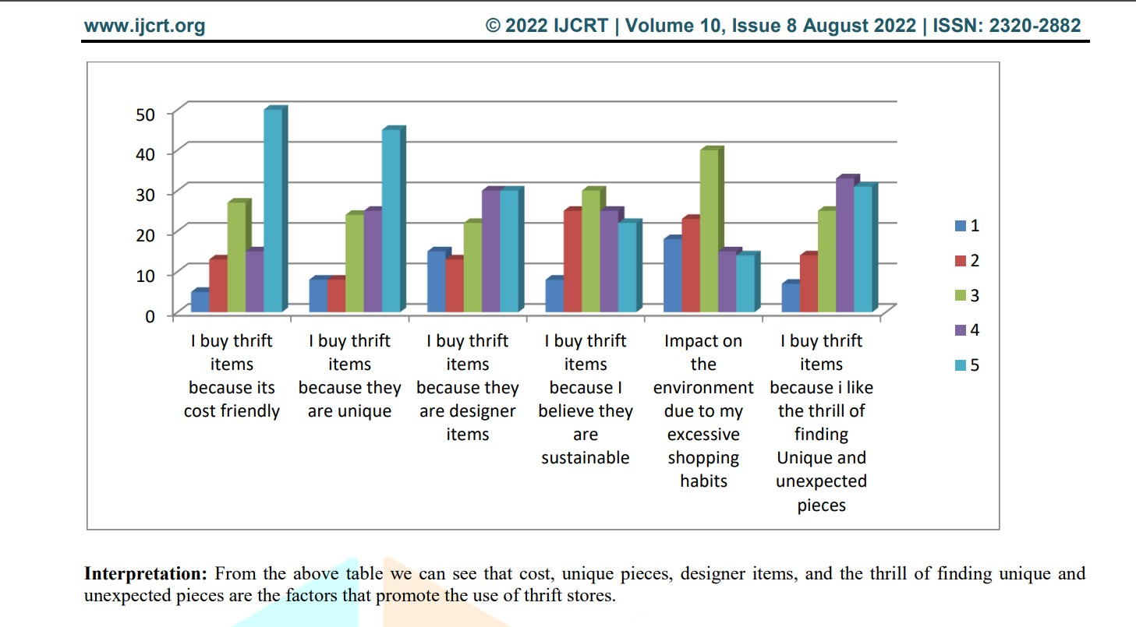

Some findings from the research include[4]:

* The study revealed that people buy thrift items mostly because of budget friendly price and uniqueness.
* Through this study it has been found that the sellers have lack of funds for expansion and upgrading the stores.
* From the study it has been found that most of customers of thrift stores are between the age group 15-25 years.
* The study revealed that most of the thrift sellers started thrift stores for income
* The study revealed that sales of thrift products have gone up after the pandemic.
* Through this Study it has been found that Thrift stores help in promoting Green Consumerism by reducing the waste produced by clothes due to fast fashion.

eBay:

eBay is an online shopping platform that connects buyers and sellers from around the world. It's like a huge virtual marketplace where users can find almost anything they’re looking for. It allows users to buy or sell a wide range of items from brand-new products to pre-owned and vintage items etc. The eBay auction system is one of its unique features.

Sellers can set up auctions for their items, and buyers can bid on them. The highest bidder wins the item. Alternatively, some items have a "Buy It Now" option, where you can purchase the item immediately at a set price. There are many different categories on eBay. Fashion, electronics, home decor, collectibles, and other items are all available. It is a flexible platform for buyers and sellers with a range of interests because of its diversity.

Globally, eBay connects people. Items can be listed for sale by sellers, and buyers can make purchases almost anywhere. Both buyers and sellers on eBay can leave ratings and reviews after a transaction. This feedback system helps build trust within the community. Sellers with good ratings are often considered more reliable. eBay aligns with the concept of sustainable and economic shopping. It provides a virtual space where individuals can explore, bid on, and purchase pre-owned items, echoing the essence of thrift store culture in a digital environment.[5]

Offer Up:

Offer Up is a user-friendly mobile app designed to connect people locally for buying and selling items. It's like having a virtual garage sale right in your pocket. It concentrates on bringing people together locally, as opposed to some online marketplaces that are global in scope. Because of this local flavor, users can buy goods made by locals. Sellers can quickly list items for sale by taking pictures with their phone, adding a description, and setting a price. It's a straightforward process that doesn't require any advanced tech skills.

On Offer Up, users can find everything from furniture and electronics to clothes and accessories. Buyers and sellers can communicate directly through the app. If user is interested in an item, they can ask questions or negotiate the price before making a purchase. It has safety measures in place to make in-person transactions more secure. It provides guidelines for meeting in public spaces and encourages users to be cautious and aware during exchanges.

It also includes a rating system where buyers and sellers can leave feedback based on their experiences. Offer Up promotes the idea of reusing items, contributing to a more sustainable and eco-friendlier lifestyle. Additionally, buyers can often find items at lower prices compared to buying new, aligning with the principles often associated with thrift stores. It represents a modern and localized approach to second-hand commerce, where people within a community can easily exchange items, fostering a sense of shared economy and sustainability.[6]

1. **Additional Research**

According to some more research, the economy is in poor shape, and a lot of people are looking for affordable options. Giving things to family members or making donations is common in our culture. Both the younger and older generations continue to practice this tradition. Some people do it online, but there is a growing trend of doing it through personal networks. Our platform aims to better organize this process.

The way we handle buying and selling stuff also affects nature. The more we can reuse and share, the less new stuff we need to make, which is good for the planet. Online thrift stores are becoming more popular since COVID. Tech initiatives to promote similar platforms abroad are common. Talking to people, we found out that some folks hesitate to buy used things in person as well as online.

On the other hand, buying new things is a struggle. When we hesitate to buy used things, we end up making more new things, which takes more resources and energy. Here’s why it's a big deal: Making a simple cotton shirt needs a lot of water—about 400 gallons for just one! This water use harms the environment. Apart from this, People also think such stores saves them money and also consider it a green alternative, which is definitely true.[7]

1. **Solution**

Our aim is to create a web application that allows people to buy and sell affordable second-hand items or donate items. This will help those struggling with inflation and contribute to reducing waste. This project taps into the cultural tradition of passing on things to family, friends or those in need. But now, this sharing tradition is evolving, and we want to give it a boost. Why? Because we all need a little help, and we all have things we could pass on. This application involves more than just buying and selling; it promotes doing good. Through this platform, sellers can decide whether to donate their goods to a reputable charity.

This application focuses on a strong commitment to quality control by offering an image quality detector with low-light and blur sensors to help sellers present high quality images and make sure buyers are able to asses’ items properly. The product description will have mandatory fields for accurate information. This application aims on providing reliability by assigning ‘Trusted-Seller’ badges based on reviews and ratings of the sellers to encourage users to shop with confidence. Additionally, it will also let users negotiate prices with the sellers. With the help of this application's recommendation system, shopping will be easy, whether the user has a specific item in mind or simply exploring. It not only streamlines the shopping process but also tailors’ suggestions to match user’s unique interests.

This platform is dedicated to prioritizing user accessibility and customer support, with a live chatbot available around-the-clock and features like font-size adjustment, text-to-speech capabilities, and real-time notifications. In essence, our solution combines availability, reliability, accessibility, and quality checks, offering a thorough and cutting-edge perspective on the thrift store mode.

Our platform will also have a SocialSense AI system integrated to stop abuse and misuse. it allows filtering of comments and reviews to encourage a safe and welcoming community.

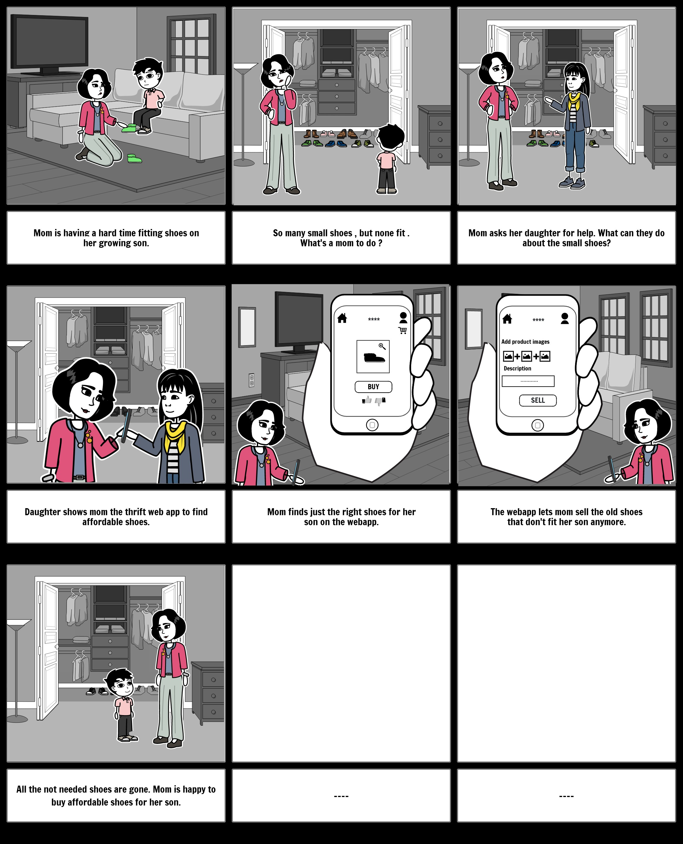

1. **Business Model**

Buying:

A small delivery fee is added when a user makes a purchase on the website to guarantee the product will arrive safely. The reliable delivery service made possible by this added expense improves the overall experience for both buyers and sellers.

Selling:

Users who sell products help the website run smoothly by deducting 5% of their earnings. This deduction is essential for continued operation because it provides a favorable environment for both buyers and sellers.

Delivery Process:

Collaborating with a trusted delivery company, the seller ensures proper packaging and shipment after a buyer completes a purchase or the donating process. This collaboration guarantees secure and timely deliveries.

Payment Methods:

COD and Online Payment: Conveniently, Cash on Delivery (COD) and online payment methods are available.

Refund and Return Policy:

users can receive a refund or return their item if it:

* Is damaged in transit.

Costs for the development and maintenance of the platform involves:

* Development: Initial setup, backend, and frontend development.
* Inventory: Investment for items
* Maintenance: Hosting, domain registration, and security.
* Payment Processing: Transaction fees for integrating payment gateways.
* Delivery Collaboration: Fees for partnering with a delivery service.
* Marketing: Advertising, social media management.
* Technology Stack: Software licenses.
* Miscellaneous: Contingency for unforeseen expenses.

1. **Deliverables**

A responsive web application that allows users to sell, buy and donate pre-used or second-hand items with ease.

1. **Technologies**

* The back-end of the application will be made using Java (Springboot , Java)
* The front-end of the application will be made using React.js
* Image processing will be implemented using python
* MySql will be used for database handling of the application.
* GitHub will be used to control the development process in remote working environments.

1. **Project Methodology:**

* FYP-I

Proposal Document:

1. Brainstorming ideas
2. Discussions
3. Finalizing idea
4. View different thrift stores online
5. Articles related to thrift stores
6. Look into NGO’s
7. Look into features
8. Gathering requirements
9. Looking into issues faced by users in existing systems
10. Brainstorming solutions
11. Finalizing solution
12. Complete Proposal document requirements

Proposal Presentation:

1. Listing supporting material
2. Creating supporting material
3. Storyboarding
4. Creating interactive wireframes
5. Creating Slides
6. Presentation

Requirement Analysis Document:

1. Survey on users who sell or buy on thrift stores
2. Survey on thrift stores owners
3. Use cases being finalized
4. Functional requirements being finalized
5. Non-functional requirements being finalized
6. Actors being finalized
7. Test Cases in narrative form

Design Document:

1. Architectural diagrams
2. Sequence diagrams
3. Class diagrams
4. DB diagrams
5. Prototypes

Interim Implementation and deployment:

1. Implementation of Registration page, Home page.
2. Implementation of defining categories.
3. Implementation of search and view items.
4. Implementation of add to wish list, add to cart.
5. Deployment of Features

Implementation document:

1. Include all the details related to implementation
2. Get feedback
3. Make improvements
4. Finalize the document

Presentation:

1. Extract points that need to be highlighted
2. Work on presentation slides
3. Create supporting material
4. Present

* FYP-II

Implementation of features:

1. Buying Items
2. Selling Items
3. Donating Items
4. Description form
5. Payment methods
6. Delivery Tracking
7. Image quality detector
8. Trusted Seller badges
9. Notifications and alerts
10. Price negotiation
11. Recommendation system
12. Chat Bot
13. Search Filters
14. Video tutorials

Deployment and User testing:

1. Deployment of features
2. Testing with diversity

Presentation:

1. List all the important points
2. Selection
3. Create supporting material
4. Create Presentation slides
5. Present
6. **Timelines:**

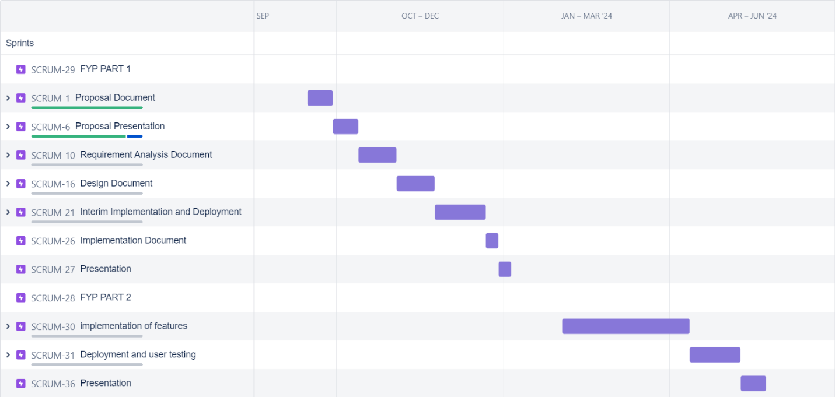

1. **Expertise:**

We have access to an expert who has a lot of experience and can help us figure things out. CV is attached below:



1. **References**

[1] <https://m.facebook.com/groups/792798928064356/?ref=share&mibextid=OgnMqR>

[2]<https://ybmbshop.com/?gclid=CjwKCAjwKipBhBtEiwAWjgwrOUGyTvggbmDgd1GR_Lg4WMS8ubnyn9MZnRVgU_slUxTOXH5ihFhoCwWUQAvD_Bw>

[3] <https://www.marketing91.com/swot-analysis-of-olx/>

[4]<https://ijcrt.org/papers/IJCRT2208238.pdf>

[5]<https://www.ebay.com/sl/sell>

[6]<https://g.co/kgs/2YqbG3>

[7]<https://my.neighbor.org/reasons-why-shop-thrift-store/>