

**BEACONHOUSE NATIONAL UNIVERSITY**

**Thrift Store Website**

PRJ-F23/336

**PROJECT PROPOSAL REPORT**

**EXTERNAL SUPERVISOR**

Muhammad Danyal

**INTERNAL SUPERVISORS**

Ms. Shazia Rizwan

Ms. Huda Sarfraz

**GROUP MEMBERS**

Aiman Zahoor F2020-550

Zainab Usama F2020-372

**SCHOOL OF COMPUTER & IT**

**September 2023**

1. **Introduction to Analysis Document**

The Analysis Document serves as a roadmap for our project, which aims to develop a web application in Pakistan that will address economic issues and cut waste by making it easy to buy and sell affordable used goods. We draw attention to Pakistan's economic hardships and the problems caused by excessive waste in the environment. The purpose of the Analysis Document is to review the current system and highlight problems with online platforms, such as quality control issues, a lack of direct selling options, and susceptibility to scams.

1. **Details of existing system**

The existing system in Pakistan is marked by economic challenges and environmental issues, leading to a scenario where people find it difficult to afford new items, resulting in excessive waste. These online stores often show up on social media like Facebook and Instagram, but there's a problem. Many of them focus only on selling clothes and forget about making sure the things they sell are good quality. The online platforms where these stores are found also have issues. They don't always have trusted sellers. Imagine wanting to buy something important, but you're not sure if the person selling it is reliable. An online store on Facebook named as Thrift store works in the same way causing hassle for the users.[1]

A lot of these platforms seem like crowded markets where everyone is competing for your attention. It's confused and unclear. Most stores don’t allow direct sales and the ones that do are not well-managed. YBMB is an example for such a store as it does not gives the option for users to sell directly on the platform.[2]

There is a significant issue with scams. It's risky when platforms don't thoroughly check the items that users are selling. It's like letting scammers who want to take advantage of others in. There must be a better way for people to interact with thrift shops and for people to find what they need without being concerned about cons or low-quality items. OLX is an online store that allows selling and buying a variety of used or new items but it is also well-known for its scams and C2C model.[3]

Background of the Organization:

The organization is motivated to address economic hardships and environmental concerns in Pakistan. The aim is to create a web application that facilitates the buying, selling, and donating of affordable second-hand items. The project aligns with cultural practices of passing on items and extends the tradition into a more organized and technology-driven approach. The organization hopes to create a community that promotes generosity and sharing in addition to a transactional platform.

Motivation of the Project:

The motivation for the project stems from the need to break the cycle of economic challenges, excessive waste, and the lack of efficient platforms for buying and selling pre-used items. By creating a user-friendly web application, the organization seeks to empower individuals economically, reduce waste, and foster a sense of community and giving.

Project’s Scope:

The project's scope includes creating a web application that addresses the shortcomings of current systems. To guarantee a safe and friendly environment, it has features like negotiation skills, trusted seller badges, direct selling options, quality control measures, and an AI system that includes filtering and chatbot.

1. **Literature Survey**

The literature survey looks at platforms and studies that are currently available about online marketplaces, thrift stores, and sustainable consumer behavior.

Thrift stores have been on the rise amongst the youth who are looking for items that are affordable. There are many people who don’t want to carry the enormous amount of clothing’s or valuables. Hence, there requires a market which allows the system of thrift. Although, thrift stores are on the rise, the condition of the stores and the market as a whole has not been advancing much. Some studies have been conducted regarding objectives like the various factors promoting the use of thrift store products.[4]

According to the survey some various factors promoting the use of thrift stores are some of the following and the table shows the number of respondents regarding the statements[4]:

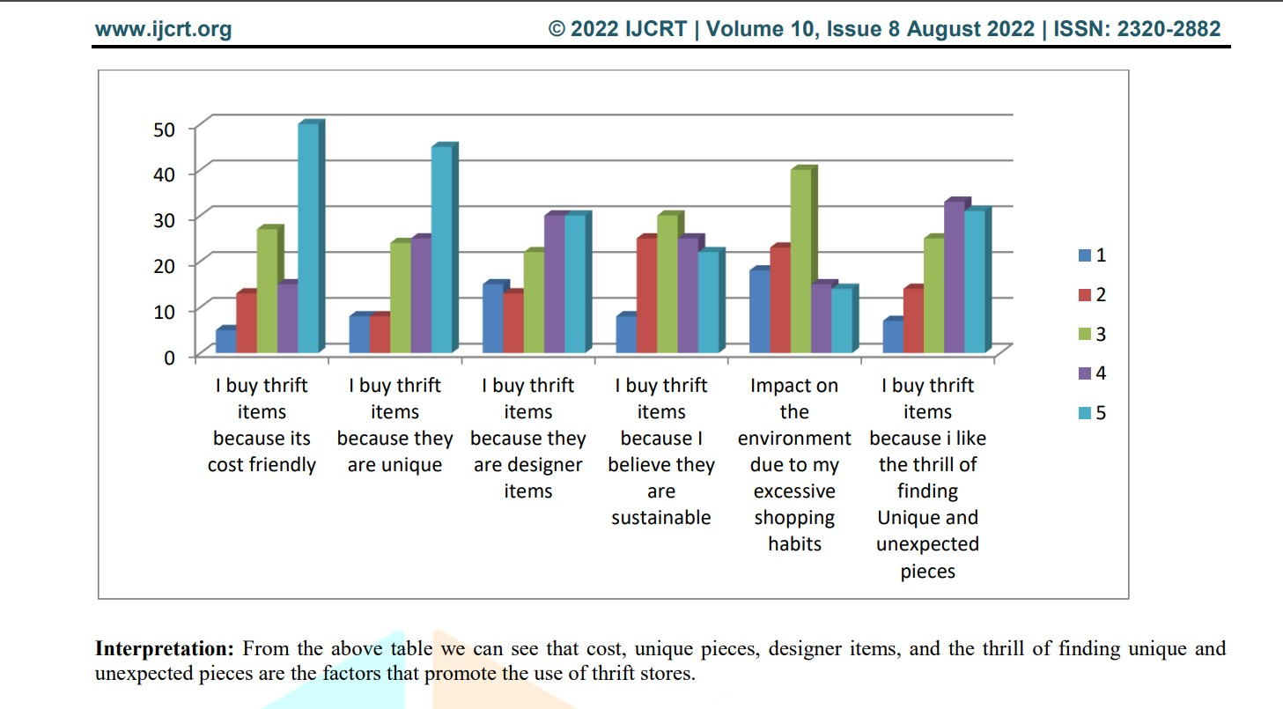

Some findings from the research include[4]:

1. The study revealed that people buy thrift items mostly because of budget friendly price and uniqueness.
2. Through this study it has been found that the sellers have lack of funds for expansion and upgrading the stores.
3. From the study it has been found that most of customers of thrift stores are between the age group 15-25 years.
4. The study revealed that most of the thrift sellers started thrift stores for income
5. The study revealed that sales of thrift products have gone up after the pandemic.
6. Through this Study it has been found that Thrift stores help in promoting Green Consumerism by reducing the waste produced by clothes due to fast fashion.

eBay:

eBay is an online shopping platform that connects buyers and sellers from around the world. It's like a huge virtual marketplace where users can find almost anything they’re looking for. It allows users to buy or sell a wide range of items from brand-new products to pre-owned and vintage items etc. The eBay auction system is one of its unique features.

Sellers can set up auctions for their items, and buyers can bid on them. The highest bidder wins the item. Alternatively, some items have a "Buy It Now" option, where you can purchase the item immediately at a set price. There are many different categories on eBay. Fashion, electronics, home decor, collectibles, and other items are all available. It is a flexible platform for buyers and sellers with a range of interests because of its diversity.

Globally, eBay connects people. Items can be listed for sale by sellers, and buyers can make purchases almost anywhere. Both buyers and sellers on eBay can leave ratings and reviews after a transaction. This feedback system helps build trust within the community. Sellers with good ratings are often considered more reliable. eBay aligns with the concept of sustainable and economic shopping. It provides a virtual space where individuals can explore, bid on, and purchase pre-owned items, echoing the essence of thrift store culture in a digital environment.[5]

Offer Up:

Offer Up is a user-friendly mobile app designed to connect people locally for buying and selling items. It's like having a virtual garage sale right in your pocket. It concentrates on bringing people together locally, as opposed to some online marketplaces that are global in scope. Because of this local flavor, users can buy goods made by locals. Sellers can quickly list items for sale by taking pictures with their phone, adding a description, and setting a price. It's a straightforward process that doesn't require any advanced tech skills.

On Offer Up, users can find everything from furniture and electronics to clothes and accessories. Buyers and sellers can communicate directly through the app. If user is interested in an item, they can ask questions or negotiate the price before making a purchase. It has safety measures in place to make in-person transactions more secure. It provides guidelines for meeting in public spaces and encourages users to be cautious and aware during exchanges.

It also includes a rating system where buyers and sellers can leave feedback based on their experiences. Offer Up promotes the idea of reusing items, contributing to a more sustainable and eco-friendlier lifestyle. Additionally, buyers can often find items at lower prices compared to buying new, aligning with the principles often associated with thrift stores. It represents a modern and localized approach to second-hand commerce, where people within a community can easily exchange items, fostering a sense of shared economy and sustainability.[6]

The literature survey concludes with the understanding that existing research and platforms provide valuable insights into user behaviors, preferences, and successful models. These insights contribute to the development of an effective solution in the proposed project.

1. **Requirement gathering and fact finding**

For effective requirement gathering and fact finding, a comprehensive approach involving multiple techniques was employed. The goal was to understand the needs, preferences, and challenges of potential users, ensuring the development of a web application aligned with their expectations.

Data Collection Techniques:

* Discussions:

Some discussions were conducted with a set of predetermined questions to gather specific information. It allowed open-ended discussions, encouraging participants to express their thoughts freely about what issues they face. Interviews were conducted with users, including both buyers and sellers, to capture diverse perspectives.

* Observations:

To identify user interactions and pain points, in-person observations of online platforms were made. This method assisted in pinpointing particular problems users encountered with the current systems.

* Literature Search:

A review was conducted of previous research studies and articles concerning thrift stores, online marketplaces, and consumer behavior. This review of the literature provided information about user behavior and global trends that may be important to the project.

* Online surveys:

A larger audience around 30-35 people were reached through online surveys, which offered participants a quick and easy way to share their opinions. Questions about preferences, difficulties, and expectations with regard to purchasing and selling used goods were asked in surveys.

Some of the results from the responses were as follows(regarding some specific questions) :

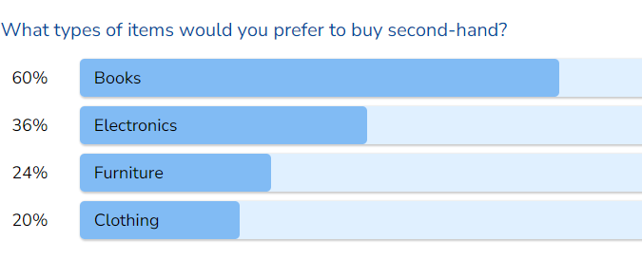

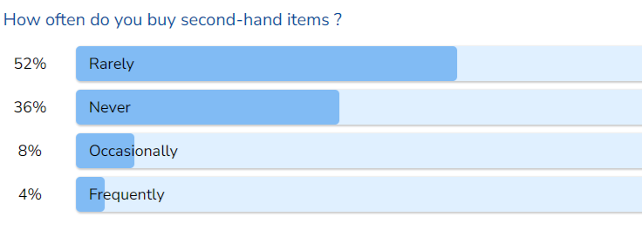

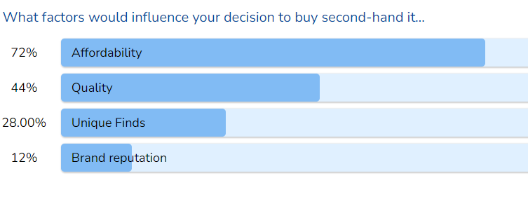

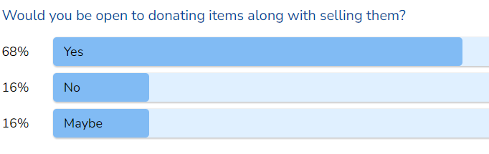

What features do you find most important in an online platform for second-hand items?

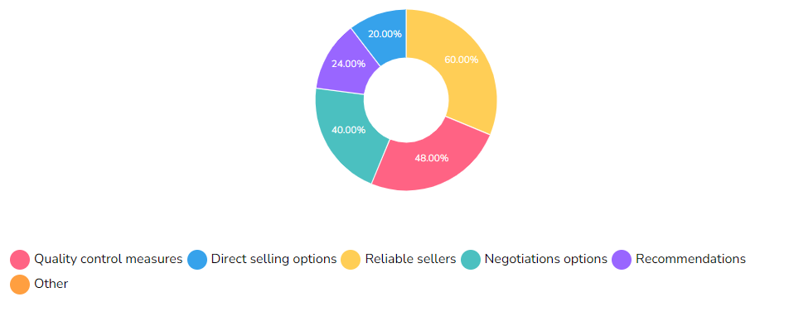

Have you ever experienced scams or unreliable sellers on online platforms?

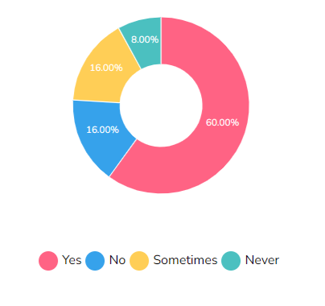

What improvements would you like to see in existing online thrift stores for second-hand items?

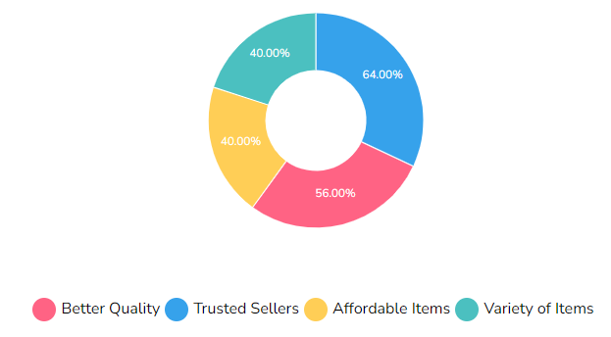

Do you think a web application dedicated to buying, selling, and donating second-hand items can contribute to your community?

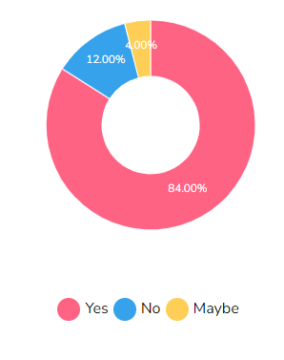

Following the collection of information through surveys, observations, and interviews, charts and graphs were used to present the results. Throughout the data collection process, trends, preferences, and pain points were found and highlighted using visual representations. In order to ensure that the web application fulfills the real needs of its users, this documentation acts as a fundamental resource.

Link to the survey form: <https://surveyheart.com/form/653a0d1e7e4a390831216110>

1. **Software Requirement Specification (SRS) Document**

Seller

NGO

Owner

Items

Buyer

Worker

Delivery Man

**System Environment**  
  
Seller sell, buyer buy, owner edit or approve or delete, worker check quality or do inspection and delivery man deliver the item. Item can also be donated to NGO.

**Actors**

* **Sellers:** Users who list and sell products on the platform.
* **Buyers:** Users who search for and purchase products on the platform.
* **Owners/Admin:** System administrators responsible for managing categories, approvals, and policies.
* **NGO (Non-Governmental Organization):** Organizations receiving donated items for distribution.
* **Delivery Man:** Individuals responsible for picking up and delivering products.
* **Workers/Quality Inspector:** Personnel inspecting items for quality and suitability.

**Functional Requirements**

* **FR1:** The system should allow users to create accounts by providing their email and password.  
  **FR2:** The system should allow registered users to log in using their credentials.
* **FR3:** The system should allow registered users to reset password using their credentials.
* **FR4:** The system allows the admin to define product categories.
* **FR5:** The homepage should function and include sections for popular items, trusted sellers, new items (remaining for a specified duration, e.g., 3 days), and recommendations.
* **FR6:** The system should allow administrators to add and manage policies on the homepage.
* **FR7:** The system should allow administrators to add and manage "About Us" content on the homepage.
* **FR8:** The system should provide video tutorials on the homepage.
* **FR9:** The system should provide customer service information on the homepage.
* **FR10:** Sellers can list products for sale.
* **FR11:** Sellers should be able to upload photos of their products when listing them for sale.
* **FR12:** Sellers must provide a detailed description of the product when listing it for sale.
* **FR13**: After filling in the product description and uploading pictures, the product goes through an approval process, and a request is sent to the admin for review.
* **FR14:** The admin should be able to review and approve or reject product listings submitted by sellers.
* **FR15:** The system should provide a search bar for buyers to search for products by various criteria.
* **FR16:** Buyers should be able to view detailed product information.
* **FR17**: The system should allow buyers to use filters to refine product search results.
* **FR18:** Buyers should be able to add products to a shopping cart for potential purchase.
* **FR19:** Buyers should be able to add products to their wishlist.
* **FR20:** Buyers can initiate the buying process, enter delivery details, select a payment method, and use text-to-speech for product descriptions.
* **FR21:** The system must facilitate product pickup from the seller's location, followed by quality inspection at a designated warehouse, with delivery to the buyer or return to the seller contingent on inspection results.
* **FR22:** Buyers can make offers on products, and sellers can accept, decline, or counter-offer.
* **FR23:** system should allow seller to donate item.
* **FR24:** The system should designate trusted sellers based on certain criteria.
* **FR25:** The system should provide product recommendations to users based on their preferences and activity.
* **FR26:** The system should provide notifications to users for various events, such as new messages, product updates, or order status.
* **FR27:** The system should define and display a return policy for users to understand the terms of returning purchased items.
* **FR28:** A 24/7 chatbot should be available to assist users with questions and provide support.

**Functional Requirements in Complete Detail:**

* **User Management:**
  + **User Registration:  
    FR1:** The system should allow users to create accounts by providing their email and password.
    1. Description: Users can register with their email and password to access the platform.
    2. Actor: Sellers, Buyers, Owners, Ngo, Delivery man
    3. Precondition: User is not registered in the system.
    4. Postcondition: User is registered and directed to the login screen.
    5. Details:
       1. Users provide a valid email address and password.
       2. The system validates the email format and ensures it is unique.
       3. User account information is securely stored in the database.
  + **User Login:   
    FR2:** The system should allow registered users to log in using their credentials.
    1. Description: Registered users can log in using their email and password.
    2. Actor: All Users
    3. Precondition: User is not logged in.
    4. Postcondition: User is logged in and gains access to their profile.
    5. Details:
       1. Users provide their valid email and password.
       2. The system validates the user's credentials.
       3. Upon successful validation, the user is granted access to their profile.
  + **Password Reset  
    FR3:** The system should allow registered users to reset password using their credentials.
    1. Description: The system should allow registered users to reset their passwords.
    2. Actor:Sellers, Buyers, Owners, Ngo, Delivery man
    3. Precondition:The user is registered.
    4. Postcondition: The user's password is successfully reset.
    5. Details:
       1. Users can request a password reset email.
       2. Users receive a password reset email containing a unique link.
       3. Users can set a new password by following the link.
  + **Define Categories (Admin):  
    FR4:** The system allows the admin to define product categories.
    1. Description: The admin has the capability to create and manage product categories. This feature provides the admin with the tools to organize and categorize products effectively.
    2. Actor: Admin
    3. Precondition: The admin is logged into the system.
    4. Postcondition: The product categories are successfully defined and available for use.
    5. Details:
       1. The admin can access the category management interface from their admin dashboard.
       2. The admin can create new product categories by specifying a name, description, and optional image.
       3. Existing categories can be edited or deleted by the admin as needed.
       4. Categories are displayed to users to assist in product navigation and search.
* **Homepage and Content Management:**
  + **Homepage Working:  
    FR5:** The homepage should function and include sections for popular items, trusted sellers, new items (remaining for a specified duration, e.g., 3 days), and recommendations.
    1. Description: The homepage should display popular items, trusted sellers, new items, and recommendations.
    2. Actor: All Users
    3. Precondition: Users visit the homepage.
    4. Postcondition: The homepage displays the mentioned sections.
    5. Details:
       1. The "Popular Items" section displays products with high user engagement and views.
       2. The "Trusted Sellers" section features sellers with a strong reputation.
       3. The "New Items" section highlights recently added products that remain on the homepage for a specific duration.
       4. The "Recommendations" section provides personalized product recommendations based on user activity.
  + **Add Policy:  
    FR6:** The system should allow administrators to add and manage policies on the homepage.
    1. Description: Admins can add and manage policies on the homepage.
    2. Actor: Admin
    3. Precondition: Admin is logged in.
    4. Postcondition: The homepage displays the mentioned Policies are added or updated on the homepage.
    5. Details:
       1. Admins can add, edit, or remove policies on the homepage.
  + **Add About Us:****FR7:** The system should allow administrators to add and manage "About Us" content on the homepage.
    1. Description: Admins can add and manage "About Us" content on the homepage.
    2. Actor: Admin
    3. Precondition: Admin is logged in.
    4. Postcondition:"About Us" content is added or updated on the homepage.
    5. Details:
       1. Admins can edit and update information about the platform, its mission, and its team on the "About Us" section of the homepage.

* + **Video Tutorials:****FR8:** The system should provide video tutorials on the homepage.
    1. Description: The homepage should provide access to video tutorials.
    2. Actor: All Users
    3. Precondition: Users visit the homepage.
    4. Postcondition: Video tutorials are accessible on the homepage.
    5. Details:
       1. Video tutorials cover various topics, such as using the platform, selling, buying, and more.
       2. Users can search for specific tutorials or browse the library.
  + **Customer Services:****FR9:** The system should provide customer service information on the homepage.
    1. Description: The homepage should provide customer service information.
    2. Actor: All Users
    3. Precondition: Users visit the homepage.
    4. Postcondition: Customer service information is accessible on the homepage.
    5. Details:
       1. Customer service information may include contact details, FAQs, and links to support resources.
* **Product Management:**
  + **Start Selling:****FR10:** Sellers can list products for sale.
    1. Description: Sellers should be able to list products for sale on the platform.
    2. Actor: Sellers
    3. Precondition: Seller is logged in.
    4. Postcondition: Product is listed for sale.
    5. Details:
       1. Sellers can create new product listings.
       2. Product listings include information such as product name, description, price, and images.
* **Upload Photo:****FR11:** Sellers should be able to upload photos of their products when listing them for sale.
  + 1. Description: Sellers can upload photos of their products during the listing process.
    2. Actor: Sellers
    3. Precondition: Seller is listing a product for sale.
    4. Postcondition: Photos of the product are uploaded.
    5. Details:
       1. Sellers can upload multiple images per product to showcase the item from various angles.
* **Proper Description of Product:****FR12:** Sellers must provide a detailed description of the product when listing it for sale.
  + 1. Description: Sellers need to provide a detailed and accurate description of the product.
    2. Actor: Sellers
    3. Precondition: Seller is listing a product for sale.
    4. Postcondition: A detailed description is provided.
    5. Details:
       1. Sellers should include key product details, such as dimensions, condition, and specifications.
* **Product Approval Request to Admin:****FR13**: After filling in the product description and uploading pictures, the product goes through an approval process, and a request is sent to the admin for review.
  + 1. Description: When sellers complete the product details and photo upload, the product undergoes an approval process, and a request is sent to the admin for review.
    2. Actor: Sellers
    3. Precondition: Seller has filled in product details and uploaded pictures.
    4. Postcondition: A request is sent to the admin for product approval.
    5. Details:
       1. The system generates a product approval request to the admin.
       2. Admins review product details and images to ensure they meet platform standards.
* **Admin Approval:****FR14:** The admin should be able to review and approve or reject product listings submitted by sellers.
  + 1. Description: The admin can review product listings and choose to approve or reject them.
    2. Actor: Admin
    3. Precondition: Admin is logged in.
    4. Postcondition: Product listing is approved or rejected by the admin.
    5. Details:
       1. Admins can access a dashboard for reviewing pending product listings.
       2. Admins can approve or reject products based on compliance with platform guidelines.
* **Product Search and Viewing:**
* **Search Bar:****FR15:** The system should provide a search bar for buyers to search for products by various criteria.
  + 1. Description: Buyers can use the search bar to search for products based on different criteria.
    2. Actor: Buyers
    3. Precondition: Buyer is logged in.
    4. Postcondition: Products matching the search are displayed.
    5. Details:
       1. The search bar allows users to enter keywords, product names, or other search criteria.
       2. Search results are displayed based on user input.
* **View Product:****FR16:** Buyers should be able to view detailed product information.
  + 1. Description: Buyers can view detailed product information, including descriptions, images, and pricing.
    2. Actor: Buyers
    3. Precondition: Buyer is logged in.
    4. Postcondition: Buyers can view product details.
    5. Details:
       1. Product details include product name, description, images, seller information, and pricing.
       2. Buyers can access a product's page for comprehensive information.
* **Filters:****FR17**: The system should allow buyers to use filters to refine product search results.
  + 1. Description: Buyers can apply filters to narrow down search results, including price ranges and trusted seller options.
    2. Actor: Buyers
    3. Precondition: Buyers are searching for products.
    4. Postcondition: Search results are filtered based on user preferences.
    5. Details:
       1. Buyers can set filters, such as price ranges, category, trusted seller, new items and more.
       2. Filters help buyers find products that match their specific criteria.
* **Shopping and Transaction:**
* **Add to Cart Feature:****FR18:** Buyers should be able to add products to a shopping cart for potential purchase.
  + 1. Description: Buyers can add products to a shopping cart for potential purchase.
    2. Actor: Buyers
    3. Precondition: Buyer view the product.
    4. Postcondition: Products are added to the shopping cart for potential purchase.
    5. Details:
       1. Buyers can add products to a virtual shopping cart for later review and purchase.
       2. The shopping cart keeps track of selected items.
* **Wishlist Feature:****FR19:** Buyers should be able to add products to their wishlist.
  + 1. Description: Buyers can add products to their wishlist for later consideration.
    2. Actor: Buyers
    3. Precondition: Buyer is viewing a product.
    4. Postcondition: Products are added to the buyer's wishlist for later consideration.
    5. Details:
       1. Buyers can create and manage a wishlist of desired products.
       2. The wishlist provides an easy way to track products of interest.
* **Add Buying Button:****FR20:** Buyers can initiate the buying process, enter delivery details, select a payment method, and use text-to-speech for product descriptions.
  + 1. Description: Buyers can initiate the buying process, enter delivery details, select a payment method, and use text-to-speech for product descriptions.
    2. Actor: Buyers
    3. Precondition: Buyer is viewing the product.
    4. Postcondition: The buying process is initiated.
    5. Details:
       1. Buyers can click the "Buy" button on a product to start the purchase process.
       2. They enter delivery information and select a preferred payment method.
       3. Buyers can use a text-to-speech feature to listen to the product description.
* **Delivery and Inspection:**
* **FR21:** **:** The system must facilitate product pickup from the seller's location, followed by quality inspection at a designated warehouse, with delivery to the buyer or return to the seller contingent on inspection results.
  + 1. Description: After placing an order, the product is picked up from the seller's location, inspected in a warehouse, and either delivered to the buyer or returned to the seller, based on the inspection results.
    2. Actor: Delivery Person, Warehouse Inspector, Seller, Buyer
    3. Precondition: Order is placed, and product pickup is initiated.
    4. Postcondition: Product is delivered to the buyer or returned to the seller.
    5. Details:
       1. Upon order confirmation, a delivery person is assigned to pick up the product from the seller's location.
       2. The product is transported to a warehouse for inspection to verify its condition and compliance with the listing description and images.
       3. If the product passes inspection, it is delivered to the buyer; if not, it is returned to the seller.
* **Negotiation Option:**
* **FR22:** Buyers can make offers on products, and sellers can accept, decline, or counter-offer.
  + 1. Description: Buyers can make offers on products, and sellers can choose to accept, decline, or counter-offer.
    2. Actor: Buyers, Sellers
    3. Precondition: Buyers click on make an offer button.
    4. Postcondition: Negotiation offers are accepted, declined, or countered.
    5. Details:
       1. Buyers can make an offer on a product with a proposed price.
       2. Sellers have the option to accept the offer, decline it, or propose a counter-offer.
       3. Negotiations continue until an agreement is reached or the negotiation ends.
* **Donation Feature:**
* **FR23**: system should allow seller to donate item.
  + 1. Description: Sellers can donate items by filling out a donation form. Donated items are collected, inspected, and sent to an NGO.
    2. Actor: Sellers, Delivery Person, Warehouse Inspector, NGO
    3. Precondition: Sellers click on donate item button.
    4. Postcondition: Donated items are collected
    5. Details:
       1. Sellers can donate items by first filling donation form, then item is collected, inspected for quality, and sent to an NGO.
* **Additional Features:**
* **Trusted Seller Feature:****FR24:** The system should designate trusted sellers based on certain criteria.
  + 1. Description: The system incorporates a feature to designate sellers as "trusted sellers" based on specific criteria. This distinction helps users identify reliable sellers within the platform.
    2. Actor: Admin
    3. Precondition: Admin is logged into the system.
    4. Postcondition: Sellers are officially designated as "trusted sellers."
    5. Details:
       1. The admin has access to the "Trusted Seller" management section within the admin dashboard.
       2. Admin can define specific criteria and thresholds that sellers need to meet to be recognized as "trusted sellers."
       3. The criteria may include factors like positive feedback, a history of successful transactions, timely responsiveness, and adherence to platform policies.
       4. Sellers who meet or exceed the defined criteria are automatically designated as "trusted sellers."
       5. Users can easily identify trusted sellers through a badge or visual indicator on their profiles and product listings.
* **Recommendation System:****FR25:** The system should provide product recommendations to users based on their preferences and activity.
  + 1. Description: The system is equipped with a recommendation system that analyzes user preferences and activity to suggest relevant products. This feature enhances the user experience and encourages product discovery.
    2. Actor: Buyers
    3. Precondition: Buyers are actively browsing products on the platform.
    4. Postcondition: Buyers receive personalized product recommendations.
    5. Details:
       1. The system collects data on buyer interactions, including product views, searches, purchases, and wishlists.
       2. Machine learning algorithms or collaborative filtering methods are used to analyze this data and generate product recommendations.
       3. Buyers are presented with personalized product suggestions on their homepage or a dedicated recommendations section.
* **Notification Feature:****FR26:** The system should provide notifications to users for various events, such as new messages, product updates, or order status.
  + 1. Description: The system offers a notification feature that keeps users informed about important events and updates on the platform, such as new messages, product changes, and order status.
    2. Actor: All Users
    3. Precondition: Users are registered on the platform and actively using it.
    4. Postcondition: Users receive relevant and timely notifications.
    5. Details:
       1. Users can opt-in to receive different types of notifications, such as messages from buyers or sellers, updates on products they are interested in, or changes in their order status.
       2. Notifications can be delivered via email, in-app alerts, or SMS, depending on user preferences.
       3. The system tracks user preferences for notification types and frequency.
       4. Notifications may include information on new products, messages, product status changes (e.g., out of stock or price reductions), order confirmations, and order shipment updates.
       5. Users have the ability to customize their notification settings and preferences through their account settings.
* **Return Policy:****FR27:** The system should define and display a return policy for users to understand the terms of returning purchased items.
  + 1. Description: The system provides a clear and accessible return policy for users to understand the terms and conditions related to returning items they have purchased.
    2. Actor: All Users
    3. Precondition: Users click on return policy.
    4. Postcondition: The return policy page is opened.
    5. Details:
       1. The return policy is accessible from a prominent location on the platform, such as the footer or a dedicated policy section.
       2. The return policy includes detailed information about the conditions under which returns are accepted, the timeline for returns, and any associated fees or costs.
       3. Users can access the return policy without the need to log in or make a purchase.
       4. The policy is written in a clear and easily understandable language.
       5. Contact information for customer support or return-related inquiries is provided within the policy.
* **24/7 Chatbot:****FR28:** A 24/7 chatbot should be available to assist users with questions and provide support.
  + 1. Description: The platform features a 24/7 chatbot designed to assist users with their questions and provide support round the clock.
    2. Actor: All Users
    3. Precondition: Users have questions or require assistance.
    4. Postcondition: Users receive timely assistance and information from the chatbot.
    5. Details:
       1. The chatbot is available for users to interact with at any time, 24/7.
       2. The chatbot is capable of answering frequently asked questions, providing information on policies, guiding users through processes, and offering support.
       3. Users can initiate a chat with the chatbot from various sections of the platform, such as the homepage or the help center.
       4. The chatbot is equipped with natural language processing capabilities to understand and respond to user queries effectively.
       5. If a query is beyond the chatbot's capabilities, it can escalate the conversation to a human support agent.

**Non-functional Requirement**

* Chatbot Response Time: The chatbot should respond to user queries within 2 seconds to provide quick assistance.
* User-Friendly Interface: The web app should have an intuitive and user-friendly interface, making it easy for users to navigate and use the platform efficiently.
* Consistency: The user interface design, layout, and navigation should be consistent across all pages to provide a uniform user experience.
* Scalability Planning: The system should be designed to accommodate a growing number of users and products. It should be capable of scaling up with increased demand.
* User Data Protection: The system must employ strong data security measures to protect user data, including encryption for sensitive information.
* Payment Security: Ensure secure payment processing by complying with industry standards and utilizing encryption for financial transactions.
* Authentication and Authorization Security: Implement robust user authentication and authorization mechanisms to safeguard against unauthorized access.
* Page Load Times: Web pages should load within 3 seconds or less to ensure a responsive user experience.
* Transaction Speed: The system should process transactions, including order placements and payments, efficiently without delays.
* System Uptime: Aim for high availability with minimal downtime for maintenance or unexpected issues.
* Data Backup and Recovery: Regularly back up system data and establish a data recovery process in case of failures.
* Regulatory Compliance: Ensure compliance with relevant legal and industry-specific regulations, such as consumer protection laws.
* Accessibility: Make the platform accessible to individuals with disabilities by following accessibility standards.
* Browser Compatibility: The system should work seamlessly on various web browsers to accommodate a broad user base.
* System Monitoring: Implement real-time system monitoring and alerting to identify and address issues promptly.
* User Analytics: Collect and analyze user data to make informed decisions for system improvements and marketing strategies.
* Video Loading Time: Ensure that video tutorials load and play without significant buffering delays.

**6. Test Cases**

**Test Cases for User Management (FR1 to FR3):  
Test Case 1: User Registration**

* Test Scenario: A new user registers in the system.
* Preconditions: The user is not registered in the system.
* Test Steps:
  1. Open the registration page.
  2. Enter a valid email address and a strong password.
  3. Confirm the password.
  4. Click the "Register" button.
* Expected Result: The user is registered and directed to the login screen. An email confirmation is sent to the user's registered email address.

**Test Case 2: User Login**

* Test Scenario: A registered user logs into the system.
* Preconditions: The user is not logged in.
* Test Steps:
  1. Open the login page.
  2. Enter a valid email and password.
  3. Click the "Login" button.
* Expected Result: The user is logged in and gains access to their profile.

**Test Case 3: Password Reset**

* Test Scenario: A registered user resets their password.
* Preconditions: The user is registered.
* Test Steps:
  1. Click on the "Forgot Password" or "Reset Password" option on the login screen.
  2. Enter the registered email address.
  3. Click the "Send Reset Email" button.
  4. Check the registered email for a password reset email.
  5. Follow the link in the email to set a new password.
* Expected Result: The user's password is successfully reset, and they can log in with the new password.

**Test Case for "Define Categories (Admin)" (FR4):**

**Test Case 4: Manage Product Categories**

* Test Scenario: An admin manages product categories by creating, editing, and deleting categories.
* Preconditions:
  1. The admin is logged into the system.
  2. The admin is on the category management interface.
* Test Steps:   
    
  A. Create a New Product Category:
  1. Click on the "Create New Category" button.
  2. Enter a name, description, and optional image for the new category.
  3. Click the "Save" or "Create" button.

B. Edit an Existing Product Category:

* 1. Select an existing product category to edit.
  2. Modify the category's name, description, or image.
  3. Click the "Save" or "Update" button.

C. Delete an Existing Product Category:

* 1. Select an existing product category to delete.
  2. Click the "Delete" or "Remove" button.
  3. Confirm the deletion action.
* Expected Result:  
   A. The new product category is successfully created and added to the list of categories.  
   B. The changes to the existing product category are successfully saved, and the category is updated.  
   C. The selected product category is successfully deleted and removed from the list of categories.

**Test Cases for Homepage and Content Management (FR5 to FR9):**  
**Test Case 5: Homepage Sections**

* Test Scenario: A user visits the homepage.
* Preconditions: User visits the homepage.
* Test Steps:
  1. Open the homepage.
* Expected Result: The homepage displays popular items, trusted sellers, new items, and recommendations sections.

**Test Case 6: Add Policy**

* Test Scenario: An admin adds a new policy to the homepage.
* Preconditions: Admin is logged in.
* Test Steps:
  1. Access the policy management interface.
  2. Add a new policy.
* Expected Result: The new policy is added and displayed on the homepage.

**Test Case 7: Add "About Us" Content**

* Test Scenario: An admin adds or updates "About Us" content on the homepage.
* Preconditions: Admin is logged in.
* Test Steps:
  1. Access the "About Us" content management.
  2. Add or update "About Us" information.
* Expected Result: The "About Us" content is added or updated on the homepage.

**Test Case 8: Access Video Tutorials**

* Test Scenario: A user wants to access video tutorials from the homepage.
* Preconditions: User is on the homepage.
* Test Steps:
  1. Search for video tutorials section.
  2. Click on a video tutorial.
* Expected Result: The user can access and view the selected video tutorial.

Test Case 9: Access Customer Service Information

* Test Scenario: A user wants to access customer service information from the homepage.
* Preconditions: User is on the homepage.
* Test Steps:
  1. Look for the customer service information section.
  2. Click on a link to access customer service resources.
* Expected Result: The user can access the provided customer service information.

**Test Cases for Product Management (FR10 to FR14):**

**Test Case 10: Start Selling**

* Test Scenario: A seller lists a product for sale.
* Preconditions: The seller is logged in.
* Test Steps:
  1. Navigate to the product listing page.
  2. Enter the product name, description, price, and other details.
  3. Click the "List for Sale" button.
* Expected Result: The product is successfully listed for sale on the platform.

**Test Case 11: Upload Photo**

* Test Scenario: A seller uploads photos of a product when listing it for sale.
* Preconditions: The seller is listing a product for sale.
* Test Steps:
  1. While creating the product listing, upload multiple images of the product.
  2. Click the "Upload" button for each image.
* Expected Result: The photos of the product are successfully uploaded and associated with the listing.

**Test Case 12: Proper Description of Product**

* Test Scenario: A seller provides a detailed description of a product when listing it for sale.
* Preconditions: The seller is listing a product for sale.
* Test Steps:
  1. Enter a detailed description of the product, including dimensions, condition, and specifications.
  2. Complete the product listing.
* Expected Result: A detailed and accurate product description is provided as part of the listing.

**Test Case 13: Product Approval Request to Admin**

* Test Scenario: A seller completes a product listing, and the product undergoes an approval process.
* Preconditions: The seller has filled in product details and uploaded pictures.
* Test Steps:
  1. Complete the product listing process.
  2. Submit the listing for approval.
* Expected Result: The system generates a product approval request to the admin for review.

**Test Case 14: Admin Approval**

* Test Scenario: An admin reviews and approves a product listing submitted by a seller.
* Preconditions: The admin is logged in and has pending product listings for review.
* Test Steps:
  1. Access the admin dashboard for reviewing pending product listings.
  2. Review the product details and images.
  3. Approve or reject the product listing based on platform guidelines.
* Expected Result: The admin can approve or reject product listings, and the status is updated accordingly.

**Test Case for "Product Search and Viewing" (FR15):**

**Test Case 15: Search and View Products**

* Test Scenario: A buyer searches for products and views detailed product information.
* Preconditions:
* The buyer is logged into the system.
* The system is accessible with products listed.
* Test Steps:
  1. In the platform, locate the search bar.
  2. Enter relevant keywords, product names, or other search criteria.
  3. Click the "Search" button.
  4. Review the search results.
  5. Click on a specific product from the search results.
* Expected Results:
  1. The search bar is visible and functional.
  2. The search results are displayed based on the entered criteria.
  3. The buyer can view detailed product information, including descriptions, images, and pricing.

**Test Case for "Filters" (FR17):**

**Test Case 16: Apply Filters to Refine Search Results**

* Test Scenario: A buyer uses filters to narrow down product search results.
* Preconditions:
  1. The buyer is logged into the system.
  2. The system is accessible with products listed.
* Test Steps:
  1. Conduct a product search using the search bar.
  2. On the search results page, locate and apply various filters such as price ranges, category, and trusted seller.
  3. Review the refined search results.
* Expected Results:
  1. The buyer can successfully apply filters during the search process.
  2. The search results are updated based on the selected filters, helping the buyer find products that match their specific criteria.

**Test Case for "Add to Cart Feature" (FR18):**

**Test Case 17: Add Products to Shopping Cart**

* Test Scenario: A buyer adds products to a shopping cart for potential purchase.
* Preconditions:
  1. The buyer is logged into the system.
  2. The buyer is viewing a product.
* Test Steps:
  1. On a product's page, locate and click the "Add to Cart" or "Add to Shopping Cart" button.
  2. Review the contents of the shopping cart.
* Expected Results:
  1. The buyer can successfully add products to their virtual shopping cart.
  2. The shopping cart displays the selected items.

**Test Case for "Wishlist Feature" (FR19):**

**Test Case 18: Add Products to Wishlist**

* Test Scenario: A buyer adds products to their wishlist for later consideration.
* Preconditions:
  1. The buyer is logged into the system.
  2. The buyer is viewing a product.
* Test Steps:
  1. On a product's page, locate and click the "Add to Wishlist" button.
  2. Review the contents of the buyer's wishlist.
* Expected Results:
  1. The buyer can successfully add products to their wishlist for later consideration.
  2. The wishlist displays the selected products.

**Test Case for "Add Buying Button" (FR20):**

**Test Case 19: Initiate Buying Process**

* Test Scenario: A buyer initiates the buying process by entering delivery details, selecting a payment method, and using the text-to-speech feature.
* Preconditions:
  1. The buyer is logged into the system.
  2. The buyer is viewing a product.
* Test Steps:
  1. On a product's page, locate and click the "Buy" button.
  2. Enter delivery information and select a preferred payment method.
  3. Use the text-to-speech feature to listen to the product description.
* Expected Results:
  1. The buyer can successfully initiate the buying process.
  2. Delivery information can be entered, a payment method selected, and the text-to-speech feature used to listen to the product description.

**Test Case for "Delivery and Inspection" (FR21):**

**Test Case 20: Delivery and Inspection of Purchased Product**

* Test Scenario: A buyer places an order, and the system arranges for the pickup, quality inspection, and delivery or return of the purchased product.
* Preconditions:
  1. The buyer has placed an order.
  2. The system is operational.
* Test Steps:
  1. A delivery person is assigned to pick up the product from the seller's location.
  2. The product is transported to a designated warehouse for inspection.
  3. The product undergoes inspection to verify its condition and compliance with the listing description and images.
  4. If the product passes inspection, it is delivered to the buyer; if it fails inspection, it is returned to the seller.
* Expected Results:
  1. A delivery person is assigned and successfully picks up the product.
  2. The product is transported to the inspection warehouse.
  3. The inspection process is completed, and the product's condition and compliance are verified.
  4. If the product passes inspection, it is delivered to the buyer; if it fails inspection, it is returned to the seller.

**Test Case for "Negotiation Option" (FR22):**

**Test Case 21: Buyer-Seller Product Negotiation**

* Test Scenario: A buyer makes an offer on a product, and the seller responds by accepting, declining, or countering the offer.
* Preconditions: A buyer and a seller are interacting on a product listing.
* Test Steps:
  1. The buyer makes an offer on the product with a proposed price.
  2. The seller has the option to accept, decline, or propose a counter-offer.
  3. Negotiations continue until an agreement is reached or the negotiation ends.
* Expected Results:
  1. The buyer successfully makes an offer on the product.
  2. The seller can accept, decline, or propose a counter-offer.
  3. Negotiations proceed until an agreement is reached or the negotiation ends.

**Test Case for "Donation Feature" (FR23):**

**Test Case 22: Seller Donates Items**

* Test Scenario: A seller uses the donation feature to donate items. Donated items are collected, inspected, and sent to an NGO.
* Preconditions: The seller is logged into the system.
* Test Steps:
  1. The seller clicks on the "Donate Item" button.
  2. The seller fills out the donation form with item details.
  3. Donated items are collected.
  4. Donated items undergo inspection for quality.
  5. Donated items are sent to an NGO.
* Expected Results:
  1. The seller successfully accesses the donation feature and fills out the donation form.
  2. Donated items are collected.
  3. The quality inspection process is completed.
  4. Donated items are successfully sent to an NGO.

**Test Case for "Additional Features” (FR24 TO FR28):**

**Test Case 23: Designating Trusted Sellers**

* Test Scenario: The admin designates sellers as "trusted sellers" based on specific criteria.
* Preconditions: The admin is logged into the system.
* Test Steps:
  1. The admin accesses the "Trusted Seller" management section.
  2. The admin defines specific criteria and thresholds for trusted seller designation.
  3. Sellers who meet or exceed the defined criteria are designated as "trusted sellers."
* Expected Results:
  1. The admin successfully accesses the "Trusted Seller" management section.
  2. The admin defines criteria and thresholds.
  3. Sellers who meet or exceed the criteria are officially designated as "trusted sellers."

**Test Case 24: Receiving Personalized Product Recommendations**

* Test Scenario: Buyers receive personalized product recommendations based on their preferences and activity.
* Preconditions: Buyers are actively browsing products on the platform.
* Test Steps:
  1. The system collects data on buyer interactions, including product views, searches, purchases, and wishlists.
  2. Machine learning algorithms or collaborative filtering methods analyze the data and generate product recommendations.
  3. Buyers are presented with personalized product suggestions on their homepage or a dedicated recommendations section.
* Expected Results:
  1. The system successfully collects and analyzes buyer interaction data.
  2. Product recommendations are generated based on the data.
  3. Buyers receive personalized product suggestions.

**Test Case for " Notification Feature" (FR26):**

**Test Case 25: Receiving Notifications for Order Status**

* Test Scenario: Users receive notifications for changes in their order status.
* Preconditions: Users have placed orders on the platform.
* Test Steps:
  1. Users have orders with different status changes, such as order confirmation and shipment updates.
  2. Users have configured their notification preferences for order status updates.
* Expected Results:
  1. Users receive timely notifications for order confirmation and shipment updates.
  2. Users have configured their notification preferences successfully.

**Test Case for " Return Policy" (FR27):**

**Test Case 26: Accessing the Return Policy**

* Test Scenario: Users access and read the return policy to understand the terms and conditions related to returning items.
* Preconditions: Users want to learn about the return policy.
* Test Steps:
  1. Users click on the "Return Policy" link.
  2. Users read the policy to understand its terms.
* Expected Results:
  1. Users can successfully access the return policy.
  2. Users can understand the terms and conditions of the return policy.

**Test Case for " 24/7 Chatbot" (FR28):**

**Test Case 27: Interacting with the 24/7 Chatbot**

* Test Scenario: Users interact with the 24/7 chatbot to seek assistance and information.
* Preconditions: Users have questions or require assistance.
* Test Steps:
  1. Users initiate a chat with the 24/7 chatbot.
  2. Users ask questions or seek information.
  3. The chatbot provides responses and assistance.
* Expected Results:
  1. Users can successfully initiate a chat with the chatbot.
  2. The chatbot provides timely and accurate responses and assistance.

**References:**

[1] <https://m.facebook.com/groups/792798928064356/?ref=share&mibextid=OgnMqR>

[2]<https://ybmbshop.com/?gclid=CjwKCAjwKipBhBtEiwAWjgwrOUGyTvggbmDgd1GR_Lg4WMS8ubnyn9MZnRVgU_slUxTOXH5ihFhoCwWUQAvD_Bw>

[3] <https://www.marketing91.com/swot-analysis-of-olx/>

[4]<https://ijcrt.org/papers/IJCRT2208238.pdf>

[5]<https://www.ebay.com/sl/sell>

[6]<https://g.co/kgs/2YqbG3>