

**BEACONHOUSE NATIONAL UNIVERSITY**

**Thriftn**

PRJ-F23/336

**PROJECT PROPOSAL REPORT**

**EXTERNAL SUPERVISOR**

Muhammad Danyal

**INTERNAL SUPERVISORS**

Ms. Shazia Rizwan

Ms. Huda Sarfraz

**GROUP MEMBERS**

Aiman Zahoor F2020-550

Zainab Usama F2020-372

**SCHOOL OF COMPUTER & IT**

**September 2023**

1. **Introduction to Analysis Document**

The Analysis Document serves as a roadmap for our project, which aims to create an eco-friendly, cost effective and socially responsible way to find unique and affordable items. We draw attention to Pakistan's economic hardships and the problems caused by excessive waste in the environment. The purpose of the Analysis Document is to review the current system and highlight problems with online platforms, such as quality control issues, a lack of direct selling options, and susceptibility to scams.

1. **Details of existing system**

The existing system in Pakistan is marked by economic challenges and environmental issues, leading to a scenario where people find it difficult to afford new items, resulting in excessive waste. Thrift stores online show up on social media like Facebook and Instagram, but there's a problem that they seem like crowded markets where people keep posting items and if someone needs to find something they need to have a lot of time on their hand. For instance, an online thrift store on Facebook named ‘Lahore Thrift Store’ [1] that causes hassle for the users in the same way. Two pictures below are the screenshots of Lahore thrift store and screen 1 shows that there are no categories set up. Everything is just posted randomly. If someone wants to find something, they have to spend a lot of time scrolling to locate it. To make it easier, people often write a note saying they need something specific. However, this has its own issue because these posts don't get much attention. On screen 2 you can see in the comments that a user wrote 'bump' asking the admin to bump their post for more reach.

**1.**

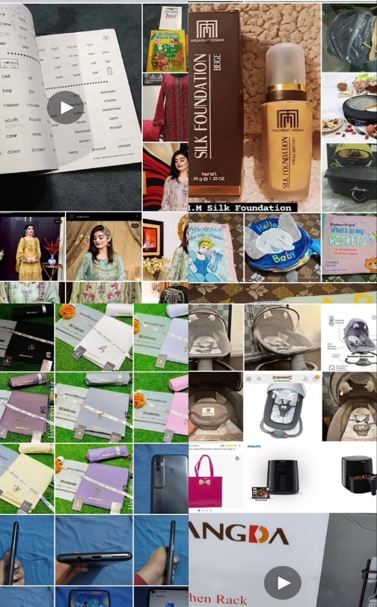

**2.**



Some online thrift stores don’t allow direct sales instead they only give one option of buying products. YBMB is an example for such a store as it does not give the option for users to sell directly on their website.[2] There is a significant issue with scams also. It's risky when platforms don't thoroughly check the items that users are selling. There must be a better way for people to interact with thrift shops and for people to find what they need without being concerned about cons or low-quality items. OLX is an online store that allows selling and buying a variety of used or new items too. OLX was Pakistan’s first such platform so it gained a lot of attention but with time it is now also well-known for its scams due to its C2C model.[3]

1. **Literature Survey**

The literature survey looks at platforms and studies that are currently available about online marketplaces, thrift stores, and sustainable consumer behavior.

Thrift stores have been on the rise amongst the youth who are looking for items that are affordable. There are many people who don’t want to carry the enormous amount of clothing’s or valuables. Hence, there requires a market which allows thrifting.

According to a survey (India,2022) for some various factors promoting the use of thrift stores are some of the following and the table shows the number of respondents regarding the statements[4]:

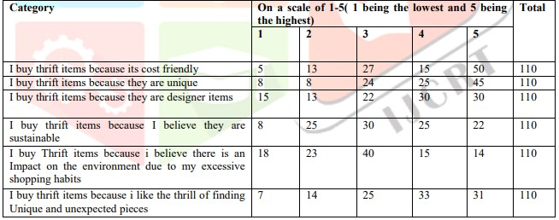

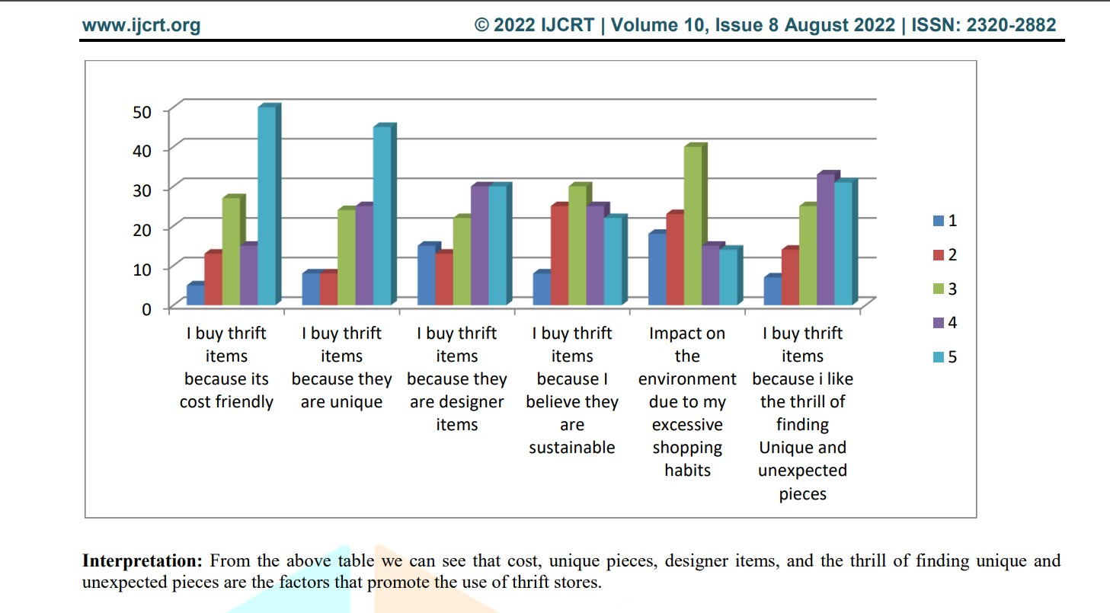

Some findings from the research include[4]:  
  
1.The study revealed that people buy thrift items mostly because of budget friendly price.

2.The study revealed that people buy thrift items mostly because of uniqueness.

3. Through this study it has been found that the sellers have lack of funds for expansion and upgrading the stores.

4.From the study it has been found that most of customers of thrift stores are between the age group 15-25 years.

5.The study revealed that most of the thrift sellers started thrift stores for income

6.The study revealed that sales of thrift products have gone up after the pandemic.

7. Through this Study it has been found that Thrift stores help in promoting Green Consumerism by reducing the waste produced by clothes due to fast fashion.

eBay:

eBay is an online shopping platform that connects buyers and sellers from around the world but it is not available in Pakistan. It is a huge virtual marketplace where users can find almost anything they’re looking for. It allows users to buy or sell a wide range of items from brand-new products to pre-owned and vintage items etc. The eBay auction system is one of its unique features.

Sellers can set up auctions for their items, and buyers can bid on them. The highest bidder wins the item. Alternatively, some items have a "Buy It Now" option, where you can purchase the item immediately at a set price. There are many different categories on eBay. Fashion, electronics, home decor, collectibles, and other items are all available. It is a flexible platform for buyers and sellers with a range of interests because of its diversity.

Globally, eBay connects people. Items can be listed for sale by sellers, and buyers can make purchases almost anywhere. Both buyers and sellers on eBay can leave ratings and reviews after a transaction. This feedback system helps build trust within the community. Sellers with good ratings are often considered more reliable. eBay aligns with the concept of sustainable and economic shopping. It provides a virtual space where individuals can explore, bid on, and purchase pre-owned items, echoing the essence of thrift store culture in a digital environment.[5]

Offer Up:

Offer Up is a user-friendly mobile app designed to connect people locally for buying and selling items. It concentrates on bringing people together locally, as opposed to some online marketplaces that are global in scope. Because of this local flavor, users buy goods made by locals. This platform is not available in Pakistan. Sellers can quickly list items for sale by taking pictures with their phone, adding a description, and setting a price. It's a straightforward process that doesn't require any advanced tech skills.

On Offer Up, users can find everything from furniture and electronics to clothes and accessories. Buyers and sellers can communicate directly through the app. If user is interested in an item, they can ask questions or negotiate the price before making a purchase. It provides guidelines for meeting in public spaces and encourages users to be cautious and aware during exchanges.

It also includes a rating system where buyers and sellers can leave feedback based on their experiences. Offer Up promotes the idea of reusing items, contributing to a more sustainable and eco-friendlier lifestyle. Additionally, buyers can often find items at lower prices compared to buying new, aligning with the principles often associated with thrift stores. It represents a modern and localized approach to second-hand commerce, where people within a community can easily exchange items, fostering a sense of shared economy and sustainability.[6]

Craigslist:

Craigslist is an online marketplace that functions as a central location for classified ads covering a broad range of categories, such as products, services, employment, real estate, and local events. It serves as a virtual marketplace that links people and companies in the local communities with possible vendors, customers, or service providers. The wide variety of listings on the platform, which support everything from the sale of used furniture to job postings, is what makes it so appealing. Craigslist's strong local focus makes transactions for items that need to be exchanged in person easier. Its cost-effectiveness is one of its main benefits; posting ads is usually free, which makes it a desirable choice for people looking to reach a local audience without spending extra money. The platform's intuitive user interface makes the listing creation and management process that enables users to add comprehensive descriptions, images, and contact details. Craigslist encourages community engagement by offering a venue for local interactions, networking, and the possible development of friendships, in addition to its practical uses. The platform's broad appeal is also attributed to the frequent opportunities it gives users to locate affordable offers.[7]

1. **Requirement gathering and fact finding**

For effective requirement gathering and fact finding, a comprehensive approach involving multiple techniques was employed. The goal was to understand the needs, preferences, and challenges of potential users, ensuring the development of a web application aligned with their expectations.

Data Collection Techniques:

* Discussions:

Some discussions were conducted with a set of predetermined questions to gather specific information. It allowed open-ended discussions, encouraging participants to express their thoughts freely about what issues they face. Interviews were conducted with users, including both buyers and sellers, to capture diverse perspectives.

* Observations:

To identify user interactions and pain points, in-person observations of online platforms were made. This method assisted in pinpointing particular problems users encountered with the current systems.

* Literature Search:

A review was conducted of previous research studies and articles concerning thrift stores, online marketplaces, and consumer behavior. This review of the literature provided information about user behavior and global trends that may be important to the project.

* Online surveys:

A larger audience around 35-40 users were reached through online surveys, which offered participants a quick and easy way to share their opinions. Questions about preferences, difficulties, and expectations with regard to purchasing and selling used goods were asked in surveys.

Some of the results from the responses were as follows (regarding some specific questions):

What types of items would you prefer to buy second-hand?

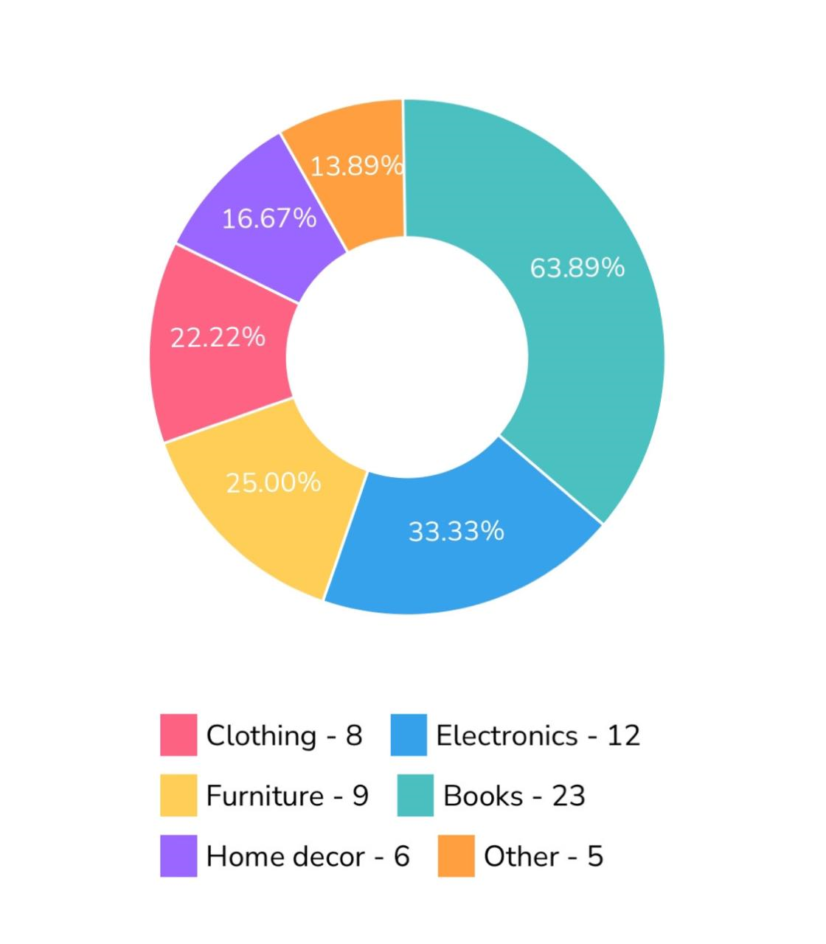

What features do you find most important in an online platform for second-hand items?

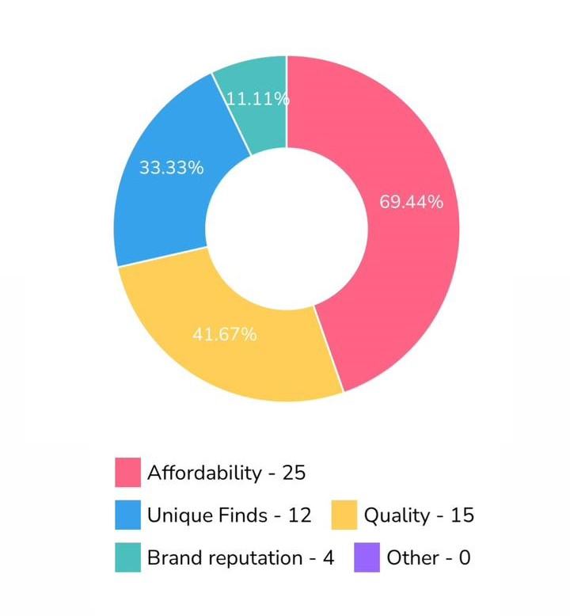

Out of 36 participants, 23 indicated that they preferred to buy books from Thrift stores. Secondly, when asked about their priorities in buying items, 25 respondents highlighted affordability as an important consideration. This highlights a noteworthy trend in which customers prioritize cost-effectiveness when making overall buying decisions and prefer thrift stores for book purchases.

Link to the survey form: <https://surveyheart.com/form/653a0d1e7e4a390831216110>

1. **Software Requirement Specification (SRS) Document**

Owner of the webapp

Web app to Post and find items

Seller

NGO

Buyer

Delivery Man

**System Environment**  
  
Seller sells, buyer buys, the owner of the web app edits or approves or deletes, and delivery man delivers the item. Item can also be donated to an NGO (for now only one NGO).

**User Roles**

* **Sellers:** Users who list and sell products on the platform.
* **Buyers:** Users who search for and purchase products on the platform.
* **Owners/Admin:** System administrators responsible for managing categories, approvals, and policies.
* **NGO (Non-Governmental Organization):** Organizations receiving donated items for distribution.
* **Delivery Man:** Individuals responsible for picking up and delivering products.

**User Story for a Buyer: Searching for and Buying Products**

As a buyer, I want to find and purchase products on the platform to meet my needs.

* When I log into the web app, I should be able to search for products using a search bar.
* I can enter product names, or categories for search.
* After hitting the "Search" button, I expect to see a list of products matching my criteria for example shoes.
* Each product listing should include details of the product name, description, images, seller information, and pricing.
* The platform should provide options for filtering products based on price ranges (e.g., 200 to 1000), item categories (popular items, new items), and trusted sellers. This feature will make it easier for me to find products that match my preferences.
* I can click on a product to view more details, and I should have the option to either "Add to Cart" or "Buy Now."
* If I choose "Buy Now," I should be able to select my delivery location, choose a payment method, and click on the Confirm the order button for immediate purchase.

**User Story for a Seller: Conveniently sell items**

As a seller, I want to list my products for sale on the platform.

* When I log into the web app, I should be able to click on the "Sell" button.
* I will then select the category for my product (books or clothes).
* Next, I will be prompted to add photos and a video of the product.
* After adding visual content, I will proceed to fill in the product listing form. The required details will be based on the category I've selected:
  + For Books: I will provide information including the book title, the book's condition (excellent, very good, average or bad), and the price.
  + For Clothes: I will specify product details including the product title, size, and the season for which the clothing is intended (e.g., summer, winter, spring).
* After that, I will select whether to on or off the negotiations option for the buyer.
* Once I've completed the form with all the necessary details, I will click the submit button.
* The item video needed to be added to list the item on the homepage.
* After submission, my item will be listed on the platform for potential buyers to view.

**Functional Requirements in Complete Detail:**

* **User Management:**
  + **User Registration:  
    FR1:** The system should allow users to create accounts by providing their email and password.
    1. Description: Users can register with their email and password to access the platform.
    2. Actor: Sellers, Buyers, Owners, Delivery man
    3. Precondition: User is not registered in the system.
    4. Postcondition: User is registered and directed to the login screen.
    5. Details:
       1. Users provide a valid email address and password.
       2. The system validates the email format and ensures it is unique.
       3. User account information is securely stored in the database.
  + **User Login:   
    FR2:** The system should allow registered users to log in using their email and password.
    1. Description: Registered users can log in using their email and password.
    2. Actor: Sellers, Buyers, Owners, Delivery man
    3. Precondition: User is not logged in.
    4. Postcondition: User is logged in and gains access to their profile.
    5. Details:
       1. Users provide their valid email and password.
       2. The system validates the user's email and password.
       3. Upon successful validation, the user is granted access to their profile.
  + **Password Reset  
    FR3:** The system should allow registered users to reset password using their email.
    1. Description: The system should allow registered users to reset their passwords.
    2. Actor:Sellers, Buyers, Owners, Delivery man
    3. Precondition:The user is registered.
    4. Postcondition: The user's password is successfully reset.
    5. Details:
       1. Users can request a password reset email.
       2. Users receive a password reset email containing a unique link.
       3. Users can set a new password by following the link.
  + **Define Categories (Admin):  
    FR4:** The system allows the admin to define product categories.
    1. Description: The admin has the capability to create and manage product categories. This feature provides the admin with the tools to organize and categorize products effectively.
    2. Actor: Admin
    3. Precondition: The admin is logged into the system.
    4. Postcondition: The product categories are successfully defined and available for use.
    5. Details:
       1. The admin can access the category management interface from their admin dashboard.
       2. The admin can create new product categories by specifying a name, description, and optional image.
       3. Existing categories can be edited or deleted by the admin as needed.
       4. Categories are displayed to users to assist in product navigation and search.
* **Listing a Product** 
  + **Start Selling:****FR5:** Sellers can list products including books and clothes for sale.
    1. Description: Sellers should be able to list products (books and clothes) for sale on the platform by clicking on the sell button.
    2. Actor: Sellers
    3. Precondition: Seller is logged in.
    4. Postcondition: The product is listed for sale.
    5. Details:
       1. Sellers select a category (books or clothes). Add photo, video of form and fill the product listing form.
* **Upload Photo:**

**FR6:** Sellers must be able to upload photos of their products during the listing process.

1. Description: Sellers can upload photos of their products during the listing process, with tips to upload photos including images of both the front and back of the product. Sellers can also add more images to showcase the item from various angles.
2. Actor: Sellers
3. Precondition: The seller is in the process of listing a product for sale.
4. Postcondition: The photos are uploaded.
5. Details:
   * 1. Sellers can upload multiple images per product to showcase the item from various angles.

* **Clicking Photos for Products  
  FR7:** Sellers must be able to take photos of their products during the listing process.
  + 1. Description: Sellers can take photos of their products during the listing process, with tips to click photos including images of both the front and back of the product. Sellers can also capture additional images to showcase the item from various angles.
    2. Actor: Sellers
    3. Precondition: The seller is in the process of listing a product for sale.
    4. Postcondition: The photos are successfully captured.
    5. Details:
       1. Sellers can capture multiple images per product to showcase the item from various angles.
       2. Tips were given while taking photos including images of both the front and back of the product.
* **Add Product Video (Required)  
  FR8:** Sellers must add a video of the product during the product listing process.

1. Description: Sellers must include a video of the product during the product listing process to provide potential buyers with a comprehensive view of the item they intend to sell.
2. Actor: Sellers
3. Precondition: Seller has added photo/s of the product.
4. Postcondition: A product video is successfully added.
5. Details:
   * + 1. Sellers can either upload a video file or record a new video using their device's camera.
       2. The tips our provided while uploading or recording video. Tips: The video should provide a clear view of the product from all sides to assist potential buyers in assessing its condition and suitability.
       3. Adding video is required because it showcases the sides of the product.

* **Product listing form:****FR9:** Sellers must complete the product listing form (a form of books or clothes) when listing the product for sale.
  + 1. Description: Sellers must complete a product listing form when adding a new product for sale on the platform. The form includes fields tailored to book and clothing categories. Sellers have the option to save their contact information for future use, and returning sellers are provided with pre-filled information that can be edited.
    2. Actor: Sellers
    3. Precondition: Seller is listing a product for sale.
    4. Postcondition: Sellers have successfully completed and submitted the product listing form and product is listed on the platform.
    5. Details:
       1. Sellers are prompted to select a category for their product: either "Books" or "Clothes."
       2. Sellers need to Add photo (click or upload) and video of the product.
       3. Based on the category selected:
          - For "Books," sellers must specify the type of book from a predefined list (action, romantic, historical, fiction, non-fiction, mystery) or manually enter it.
          - For "Clothes," sellers choose the gender category (men, women, kids) and the season category (summer, winter, autumn, spring) or manually enter it.
       4. Sellers proceed to fill in the following product details:
       - Product Title: A descriptive title for the product.
         * Product Condition: Choose from predefined options: "Excellent," "Very Good," "Average," and "Bad."
         * Price: The price at which the product will be listed.
         * Product Description(optional): A brief description of the product's features, condition, or any additional information.
         * Negotiation Feature: A toggle to enable or disable the negotiation feature (default is disabled).
       1. After providing product details, sellers enter their contact information:
          - City: The seller's location or city.
          - Postal Code: Relevant postal code.
          - Phone Number: Contact number for potential buyers.
          - Address: The physical address, editable for returning sellers.
       2. Sellers have two options after reviewing the form:
          - Save Information: Save the provided contact details for future use.
          - Submit Product Listing: Confirm and submit the product listing.
       3. Returning sellers, upon initiating a new product listing, will be presented with pre-filled contact information and the option to edit it as needed. This streamlines the process for experienced sellers and reduces redundancy.
* **Negotiate Button Enable or Disable:  
  FR10:** The system must allow the seller to turn on or off the negotiate button. (the price of the product needs to be set whether the negotiate button is enabled or disabled)
  + 1. Description: While listing a product for sale, sellers should have the option to control the availability of the "Negotiate" button on their product listings, allowing them to turn it on or off.
    2. Actor: Sellers
    3. Precondition: Sellers are in the process of listing a product for sale on the platform.
    4. Postcondition: The "Negotiate" button on the seller's product listing is either enabled (turned on) or disabled (turned off) according to their preference as set during the listing process.
    5. Details:
       1. During the product listing process, sellers encounter an option to enable or disable the "Negotiate" button.
       2. Enabling the "Negotiate" button means that buyers can initiate negotiations.
       3. Disabling the "Negotiate" button restricts buyers from initiating negotiations.
       4. Sellers have the flexibility to enable or disable the "Negotiate" button for each product they list.
       5. By default, the negotiate option is disabled.
* **Homepage and Content Management:**
  + **Displaying Popular Items on the Homepage:  
    FR11:** The homepage should include a section for popular items.
    1. Description: The homepage should feature an automated section displaying popular items available for sale on the platform, determined by a computed popularity score based on the criteria that a product must have more than 60 views and 20 likes.
    2. Actor: Buyers, Sellers and Admin
    3. Precondition: Users visit the homepage.
    4. Postcondition: The popular items section is visible on the homepage.
    5. Details:
       1. The system continuously collects and processes data on user interactions with products, including views and likes.
       2. The admin has access to the "popular items" management section within the admin dashboard.
       3. Admin establishes specific criteria for achieving the "popular item" status, including prerequisites: each product needs to meet a popularity score computed based on having more than 60 views and 20 likes.
       4. Only products exceeding the defined popularity score (60 views and 20 likes) threshold are displayed in the popular items section.
       5. Users can click on products within the popular items section to view more details.
  + **Displaying trusted sellers on the Homepage:  
    FR12:** The homepage should include a section for trusted sellers.
    1. Description: The homepage should prominently feature a section dedicated to showcasing trusted sellers on the platform. Trusted sellers are designated based on achieving the following criteria: accumulating positive reviews and ratings, successfully completing a minimum of 10 sales, and unwavering adherence to platform policies.
    2. Actor: Buyers, Sellers And Admin
    3. Precondition: Users visit the homepage of the platform.
    4. Postcondition: The trusted seller’s section is visible on the homepage.
    5. Details:
       1. The homepage prominently displays a section that highlights trusted sellers, enabling users to easily identify reliable sellers for their purchases.
       2. Trusted sellers are recognized for consistently providing excellent products and service, maintaining high ratings, receiving positive reviews, and having a history of successful transactions.
       3. The admin has access to the "Trusted Seller" management section within the admin dashboard.
       4. Admin establishes specific criteria for achieving the "trusted seller" status, including prerequisites: completing a minimum of 10 successful transactions, maintaining positive reviews and ratings, and demonstrating unwavering adherence to platform policies.
       5. Sellers who meet or exceed the defined criteria are automatically designated as "trusted sellers."
       6. Users can readily identify trusted sellers through badges displayed on their profiles and product listings.
  + **Displaying new items on the Homepage:  
    FR13:** The homepage should include a section for new items (remaining for a specified duration defined by the admin, e.g., 3 days).
    1. Description: The homepage should have a section displaying new items available in the section for the specified duration defined by the admin.
    2. Actor: Buyers, Sellers and Admin
    3. Precondition: Users visit the homepage of the platform.
    4. Postcondition: The new items section is visible on the homepage.
    5. Details:
       1. The "New Items" section would have products that have been recently listed by sellers and remain there for a specific duration (e.g., first three days).
       2. The admin has access to the "New items" management section within the admin dashboard.
       3. Admin set a specific duration (e.g., first three days) for new items to remain on the new items section.

* + **Displaying Recommended items on the Homepage:  
    FR14:** The homepage should include a section for recommended items.
    1. Description: The homepage should display a section suggesting items recommended for users based on factors, including previous searches, purchases, wishlists, product views, preferred product categories, seasonal trends, and complementary products.
    2. Actor: Buyers
    3. Precondition: Users visit the homepage of the platform.
    4. Postcondition: The recommended items section is visible on the homepage.
    5. Details:
       1. The system gathers a comprehensive dataset of buyer interactions. This dataset encompasses product views, searches, purchases, and wishlists. Additionally, it records each buyer's preferred product categories.
       2. Utilizing advanced machine learning algorithms and collaborative filtering techniques, the system analyzes the collected data. These algorithms take into account a buyer's historical behavior, identifying patterns and preferences. For instance, if a buyer frequently searches for and buys clothes, the system learns that clothes are a preferred category.
       3. The recommendation system incorporates seasonal trends to reflect time-based patterns and preferences. For instance, during the holiday season, it considers the heightened demand for festive items and adjusts recommendations accordingly.
       4. The system identifies complementary products by evaluating user interactions. If a buyer adds a shirt to their cart, the system may suggest related accessories such as pants, jeans, or skirts based on the purchase histories and patterns of other users.
       5. Buyers receive tailored product suggestions on the homepage.
  + **Add Policy:  
    FR15:** The system should allow administrators to add and manage policies on the homepage.
    1. Description: Admins can add and manage policies (in the form of text) on the homepage.
    2. Actor: Admin
    3. Precondition: Admin is logged in.
    4. Postcondition: The homepage displays the mentioned Policies that are added or updated on the homepage.
    5. Details:
       1. Admins can add, edit, or remove policies written in text form on the homepage.
  + **Add About Us:****FR16:** The system should allow administrators to add and manage "About Us" content (in the form of text) on the homepage.
    1. Description: Admins can add and manage "About Us" content on the homepage.
    2. Actor: Admin
    3. Precondition: Admin is logged in.
    4. Postcondition:"About Us" content is added or updated on the homepage.
    5. Details:
       1. Admins can edit and update information about the platform, its mission, and its team on the "About Us" section of the homepage.
  + **Customer Services:****FR17:** The system should provide customer service information which includes FAQs, the email address of the organization, and a helpline on the homepage.
    1. Description: The homepage should provide customer service information.
    2. Actor: All Users
    3. Precondition: Users visit the homepage.
    4. Postcondition: Customer service information is accessible on the homepage.
    5. Details:
       1. Customer service information includes FAQs, the email address of the organization, and a helpline.
* **Product Search Viewing and browsing:**
* **Search Bar:****FR18:** The system should provide a search bar for buyers to search for products by various criteria.
  + 1. Description: Buyers can use the search bar to search for products based on different criteria.
    2. Actor: Buyers
    3. Precondition: Buyer is logged in.
    4. Postcondition: Products matching the search are displayed.
    5. Details:
       1. The search bar allows users to enter keywords, product names, or other search criteria.
       2. Search results are displayed based on user input.
* **View Product**   
  **FR19:** Buyers should be able to view detailed product information.
  + 1. Description: Buyers can view detailed product information, including descriptions, images, and pricing.
    2. Actor: Buyers
    3. Precondition: Buyer is logged in.
    4. Postcondition: Buyers can view product details.
    5. Details:
       1. Product details include product name, description, images, seller information, and pricing.
       2. Buyers can access a product's page for comprehensive information.
* **Filters:****FR20**: The system should allow buyers to use filters to refine product search results.
  + 1. Description: Buyers can apply filters to narrow down search results, including price ranges and trusted seller options.
    2. Actor: Buyers
    3. Precondition: Buyers are searching for products.
    4. Postcondition: Search results are filtered based on user preferences.
    5. Details:
       1. Buyers can set filters, including price ranges (from 200 to 1000, 1000 to 1800, 1800 to 2600, and above 2600) category, trusted seller, new items and recommended items.
       2. Filters help buyers find products that match their specific criteria.
* **Shopping and Transaction:**
* **Add to Cart Feature:****FR21:** Buyers should be able to add products to a shopping cart for potential purchase.
  + 1. Description: Buyers can add products to a shopping cart for potential purchase.
    2. Actor: Buyers
    3. Precondition: Buyer views the product.
    4. Postcondition: Products are added to the shopping cart for potential purchase.
    5. Details:
       1. Buyers can add products to a virtual shopping cart for later review and purchase.
       2. The shopping cart keeps track of selected items.
* **Wishlist Feature:****FR22:** Buyers should be able to add products to their wishlist.
  + 1. Description: Buyers can add products to their wishlist for later consideration.
    2. Actor: Buyers
    3. Precondition: Buyer is viewing a product.
    4. Postcondition: Products are added to the buyer's wishlist for later consideration.
    5. Details:
       1. Buyers can create and manage a wishlist of desired products.
       2. The wishlist provides an easy way to track products of interest.
* **Buying Button****FR23:** Buyers can initiate the buying process, enter delivery details, select a payment method, and use text-to-speech for product descriptions.
  + 1. Description: Buyers can initiate the buying process, enter delivery details, select a payment method, and use text-to-speech for product descriptions.
    2. Actor: Buyers
    3. Precondition: The buyer is viewing the product.
    4. Postcondition: The buying process is initiated.
    5. Details:
       1. Buyers can click the "Buy" button on a product to start the purchase process.
       2. They enter delivery information and select a preferred payment method.
       3. Buyers can use a text-to-speech feature to listen to the product description.
* **Order Tracking:**
* **FR24:** The system should provide an order tracking feature that allows users to monitor the status (pick from seller’s house, at the warehouse, on the way to buyer’s house, and delivered) and the location of their orders.
  + 1. Description: The system should offer an order tracking feature enabling users to monitor the status and location of their orders, including pick-up from the seller's house, in the warehouse, en route to the buyer's house, and delivered.
    2. Actor: Delivery Person, Seller, Buyer
    3. Precondition: An Order has been placed.
    4. Postcondition: Users can access real-time information about their order's status and location.
    5. Details:
       1. The system tracks each order and provides a unique order tracking number or identifier for reference.
       2. Buyers can access their order tracking information from their user accounts or order history.
       3. The tracking feature shows the order's status as it progresses through stages: "Picked up from seller's house," "In the warehouse for inspection," "On the way to the buyer's house," and "Delivered."
       4. In case of any delays or issues, notifications are sent to the involved parties to keep them informed.
* **Negotiation Option (wireframes attached in end of the docs)**
* **FR25:** The system should allow buyers to negotiate on items if the negotiate button is enabled and sellers can accept, decline, or counter-offer.
  + 1. Description: Buyers can negotiate on items if the negotiate button is enabled and sellers can accept, decline, or counter-offer. During the negotiation process, multiple buyers can initiate separate negotiations for the same product, and another buyer can also choose to purchase the product directly by clicking on buy now. Each buyer is allowed to make up to 4 negotiation offers (this is set by the admin).
    2. Actor: Buyers, Sellers
    3. Precondition: Negotiate button is enabled.
    4. Postcondition: Negotiation offers are accepted, declined, or countered. The product may be purchased directly by another buyer (by clicking on buy now) during an ongoing negotiation.
    5. Details:
       1. Buyers can negotiate on a product with a proposed price.
       2. Sellers have the option to accept the offer, decline it, or propose a counteroffer.
       3. Negotiations continue until an agreement is reached or the negotiation ends.
       4. During an ongoing negotiation between a seller and a buyer, other buyers can initiate separate negotiations for the same product with sellers.
       5. Additionally, while a negotiation is ongoing, another buyer can choose to buy the product directly by selecting the "Buy Now" option.
       6. If the negotiate offer is accepted by the seller, the buyer has 24 hours to complete the purchase. After this time frame, if the buyer does not proceed with the purchase, the item's "Buy Now" option becomes available to other buyers.
       7. Each buyer is limited to making up to 4 negotiation offers. Once a buyer has made 4 offers for a particular product, they can no longer initiate negotiations for that specific product.

* **Donation Feature:**
* **FR26**: The system should allow the seller to donate items to an NGO linked with the organization (linked NGO is only one).
  + 1. Description: Sellers can donate items by filling out a donation form. Donated items are collected, inspected, and sent to an NGO.
    2. Actor: Sellers, Delivery Person, Warehouse Inspector, NGO
    3. Precondition: Sellers click on donate item button.
    4. Postcondition: Donated items are collected
    5. Details:
       1. Sellers can donate items by first filling donation form, then item is collected, inspected for quality, and sent to an NGO.
* **Additional Features:**
* **Notification Feature:****FR27:** The system should provide notifications to users for various events, such as new messages, product updates, or order status.
  + 1. Description: The system offers a notification feature that keeps users informed about important events and updates on the platform, such as new messages, product changes, and order status.
    2. Actor: All Users
    3. Precondition: Users are registered on the platform and actively using it.
    4. Postcondition: Users receive relevant and timely notifications.
    5. Details:
       1. Users can opt-in to receive different types of notifications, such as messages from buyers or sellers, updates on products they are interested in, or changes in their order status.
       2. Notifications can be delivered via email, in-app alerts, or SMS, depending on user preferences.
       3. The system tracks user preferences for notification types and frequency.
       4. Notifications may include information on new products, messages, product status changes (e.g., out of stock or price reductions), order confirmations, and order shipment updates.
       5. Users have the ability to customize their notification settings and preferences through their account settings.
* **Return Policy:****FR28:** The system should define and display a return policy for users to understand the terms of returning purchased items.
  + 1. Description: The system provides a clear and accessible return policy for users to understand the terms and conditions related to returning items they have purchased.
    2. Actor: All Users
    3. Precondition: Users click on return policy.
    4. Postcondition: The return policy page is opened.
    5. Details:
       1. The return policy is accessible from a prominent location on the platform, such as the footer or a dedicated policy section.
       2. The return policy includes detailed information about the conditions under which returns are accepted, the timeline for returns, and any associated fees or costs.
       3. Users can access the return policy without the need to log in or make a purchase.
       4. The policy is written in a clear and easily understandable language.
       5. Contact information for customer support or return-related inquiries is provided within the policy.
* **24/7 Chatbot:****FR29:** A 24/7 chatbot should be available to assist users with questions and provide support.
  + 1. Description: The platform features a 24/7 chatbot designed to assist users with their questions and provide support round the clock.
    2. Actor: All Users
    3. Precondition: Users have questions or require assistance.
    4. Postcondition: Users receive timely assistance and information from the chatbot.
    5. Details:
       1. The chatbot is available for users to interact with at any time, 24/7.
       2. The chatbot is capable of answering frequently asked questions, providing information on policies, guiding users through processes, and offering support.
       3. Users can initiate a chat with the chatbot from homepage.
       4. The chatbot is equipped with natural language processing capabilities to understand and respond to user queries effectively.
       5. If a query is beyond the chatbot's capabilities, it can escalate the conversation to a human support agent.
* **Adding Product Reviews and Ratings**:  
  **FR30:** The system should allow buyer to add review and rating of item after the product is delivered to them.

1. Description: The system should enable buyers to submit reviews and ratings for products after the items have been delivered to them.
2. Actor: Buyers
3. Precondition: Buyer has received the ordered product.
4. Postcondition: The product review and rating are successfully added to the platform.
5. Details:
   * + 1. Buyers can access the product they've purchased and find an option to add a review and rating.
       2. Reviews include text-based feedback or comments about the product.
       3. Ratings are provided on a scale, from 1 to 5 stars, with 1 being the lowest and 5 being the highest rating.
       4. The system records and displays these reviews and ratings on the respective product's page.

**Non-functional Requirement**

* Chatbot Response Time: The chatbot should respond to user queries within 2 seconds to provide quick assistance.
* User-Friendly Interface: The web app should have an intuitive and user-friendly interface, making it easy for users to navigate and use the platform efficiently.
* Consistency: The user interface design, layout, and navigation should be consistent across all pages to provide a uniform user experience.
* Scalability Planning: The system should be designed to accommodate a growing number of users and products. It should be capable of scaling up with increased demand.
* User Data Protection: The system must employ strong data security measures to protect user data, including encryption for sensitive information.
* Payment Security: Ensure secure payment processing by complying with industry standards and utilizing encryption for financial transactions.
* Authentication and Authorization Security: Implement robust user authentication and authorization mechanisms to safeguard against unauthorized access.
* Page Load Times: Web pages should load within 3 seconds or less to ensure a responsive user experience.
* Transaction Speed: The system should process transactions, including order placements and payments, efficiently without delays.
* System Uptime: Aim for high availability with minimal downtime for maintenance or unexpected issues.
* Data Backup and Recovery: Regularly back up system data and establish a data recovery process in case of failures.
* Regulatory Compliance: Ensure compliance with relevant legal and industry-specific regulations, such as consumer protection laws.
* Accessibility: Make the platform accessible to individuals with disabilities by following accessibility standards.
* Browser Compatibility: The system should work seamlessly on various web browsers to accommodate a broad user base.
* System Monitoring: Implement real-time system monitoring and alerting to identify and address issues promptly.
* Video Loading Time: Ensure that video tutorials load and play without significant buffering delays.

**6. Test Cases**

**Test Cases for User Management (FR1 to FR3):  
Test Case 1: User Registration**

* Test Scenario: A new user registers in the system.
* Preconditions: The user is not registered in the system.
* Test Steps:
  1. Open the registration page.
  2. Enter a valid email address and a strong password.
  3. Confirm the password.
  4. Click the "Register" button.
* Expected Result: The user is registered and directed to the login screen. An email confirmation is sent to the user's registered email address.

**Test Case 2: User Login**

* Test Scenario: A registered user logs into the system.
* Preconditions: The user is not logged in.
* Test Steps:
  1. Open the login page.
  2. Enter a valid email and password.
  3. Click the "Login" button.
* Expected Result: The user is logged in and gains access to their profile.

**Test Case 3: Password Reset**

* Test Scenario: A registered user resets their password.
* Preconditions: The user is registered.
* Test Steps:
  1. Click on the "Forgot Password" or "Reset Password" option on the login screen.
  2. Enter the registered email address.
  3. Click the "Send Reset Email" button.
  4. Check the registered email for a password reset email.
  5. Follow the link in the email to set a new password.
* Expected Result: The user's password is successfully reset, and they can log in with the new password.

**Test Case for "Define Categories (Admin)" (FR4):**

**Test Case 4: Manage Product Categories**

* Test Scenario: An admin manages product categories by creating, editing, and deleting categories.
* Preconditions:
  1. The admin is logged into the system.
  2. The admin is on the category management interface.
* Test Steps:   
    
  A. Create a New Product Category:
  1. Click on the "Create New Category" button.
  2. Enter a name, description, and optional image for the new category.
  3. Click the "Save" or "Create" button.

B. Edit an Existing Product Category:

* 1. Select an existing product category to edit.
  2. Modify the category's name, description, or image.
  3. Click the "Save" or "Update" button.

C. Delete an Existing Product Category:

* 1. Select an existing product category to delete.
  2. Click the "Delete" or "Remove" button.
  3. Confirm the deletion action.
* Expected Result:  
   A. The new product category is successfully created and added to the list of categories.  
   B. The changes to the existing product category are successfully saved, and the category is updated.  
   C. The selected product category is successfully deleted and removed from the list of categories.

**Test Cases for "Listing a Product" (FR5 to FR10):**

**Test Case 5: Seller Lists a Product (FR5)**

* Test Scenario: A seller lists a product for sale on the platform.
* Preconditions: The seller is logged in.
* Test Steps:
  1. Click on the "Sell" button.
  2. Select a category (books or clothes).
  3. Add photos and videos of the product.
  4. Fill in the product listing form.
  5. Optionally enable the "Negotiate" button.
  6. Click the "Submit Product Listing" button.
* Expected Result: The product is successfully listed for sale on the platform.

**Test Case 6: Seller Uploads Product Photos (FR 6)**

* Test Scenario: A seller uploads photos of their product during the listing process.
* Preconditions: The seller is in the process of listing a product.
* Test Steps:
  1. Click on the "Sell" button.
  2. Select a category (books or clothes).
  3. Upload multiple images of the product.
* Expected Result: The photos are successfully uploaded.

**Test Case 7: Seller Captures Photos of the Product (FR 7)**

* Test Scenario: A seller captures photos of their product during the listing process.
* Preconditions: The seller is in the process of listing a product.
* Test Steps:
  1. Log in as a seller.
  2. Click on the "Sell" button.
  3. Select a category (books or clothes).
  4. Capture multiple images of the product.
* Expected Result: The photos are successfully captured.

**Test Case 8: Seller Adds a Product Video (FR 8)**

* Test Scenario: A seller adds a video of the product during the product listing process.
* Preconditions: Seller has added photos of the product.
* Test Steps:
  1. Click on the "Sell" button.
  2. Select a category (books or clothes).
  3. Add photos of the product.
  4. Add a product video by uploading a video file or recording a new video.
* Expected Result: A product video is successfully added.

**Test Case 9: Seller Completes Product Listing Form (Books) (FR 9)**

* Test Scenario: A seller completes the product listing form for a book.
* Preconditions: Seller is listing a book for sale.
* Test Steps:
  1. Click on the "Sell" button.
  2. Select the "Books" category.
  3. Add photos and videos of the book.
  4. Fill in the product listing form for a book, including book type, title, condition, price, and contact information.
  5. Choose to save contact information and submit the product listing.
* Expected Result: The product listing for the book is successfully submitted.

**Test Case 10: Seller Completes Product Listing Form (Clothes) (FR 9)**

* Test Scenario: A seller completes the product listing form for clothes.
* Preconditions: Seller is listing clothes for sale.
* Test Steps:
  1. Click on the "Sell" button.
  2. Select the "Clothes" category.
  3. Add photos and videos of the clothes.
  4. Fill in the product listing form for clothes, including gender, season, title, condition, price, and contact information.
  5. Choose to save contact information and submit the product listing.
* Expected Result: The product listing for clothes is successfully submitted.

**Test Case 11: Seller Enables Negotiate Button (FR 10)**

* Test Scenario: A seller enables the "Negotiate" button during the product listing.
* Preconditions: Seller is in the process of listing a product.
* Test Steps:
  1. Click on the "Sell" button.
  2. Select a category (books or clothes).
  3. Add photos and videos of the product.
  4. Fill in the product listing form.
  5. Enable the "Negotiate" button.
  6. Click the "Submit Product Listing" button.
* Expected Result: The "Negotiate" button on the seller's product listing is enabled, allowing buyers to initiate negotiations.

**Test Case 12: Seller Disables Negotiate Button (FR 10)**

* Test Scenario: A seller disables the "Negotiate" button during the product listing.
* Preconditions: Seller is in the process of listing a product.
* Test Steps:
  1. Click on the "Sell" button.
  2. Select a category (books or clothes).
  3. Add photos and videos of the product.
  4. Fill in the product listing form.
  5. Disable the "Negotiate" button.
  6. Click the "Submit Product Listing" button.
* Expected Result: The "Negotiate" button on the seller's product listing is disabled, restricting buyers from initiating negotiations.

**Test Cases for Homepage and Content Management (FR11 to FR17):**  
**Test Case 13: Displaying Popular Items on the Homepage (FR11)**

* Test Scenario: A user visits the homepage.
* Preconditions: Popular items meet the criteria (more than 60 views and 20 likes).
* Test Steps:
  1. Open the homepage.
* Expected Result: The popular items section is visible and displays products meeting the popularity criteria.

**Test Case 14: Verify Trusted Sellers Display (FR 12)**

* Test Scenario: Users visit the homepage.
* Preconditions: Trusted sellers meet the criteria (positive reviews, 10+ successful sales, policy adherence).
* Test Steps: Open the homepage.
* Expected Result: The trusted seller's section is visible and displays trusted sellers with badges.

**Test Case 15: Verify New Items Display (FR 13)**

* Test Scenario: Users visit the homepage.
* Preconditions: New items have been listed within the specified duration.
* Test Steps: Open the homepage.
* Expected Result: The new items section is visible and displays recently listed products.

**Test Case 16: Verify Recommended Items Display (FR 14)**

* Test Scenario: Users visit the homepage.
* Preconditions: User interactions and recommendations are available.
* Test Steps: Open the homepage.
* Expected Result: The recommended items section is visible and displays personalized product suggestions.

**Test Case 17: Add Policy (FR 15)**

* Test Scenario: An admin adds a new policy to the homepage.
* Preconditions: Admin is logged in.
* Test Steps:
  1. Access the policy management interface.
  2. Add a new policy.
* Expected Result: The new policy is added and displayed on the homepage.

**Test Case 18: Add "About Us" Content (FR16)**

* Test Scenario: An admin adds or updates "About Us" content on the homepage.
* Preconditions: Admin is logged in.
* Test Steps:
  1. Access the "About Us" content management.
  2. Add or update "About Us" information.
* Expected Result: The "About Us" content is added or updated on the homepage.

**Test Case 19: Access Customer Service Information (FR17)**

* Test Scenario: A user wants to access customer service information from the homepage.
* Preconditions: User is on the homepage.
* Test Steps:
  1. Look for the customer service information section.
  2. Click on a link to access customer service resources.
* Expected Result: The user can access the provided customer service information.

**Test Case for "Product Search and Viewing" (FR18, FR19):**

**Test Case 20: Search and View Products (FR18, FR19)**

* Test Scenario: A buyer searches for products and views detailed product information.
* Preconditions:
* The buyer is logged into the system.
* The system is accessible with products listed.
* Test Steps:
  1. In the platform, locate the search bar.
  2. Enter relevant keywords, product names, or other search criteria.
  3. Click the "Search" button.
  4. Review the search results.
  5. Click on a specific product from the search results.
* Expected Results:
  1. The search bar is visible and functional.
  2. The search results are displayed based on the entered criteria.
  3. The buyer can view detailed product information, including descriptions, images, and pricing.

**Test Case for "Filters" (FR20):**

**Test Case 21: Apply Filters to Refine Search Results**

* Test Scenario: A buyer uses filters to narrow down product search results.
* Preconditions:
  1. The buyer is logged into the system.
  2. The system is accessible with products listed.
* Test Steps:
  1. Conduct a product search using the search bar.
  2. On the search results page, locate and apply various filters including price ranges, category, trusted seller, newly added items, and recommended items.
  3. Review the refined search results.
* Expected Results:
  1. The buyer can successfully apply filters during the search process.
  2. The search results are updated based on the selected filters, helping the buyer find products that match their specific criteria.

**Test Case for "Add to Cart Feature" (FR21):**

**Test Case 22: Add Products to Shopping Cart**

* Test Scenario: A buyer adds products to a shopping cart for potential purchase.
* Preconditions:
  1. The buyer is logged into the system.
  2. The buyer is viewing a product.
* Test Steps:
  1. On a product's page, locate and click the "Add to Cart" or "Add to Shopping Cart" button.
  2. Review the contents of the shopping cart.
* Expected Results:
  1. The buyer can successfully add products to their virtual shopping cart.
  2. The shopping cart displays the selected items.

**Test Case for "Wishlist Feature" (FR22):**

**Test Case 23: Add Products to Wishlist**

* Test Scenario: A buyer adds products to their wishlist for later consideration.
* Preconditions:
  1. The buyer is logged into the system.
  2. The buyer is viewing a product.
* Test Steps:
  1. On a product's page, locate and click the "Add to Wishlist" button.
  2. Review the contents of the buyer's wishlist.
* Expected Results:
  1. The buyer can successfully add products to their wishlist for later consideration.
  2. The wishlist displays the selected products.

**Test Case for "Buying Button" (FR23):**

**Test Case 24: Initiate Buying Process**

* Test Scenario: A buyer initiates the buying process by entering delivery details, selecting a payment method, and using the text-to-speech feature.
* Preconditions:
  1. The buyer is logged into the system.
  2. The buyer is viewing a product.
* Test Steps:
  1. On a product's page, locate and click the "Buy" button.
  2. Enter delivery information and select a preferred payment method.
  3. Use the text-to-speech feature to listen to the product description.
* Expected Results:
  1. The buyer can successfully initiate the buying process.
  2. Delivery information can be entered, a payment method selected, and the text-to-speech feature used to listen to the product description.

**Test Case for "Oreder Tracking" (FR24):**

**Test Case 25: Oreder Tracking**

* + Test Scenario: A buyer wants to track the status and location of their order.
  + Preconditions:
    1. An order has been successfully placed.
    2. The buyer is logged into their account on the platform.
  + Test Steps:
  1. Go to the "Order History" or "Order Tracking" section in the buyer's account.
  2. Find the specific order you want to track.
  3. Enter the order tracking number or identifier associated with the order.
  4. Click on the "Track Order" button.
  + Expected Results:
  1. The system displays real-time information about the order's status and location.
  2. The status should indicate one of the following stages: "Picked up from seller's house," "In the warehouse for inspection," "On the way to the buyer's house," or "Delivered."
  3. If there are delays or issues, the system sends notifications to keep the buyer informed.

**Test Case for "Negotiation Option" (FR25):**

**Test Case 26: Buyer-Seller Product Negotiation**

* Test Scenario: A buyer negotiate on a product, and the seller responds by accepting, declining, or countering the offer. Multiple buyers can negotiate for the same product, and another buyer can also choose to purchase the product directly by clicking on "Buy Now." Each buyer is allowed to make up to 4 negotiation offers.
* Preconditions: A buyer and a seller are interacting on a product listing.
* Test Steps:
  1. The buyer makes an offer on the product with a proposed price.
  2. The seller has the option to accept, decline, or propose a counter-offer.
  3. Negotiations continue until an agreement is reached or the negotiation ends.
  4. Additionally, while a negotiation is ongoing, another buyer can choose to buy the product directly by selecting the "Buy Now" option.
  5. The buyer is limited to making up to 4 negotiation offers for the same product.
* Expected Results:
  1. The buyer successfully makes an offer on the product.
  2. The seller can accept, decline, or propose a counter-offer.
  3. Negotiations proceed until an agreement is reached or the negotiation offers limit ends. Multiple buyers can initiate separate negotiations for the same product with seller.
  4. Another buyer can choose to buy the product directly by selecting the "Buy Now" option.
  5. The system enforces the limit of 4 negotiation offers for the same buyer for a specific product.

**Test Case for "Donation Feature" (FR26):**

**Test Case 27: Seller Donates Items**

* Test Scenario: A seller uses the donation feature to donate items. Donated items are collected, inspected, and sent to an NGO (only one NGO).
* Preconditions: The seller is logged into the system.
* Test Steps:
  1. The seller clicks on the "Donate Item" button.
  2. The seller fills out the donation form with item details.
  3. Donated items are collected.
  4. Donated items undergo inspection for quality.
  5. Donated items are sent to an NGO.
* Expected Results:
  1. The seller successfully accesses the donation feature and fills out the donation form.
  2. Donated items are collected.
  3. The quality inspection process is completed.
  4. Donated items are successfully sent to an NGO.

**Test Case for "Additional Features” (FR27 TO FR30):  
  
Test Case 28: Receiving Notifications for Order Status ( FR 27)**

* Test Scenario: Users receive notifications for changes in their order status.
* Preconditions: Users have placed orders on the platform.
* Test Steps:
  1. Users have orders with different status changes, such as order confirmation and shipment updates.
  2. Users have configured their notification preferences for order status updates.
* Expected Results:
  1. Users receive timely notifications for order confirmation and shipment updates.
  2. Users have configured their notification preferences successfully.

**Test Case for " Return Policy" (FR 28):**

**Test Case 29: Accessing the Return Policy**

* Test Scenario: Users access and read the return policy to understand the terms and conditions related to returning items.
* Preconditions: Users want to learn about the return policy.
* Test Steps:
  1. Users click on the "Return Policy" link.
  2. Users read the policy to understand its terms.
* Expected Results:
  1. Users can successfully access the return policy.
  2. Users can understand the terms and conditions of the return policy.

**Test Case for " 24/7 Chatbot" (FR 29):**

**Test Case 30: Interacting with the 24/7 Chatbot**

* Test Scenario: Users interact with the 24/7 chatbot to seek assistance and information.
* Preconditions: Users have questions or require assistance.
* Test Steps:
  1. Users initiate a chat with the 24/7 chatbot.
  2. Users ask questions or seek information.
  3. The chatbot provides responses and assistance.
* Expected Results:
  1. Users can successfully initiate a chat with the chatbot.
  2. The chatbot provides timely and accurate responses and assistance.

**Test Case 31: Buyer Adds a Review and Rating (FR 30)**

* Test Scenario: A buyer wants to add a review and rating for a product they received.
* Preconditions: The buyer has received the ordered product.
* Test Steps:
  1. Log in.
  2. Go to the product page of the received item.
  3. Find the option to add a review and rating.
  4. Write a review in the provided text field.
  5. Select a rating (1 to 5 stars).
  6. Click the "Submit" button.
* Expected Result: The review and rating are successfully added to the platform and displayed on the product's page.

**References:**

[1]<https://m.facebook.com/groups/832226130674752/?ref=share&mibextid=BAajgi>

[2]<https://ybmbshop.com/?gclid=CjwKCAjwKipBhBtEiwAWjgwrOUGyTvggbmDgd1GR_Lg4WMS8ubnyn9MZnRVgU_slUxTOXH5ihFhoCwWUQAvD_Bw>

[3] <https://www.marketing91.com/swot-analysis-of-olx/>

[4]<https://ijcrt.org/papers/IJCRT2208238.pdf>

[5]<https://www.ebay.com/sl/sell>

[6]<https://g.co/kgs/2YqbG3>

[7] <https://sfbay.craigslist.org/search/sss#search=1~gallery~0~0>

**Negotiation Frames:**

