Hasil Arsitektur Model Segmentasi 1:

U-Net with Transfer Learning DenseNet & Generative Model cGAN based pix2pix

1. Setting Yang Digunakan
   * Dataset: Iris Needle Mixed
   * Batch Size: 8
   * Shuffle Buffer: 10000
   * Img Height: 128
   * Img Width: 128
   * Steps per Epoch: Panjang Training Dataset // Batch Size
   * Fine Tuning: True
   * Optimizer: Adam
   * Epoch: 50
   * Classes: 256
   * [64 -> 256 -> 512 -> 1024 -> 1024] [512 -> 256 -> 128 -> 64 -> 256]

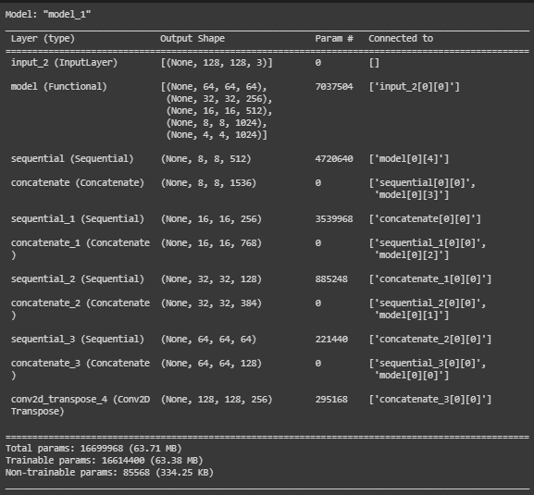

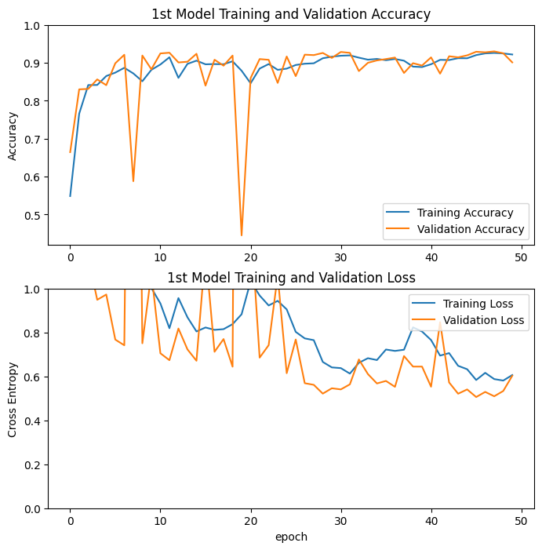

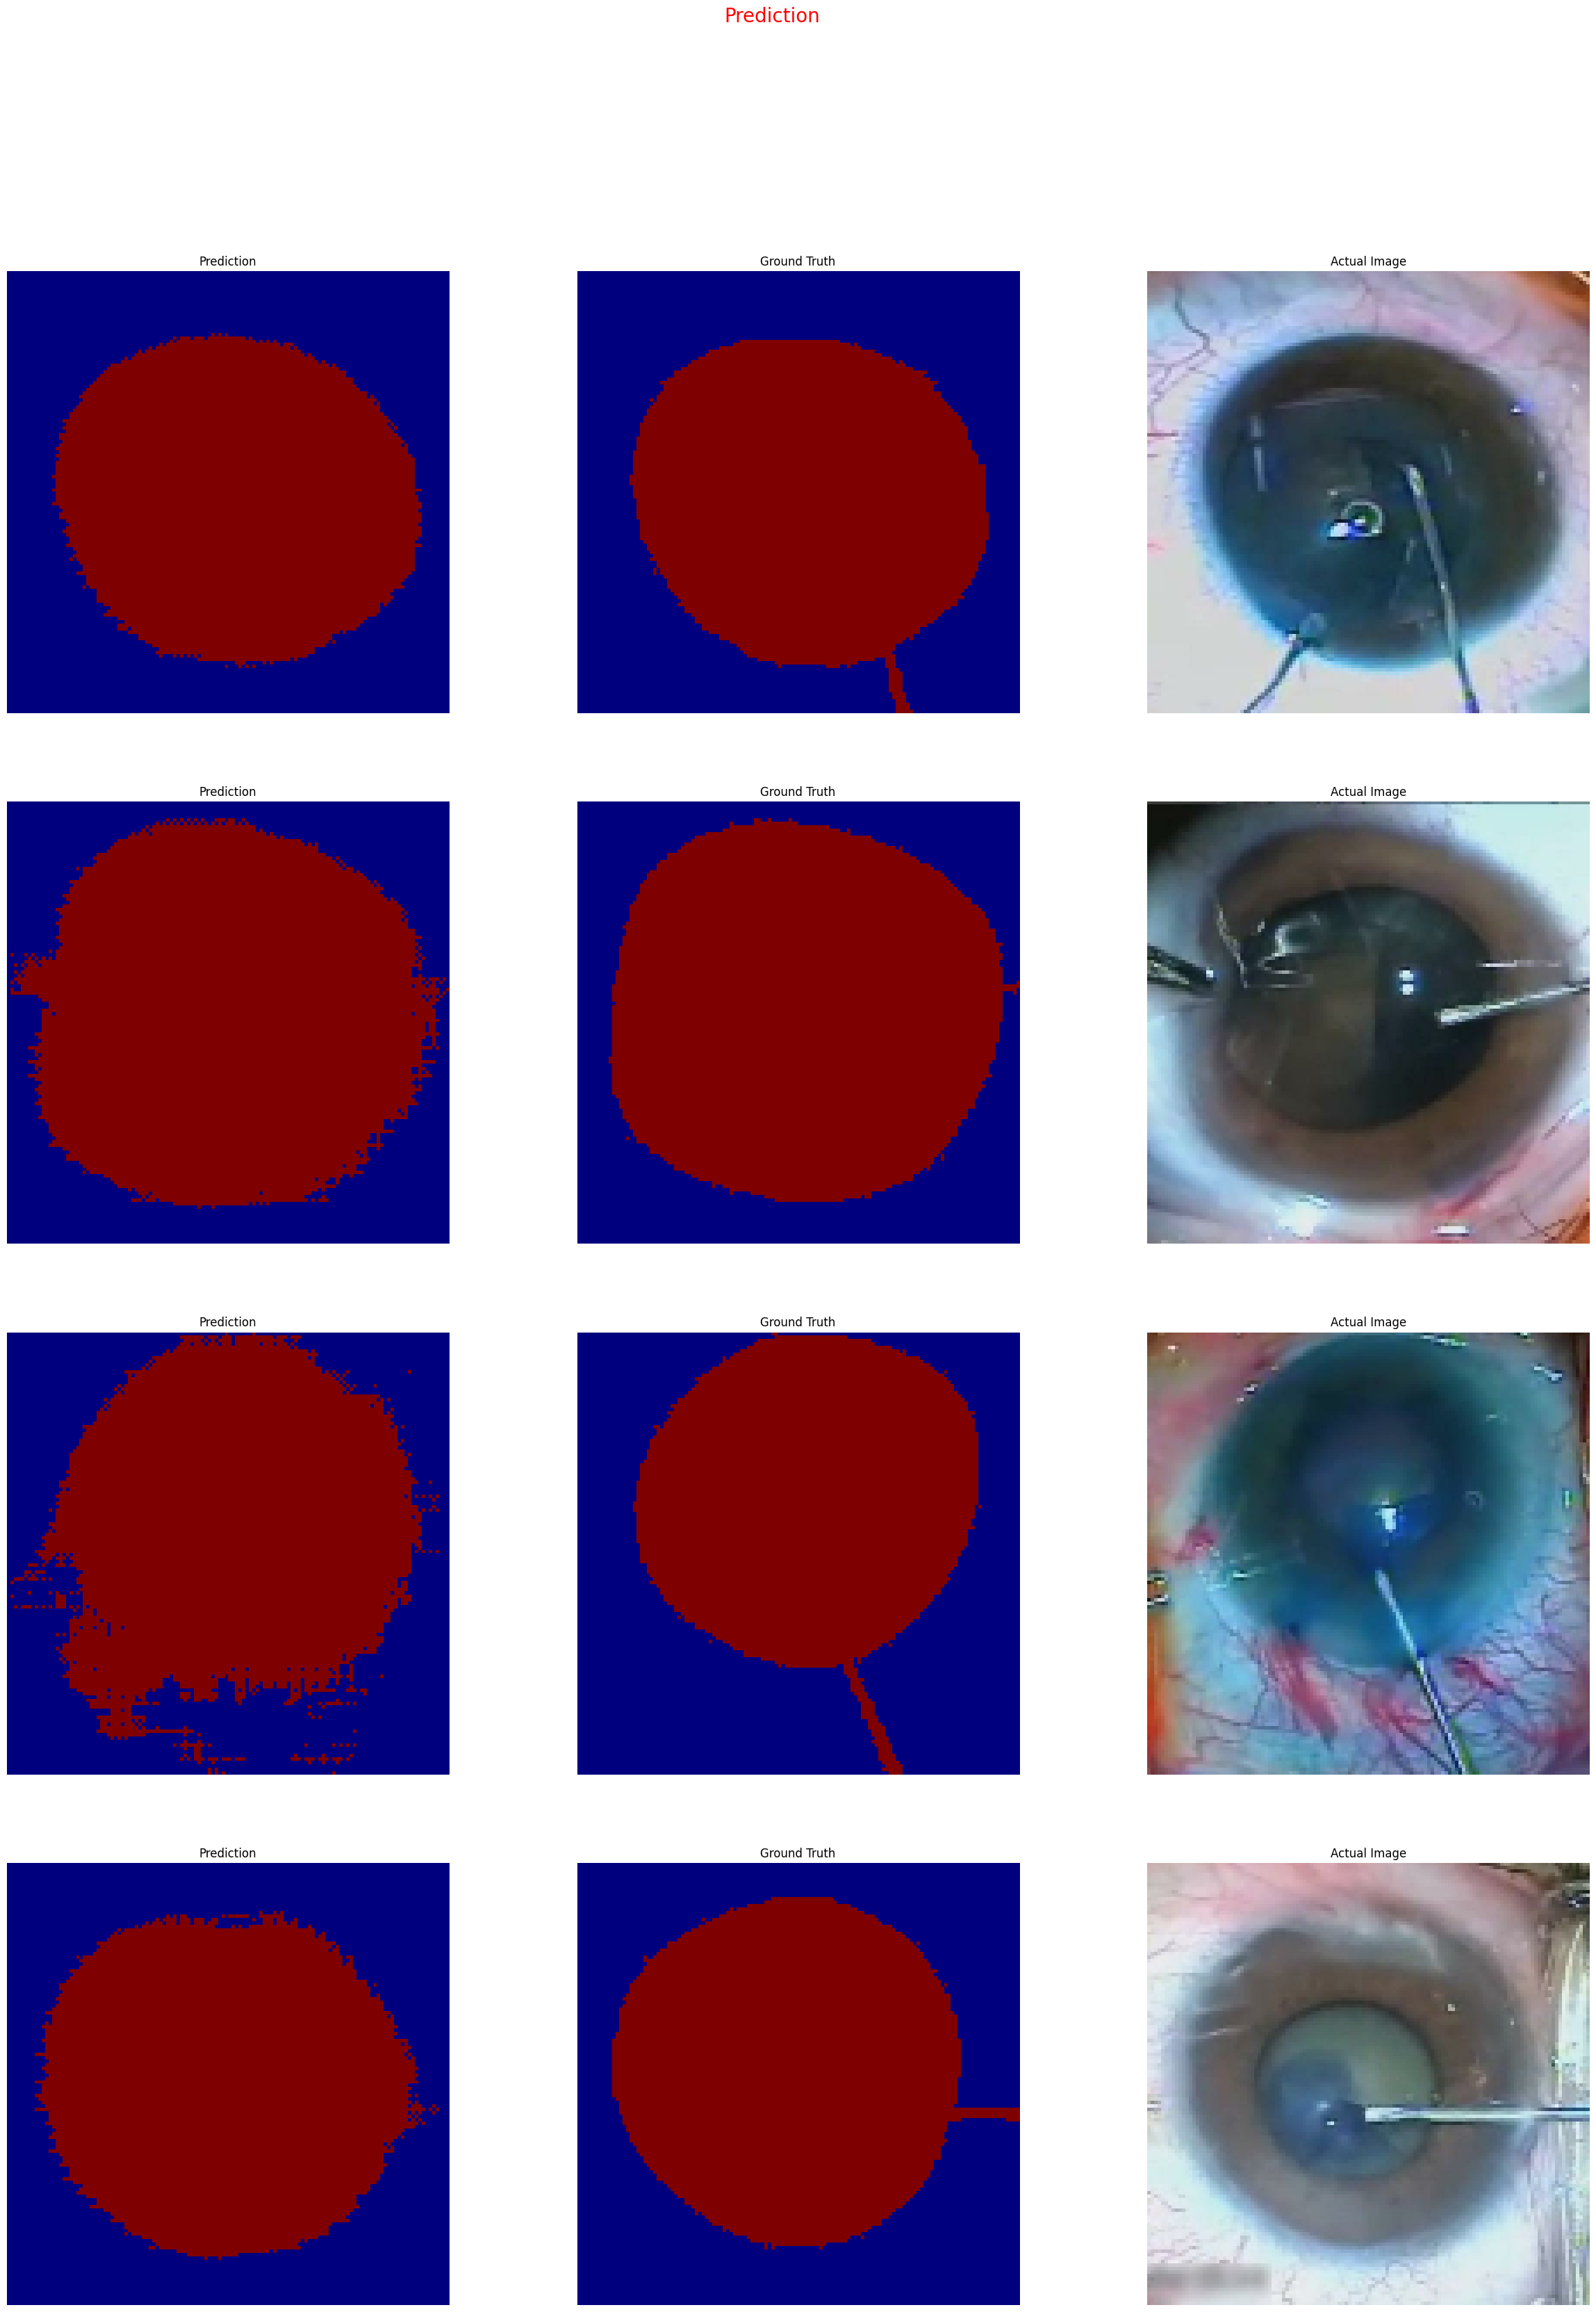

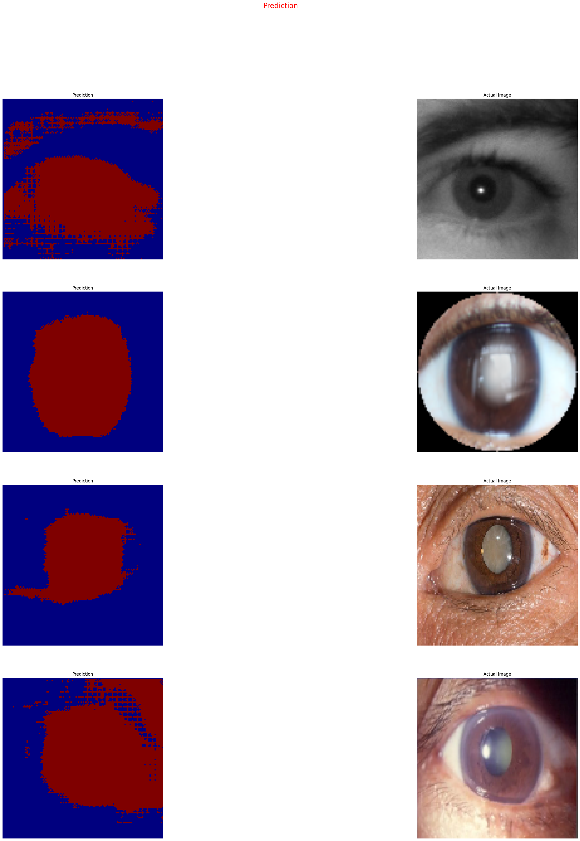

Hasil Arsitektur Model Segmentasi 1:

U-Net Vanilla

1. Setting Yang Digunakan
   * Dataset: Iris Needle Mixed
   * Batch Size: 8
   * Shuffle Buffer: 10000
   * Img Height: 128
   * Img Width: 128
   * Steps per Epoch: Panjang Training Dataset // Batch Size
   * Optimizer: Adam
   * Epoch: 50
   * Classes: 256
   * [64 -> 128 -> 256 -> 1512 -> 1024] [512 -> 256 -> 128 -> 64 -> 256]

