Activity Report

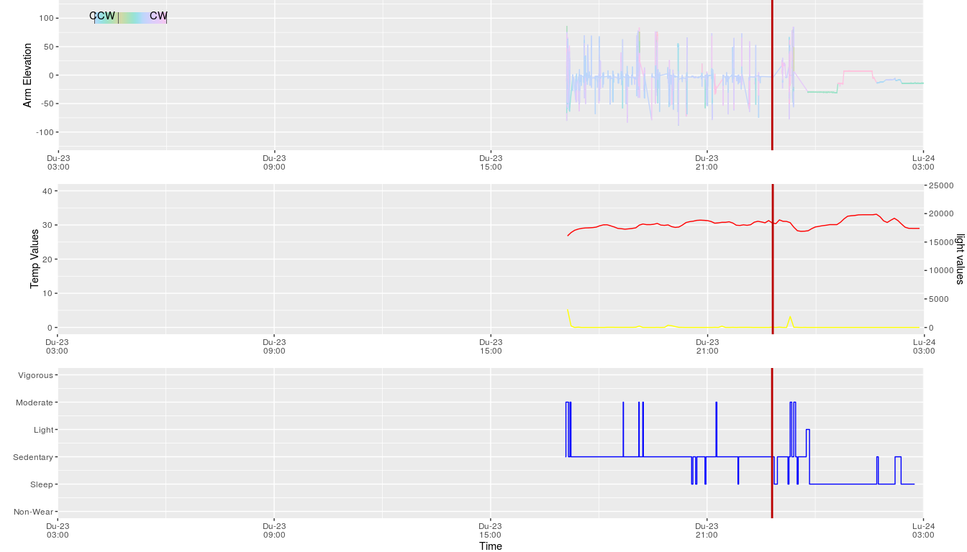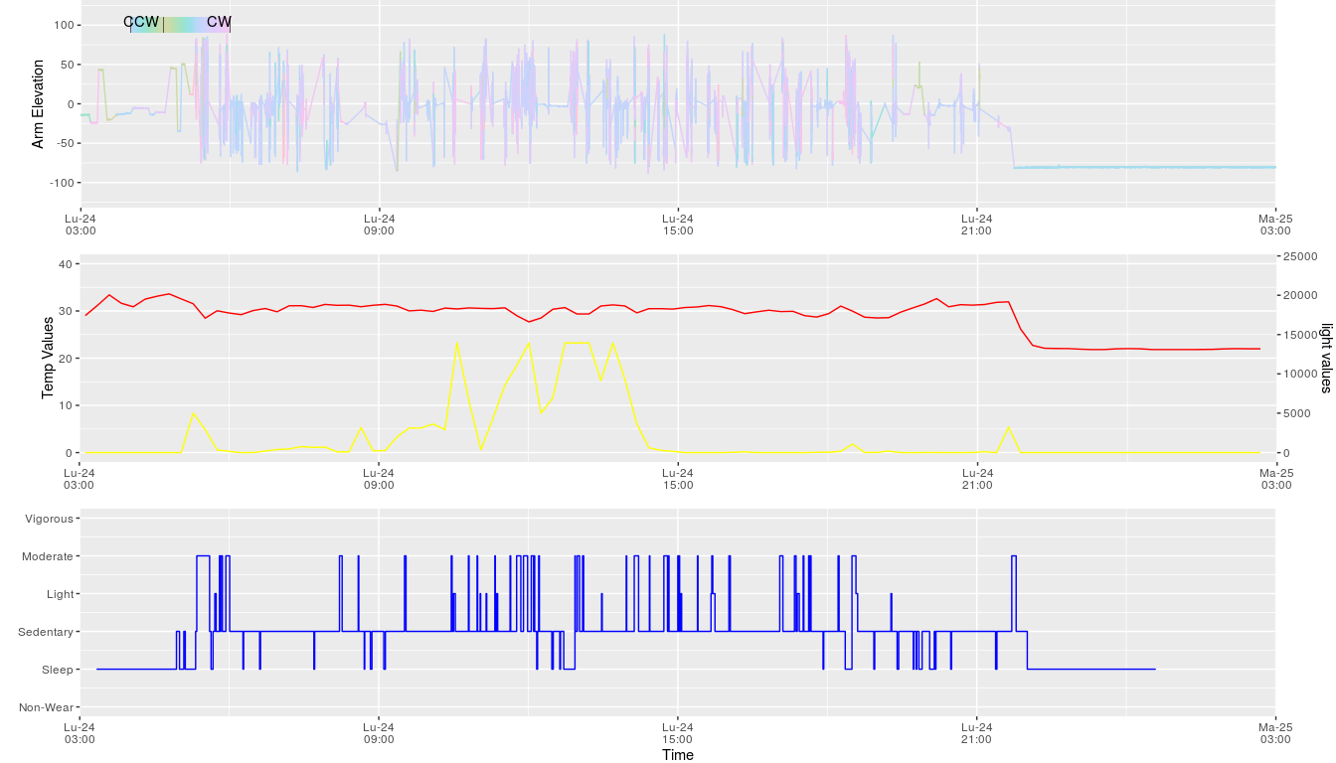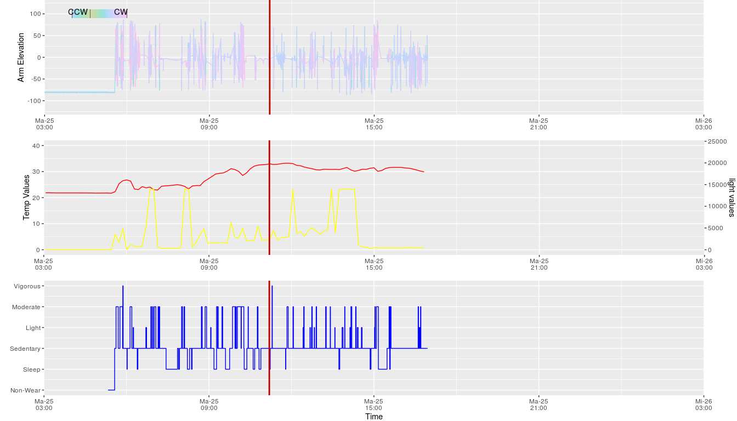

##### Activity Daily Summary.

|  |  |  |  |  |  |  |  |
| --- | --- | --- | --- | --- | --- | --- | --- |
| Day.Number | Steps | Non_Wear | Sleep | Sedentary | Light | Moderate | Vigorous |
| 1 | 588 | 00:00 | 03:32 | 06:22 | 00:05 | 00:15 | 00:00 |
| 2 | 3644 | 00:00 | 10:05 | 14:08 | 00:16 | 01:28 | 00:00 |
| 3 | 2504 | 00:14 | 01:28 | 08:22 | 00:15 | 01:17 | 00:01 |

##### Device Details.

|  |  |
| --- | --- |
| Title | Sleep_Report |
| Date_Created | 2022-01-31 |
| Binfile | /home/alex/work/AI-MAS/projects/2020-ALAMEDA-H2020/dev/alameda/geneactiv/GENEActiv-R-Markdowns-MAY-21-1/Activinsights_Activity_Report_May21_v1/Activinsights_Activity_Report_May21_v1/Data/asorici_right_wrist_test2.bin |
| Analysis_Code_Version | 0.1 |
| Subject_Code | asorici |
| Serial_Code | 1986-3-27 |
| Date_Of_Birth | 1986-3-27 |
| Sex | male |
| height_m | 181 |
| weight_kg | 72 |
| handedness | right |
| Original_sample_frequency_Hz | 50.0 |
| Start_Time | 2022-01-23 17:02:45:000 |
| Measurement_period | 48 Hours |